In-class Exercise: Creating Schemas

Take the ERDs from the previous in-class exercise (on the next page) and convert each to a schema. Remember, the schema is the implementation of an ERD – you’ll wind up with a set of tables that make up your database.

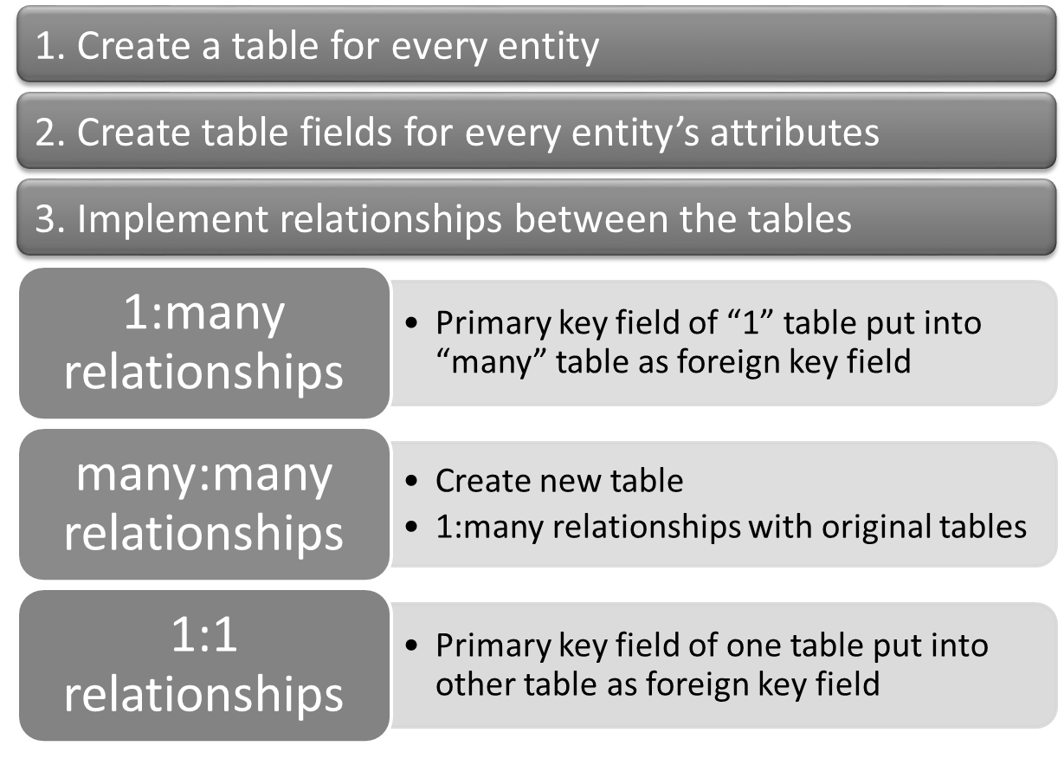

So, for example, if you have this (very simple) ERD with a many-to-many relationship:

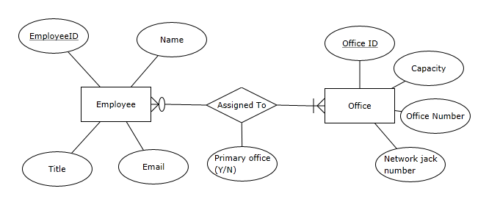

You’ll wind up with this schema (note that we only specified maximum cardinality):

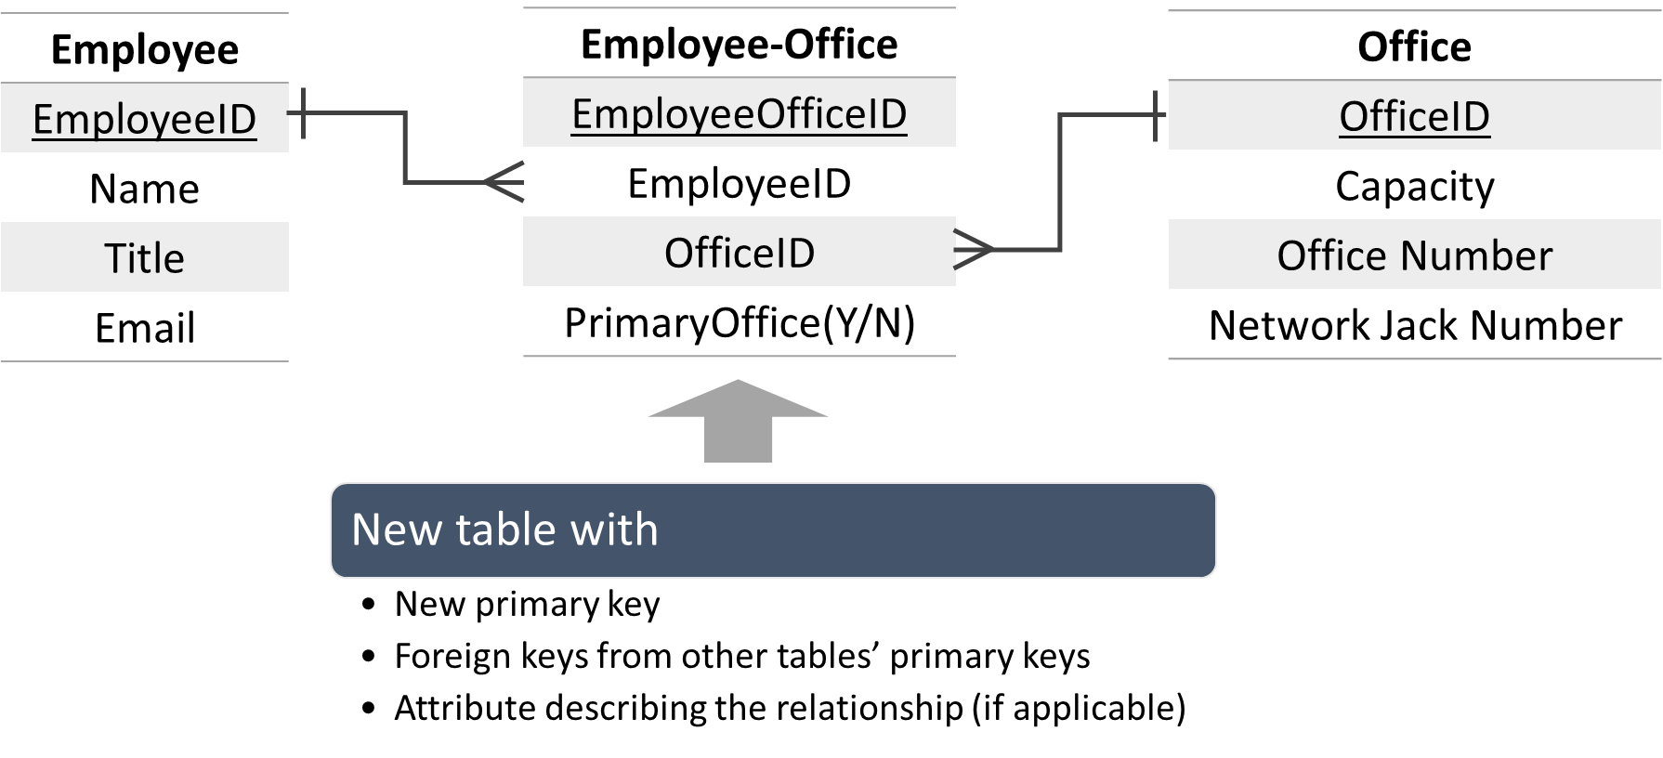

Now create the schemas for the following ERDs:

Scenario 1: Inventory and Parts
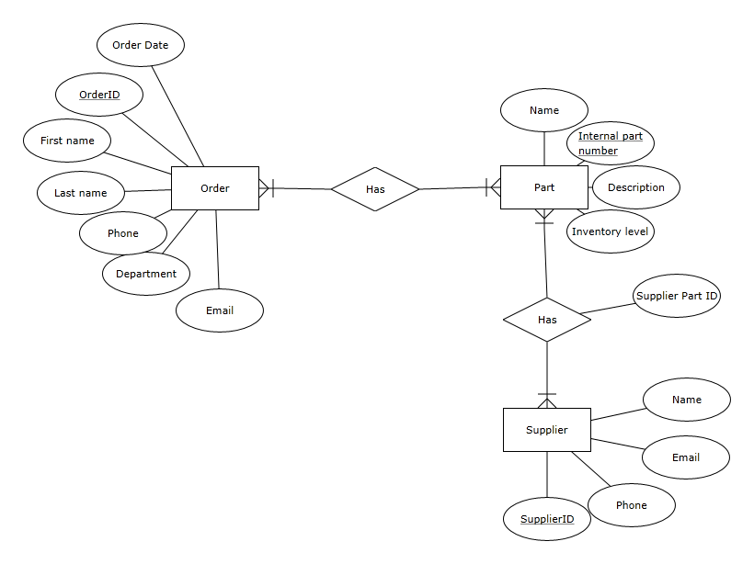
Scenario 2: Housing Authority

