Quick Guide to Installing and Setting Up MySQL Workbench
If you want to install MySQL Workbench on your own computer:
Before you begin, if you’re using a Windows-based PC you will need to install the “C++ Redistributable Package.” This has some basic software that MySQL Workbench needs to run.
- You can get the latest version here:
http://www.microsoft.com/download/en/confirmation.aspx?id=5555
- Once downloaded, install the software just like you would any other program (double-click on the installer and follow the wizard’s instructions).
Now you are ready to install MySQL Workbench:
- Go to: http://www.mysql.com/downloads/workbench/
- To use the version that matches the one in the Netbook lab, install version 5.2.47 instead of version 6.0.8 (the current version). To get the older version, click on “Looking for previous GA versions?”
- Download the version for your operating system. For Windows, use the “Windows (x86, 32-bit), MSI Installer.” For Mac, use the “Mac OS X (x86, 32-bit), DMG Archive.”
Note that we’ve tested this for Windows, but not the Mac. You’ll be trying that version at your own risk. If you’re running Windows on your Mac, we suggest using the Windows version.
- Install the software just like you would any other program (double-click on the installer and follow the wizard’s instructions).

Setting up a connection in SQL Workbench (in the lab or your own laptop):
- If you’re working outside of Temple’s campus, you can skip to step 2.
If you’re on a lab computer, make sure you have logged in with your own MIS username. Otherwise, you might accidentally log in to SQL Workbench as someone else. If the computer is already logged in, log out first!
If you are on your own laptop on Temple’s campus, make sure you are connected through the TUSecure wireless network. To get instructions for connecting to TUSecure visit: http://www.temple.edu/cs/wireless/#tusecure
- Start SQL Workbench.
- Under SQL Development, select “New Connection” if one isn’t there already.
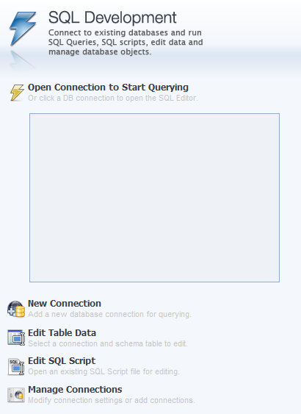

- You’ll see a “Setup New Connection” dialog. Fill in the following information:
Connection Name: class1
Hostname: class1.mis.temple.edu
Username: Your username given to you by your instructor
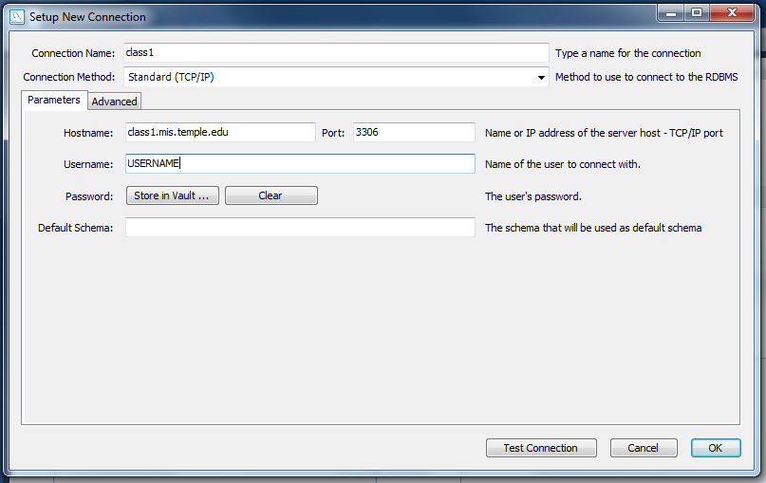
- Click “OK” and you’ll see the connection under “SQL Development”:
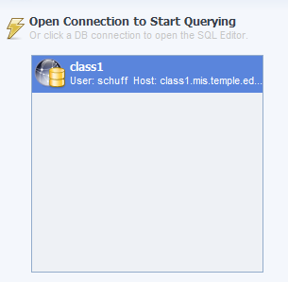

- Double-click on your new connection. You’ll see a password dialog:
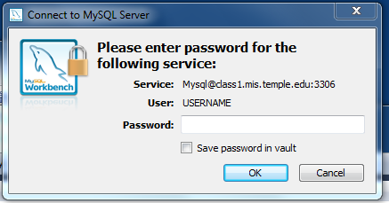
- Enter your password. Then click “OK.”
If you are using your own computer, you can save it in the vault (so you won’t have to enter it again). But if you are in a lab, just to be safe DO NOT save your password.
- You should see the main screen for SQL Workbench:
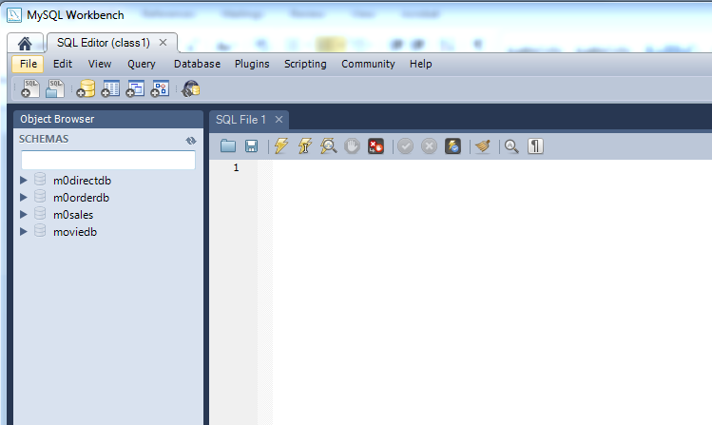
Yours might look a little different, depending on the version you downloaded. But if it basically looks like this, you’ve successfully logged in to the MySQL server using MySQL Workbench!

- Try a query. In the SQL File 1 window, type:
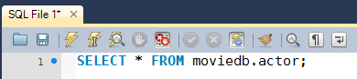
Then click the lightning bolt to execute the query:
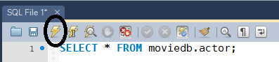

You’ll see output like this:

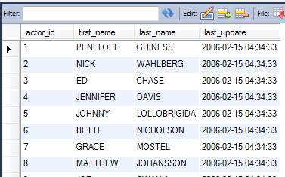

You’ve successfully run your first query!

