In-Class Exercise: Reading Decision Tree Output
The following is the output from a decision tree analysis in SAS Enterprise Miner. It uses the same data set (a charity donation database) you’ll be using in your in-class exercise, but I’ve changed the model parameters so we get some different results.
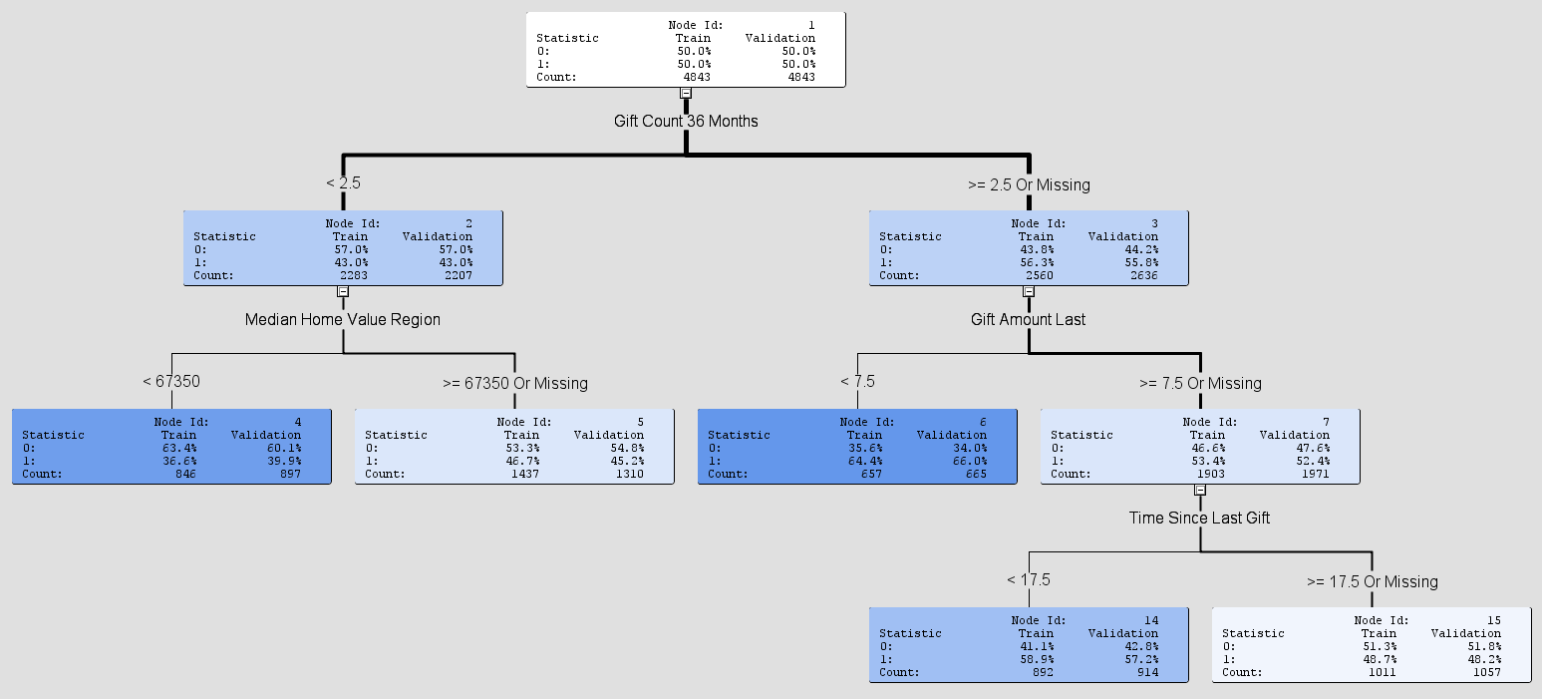
Labels:
Gift Count 36 Months – Number of donations the person made in the last 36 months
Gift Amount Last – Value of the last donation the person made (in $ thousands)
Time Since Last Gift – Number of months since the person’s last donation
Median Home Value Region – The median home value in the donor’s geographic region

Outcome statistic (look at the validation set results when evaluating):
0 = person doesn’t donate an additional gift within the next 3 months
1 = person does donate an additional gift within the next 3 months

Answer the following questions about this tree on the next page:

- What is the probability that the following people will donate an additional gift in the next 3 months?
  - Someone who has made two donations in the last 36 months and the median home value in their region is $85,000.
  - Someone who has made five donations in the last 36 months and their last gift amount was $3,000.
  - Someone who has made three donations in the last 36 months, their last gift amount was $10,000, and it’s been 12 months since their last donation.
  - Someone who has made three donations in the last 36 months, their last gift amount was $10,000, and it’s been 24 months since their last donation.
- What does it mean that median home value isn’t a split variable when more than three donations were made in the last 36 months?
- Check out this screen shot from SAS Enterprise Miner. This is the list of logworth values used to choose the first split variable for the data.
  - According to this list, which variable is the best one to choose for that first split? Why?
  - How does this correspond to the final decision tree on the previous page?
