MIS2502: Data Analytics
In-Class Exercise: Creating Infographics with Piktochart
Objective: Learn how to create an infographic using Piktochart.
Learning Outcomes:
- Create relevant content for an infographic
- Export a finished graphic from Piktochart
This tutorial will take you through the process of creating and infographic using Piktochart, a free web-based tool.
Before you begin:
Download the graphic files from the Community Site: (1) Impact of beverage prices, (2) Obesity by County, and (3) Philadelphia Area. Save these files to your desktop or flash drive.
Part 1: Sign in to Piktochart
- Open your browser and go to http://www.piktochart.com.
- If you don’t have an account, click on Sign Up. Otherwise, click Sign In.
- Click on “Sign In with Google”
- Enter your Temple email address (AccessNetID@temple.edu) and password.
- It may ask you to sign in again at a Temple “Google Apps” page. It’s annoying, but just do it.
- It may ask you for permission to give Piktochart access to your Google Account. Allow it.
- You’re now signed in to Piktochart. You’ll see something like this:
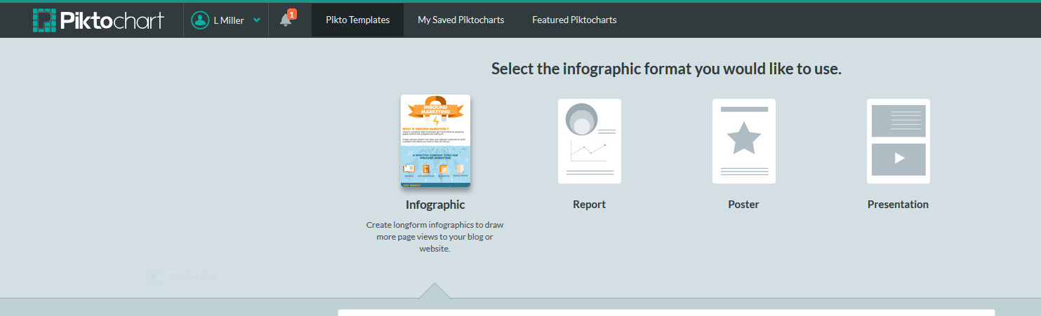
Part 2: Create your infographic template and upload your images
- Choose the infographic icon on the far left (the first option).
- Scroll down to the free templates. Run your mouse over the ‘Create your own Infographic’ image and click “Create”
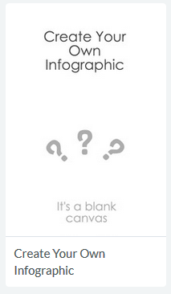
- Name your infographic “Obesity Facts!”
- You’ll see the template for your infographic. It’s ready to be filled in.
- Upload your graphics. Click on the Uploads button on the left and then click on “Select Image From Computer”
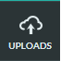 | 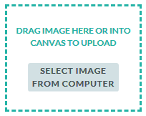

- Find the graphic “Impact of beverage prices” and click “Open.” You’ll see a thumbnail of the image under UPLOADED IMAGES:
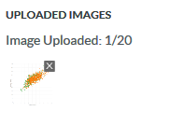
- Now upload “Obesity by County” and “Philadelphia Area Obesity Rates.” They will also appear under UPLOADED IMAGES.
Part 3: Add your content
- In the first content block add one additional text block. Click on the “Text” Button in the left sidebar and select “Body Text.”
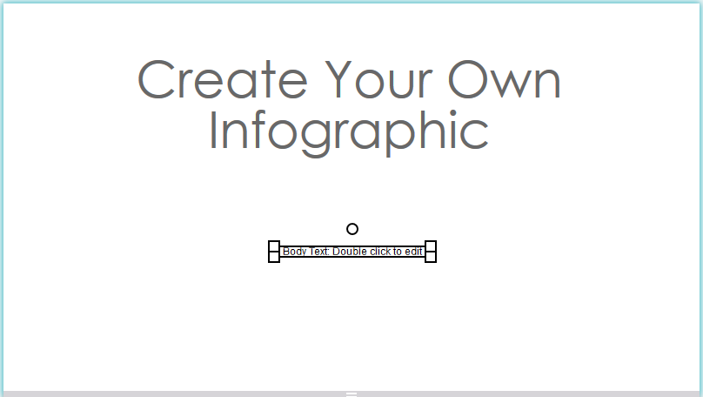
- Double-click the text area ‘Create Your Own Infographic’ and change the text to read “Obesity in America”
- Change the size of the text to 45 point (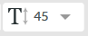), resize the box so it fits on one line, and move it to the top left corner of the white space.

- Double-click the text area that you added and change the text to read:
National Adult Obesity Rates (2012): 29%
National Child Obesity Rates (2011): 14%
- Change the font typeface to Georgia (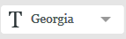) and resize it so it fits nicely in the bottom-right corner of the white space.
- Click on Uploads and drag the Obesity by County map
underneath the “Obesity in America” text. Resize the graphic so it starts to overlap the text.

- Click on each text box and select “Bring to Front” from the menu.
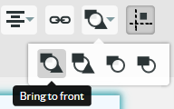
- The first content block should look something like this:
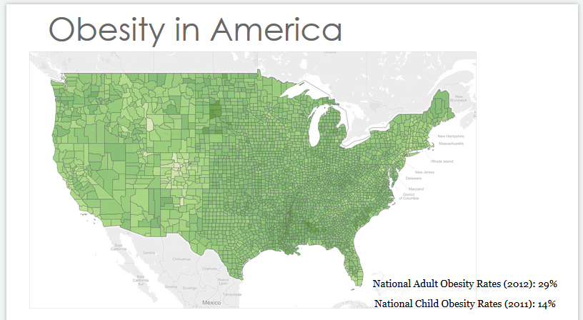

- Change the background for the first block by clicking on background and selecting a background that works with the text and graphic.

- Click anywhere in the second content block. Remove all the content. You can delete an element by clicking on it and pressing the delete key. Add two text boxes by clicking on “Body Text” under “Text” twice. They’ll be on top of each other, so you’ll need to drag one away from the middle of the page to see both, like this:
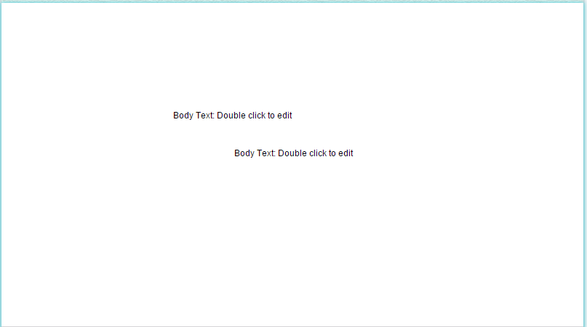

- Drag the scatterplot to the left side of the content area. If it blocks the text boxes, send the scatterplot to back by selecting “Send to back” from the menu.
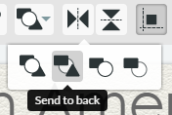

- Edit one text box to read
Green: Soda more expensive
Orange: Milk more expensive

And change the font typeface to Georgia and the size to 15 point. Then resize the block so that it fits on two lines and put it in the lower right corner of the plot.

- Double-click on the other text block and edit it to read:
Is it economics?
Where milk is more expensive than soda, adult obesity and diabetes rates are higher!
- Change the font typeface to Nanum Gothic and the font size to 23.

- Change the background for the second block. Be sure to choose something that sets it apart from the first block.

- Finally, click on the “Graphics” button in the left sidebar and select “Food & Drinks” from the drop-down menu. Choose an image to place under the text.
- The second content block should wind up looking something like this:
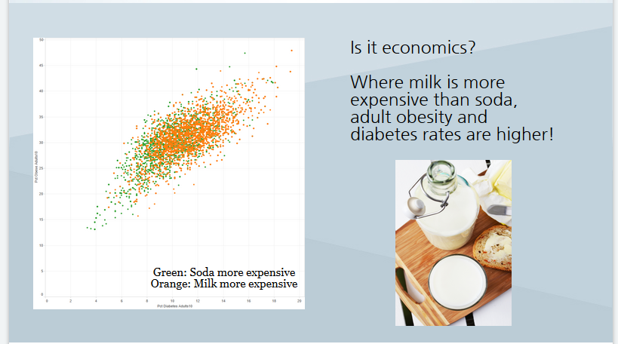

- Click on the third content block to select it and remove everything from the block.

- Drag the “Philadelphia Area” graphic to the right side of the blank space in the third (empty) content block. Resize it as needed.
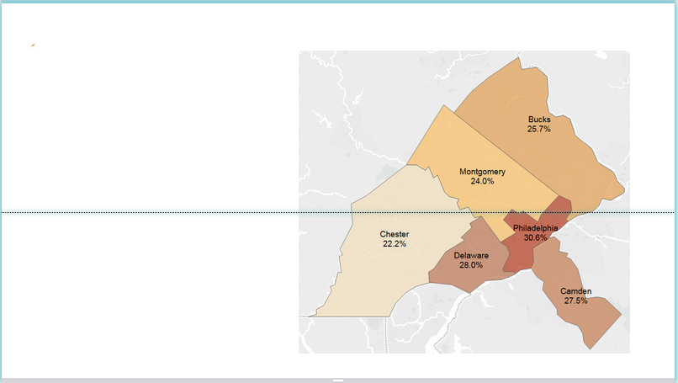

Part 4: Finish the infographic
Insert text, a background and graphics to finish the third content area. How will you finish the story the infographic is telling?

Part 5: Export the infographic as a graphics file
Your infographic is automatically saved to your online Piktochart account. You can also download the file as a graphic to use other places.
- At the top right corner of the screen, click “Download.”
- Choose the image resolution (original is fine for this assignment), and the file type (PNG generally looks better than JPG, but not always).
- Follow the instructions to save the graphic to your computer.

