In-Class Exercise: Descriptive Statistics Review
Part 1: Median, Average, and Outliers
Consider the following are the incomes of 22 households from two neighborhoods.
Neighborhood A |  | Neighborhood B
$22,000 |  | $32,000
$30,000 |  | $33,000
$35,000 |  | $35,000
$38,000 |  | $36,000
$40,000 |  | $40,000
$42,000 |  | $42,000
$55,000 |  | $45,000
$62,000 |  | $60,000
$65,000 |  | $70,000
$250,000 |  | $74,000
$350,000 |  | $75,000

- What is the average income of each neighborhood? Which neighborhood is higher?
A is higher: $89,909 vs. $49,273
- What is the median income of each neighborhood?
$42,000 for both
- Now remove the top two incomes from each group. Excluding those households, which neighborhood has the highest average income?
Neighborhood B: $43,667 vs. $43,222
- If you include all the data, which measure (median or average) better explains the income distribution of the two neighborhoods? Why?
Median is better because the two outliers in neighborhood A skew the results

Part 2: Interpreting a Histogram
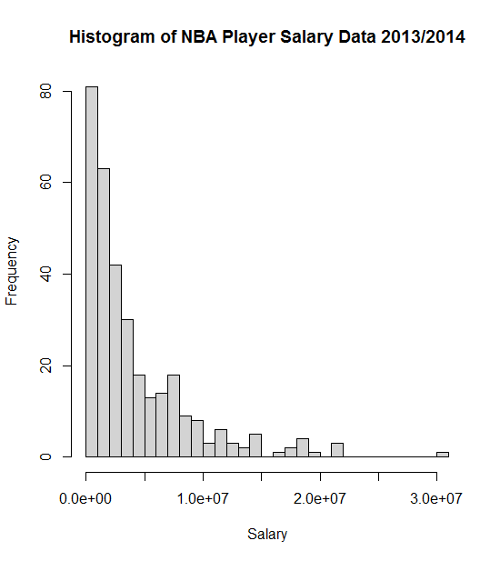
The following is a histogram of salaries for the 483 players in the NBA along with some summary statistics, all provided by R.
Source: draftexpress.com

Mean: 4142000
Std.Dev = 4610687
N=483

- What is the mean player salary?
$4,142,000
- Do most players make more or less than the mean? Explain.
Most make less than the mean. You know this because the largest bars are to the left of the peak of the normal curve.

- Are player salaries normally distributed? Explain.
No, they aren’t. The histogram doesn’t follow the shape of the normal curve.
- What do you learn about player salaries based on the standard deviation being greater than the mean?
This means there probably are a lot of outliers (a lot of players making low salaries and some making really high salaries).
Part 3: Interpreting Statistical Tests
The following is the output of statistically testing the average NBA salaries for point guards versus shooting guards (Source: draftexpress.com):
Point Guards: $4,076,414.56 (n=110)
Shooting Guards: $4,158,783.82 (n=115)
F-value = 0.017, p-value = 0.895
From this, do you conclude that the two player groups have a statistically significant difference in their salaries? Why?
No, because the p-value is much larger than 0.05 (or even 0.01).

Now let’s look at the output of statistically testing the difference in average salary of the 50 highest paid basketball players versus the 50 highest paid baseball players
(Source: draftexpress.com and newsday.com):
Baseball: $18,538,001.90 (n=50)
Basketball: $15,458,543.62 (n=50)
F-value = 17.509, p-value = 0.000
From this, do you conclude that the two sports have a statistically significant difference in their salaries? Why?
Yes, because the p-value is much smaller than 0.05 (or even 0.01).

Part 3: Probability
Consider flipping a “fair” coin (50% chance of heads, 50% chance of tails).
- What’s the probability of getting “tails” two times in a row?
0.5 * 0.5 = 0.25 (or 25%)
- What’s the probability of getting “tails” three times in a row?
0.5 * 0.5 * 0.5 = 0.125 (or 12.5%)

Now imagine there is a bag with four red marbles and one green marble.
- What’s the chance of drawing a red marble?
4 out of 5 4/5 = 0.8 (or 80%)
- Let’s say you get that red marble. Now what’s the chance of drawing another red marble from the remaining marbles?
3 out of 4 3/4 = 0.75 (or 75%)

