In-Class Exercise: Descriptive Statistics Review
Part 1: Median, Average, and Outliers
Consider the following are the incomes of 22 households from two neighborhoods.
Neighborhood A |  | Neighborhood B
$22,000 |  | $32,000
$30,000 |  | $33,000
$35,000 |  | $35,000
$38,000 |  | $36,000
$40,000 |  | $40,000
$42,000 |  | $42,000
$55,000 |  | $45,000
$62,000 |  | $60,000
$65,000 |  | $70,000
$250,000 |  | $74,000
$350,000 |  | $75,000

- What is the average income of each neighborhood? Which neighborhood is higher?

- What is the median income of each neighborhood?

- Now remove the top two incomes from each group. Excluding those households, which neighborhood has the highest average income?
- If you include all the data, which measure (median or average) better explains the income distribution of the two neighborhoods? Why?

Part 2: Interpreting a Histogram
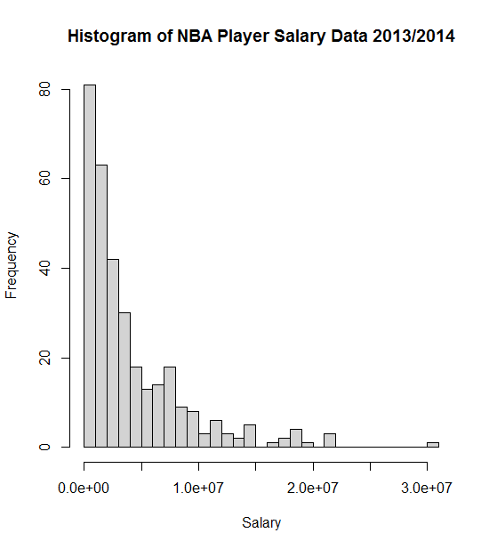
The following is a histogram of salaries for the 483 players in the NBA along with some summary statistics, all provided by R.
Source: draftexpress.com
Mean: 4142000
Std.Dev = 4610687
N=483

- What is the mean player salary?
- Do most players make more or less than the mean? Explain.
- Are player salaries normally distributed? Explain.
- What do you learn about player salaries based on the standard deviation being greater than the mean?

Part 3: Interpreting Statistical Tests
The following is the output of statistically testing the average NBA salaries for point guards versus shooting guards (Source: draftexpress.com):
Point Guards: $4,076,414.56 (n=110)
Shooting Guards: $4,158,783.82 (n=115)
F-value = 0.017, p-value = 0.895
From this, do you conclude that the two player groups have a statistically significant difference in their salaries? Why?

Now let’s look at the output of statistically testing the difference in average salary of the 50 highest paid basketball players versus the 50 highest paid baseball players
(Source: draftexpress.com and newsday.com):
Baseball: $18,538,001.90 (n=50)
Basketball: $15,458,543.62 (n=50)
F-value = 17.509, p-value = 0.000
From this, do you conclude that the two sports have a statistically significant difference in their salaries? Why?

Part 3: Probability
Consider flipping a “fair” coin (50% chance of heads, 50% chance of tails).
- What’s the probability of getting “tails” two times in a row?
- What’s the probability of getting “tails” three times in a row?

Now imagine there is a bag with four red marbles and one green marble.
- What’s the chance of drawing a red marble?
- Let’s say you get that red marble. Now what’s the chance of drawing another red marble from the remaining marbles?

