Assignment #2: SQL Part 1 - Getting Data out of the Database
(Due Saturday, Feb 18, 23:59pm)
1. Scenario
For this assignment, you will be working with the same movie rental database as the In-class Activity #5 (ICA#5) we will be have (moviedb). The schema is also the same, so you can use the one provided for ICA #5 as a guide.
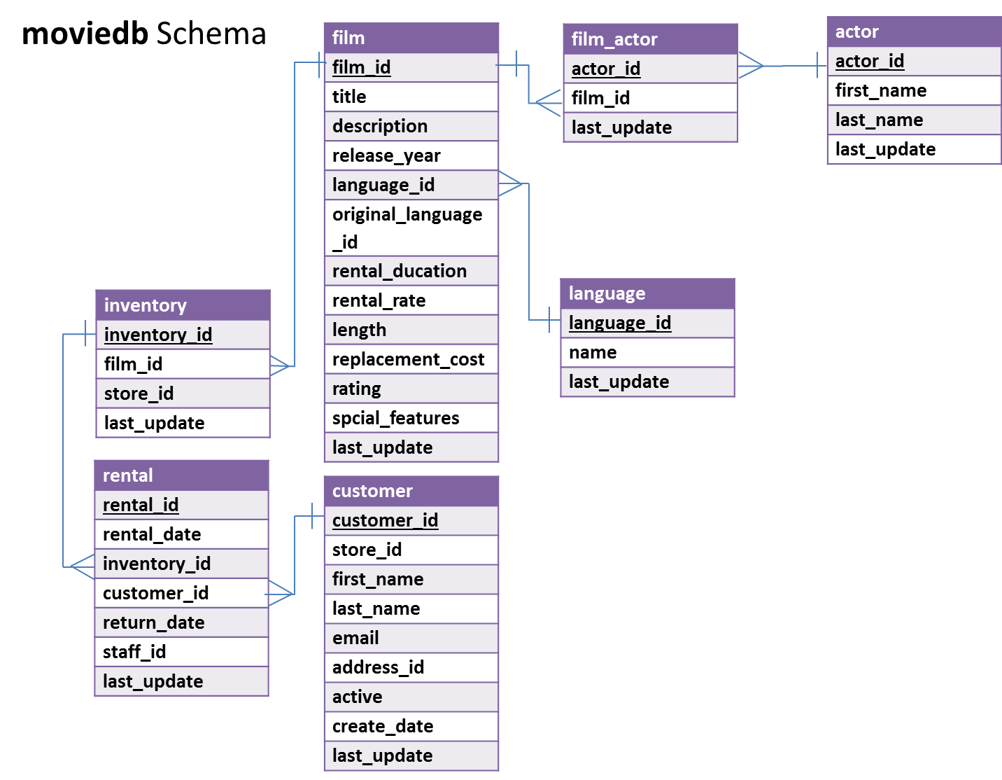
In MySQL Workbench, open the connection to the dataanalytics.temple.edu server using your username and password. Click on the “moviedb” schema and then the tables tab to see the list of tables. Recall the connection configuration as follows:
Connection Name: mis2502
Hostname: dataanalytics.temple.edu
Username: Your username is available on Blackboard under My Grades
You will construct a single SQL query to each of the questions below. You should also provide the answer to the question by using MySQL Workbench to run each query (that is, the results returned after executing SQL statements in MySQL Workbench). Some of the questions can be answered by querying one table; others will require joining multiple tables to get the answer.
2. Guidelines
Complete and submit the answer sheet on pages 4-5 as a WORD document through Blackboard before deadline.
- You can copy and paste the SQL query and the results from SQL Workbench.
- If you do not follow the instructions, your assignment will be counted late.
3. Evaluation
Your submission will be graded using two factors:
- A correctly formed SQL query that answers the specific question asked (no extra rows or columns).
- Providing the correct answer to the question (the results the query returns).
4. Questions
- What are the title and length for films rated PG and longer than 180 minutes?
Display: movie title and length

- What is the average rental rate for each movie rating (i.e., G, PG, PG-13, R, NC-17)?
Display: rating and average rental rate
- How many R movies mention ‘drama’ in their description?
(Hint: use WHERE…LIKE with a wildcard. Remember, %dog% will match any value containing “dog,” %dog will any value ending in “dog,” and dog% will match any value beginning in “dog.”)
Display: number of movies

- Who were the stars of the movie “Operation Operation”?
Display: first name and last name

- What are the three most popular last names among the actors in the database (Assume no ties)?
Display: last name and how many times that name appears in the database

- For different film ratings (i.e., G, PG, R, NC-17), which rating has the highest average rental rate? (Assume no ties - there is only one film rating with the highest average rental rate)
Display: rating and its average rental rate
- Who has starred in movies in the Mandarin language? Return only the first five results in alphabetical order by last name.
(Hints: (1) Create the query to only return the first five, in alphabetical order by last name; (2) Be sure to reference the language name “Mandarin” in your query. In the language table, there is a field “name” that contains the film language names.)
Display: first name and last name
- Who has rented the fewest movies? How many movies did they rent?
(Hint: Get a list of all customers and the number of movies they rented, arranged in ascending order and returning only the first row. Assume no ties - there’s only one customer with the lowest value.)
Display: first name, last name and number of movies

- What is the longest G-rated movie in English? And how long is it?
(Hint: a. G-rated movies have rating value equal to ‘G’; b. Use a subselect statement with the MAX() function to return only the longest movie(s). There may be more than one movie returned.)
Display: movie title and movie length
- What was the shortest movie starring Salma Nolte? And how long is it?
(Hint: Use a subselect statement with the MIN() function to return only the movie with the greatest length by Salma Nolte. There may be more than one movie returned)
Display: movie title and movie length

ANSWER SHEET FOR SUBMISSION
Assignment #2: SQL Part 1 - Getting Data out of the Database

Name:
TUID:
Question |  | SQL Query | Results/Answer from MySQL Workbench
1 | What are the title and length for films rated PG and longer than 180 minutes? [5]
2 | What is the average rental rate for each movie rating? [5]
3 | How many R movies mention ‘drama’ in their description? [5]
4 | Who were the stars of the movie “Operation Operation”? [10]
5 | What are the three most popular last names among the actors in the database? [5]
6 | For different film ratings (i.e., G, PG, R, NC-17), which rating has the highest average rental rate? [15]
7 | Who has starred in movies in the Mandarin language? Return only the first five results in alphabetical order by last name. [15]
8 | Who has rented the fewest movies? How many movies did they rent? [15]
9 | What is the longest G-rated movie in English? And how long is it? [15]
10 | What was the shortest movie starring Salma Nolte? How long is it? [15]

