Assignment #3: SQL 2 -- Putting Information into a Database
(Due Feb 27, 9:00am)
For this assignment, you will finish building the contact management database for MarketCo that you started during ICA #6 - SQL In. Therefore, you must complete the in-class activity before you do this assignment.
To refresh your memory – here is the schema for that database (the schema is called “mxxws”):
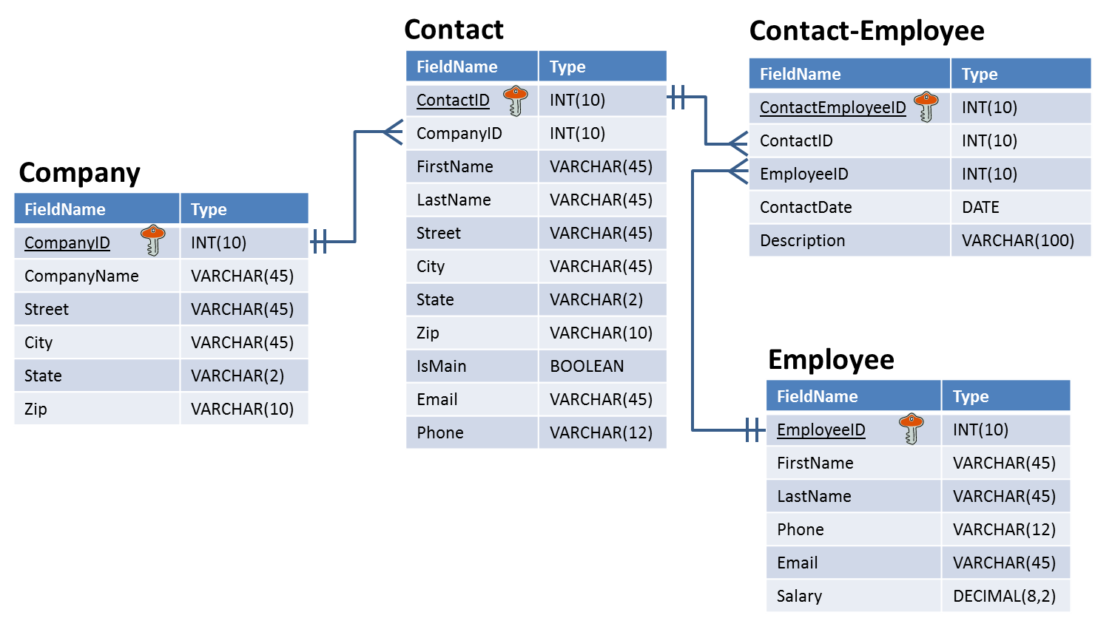
The schema name should be mxxws, where mxx is your MySQL user name. You built the Company table during the in-class activity. Now you will build the other three tables, populate them with data, and manipulate the data in those tables. You will record the queries you used to complete the assignment on the next page.
Guidelines
Submit your solution as a word or PDF document through Blackboard before deadline. If you do not follow the instructions, your assignment will be counted late.
- You can revise and resubmit any time before the deadline, but only the last attempt will be graded.
Evaluation
Your submission will be graded based on the correctness of the SQL statements that update the database according to each scenario.

Create the rest of the contact management database by writing the statements that do each of the following items below. For each one: (1) execute them on your copy of the database, and (2) write the statements in the space:
- Statement to create the Contact table (one statement):
- Statement to create the Employee table (one statement):
- Statement to create the Contact-Employee table (one statement):
HINT: Use DATE as the datatype for ContactDate. It allows you to store the date in this format: YYYY-MM-DD (i.e., ‘2014-03-12’ for March 12, 2014). Make sure you surround your date values with single quotes.
ANOTHER HINT: Try putting single “back quotes” around Contact-Employee when you name the table.

- Statements that add the following two Companies to the Company table (there are two statements):
CompanyID | CompanyName | Street | City | State | Zip
110 | Wegmans Food Markets | 1500 Brooks Ave. | Rochester | NY | 14624
111 | Acme Markets | 75 Valley Stream Parkway | Malvern | PA | 19355

- Statements that add the following three Contacts to the Contact table (there are three statements):
ContactID | CompanyID | FirstName | LastName | Street | City | State | Zip | IsMain | Email | Phone
501 | 110 | Lee | Benson | 4777 Cameron Rd. | Buffalo | NY | 14209 | Yes | lbenson@wegmans.com | 716-555-5454
502 | 111 | Bonnie | Johnson | 3600 Elk City Rd. | Ridley Park | PA | 19078 | Yes | bonniej@acme.com | 610-555-1234
503 | 110 | Cynthia | Lewis | 773 Rose St. | Wood Dale | IL | 60191 | No | clewis@wegmans.com | 708-555-4321
Remember: IsMain is a Boolean value. Assign a “1” to yes values, and “0” to no values when you create the SQL statement. )

- Statements that add the following three Employees to the Employee table (there are three statements):
EmployeeID | FirstName | LastName | Phone | Email
1001 | Lesley | Bland | 215-555-5678 | lbland@marketco.com
1002 | Dianne | Witham | 215-555-5679 | dwitham@marketco.com
1003 | Jerry | Smith | 215-555-5680 | jsmith@marketco.com

- Statements that record the following contact events in the Contact-Employee table. Remember, a “contact event” occurs when an employee of MarketCo communicates with one of its customers (contact). MarketCo wants to keep track all contact between its own employees and its clients.
Contact: Lee Benson  Employee: Lesley Bland  Date: February 12, 2014  Description: Phone call to discuss marketing plan | Contact: Bonnie Johnson  Employee: Lesley Bland  Date: February 15, 2014  Description: Emailed new marketing plan for approval
Contact: Cynthia Lewis  Employee: Dianne Witham  Date: February 21, 2014  Description: Check-up call to see if they have additional marketing needs. Waiting for reply. | Contact: Lee Benson  Employee: Jerry Smith  Date: February 21, 2014  Description: Phone call to discuss pricing for advertising
Hints (there will be four statements):
- You must assign unique numbers for ContactEmployeeID – they can be anything you want as long as they are unique as are shorter than INT(10).
- Your ContactID and EmployeeID values will come from finding the right ID numbers associated with the Contact and Employee names in the appropriate tables.
- Remember, date is stored as ‘YYYY-MM-DD’

- In the Employee table, the statement that changes Lesley Bland’s phone number to 215-555-8800 (one statement).
- In the Company table, the statement that changes the name of Acme Markets to Acme (one statement).
- In Contact-Employee table, the statement that removes Dianne Witham’s contact event with Cynthia Lewis (one statement).
HINT: Use the primary key of the Contact-Employee table to specify the correct record to remove.
And finally…
- Write the SQL SELECT query that displays the names of the employees that have contacted Wegmans Food Markets (one statement). Run the SQL SELECT query in MySQL Workbench. Copy the results below as well.

