ICA # 8: Data Visualization Principles
(Due Friday, Mar. 3, 9:00am)
Scenarios:
You’ve been asked to the headquarters of DS’s Fine Foods Emporium. After gaining a new appreciation of the potential for using business analytics in their organization, they ask you to help them communicate the results of their analysis. They have already put together a dashboard (see figures below), but the managers found the figures confusing; so confusing, in fact, that they started questioning the analysis itself.
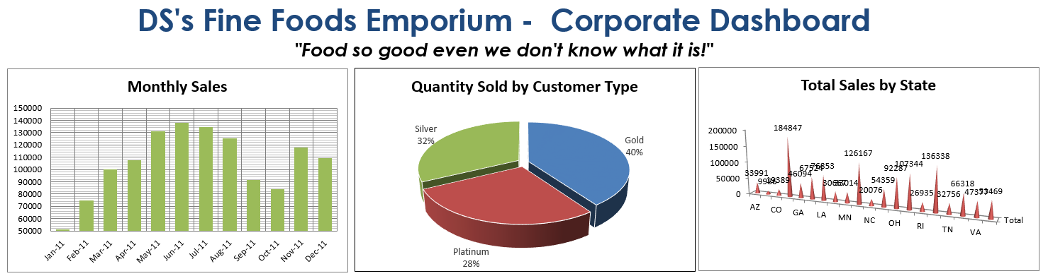
Download the “In-Class Exercise #8 - Food-Emporium_Dashboard.xlsx” file from the Community site.
The dashboard is a worksheet (“Dashboard”) in the file. The underlying pivot tables are on the “Pivot Tables” sheet and are still linked to the charts. Your task is to re-examine each one of the three charts and make improvements to the charts.
What to Do:
Submit a word or PDF file. The submission should include the following for each chart:
- Evaluation of each chart using the data visualization principles presented earlier (i.e., ability to tell a story, graphical integrity, minimize graphical complexity, etc.). I suggest writing several bullet points summarizing the problems with each chart. You do NOT need to actually calculate the data-ink ratio or lie-factor!
- Improved chart created from excel. You can do anything you’d like to the charts, and you can also create additional charts if you think that is necessary. Also provide some note/description here too, justifying what you’ve done.

A pivot table is a data summarization tool found in data visualization programs such as spreadsheets. A pivot table can automatically sort, count, total or average the data stored in one table or spreadsheet, displaying the results in a second table showing the summarized data.

