**Practice for SQL**

**Part 1: SQL In-Putting Data into the Data Base**

(You don’t need to do this in SQL Workbench).

Consider the following schema for a consulting company named MarketCo. The data base helps track the communication between employees of the MarketCo and the contact person of their clients (company). Here is some information that will help you:

* The schema (database) name is **wsDB**;
* The **Company** table contains companies that are clients of the MarketCo.;
* The **Contact** table contains the information of the contact person in client companies;
* The **Employee** table contains the information of the employees working in MarketCo;
* The **Contact-Employee** table contains the contact details between the employee and the contact person of the client company.

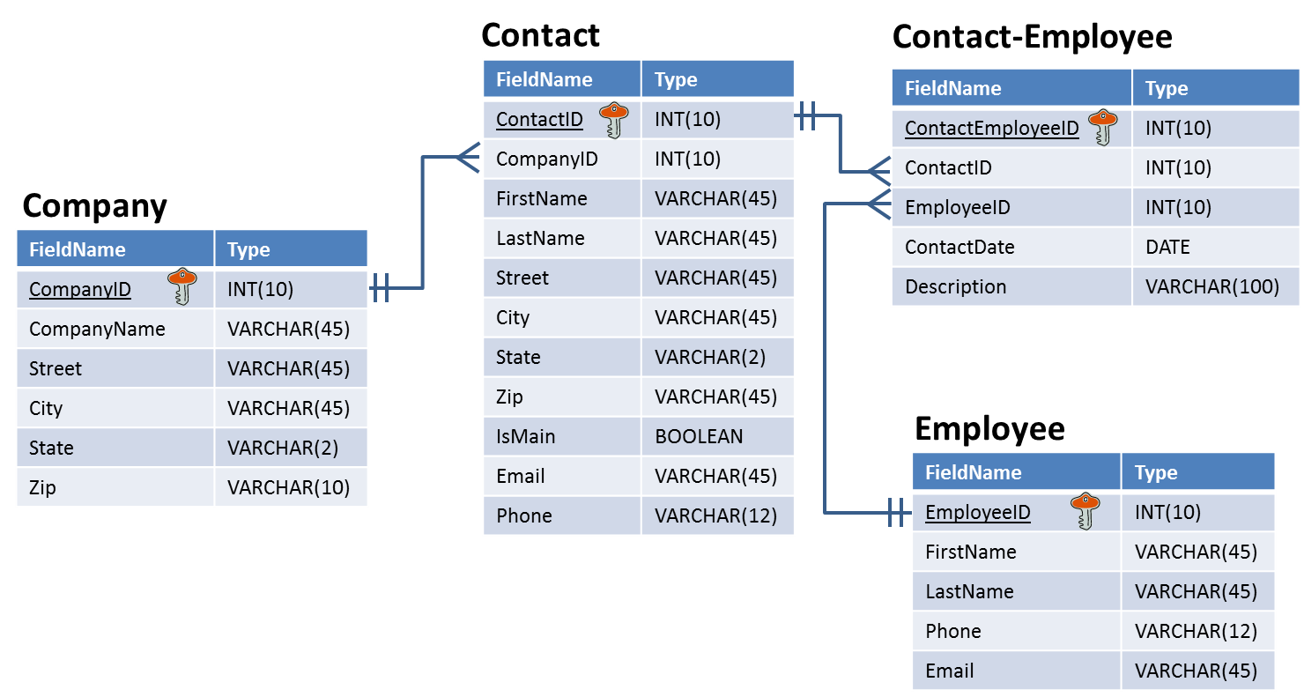

Some basic SQL syntax to get you started:

* To create a new table (example with two columns and a foreign key):  
  CREATE TABLE schema_name.table_name (  
  columnName1 datatype [NULL][NOT NULL],   
  columnName2 datatype [NULL][NOT NULL],  
  PRIMARY KEY (KeyName),

FOREIGN KEY (ForeignKeyName) REFERENCES reference_table_name(ReferenceKeyName));

* To drop a table:

DROP TABLE schema_name.table_name;

* To add a column to the table:

ALTER TABLE schema_name.table_name  
ADD COLUMN column_name datatype [NULL][NOT NULL];

* To remove a column from the table:

ALTER TABLE schema_name.table_name

DROP COLUMN column_name;

* To change a column in the table:

ALTER TABLE schema_name.table_name

CHANGE COLUMN old_column_name new_column_name datatype [NULL][NOT NULL];

* To insert a record into a table:  
  INSERT INTO schema_name.table_name (columnName1, columnName2, columnName3)   
  VALUES (value1, value2, value3);
* To change data in a row:  
  UPDATE schema_name.table_name SET columnName1=value1, columnName2=value2   
  WHERE condition;
* To delete a row from a table:  
  DELETE FROM schema_name.table_name WHERE condition;

**Write the SQL statement (just one for each question) that performs the following tasks.**

**1). Create the Company table using SQL.**

2). Now we think 45 characters for City is not necessary. Let’s changeit to 15 characters.

3). Let’s add two companies to the table:

|  |  |  |  |  |  |
| --- | --- | --- | --- | --- | --- |
| **CompanyID** | **CompanyName** | **Street** | **City** | **State** | **Zip** |
| 101 | Comcast | 1701 JFK Blvd. | Philadelphia | PA | 19103 |
| 102 | Verizon | 140 West St. | New York | NY | 10007 |

4). Now let’s change the CompanyName of Verizon to Verizon Communications and the Zip code to 10007-1111:

5). You forgot to add the description column in **Contact-Employee** table. Please add this column.

**Part 2: SQL Out-Join tables and Subselect**

(You can but not need to use SQL Workbench)

Please consider the following schema moviedb. And answer the following question.

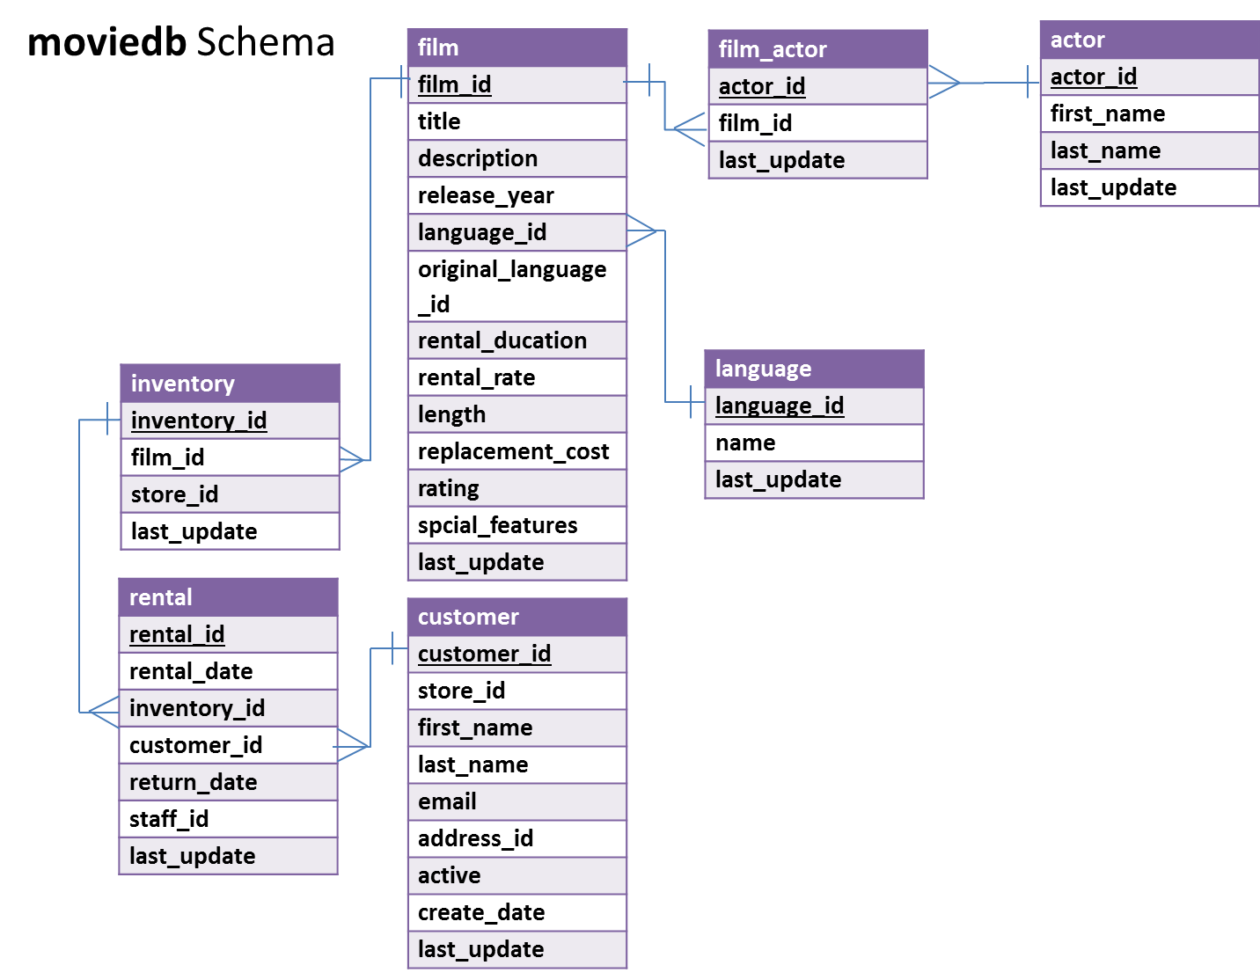

Some basic SQL syntax to get you started:

* To select fields from a table:  
  SELECT column_name(s) FROM schema_name.table_name   
  WHERE condition [AND condition]
* To apply a function (COUNT, SUM, AVG, MIN, MAX) to a column:  
  SELECT function(column_name) FROM schema_name.table_name
* You may also use some of the following SQL keywords or functions
  + DISTINCT
  + WHERE
  + AND/OR
  + COUNT, AVG, MIN, MAX, SUM
  + GROUP BY
  + ORDER BY (ASC/DESC)
* Here is a full syntax for SELECT

SELECT [DISTINCT] expression(s)

FROM schema_name.table_name(s)

[WHERE condition(s)]

[GROUP BY expression(s)]

[ORDER BY expression(s) [ ASC | DESC ]]

[LIMIT number_rows];

**Questions**

#1 Who are the actors of the movie “Flash Wars”?

#2 Please identify the 3 most valuable customers who rented most often.

#3 For different film ratings (i.e., G, PG, R, NC-17), which rating has the highest average rental rate?

#4. What are the title and length for films rated PG and longer than average length?

#5 What's the most expensive (in terms of rental rate) film by Salma Nolte? And waht is the rental rate?