ICA #9.1 Getting Started with R/RStudio (will not be collected)

This exercise involves running an R script for the first time using RStudio and learning the basics of the environment and the language.

Part 1: Run the Test Script
- Download the files TestScript.r and USBalanceOfTrade.csv from the Community Site post where you got these instructions. Save those files to a place where you can find them again.
I suggest you create a new folder on your hard drive called RFiles (i.e., C:\RFiles). If you’re using a lab computer, just create the RFiles folder on a flash drive.
- Open USBalanceOfTrade.csv in Excel and verify the data is there. It’s a list of the total value of US Exports and Imports every five years (except 2013) starting in 1960.

- Start RStudio. RStudio is an Integrated Development Environment (IDE) that makes it easier to use R. Always use RStudio instead of starting R directly. It will make your life much easier!
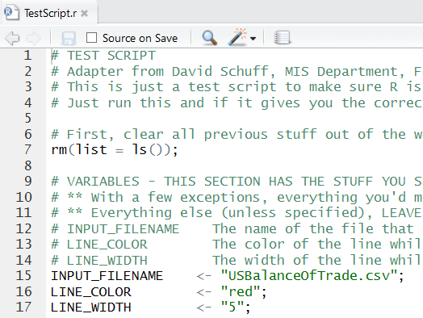
- Go to the File menu and select “Open File…”
- Browse for the TestScript.r file. It will open and look like this:

- Notice that on line 15 it identifies USBalanceOfTrade.csv as your input file. It does this by assigning a value to a variable. In this case the value is “USBalanceOfTrade.csv” and the variable is INPUT_FILENAME.

- Now when we refer to INPUT_FILENAME on line 23, it will retrieve the value USBalanceOfTrade.csv.
- We still need to tell RStudio where to find the input file. The easiest way to do this is to go to the Session menu and select Set Working Directory/To Source File Location.
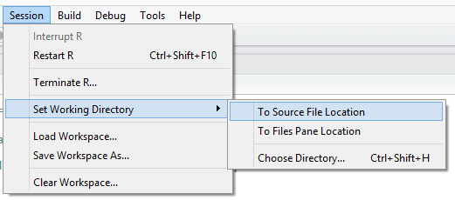
It will create and execute a setwd() function (as in “set working directory”) in the Console window at the bottom of the screen (Yours may look a little different depending on your OS and the directory you use. That’s ok. Trust RStudio!):
- Now run the script. Go to the Code menu and select Run Region/Run All…
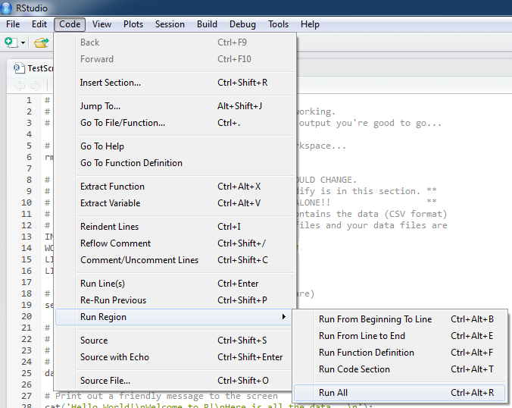
- If everything works, the script will run and you’ll see this plot in the bottom right of the screen (the line should be red):
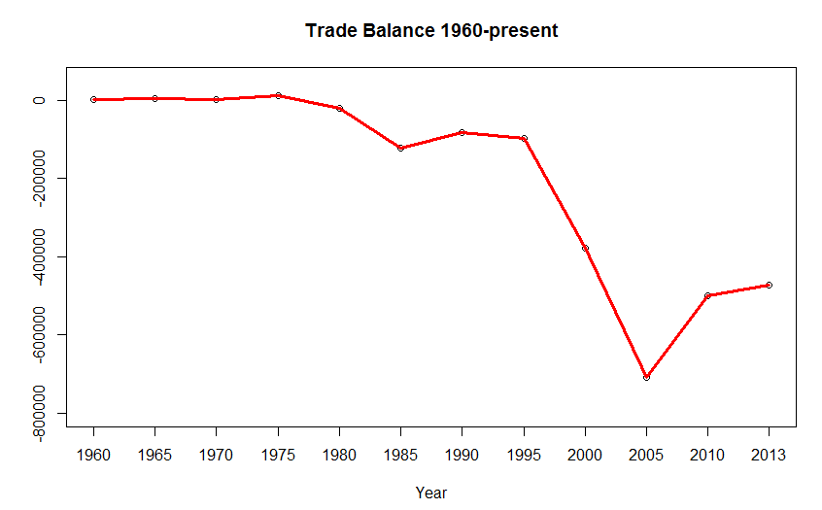
- That’s it. You have successfully run your first R script using RStudio!

Part 2: Try Changing Values in the Script

Let’s play around with variables and values.

- Go to line 16 and change the LINE_COLOR variable to blue. Make sure the word “blue” is still in quotes. Then rerun the script (Code/Run Region/Run All).
- Go to line 17 and change the LINE_WIDTH to 20. The number will NOT be in quotes, and don’t put them in! Then rerun the script.
- Now check out line 61 of the script:
lines(tradeBalance, col=LINE_COLOR, lwd=LINE_WIDTH);
The lines() function draws a line on the chart connecting the plotted points. To see the plotted points by themselves, put a # sign in front of lines():
#lines(tradeBalance, col=LINE_COLOR, lwd=LINE_WIDTH);
This instructs R to skip the line. Now rerun the script.
Try It Yourself:

Go to lines 52 and 53. The plot() function creates a scatterplot of the points in your data set. Look at the comments in the script above the plot() function to understand how it works and then change the title to “An Important Graph!” Rerun the script to make sure it works.

Part 3: Want extra practice with R?
As mentioned in class, if you’re looking for an additional tutorial on R syntax, try this CodeSchool site: http://tryr.codeschool.com/.
It is not required that you do this, but some of you might find it helpful. Remember, all the information you need for the course is in the in-class exercises, slides, and notes. But sometimes people want something extra, and this is a pretty good interactive walkthrough.
The most relevant chapters are 1, 2, 4, and 7. However, it looks like you have to do them in order (you have to complete chapters 1 and 2 to get to chapter 3, etc.). So my suggestion would be to at least go through Chapter 1. If you find it useful, keep going!

