In-Class Activity #1.3: Converting ERDs to Schemas

Submission Instructions
Submit your solutions as a word or pdf file through Canvas>Assignments>In-Class Activity Submissions. Please submit your solution within three hours after class.

I suggest you use the PowerPoint template I posted for this exercise to create your schemas and paste it to a word document as a picture.

NOTE: You may have noticed that ERDPlus can also convert an ERD to a schema. But I recommend you NOT to use ERDPlus to create schema because it will not show cardinality.

In this activity, we will convert two ERDs (from ICA #1.2) to database schemas. Below are the rules of how to successfully convert an ERD to a schema.

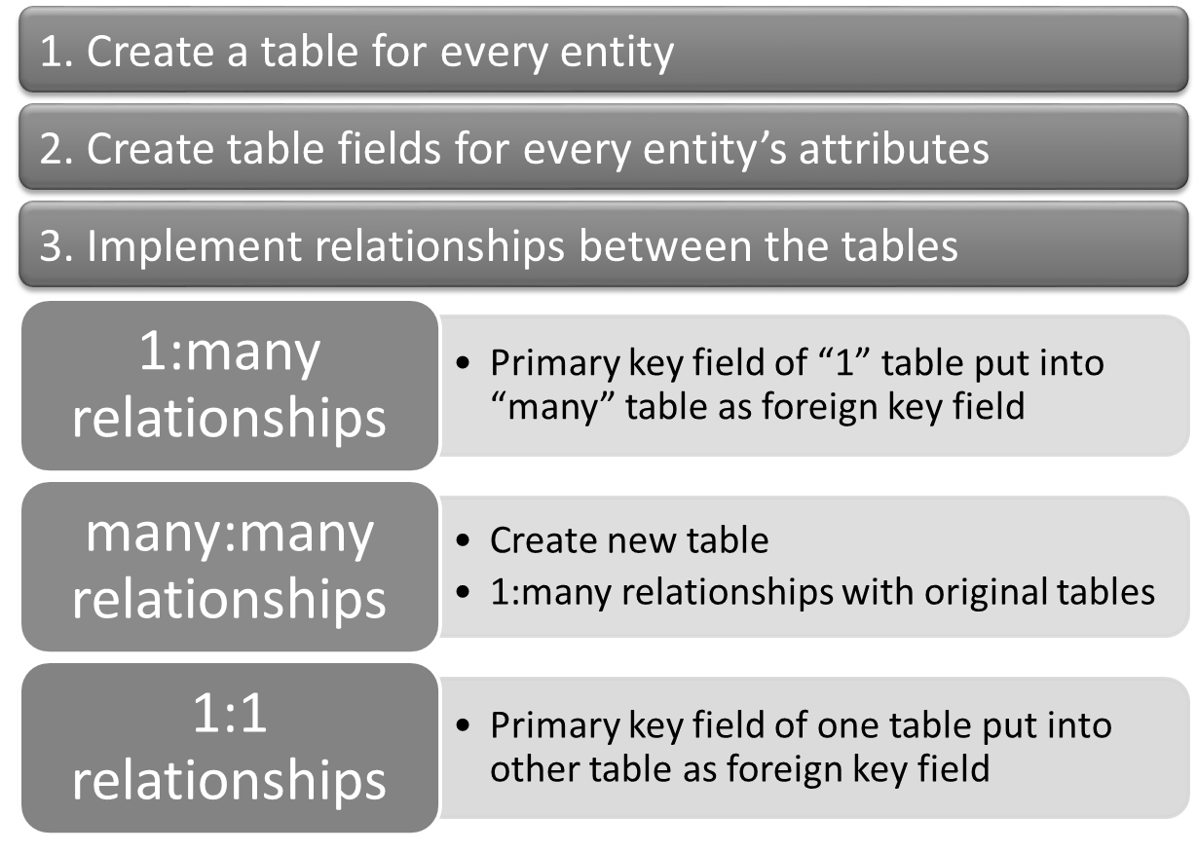

So, for example, if you have this (very simple) ERD with a many-to-many relationship:

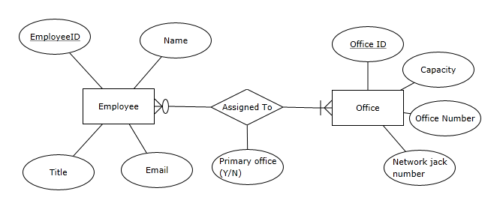

You’ll wind up with this schema (note that we only specified maximum cardinality):

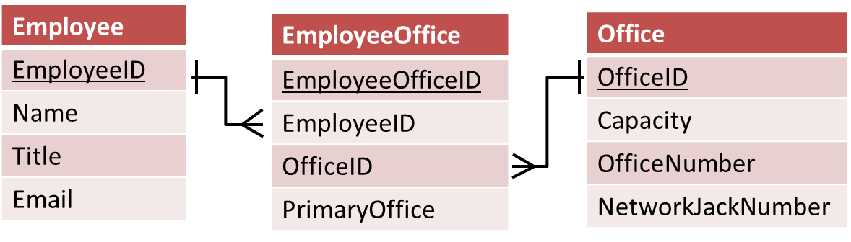

Now create the schemas for the following ERDs.

(For simplicity, you DO NOT need to specify minimum cardinality for the ICA)

Scenario 1: Inventory and Parts
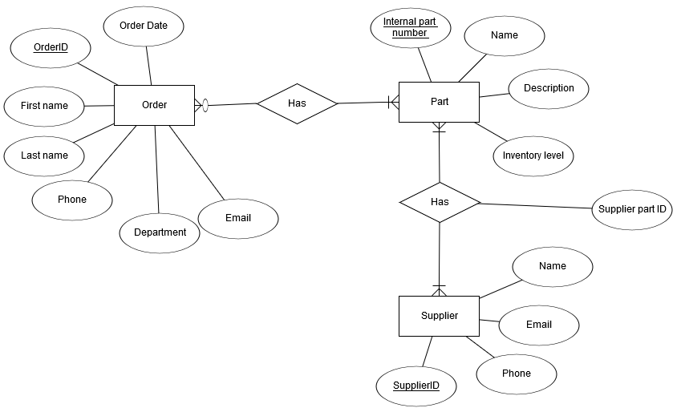
Scenario 2: Housing Authority
