In-class Activity #2.1: Pen-and-Paper Query Exercise

Submission Instructions
Submit your solutions as a word or pdf file through Canvas>Assignments>In-Class Activities. Please submit your solution within two hours after class.

Recall our Housing Authority schema from the last in-class exercise:

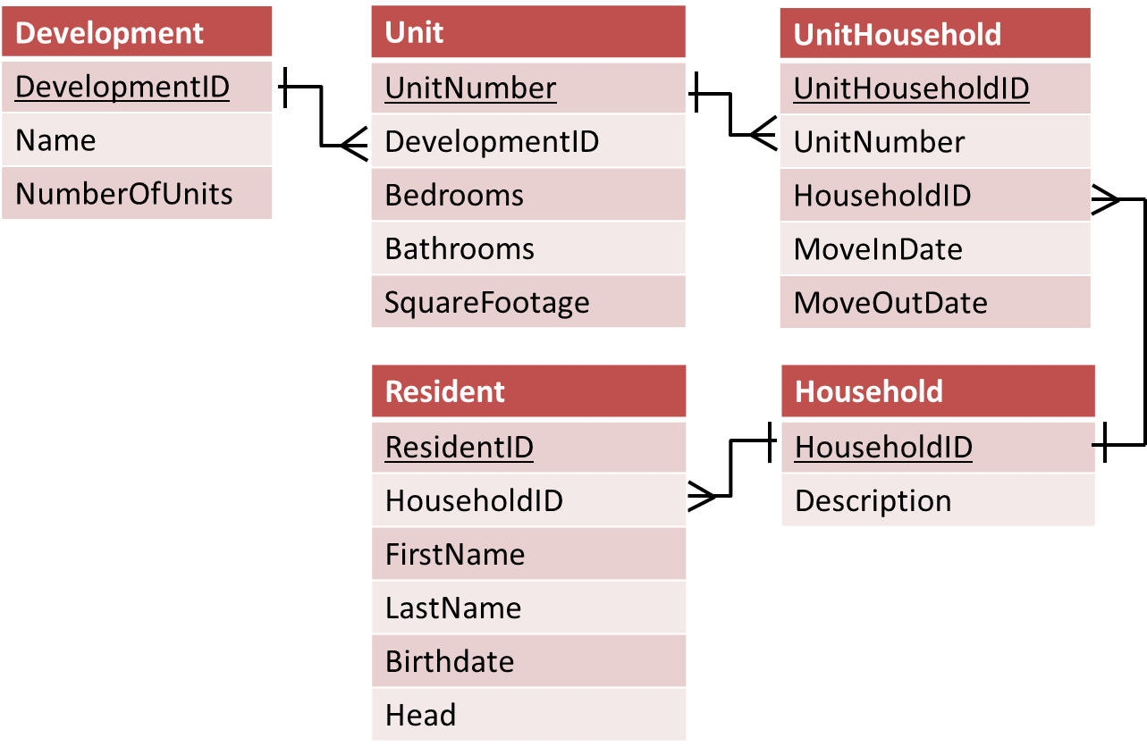
Assume the database schema is called hdb (for “housing database” – clever!). So, in a query, you’ll reference the Development table as hdb.Development.
In groups of two or three, create a single SQL query that answers each question below. Make sure you are only returning the information needed to answer the question (don’t just use SELECT *).

- Which housing units (by unit number) have more than two bathrooms?
- What is the birthdate of the resident named Tom Haverford?

- What are the names of all heads of household (list in ascending alphabetical order by last name)?
(HINT: The field “head” can take the value “Yes” or “No”. You will need to write a WHERE condition like this: WHERE Head=’Yes’)

- How many units are smaller than 2000 square feet?

- What is the average square footage of all units in the database?

- What is the average square footage of units by number of bedrooms (in other words, write a query that computes the average square footage of one bedroom units, two bedroom units, etc.).

