In Class Exercise: Designing a Dimensional Database
Congratulations! You’ve just been hired as the Sales Business Analyst at Food Emporium.

It’s your 2nd day. You just got a voice mail from the VP of Sales.

“We need a new sales report. It needs to report sales amount – gross, discounts, net, with average selling price by product group and customer group over time. In particular, it needs to be able to report where the customer resides, the product, and we need to know if the customer is gold or platinum or whatever and we need to know the quantity sold and what products or customers are getting the big discount% taken. And, of course the list selling price and the effective average unit selling price. Top 10 views sorted by quantity and amount too.

Oh, and we don’t want standard hardcopy reports. One of my counterparts at the sales conference in Boca had an Excel workbook on their laptop that allowed them to move fields around and look at data different ways. I want one of those slicey dicey things. All this stuff is in our transaction systems. Talk to IT and let me know when it’s ready. “

Your deliverable is to create a design for this reporting application.

What clarifying questions do you want to ask?
Hints:
You want report what by what ? gross sales, discounts, net sales and quantity by Customer by Product by Time

Do you know the value of your dimensional attributes?
Product Group – Meat, Cheese, Drink – each product is assigned to one and only one
Customer Group – Retail, Wholesale, Ecommerce – each product is assigned to one and only one
What’s the ‘grain’? Customer ? Y Order ? Y Order Line Item? N Product/package SKU combinations? N Daily N – Monthly

List the Dimensions and their attributes in table form. Underline key.
Customer, Product, Time, Order
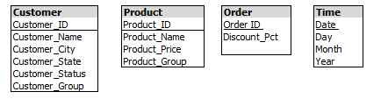

Why is Discount_Pct on the Order dimension ?

List the Measures
Quantity, Gross Sales Amount, Discount Amount, Net Sales Amount, Price,

Are there any Calculated Measures? Yes
- Net Sales Amount = (Gross Sales + (Discounts) )
- Average Gross Selling Price = (Gross Sales Amount /Quantity)

Are the any Non Aggregatable Measures? Yes
- Unit Price – only meaningful at lowest level
- Average Gross Selling Price (recalculated at each intersection)
- Discount % - only meaningful at lowest level

Design the Fact Table ? List the measures and foreign keys
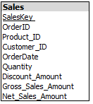

Do you have any other questions for the VP Sales? For IT?

Draw the Star Schema. Remember your keys and cardinality !!
