**In-Class Exercise: Getting Familiar with SAS Enterprise Miner**

(adapted from Applied Analytics using SAS Enterprise Miner, SAS Institute, Cary, NC. 2010)

******Creating a SAS Enterprise Miner Project**

A SAS Enterprise Miner project contains materials related to a particular analysis task. These materials include analysis process flows, intermediate analysis data sets, and analysis results.

To define a project, you must specify a project name and the location of the project on the   
SAS Foundation Server. Follow the steps below to create a new SAS Enterprise Miner project.

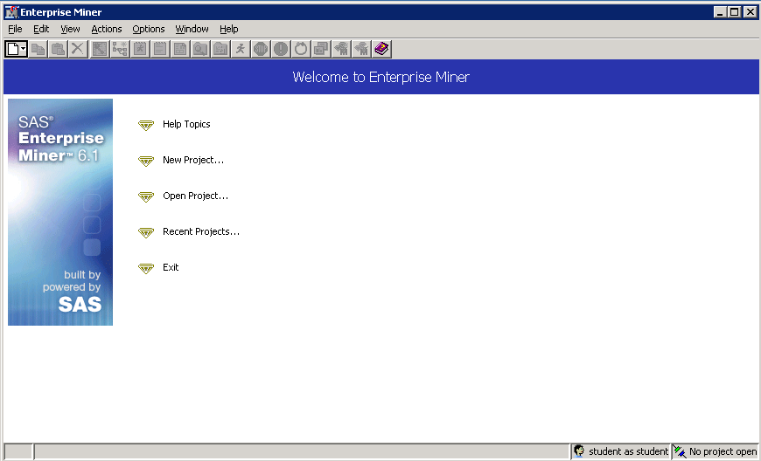

1. Select **File** ⇨ **New** ⇨ **Project** from the main menu. The Create New Project wizard opens at Step 1.

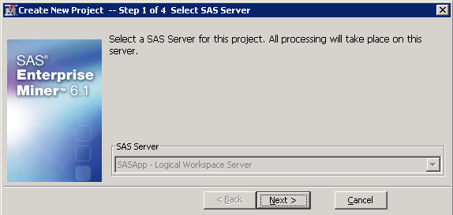

In this configuration of SAS Enterprise Miner, the only server available for processing is the host server listed above.

1. Select **Next >**.
2. Name the project.

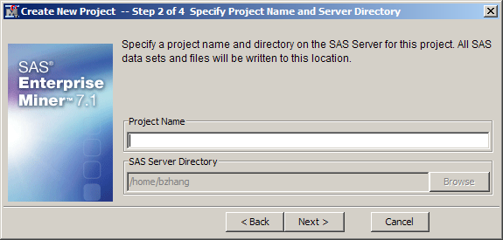

Step 2 of the Create New Project wizard is used to specify the following information:

* the name of the project you are creating
* the location of the project

1. Type a project name, for example, **My Project**, in the Name field.

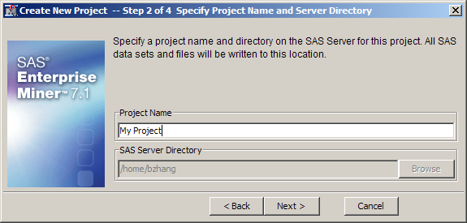

The path specified by the SAS Server Directory field is the physical location where the project folder will be created. This may look different for your account. That’s ok. Go with the default.

1. Select **Next >**.

**🖉** If you have an existing project directory with the same name and location as specified, this project will be added to the list of available projects in SAS Enterprise Miner. This technique can be used to import a project created by another installation of SAS Enterprise Miner.

1. Select a location for the project’s metadata.

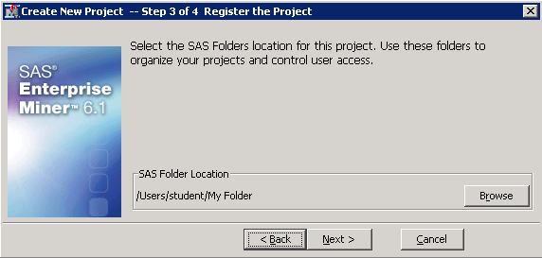

**🖉** The SAS folder, My Folder, is in a WebDAV directory. This is where the metadata associated with the project is stored. This folder can be accessed and modified using SAS Management Console.

1. Select **Next >**.

Information about your project is summarized in Step 4.

1. To finish defining the project, select **Finish**.

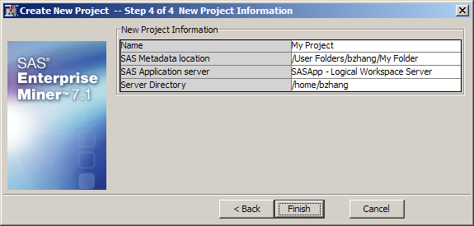

The SAS Enterprise Miner client application opens the project that you created.

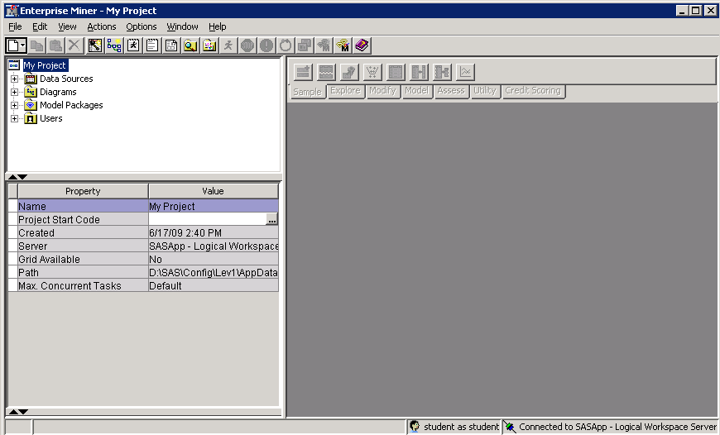

Creating a SAS Enterprise Miner Diagram

A SAS Enterprise Miner diagram workspace contains and displays the steps involved in your analysis.   
To define a diagram, you need only specify its name.

Follow the steps below to create a new SAS Enterprise Miner diagram workspace.

1. Select **File** ⇨ **New** ⇨ **Diagram…** from the main menu.

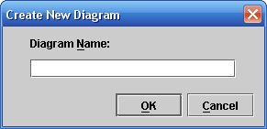

1. Type the name **Predictive Analysis** in the Diagram Name field and select **OK**.   
   SAS Enterprise Miner creates an analysis workspace window labeled Predictive Analysis.

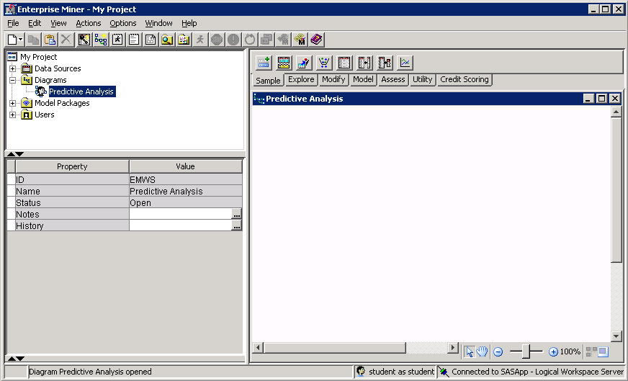

You use the Predictive Analysis window to create process flow diagrams.

Defining a Data Source

#### Specifying Source Data

A data source links SAS Enterprise Miner to an existing analysis table. To specify a data source, you need to define a SAS library and know the name of the table that you will link to SAS Enterprise Miner.

Follow these steps to specify a data source.

1. Select **File** ⇨ **New** ⇨ **Data Source…** from the main menu. The Data Source Wizard – Step 1of 7 Metadata Source opens.

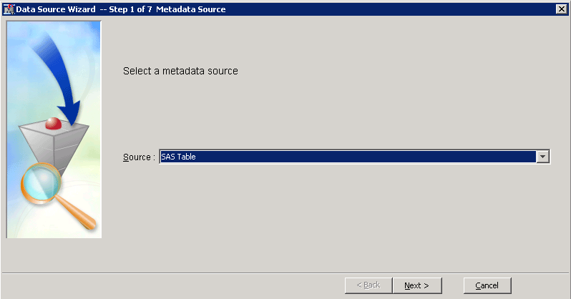

The Data Source Wizard guides you through a seven-step process to create a SAS Enterprise Miner data source. Step 1 tells SAS Enterprise Miner where to look for initial metadata values.

Click on **Source:** and select **Metadata Repository**

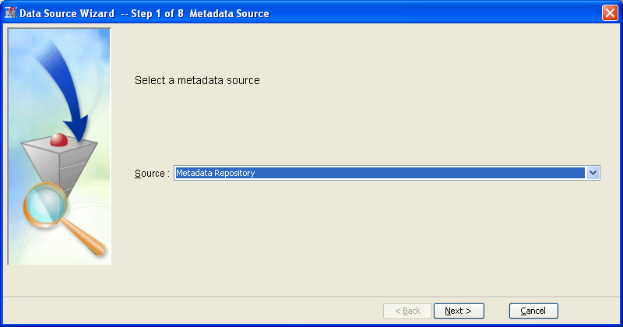

1. Select **Next >**

The Data Source Wizard continues to Step 2 of 7 Select a SAS Table.

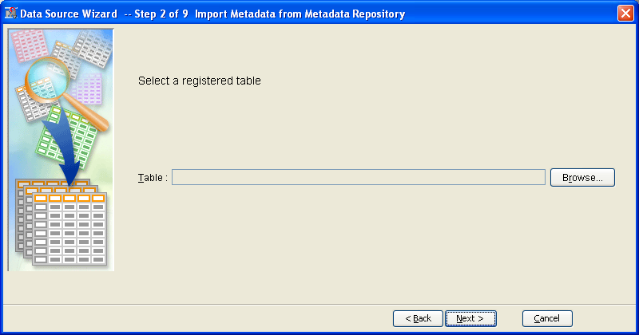

1. In this step, select the SAS table that you want to make available to SAS Enterprise Miner. Click **Browse** on the right hand side.

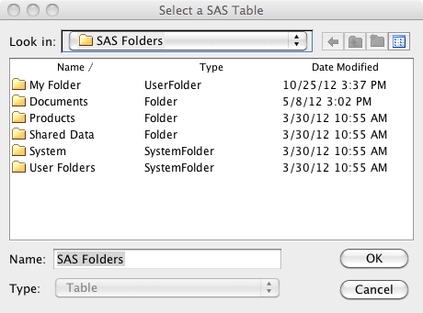

1. Select the **Shared Data** 🡪 **Libraries** 🡪 **AAEM** 🡪 **Pva97nk** SAS table in the screen above.
2. Select **OK**. The Select a SAS Table window closes and the selected table appears in the Table field.

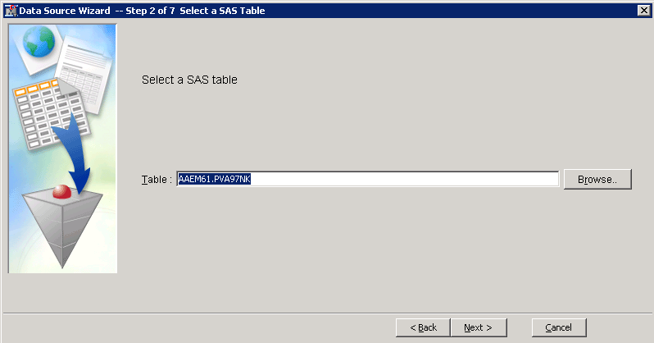

1. Select **Next >**. The Data Source Wizard proceeds to Step 3 of 9 Table Information.

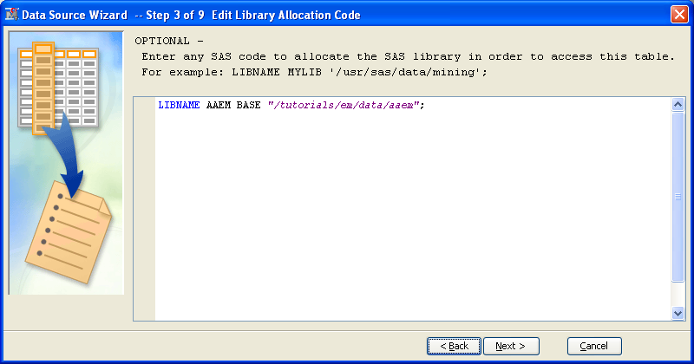

Click **Next**

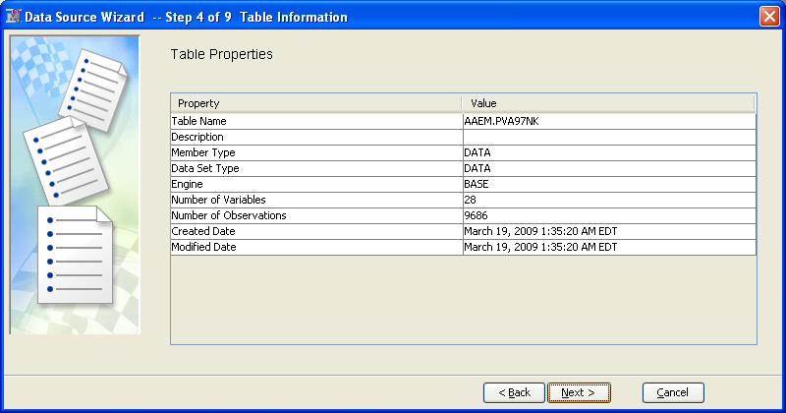

This step of the Data Source Wizard provides basic information about the selected table.

**🖉** The SAS table **PVA97NK** is used in this chapter and subsequent chapters to demonstrate the predictive modeling tools of SAS Enterprise Miner. As seen in the Data Source Wizard – Step 3 of 7 Table Information window, the table contains 9,686 cases and 28 variables.

#### Defining Column Metadata

With a data set specified, your next task is to set the column metadata. To do this, you need to know the modeling role and proper measurement level of each variable in the source data set.

Follow these steps to define the column metadata:

1. Select **Next >**. The Data Source Wizard proceeds to Step 5 of 9 Metadata Advisor Options.

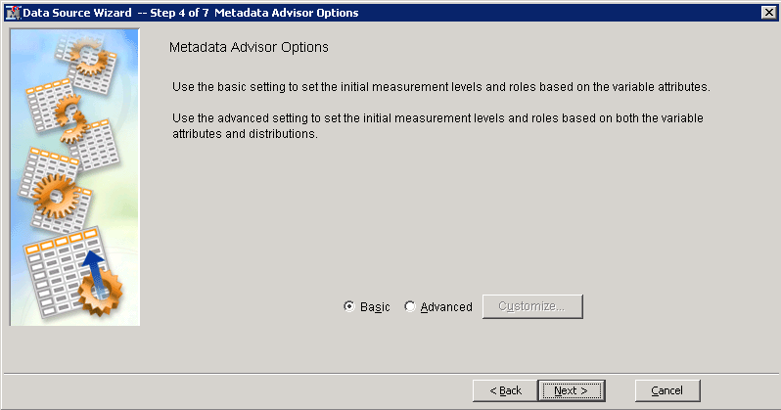

This step of the Data Source Wizard starts the metadata definition process. SAS Enterprise Miner assigns initial values to the metadata based on characteristics of the selected SAS table. The Basic setting assigns initial values to the metadata based on variable attributes such as the variable name, data type, and assigned SAS format. The Advanced setting assigns initial values to the metadata in the same way as the Basic setting, but it also assesses the distribution of each variable to better determine the appropriate measurement level.

1. Select **Next >** to use the Basic setting.

The Data Source Wizard proceeds to Step 6 of 9, Column Metadata.

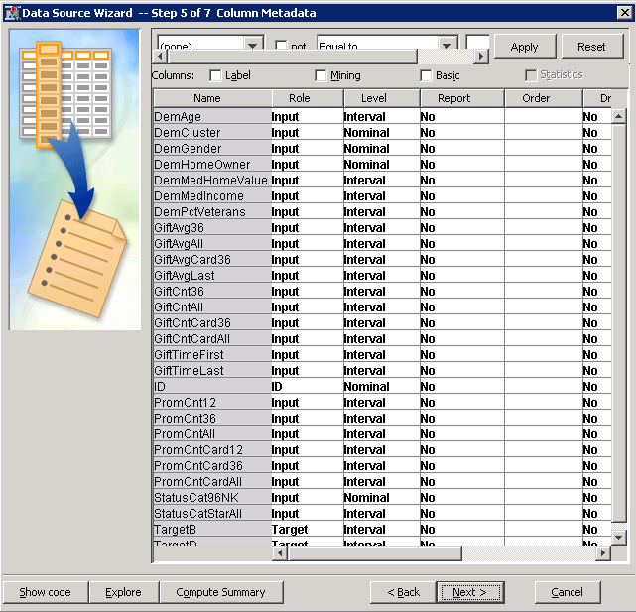

The Data Source Wizard displays its best guess for the metadata assignments. This guess is based on the name and data type of each variable. The correct values for model role and measurement level are found in the **PVA97NK** metadata table on the next page.

A comparison of the currently assigned metadata (on next page) to that in the **PVA97NK** metadata table shows several discrepancies. While the assigned modeling roles are mostly correct, the assigned measurement levels for several variables are in error.

It is possible to improve the default metadata assignments by using the Advanced option in the Metadata Advisor.

1. Select **< Back** in the Data Source Wizard. This returns you to Step 5 of 9 Metadata Advisor Options.
2. Select the **Advanced** option.

#### PVA97NK Metadata Table

|  |  |  |  |
| --- | --- | --- | --- |
| **Name** | **Model Role** | **Measurement Level** | **Description** |
| **DemAge** | Input | Interval | Age |
| **DemCluster** | Input | Nominal | Demographic Cluster |
| **DemGender** | Input | Nominal | Gender |
| **DemHomeOwner** | Input | Binary | Home Owner |
| **DemMedHomeValue** | Input | Interval | Median Home Value Region |
| **DemMedIncome** | Input | Interval | Median Income Region |
| **DemPctVeterans** | Input | Interval | Percent Veterans Region |
| **GiftAvg36** | Input | Interval | Gift Amount Average 36 Months |
| **GiftAvgAll** | Input | Interval | Gift Amount Average All Months |
| **GiftAvgCard36** | Input | Interval | Gift Amount Average Card 36 Months |
| **GiftAvgLast** | Input | Interval | Gift Amount Last |
| **GiftCnt36** | Input | Interval | Gift Count 36 Months |
| **GiftCntAll** | Input | Interval | Gift Count All Months |
| **GiftCntCard36** | Input | Interval | Gift Count Card 36 Months |
| **GiftCntCardAll** | Input | Interval | Gift Count Card All Months |
| **GiftTimeFirst** | Input | Interval | Time Since First Gift |
| **GiftTimeLast** | Input | Interval | Time Since Last Gift |
| **ID** | ID | Nominal | Control Number |
| **PromCnt12** | Input | Interval | Promotion Count 12 Months |
| **PromCnt36** | Input | Interval | Promotion Count 36 Months |
| **PromCntAll** | Input | Interval | Promotion Count All Months |
| **PromCntCard12** | Input | Interval | Promotion Count Card 12 Months |
| **PromCntCard36** | Input | Interval | Promotion Count Card 36 Months |
| **PromCntCardAll** | Input | Interval | Promotion Count Card All Months |
| **StatusCat96NK** | Input | Nominal | Status Category 96NK |
| **StatusCatStarAll** | Input | Binary | Status Category Star All Months |
| **TargetB** | Target | Binary | Target Gift Flag |
| **TargetD** | Rejected | Interval | Target Gift Amount |

1. Select **Next >** to use the Advanced setting. The Data Source Wizard again proceeds to Step 6 of 9 Column Metadata.

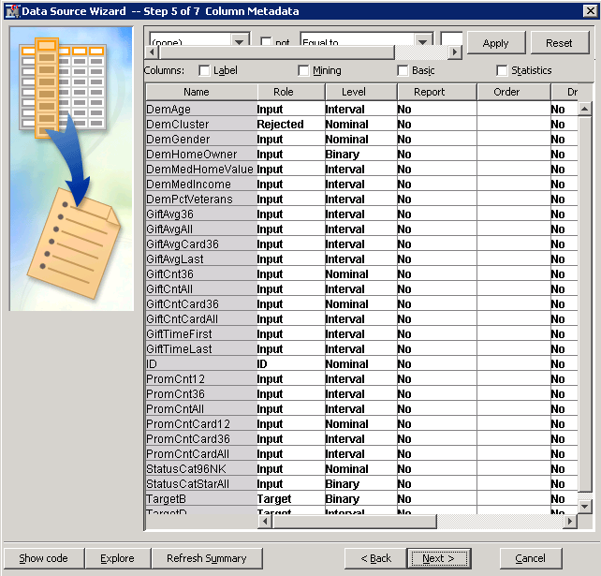

While many of the default metadata settings are correct, there are several items that need to be changed. For example, the **DemCluster** variable is rejected (for having too many distinct values), and several numeric inputs have their measurement level set to Nominal instead of Interval (for having too few distinct values).

To avoid the time-consuming task of making metadata adjustments, go back to the previousData Source Wizard step and customize the Metadata Advisor.

1. Select **< Back**. You return to the Metadata Advisor Options window.
2. Select **Customize…**. The Advanced Advisor Options dialog box opens.

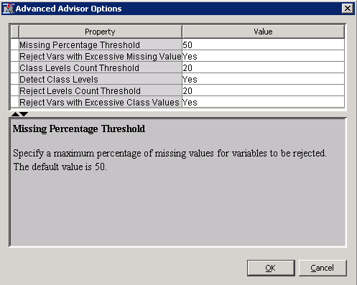

Using the default Advanced options, the Metadata Advisor can do the following:

* reject variables with an excessive number of missing values (default=50%)
* detect the number class levels of **numeric** variables and assign a role of Nominal to those with class counts below the selected threshold (default=20)
* detect the number class levels of **character** variables and assign a role of Rejected to those with class counts above the selected threshold (default=20)

**🖉** In the **PVA97NK** table, there are several numeric variables with fewer than 20 distinct values that should **not**be treated as nominal. Similarly, there is one class variable with more than 20 levels that should **not** be rejected.

To avoid changing many metadata values in the next step of the Data Source Wizard, you should alter these defaults.

1. Type **3** as the Class Levels Count Threshold value so that only binary numeric variables are treated as categorical (specifying three means it treats anything with LESS than 3 values as nominal – i.e., a two value variable – 1/0).

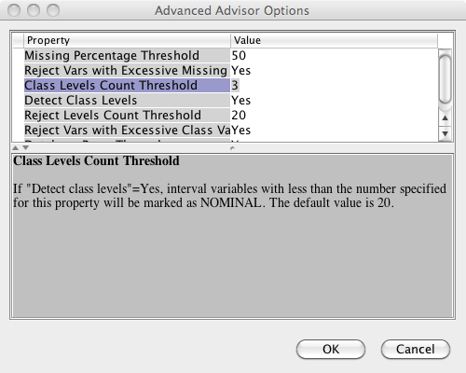

1. Type **100** as the Reject Levels Count Threshold value, so that only character variables with more than 100 distinct values are rejected.

**🖉** Be sure to press ENTER after you type the number **100**. Otherwise, the value might not be registered in the field.

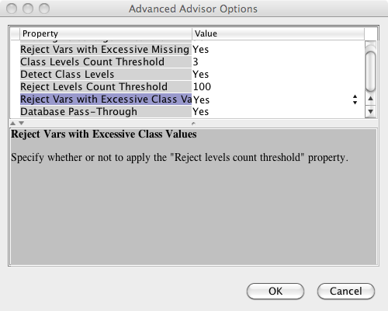

1. Select **OK** to close the Advanced Advisor Options dialog box.
2. Select **Next >** to proceed to Step 5 of the Data Source Wizard.

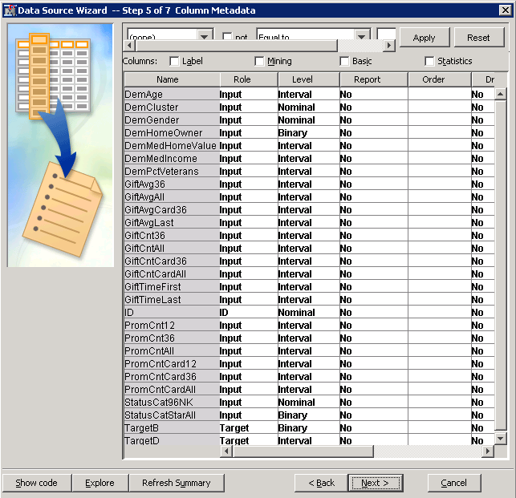

A comparison of the Column Metadata table to the table at the beginning of the demonstration shows that most of the metadata is correctly defined. SAS Enterprise Miner correctly inferred the model roles for the non-input variables by their names. The measurement levels are correctly defined by using the Advanced Metadata Advisor.

The analysis of the **PVA97NK** data in this course focuses on the **TargetB** variable, so the **TargetD** variable should be rejected.

1. Select **Role** ⇨ **Rejected** for **TargetD**.

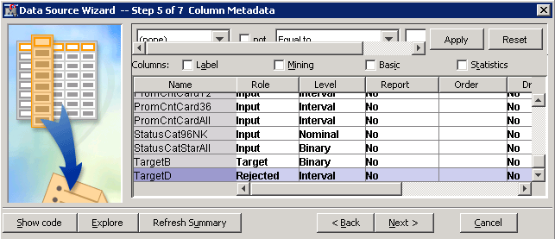

In summary, Step 5 of 7 Column Metadata is usually the most time-consuming of the Data Source Wizard steps. You can use the following tips to reduce the amount of time required to define metadata for SAS Enterprise Miner predictive modeling data sets:

* Only include variables that you intend to use in the modeling process in your raw data source.
* For variables that are not inputs, use variable names that start with the intended role. For example,   
  an ID variable should start with **ID** and a target variable should start with **Target**.
* Inputs that are to have a nominal measurement level should have a **character** data type.
* Inputs that are to be interval must have a **numeric** data type.
* Customize the Metadata Advisor to have a Class Level Count set equal to **3** and a Reject Levels Count set equal to a number greater than the maximum cardinality (level count) of your nominal inputs.

#### Finalizing the Data Source Specification

Follow these steps to complete the data source specification process:

1. Select **Next >** to proceed to Decision Configuration.

**🖉** The Data Source Wizard gained an extra step due to the presence of a categorical (binary, ordinal, or nominal) target variable. Select **No**

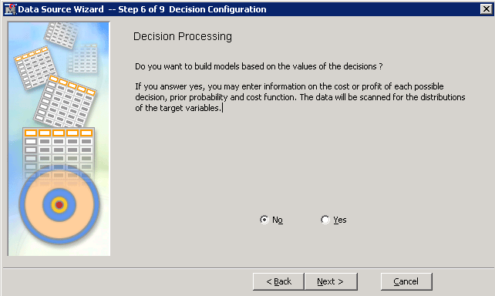

When you define a predictive modeling data set, it is important to properly configure decision processing. In fact, obtaining meaningful models often requires using these options. The **PVA97NK** table was structured so that reasonable models are produced **without** specifying decision processing. However, this might not be the case for data sources that you will encounter outside this course. Because you need to understand how to set these options, a detailed discussion of decision processing is provided in Chapter 6, “Model Assessment.”

**🖉** Do **not** select **Yes** here because that changes the default settings for subsequent analysis steps and yields results that diverge from those in the course notes.

1. Select **Next >**. You will be asked whether you want to create a sample data set. Make sure “No” is selected and click **Next>** again.
2. Now you’ll reach this step of the Data Source Wizard.

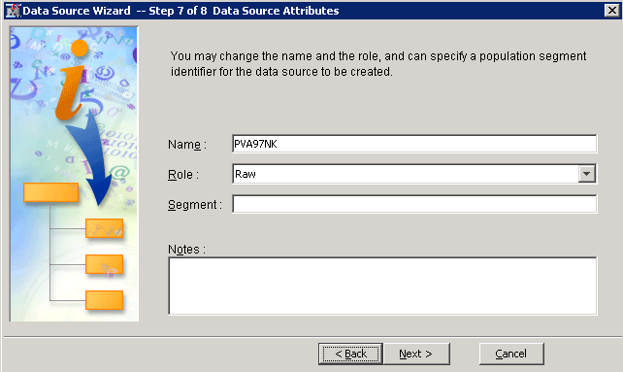

This penultimate step enables you to set a role for the data source and add descriptive comments about the data source definition. For the upcoming analysis, a table role of Raw is acceptable.

1. The final step in the Data Source Wizard provides summary details about the data table that you created. Select **Finish**.

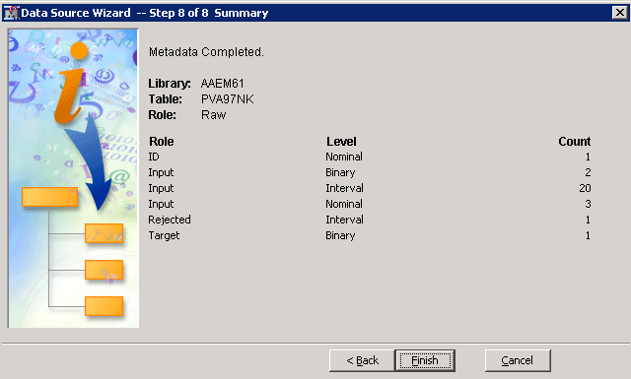

The **PVA97NK** data source is added to the Data Sources entry in the Project panel.

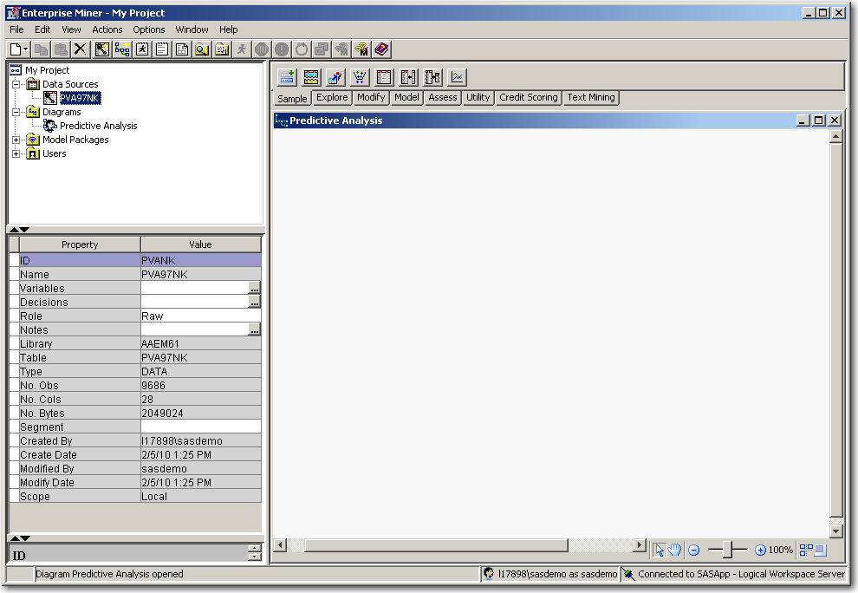

1. Select the **PVA97NK** data source to obtain table properties in the SAS Enterprise Miner Properties panel.

Exploring Source Data

SAS Enterprise Miner can construct interactive plots to help you explore your data. This demonstration shows the basic features of the Explore window. These include the following:

* opening the Explore window
* changing the Explore window sample size
* creating a histogram for a single variable
* changing graph properties for a histogram
* changing chart axes
* adding a missing bin to a histogram
* adding plots to the Explore window
* exploring variable associations

#### Opening the Explore Window

There are several ways to access the Explore window. Use these steps to open the Explore window through the Project panel.

1. Open the Data Sources folder in the Project panel and right-click the data source of interest. The Data Source Option menu appears.

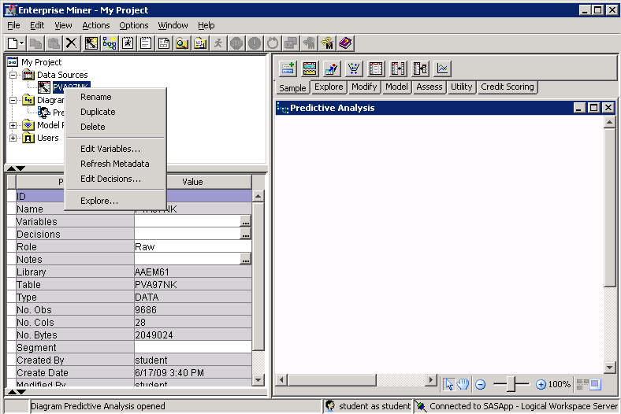

1. Select **Explore…** from the Data Source Option menu. The Explore – AAEM61.PVA97NK window opens.

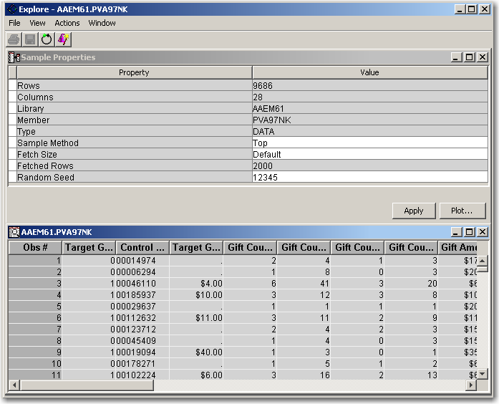

The Explore window features a 2000-observation sample from the **PVA97NK** data source. Sample properties are shown in the top half of the window and a data table is shown in the bottom half.

1. If at first you cannot see any tables here, select **Window 🡪 Tile**. The windows should then become visible.

#### Changing the Explore Sample Size

The Sample Method property indicates that the sample is drawn from the **top** (first 2000 rows) of the data set. Use these steps to change the sampling properties in the Explore window.

**🖉** Although selecting a sample through this method is quick to execute, fetching the top rows of a table might not produce a representative sample of the table.

1. Left-click the **Sample Method** value field. The Option menu lists two choices: Top (the current setting) and Random.
2. Select **Random** from the Option menu.

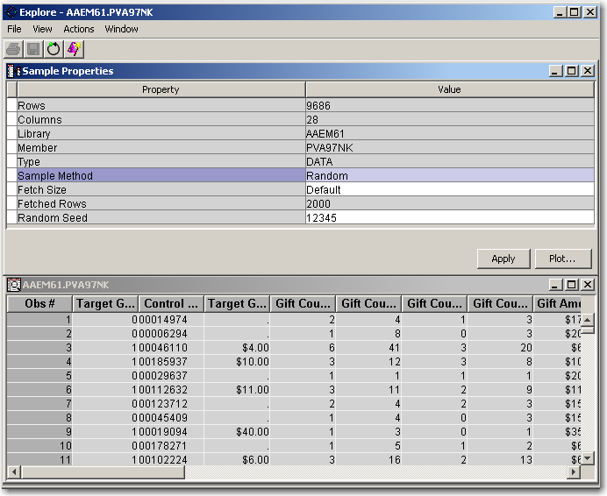

1. Select **Actions** ⇨ **Apply Sample Properties** from the Explore window menu. A new, random sample of 2000 observations is made. This 2000-row sample now has distributional properties that are similar to the original 9686 observation table. This gives you an idea about the general characteristics of the variables. If your goal is to examine the data for potential problems, it is wise to examine the entire data set.

**🖉** SAS Enterprise Miner enables you to increase the sample transferred to the client (up to a maximum of 30,000 observations). See the SAS Enterprise Miner Help file to learn how to increase this maximum value.

1. Select the **Fetch Size** property and select **Max** from the Option menu.
2. Select **Actions** ⇨ **Apply Sample Properties**. Because there are fewer than 30,000 observations, the entire **PVA97NK** table is transferred to the SAS Enterprise Miner client machine, as indicated by the Fetched Rows field.

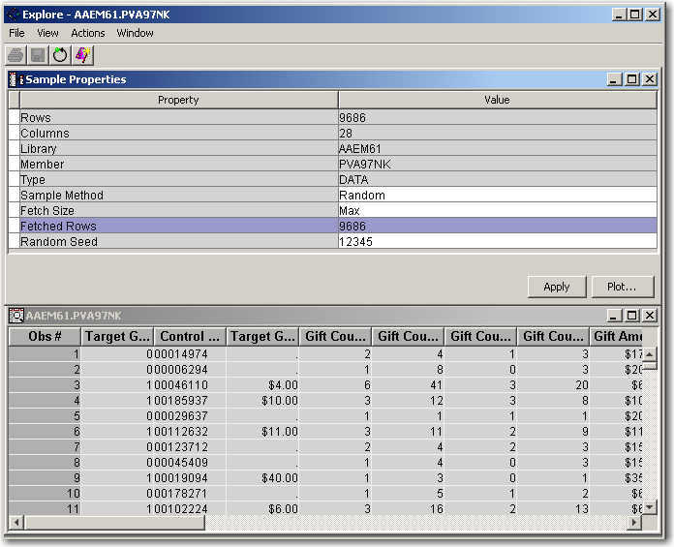

#### Creating a Histogram for a Single Variable

While you can use the Explore window to browse a data set, its primary purpose is to create statistical analysis plots. Use these steps to create a histogram in the Explore window.

1. Select **Actions** ⇨ **Plot** from the Explore window menu. The Chart wizard opens to the Select a Chart Type step.

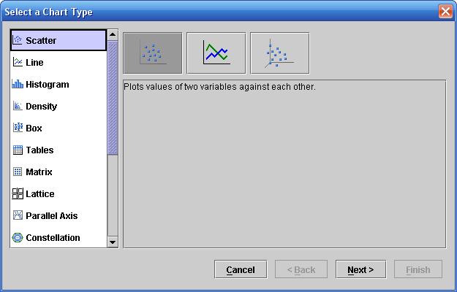

The Chart wizard enables the construction of a multitude of analysis charts. This demonstration focuses on histograms.

1. Select **Histogram**.

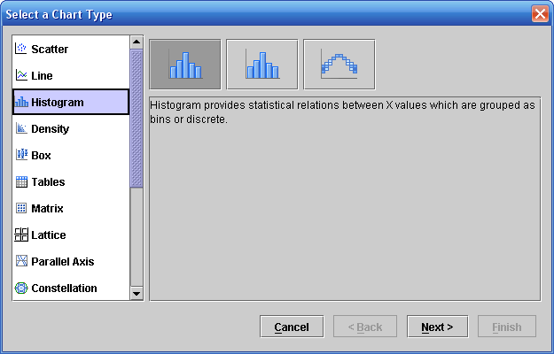

Histograms are useful for exploring the distribution of values in a variable.

1. Select **Next >**. The Chart wizard proceeds to the next step, Select Chart Roles.

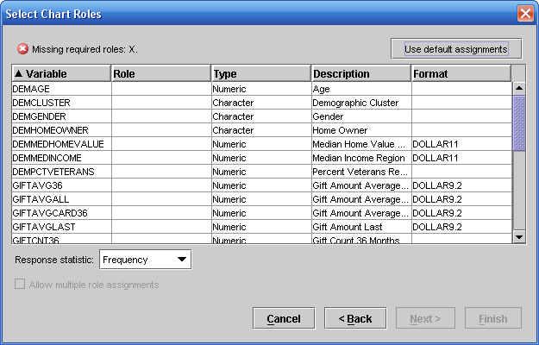

To draw a histogram, one variable must be selected to have the role X.

1. Select **Role** ⇨ **X** for the **DemAge** variable.

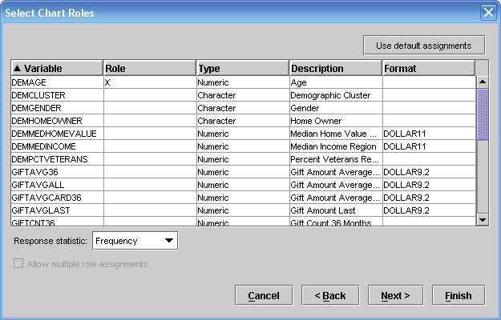

The Chart wizard is ready to make a histogram of the **DemAge** variable.

1. You will then be presented with a window asking if you want to filter the data plotted in the histogram based on some WHERE condition. Ignore this for now.

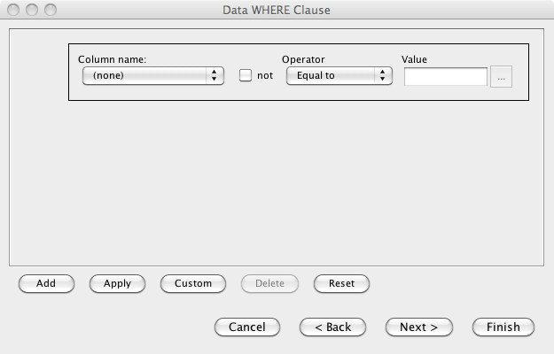

1. Select **Finish**. The Explore window is filled with a histogram of the **DemAge** variable.

**🖉** Variable descriptions, rather than variable names, are used to label the axes of plots in the Explore window.

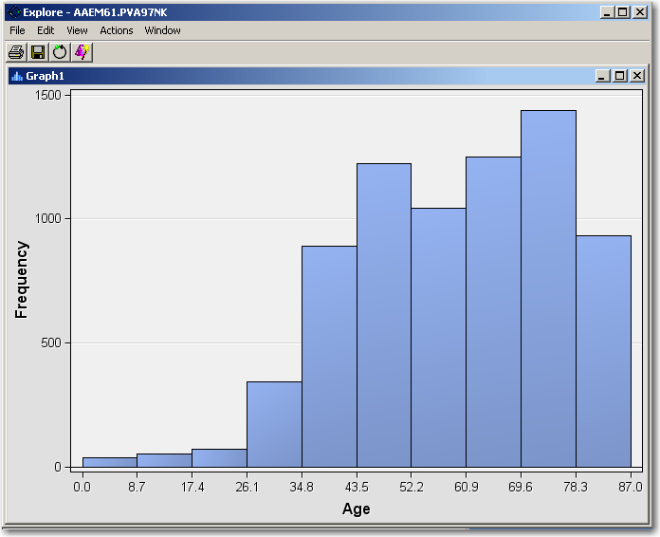

Axes in Explore window plots are chosen to range from the minimum to the maximum values of the plotted variable. Here you can see that **Age** has a minimum value of 0 and a maximum value of 87. The mode occurs in the ninth bin, which ranges between about 70 and 78. **Frequency** tells you that there are about 1400 observations in this range.

#### Changing the Graph Properties for a Histogram

By default, a histogram in SAS Enterprise Miner has 10 bins and is scaled to show the entire range of data. Use these steps to change the number of bins in a histogram and change the range of the axes.

While the default bin size is sufficient to show the general shape of a variable’s distribution, it is sometimes useful to increase the number of bins to improve the histogram’s resolution.

1. Right-click in the data area of the **Age** histogram and select **Graph Properties…** from the Option menu. The Properties-Histogram window opens.

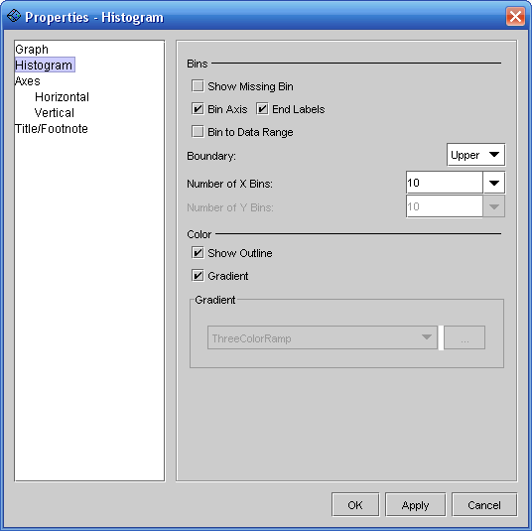

This window enables you to change the appearance of your charts. For histograms, the most important appearance property (at least in a statistical sense) is the number of bins.

1. Type **87** into the Number of X Bins field.

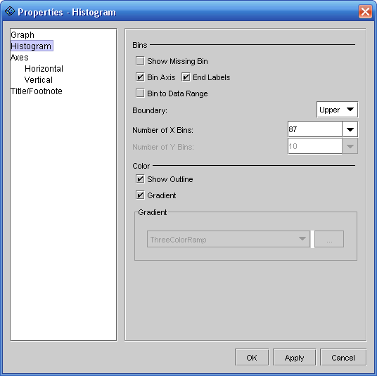

Because **Age** is integer-valued and the original distribution plot had a maximum of 87, there will be one bin per possible **Age** value.

1. Select **OK**. The Explore window reopens and shows many more bins in the **Age** histogram.

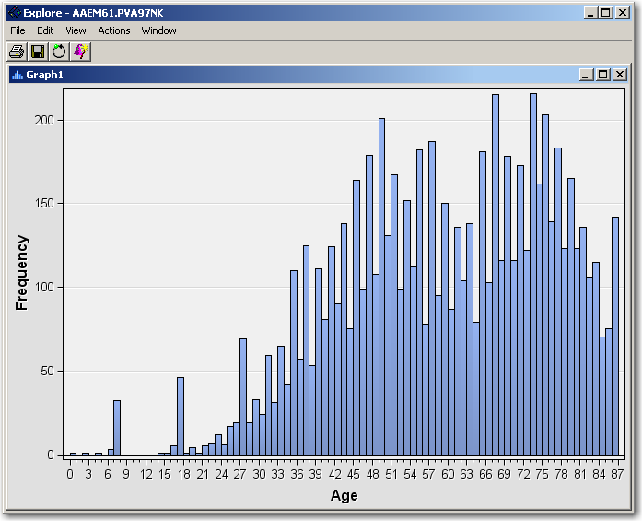

With the increase in resolution, unusual features become apparent in the **Age** variable. For example, there are unexpected spikes in the histogram at 10-year intervals, starting at **Age**=7. Also, you must question the veracity of ages below 18 for donors to the charity.

#### Adding Plots to the Explore Window

You can add other plots to the Explore window. Follow these steps to add a pie chart of the target variable.

1. Select **Actions** ⇨ **Plot** from the Explore window menu. The Chart wizard opens to the Select a Chart Type step.
2. Scroll down in the chart list and select a **Pie** chart.

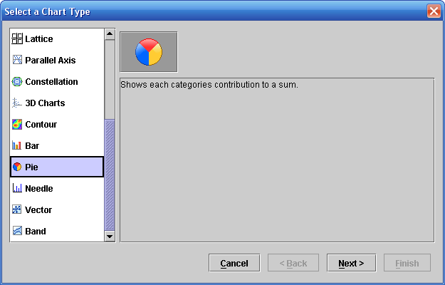

1. Select **Next >**. The Chart wizard continues to the Select Chart Roles step.

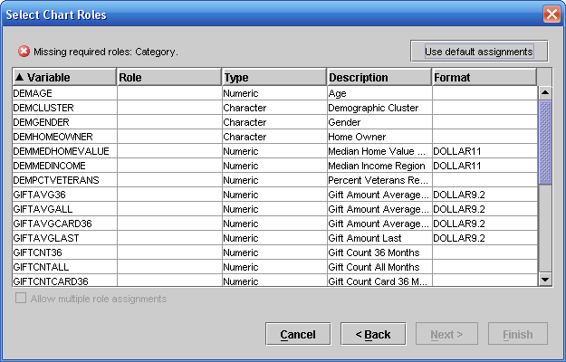

The message at the top of the Select Chart Roles window states that a variable must be assigned the **Category** role.

1. Scroll the variable list and select **Role** ⇨ **Category** for the **TargetB** variable. Again, skip over the data filtering option and click Finish.

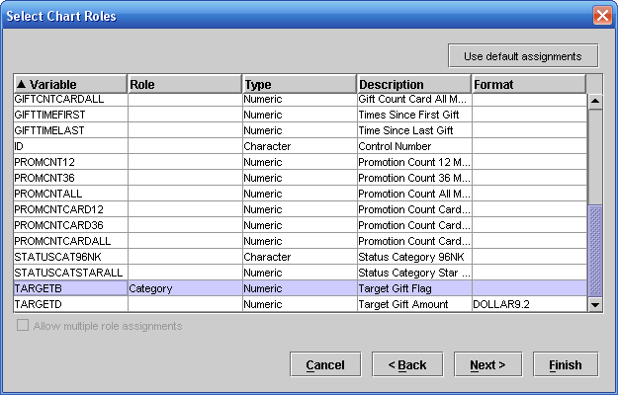

1. Select **Finish** to create the pie chart for **TargetB**.

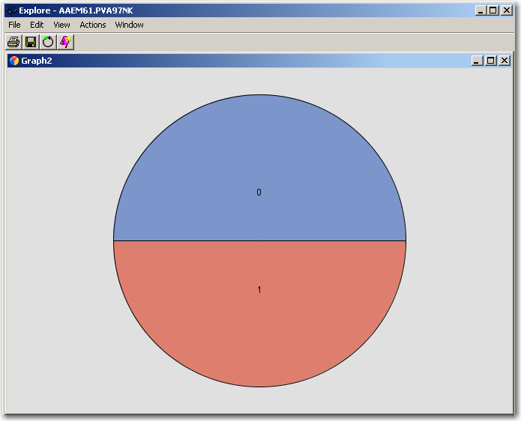

The chart shows an equal number of cases for **TargetB**=0 (top) and **TargetB**=1 (bottom).

1. Select **Window** ⇨ **Tile** to simultaneously view all sub-windows of the Explore window.

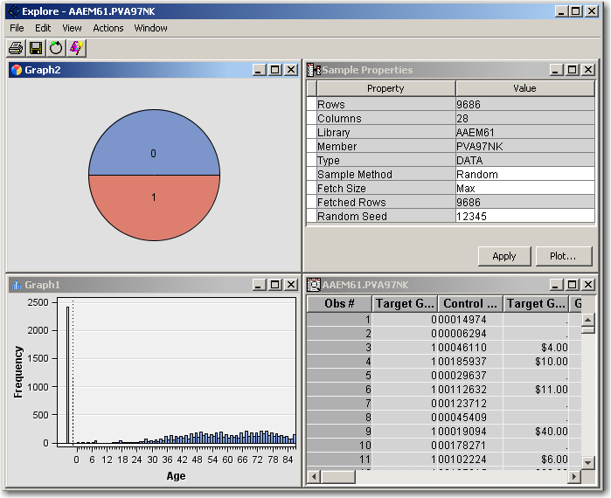

#### Exploring Variable Associations

All elements of the Explore window are connected. By selecting a bar in one histogram, for example, corresponding observations in the data table and other plots are also selected. Follow these steps to use this feature to explore variable associations:

1. Double-click the **Age** histogram title bar so that it fills the Explore window.
2. Click and drag a rectangle in the Age histogram to select cases with **Age** in excess of 70 years.

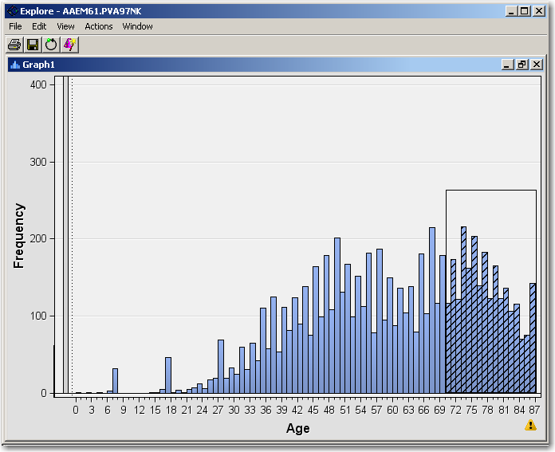

The selected cases are cross-hatched. (The vertical axis is rescaled to show the selection better.)

1. Double-click the **Age** histogram title bar. The tile display is restored.

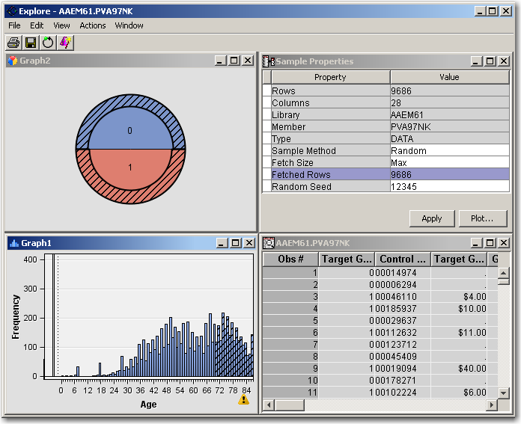

Notice that part of the TargetB pie chart is selected. This selection shows the relative proportion of observations with **Age** greater than 70 that do and do not donate. Because the arc on the **TargetB**=1 segment is slightly thicker, it appears that there is a slightly higher number of donors than non-donors in this **Age** selection.

1. Double-click the **TargetB** pie chart title bar to confirm this observation.

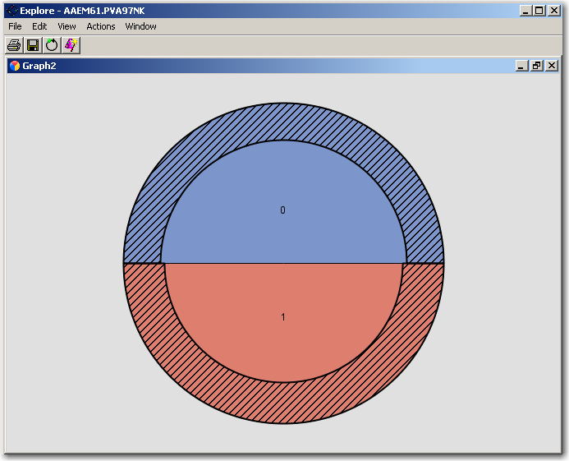

1. Close the Explore window to return to the SAS Enterprise Miner client interface screen.

Changing the Explore Window Sampling Defaults

Follow these steps to change the preference settings of SAS Enterprise Miner to use a random sample   
for all of the data source data in the Explore window:

1. Select **Options** ⇨ **Preferences…** from the main menu. The Preferences window opens.

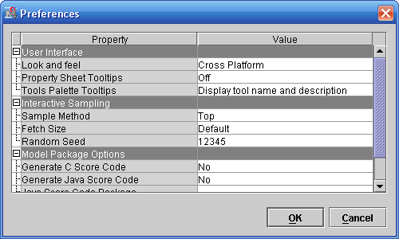

1. Select **Sample Method** ⇨ **Random**.

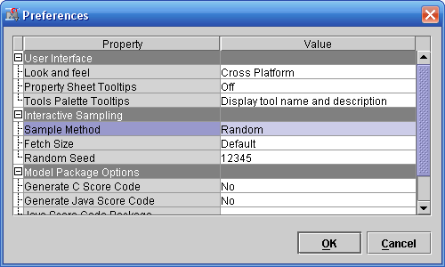

The random sampling method improves on the default method (at the top of the data set) by guaranteeing that the Explore window data is representative of the original data source. The only negative aspect is an increase in processing time for extremely large data sources.

1. Select **Fetch Size** ⇨ **Max**.

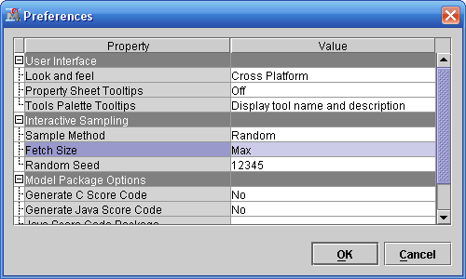

The Max fetch size enables a larger sample of data to be extracted for use in the Explore window.

If you use these settings, the Explore window uses the entire data set or a random sample of up to 30,000 observations (whichever is smaller).

Modifying and Correcting Source Data

This demonstration shows you how to replace a placeholder value for missing with a true missing value indicator. In this way, SAS Enterprise Miner tools can correctly respond to the true, but unknown, value. SAS Enterprise Miner includes several tools that you can use to modify the source data for your analysis.

First, create a histogram for the **DemMedIncome** variable. You’ve done these steps before, so

1. Right-click on the **PVA97NK** data source and select **Explore…**

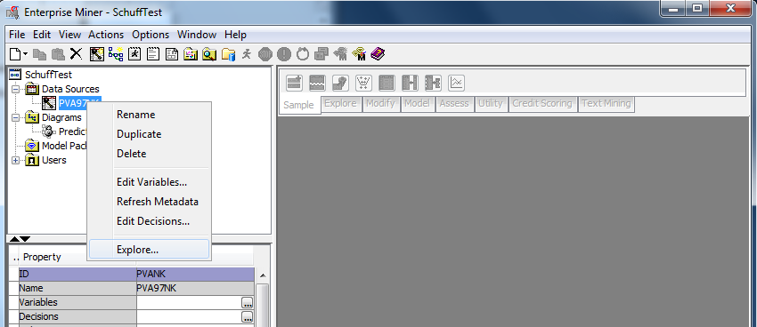

1. The **Explore** window will appear. Select **Actions/Plot…**

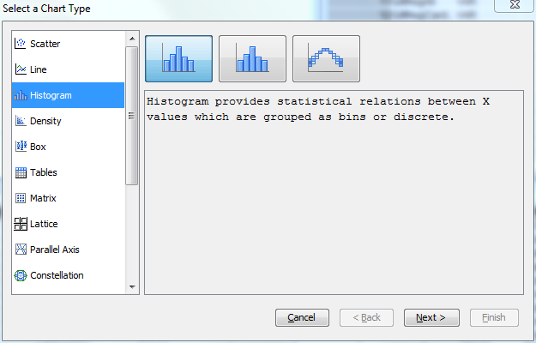

1. Select Histogram and click **Next…**

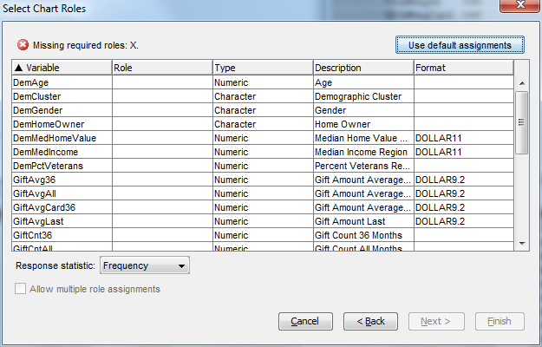

1. Give the **DemMedIncome** variable the **Role** of “X”
2. Click the **Finish** button and you’ll see the histogram:

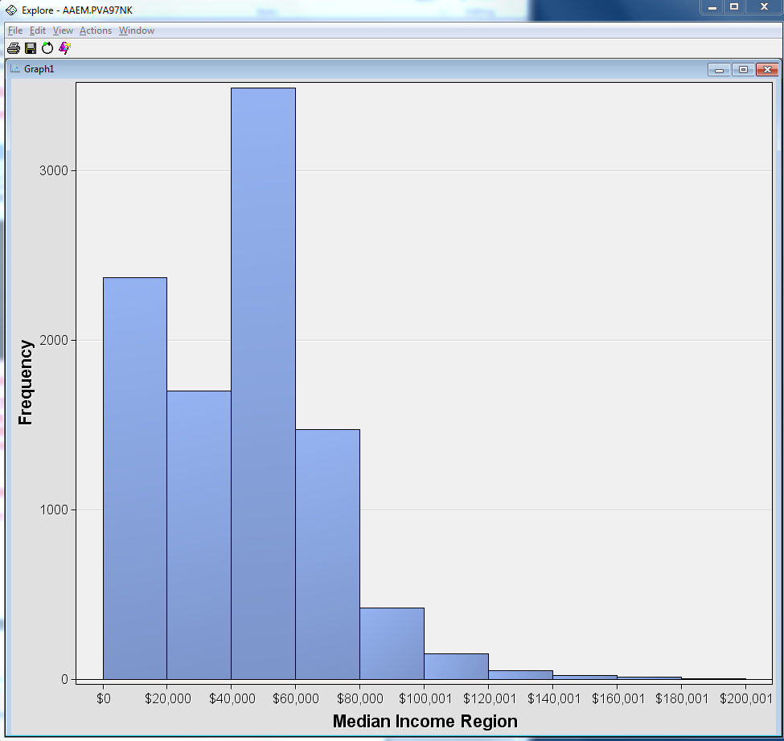

1. Right-click anywhere inside the chart area and select **Graph Properties…**

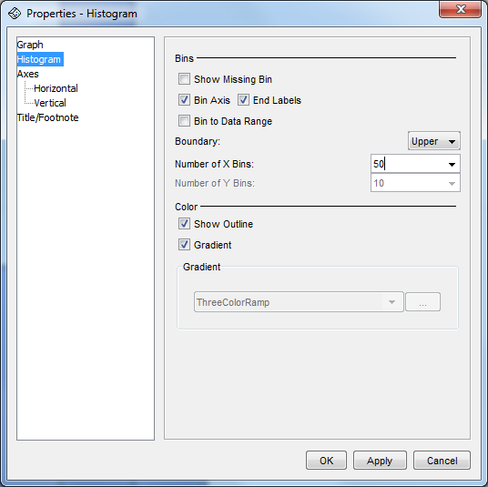

1. Change the number of **X Bins** to **50** and click the **OK** button. You’ll now see the following:

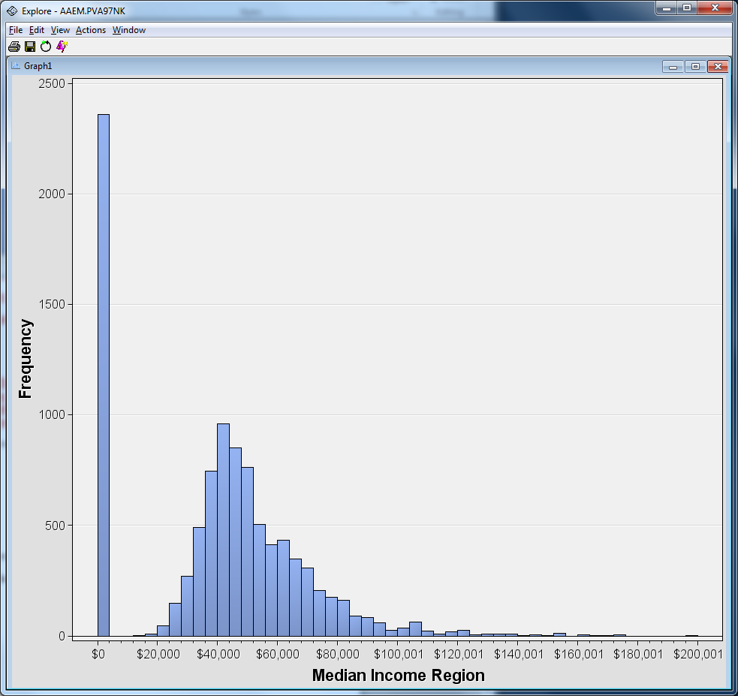

This reveals that the original appearance of a high number (frequency) of people with an income between $0 and $20,000 actually is misleading. In reality, there is an unusual spike at 0.   
  
This phenomenon often occurs in data extracted from a relational database table where 0 or another number is used as a substitute for the value missing or unknown. Clearly, having zero income is considerably different from having an unknown income. If you properly use the **income** variable in a predictive model, this discrepancy can be addressed.

The following demonstrations show how to use the Replacement node to modify incorrect or improper values for a variable.

#### Process Flow Setup

Use the following steps to set up the process flow that will modify the **DemMedIncome** variable:

1. Drag the **PVA97NK** data source to the Predictive Analysis workspace window.

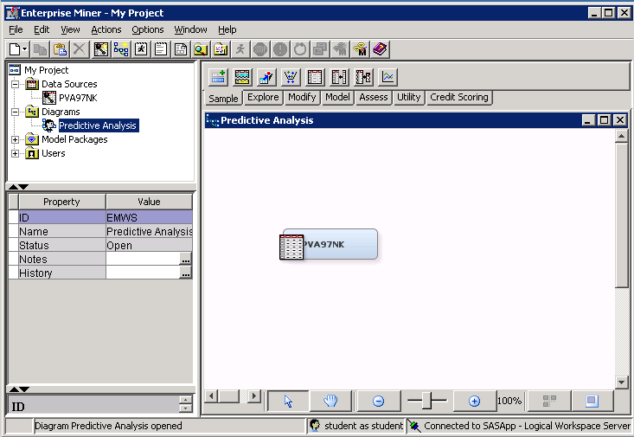

1. Select the **Modify** tab to access the Modify tool group.

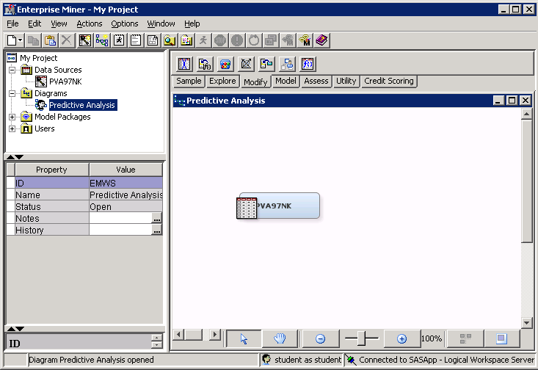

1. Drag the **Replacement** tool (third from the right) from the Tools Palette into the Predictive Analysis workspace window.

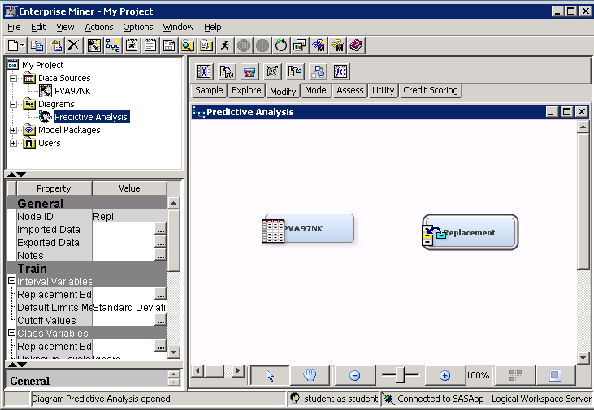

1. Connect the **PVA97NK** data to the Replacement node by clicking near the right side of the **PVA97NK** node and dragging an arrow to the left side of the Replacement node.

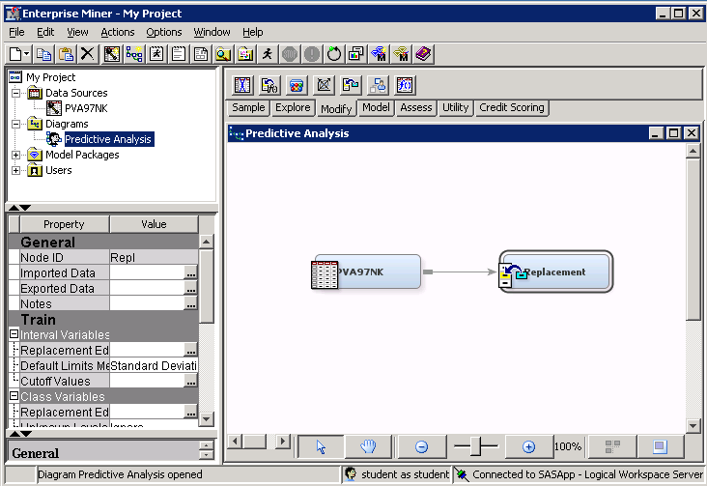

You created a process flow, which is the method that SAS Enterprise Miner uses to carry out analyses. The process flow, at this point, reads the raw **PVA97NK** data and replaces the unwanted values of the observations. You must, however, specify which variables have unwanted values and what the correct values are. To do this, you must change the settings of the Replacement node.

#### Changing the Replacement Node Properties

Use the following steps to modify the default settings of the Replacement node:

1. Select the **Replacement** node and examine the Properties panel.

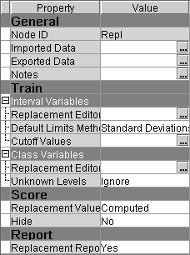

The Properties panel displays the analysis methods used by the node when it is run. By default, the node replaces all interval variables whose values are more than three standard deviations from the variable mean.

**🖉** You can control the number of standard deviations by selecting the **Cutoff Values** property.

In this demonstration, you only want to replace the value for **DemMedIncome** when it equals zero. Thus, you need to change the default setting.

1. Select the **Default Limits Method** property and select **None** from the Options menu.

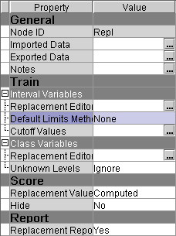

You want to replace improper values with missing values. To do this, you need to change the Replacement Value property.

1. Select the **Replacement Value** property and select **Missing** from the Options menu.

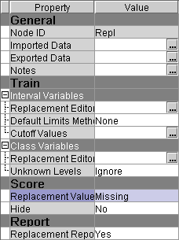

You are now ready to specify the variables that you want to replace.

1. Select  (Interval Variables: Replacement Editor ellipsis) from the Replacement node properties panel.

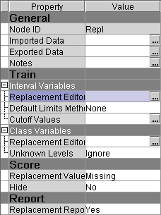

**🖉** Be careful to open the Replacement Editor for Interval Variables, **not** for Class Variables.

The Interactive Replacement Interval Filter window opens.

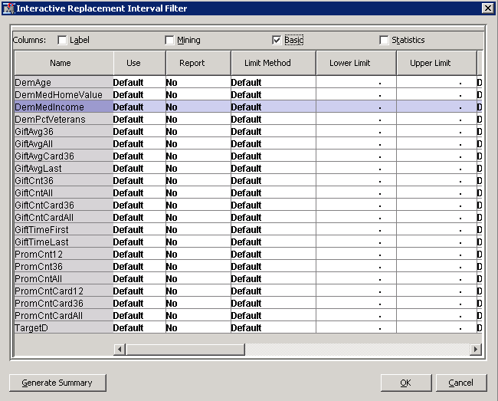

1. Select **User Specified** as the Limit Method value for **DemMedIncome**.

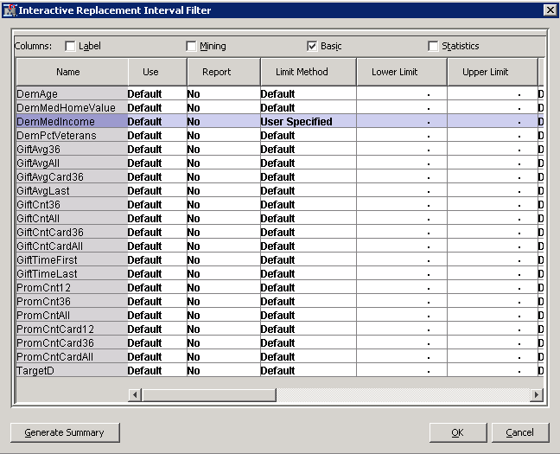

1. Type **1** as the Lower Limit value for **DemMedIncome**.

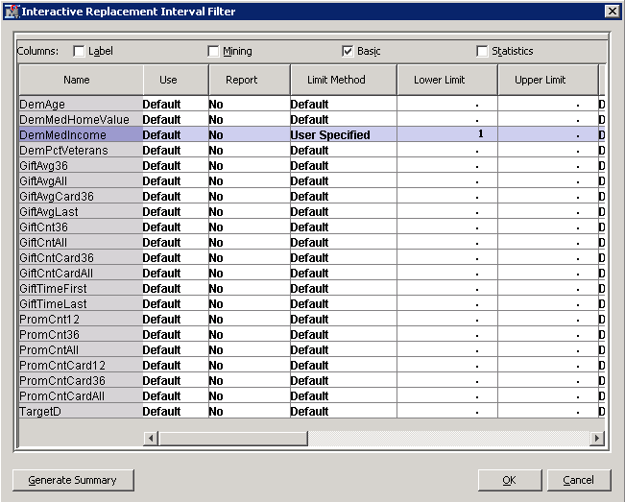

If you use this specification, any **DemMedIncome** values that fall below the lower limit of 1 are set to missing. All other values of this variable do not change.

1. Select **OK** to close the Interactive Replacement Interval Filter window.

#### Running the Analysis and Viewing the Results

Use these steps to run the process flow that you created.

1. Right-click on the **Replacement** node and select **Run** from the Option menu. A Confirmation window appears, and requests that you verify the run action.

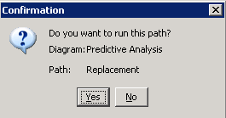

1. Select **Yes** to close the Confirmation window. A small animation in the lower right corner of each node indicates analysis activity in the node.

The Run Status window opens when the process flow run is complete.

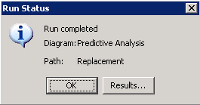

1. Select **Results…** to review the analysis outcome. The Results - Node: Replacement Diagram: Predictive Analysis window appears.

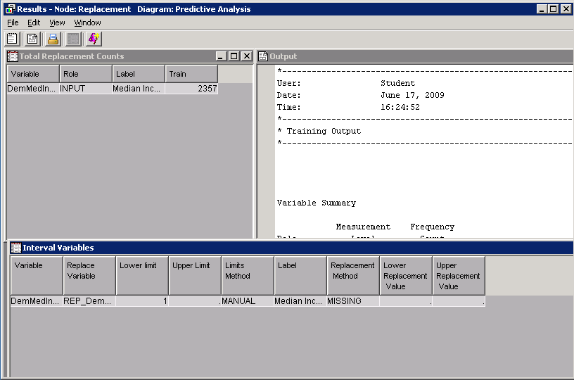

The Replacement Counts window shows that 2357 observations were modified by the Replacement node. The Interval Variables window summarizes the replacement that was conducted. The Output window provides more or less the same information as the Total Replacement Counts window and the Interval Variables window (but it is presented as a static text file).

1. Close the Results window.