Creating Your SAS OnDemand Enterprise Miner Account
In order to use SAS Enterprise Miner, you’ll need an account. Then you will need to activate your enrollment using a link provided by your instructor. The instructions below take you through this process.

Step 1: Get a SAS Enterprise Miner Account

- Go to https://support.sas.com/ctx3/sodareg/index.html?execution=e1s1
- At the log in screen, skip the user name and password fields and click on “Register for an Account” link.
- At the next screen, fill in your first name, last name, and email address. Use your Temple University email address!
- Click Submit.
- Check your email for a message from SAS. The message will contain a link. Click on that link to verify your email address and continue the registration process.
- At the next screen, fill in the email address you used to register and make up a password. Check the box to agree to the license terms and click “Create Account.”
(When it says “The next step may take some time. Please be patient.” they mean it! It can take a while. Do not close the browser window!)
- At the next screen it will confirm your registration and give you your user id. Usually this is your email address without the @temple.edu (i.e., tux12345).
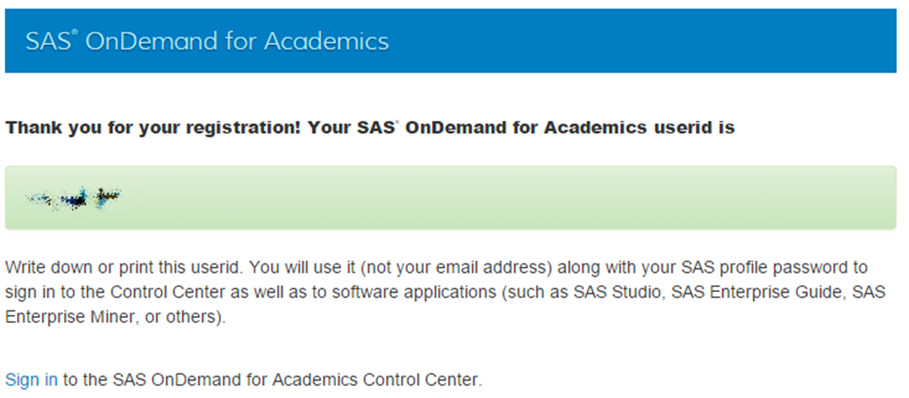
(Your username won’t be blurry!)
- You’ve successfully created your account! Keep track of your username and password.
Step 2: Get the SAS Enterprise Miner license from your instructor’s enrollment link.
- Find the email you received with the enrollment. Click on that link.
- At the SAS sign in screen, enter your username and password.
(Remember, your username is not your entire email address, just the part before the “@temple.edu”)
- You’ll see a confirmation screen like this:
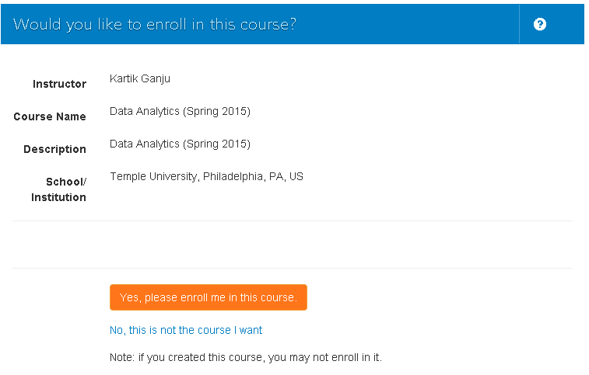
- Click “Yes, please enroll me in this course.”
- You’ll see SAS Enterprise Miner as one of your applications:
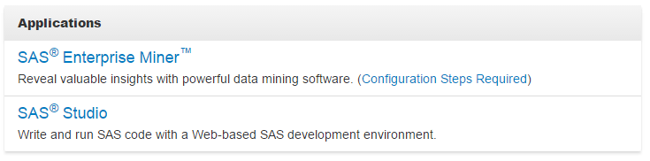

- Click “SAS Enterprise Miner.” It will download a file called main.jnlp. Open this file and it will launch SAS Enterprise Miner.
That main.jnlp file is all you need to launch SAS Enterprise Miner. If you don’t want to sign on to the SAS site each time to get the file, you can save it to your flash drive, or use the quick link from the Community Site to download it.
- If this is the first time you’re running SAS Enterprise Miner on your computer, it will take a while to download. Eventually, you’ll see this log on screen:
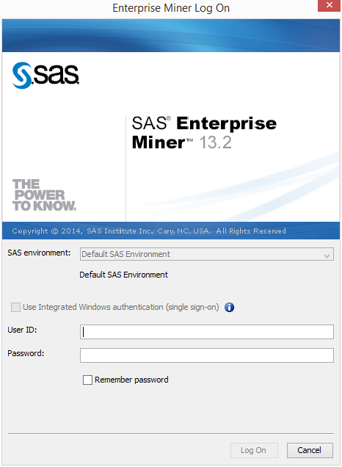
Enter your SAS username and password and click “Log On.”

- A successful log on will display this screen:
s