In-Class Exercise: Understanding Decision Tree Output
The following is the output from a decision tree analysis in SAS Enterprise Miner. It uses the same data set (a charity donation database) you’ll be using in your in-class exercise, but I’ve changed the model parameters so we get some different results.
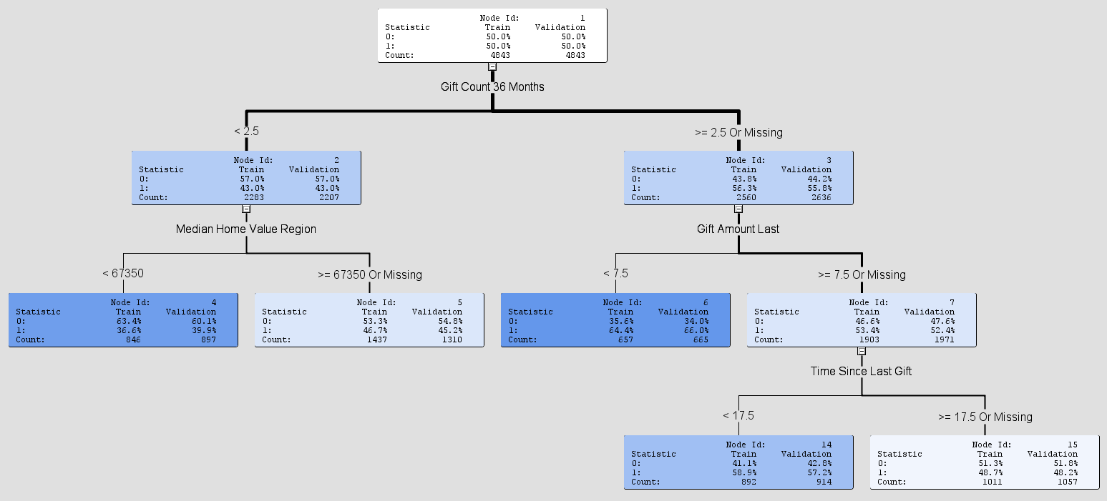
Labels:
Gift Count 36 Months – Number of donations the person made in the last 36 months
Gift Amount Last – Value of the last donation the person made (in $ thousands)
Time Since Last Gift – Number of months since the person’s last donation
Median Home Value Region – The median home value in the donor’s geographic region

Outcome statistic (look at the validation set results when evaluating):
0 = person doesn’t donate an additional gift within the next 3 months
1 = person does donate an additional gift within the next 3 months

Answer the following questions about this tree on the next page:

- What is the probability that the following people will donate an additional gift in the next 3 months?
  - Someone who has made two donations in the last 36 months and the median home value in their region is $85,000.
  - Someone who has made five donations in the last 36 months and their last gift amount was $3,000.
  - Someone who has made three donations in the last 36 months, their last gift amount was $10,000, and it’s been 12 months since their last donation.
  - Someone who has made three donations in the last 36 months, their last gift amount was $10,000, and it’s been 24 months since their last donation.
- What does it mean that median home value isn’t a split variable when more than three donations were made in the last 36 months?
- Check out this screen shot from SAS Enterprise Miner. This is the list of logworth values used to choose the first split variable for the data.
  - According to this list, which variable is the best one to choose for that first split? Why?
  - How does this correspond to the final decision tree on the previous page?
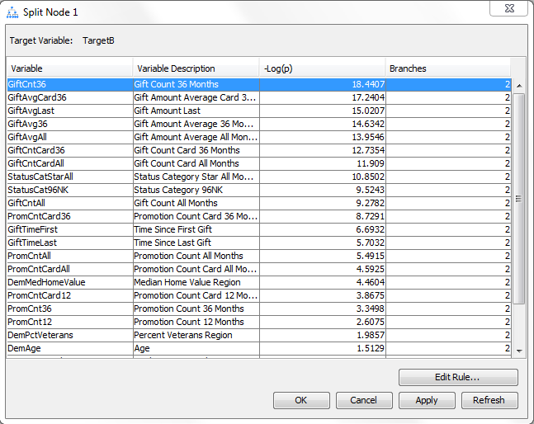

- Remember the logworth value is the log of the p-value derived from the Chi-Squared statistic. So the logworth value is directly related to a Chi-Squared calculation comparing observed outcomes versus expected outcomes.
With this in mind, consider these two hypothetical scenarios for a different set of donor data:
Scenario 1: Gender as a split variable
 | Observed |  |  |  |  | Expected
 | Male | Female |  |  |  | Male | Female
Gift | 375 | 125 | 500 |  | Gift | 400 | 100 | 500
No Gift | 425 | 75 | 500 |  | No Gift | 400 | 100 | 500
 | 800 | 200 | 1000 |  |  | 800 | 200 | 1000

Scenario 2: Age as a split variable
 | Observed |  |  |  |  | Expected
 | <40 | >=40 |  |  |  | <40 | >=40
Gift | 405 | 95 | 500 |  | Gift | 400 | 100 | 500
No Gift | 395 | 105 | 500 |  | No Gift | 400 | 100 | 500
 | 800 | 200 | 1000 |  |  | 800 | 200 | 1000
a) What is the Chi-Squared value for Scenario 1 and Scenario 2?
Scenario 1 (Gender): ______________________ Scenario 2 (Age): ____________________
b) Which split variable, Gender or Age, is a more powerful differentiator whether someone will donate a gift?
Answer: _________________________
c) Briefly explain why:
Answer: _________________________________________________________________
d) Which split variable, Gender or Age, will have the higher logworth value?
Answer: _________________________

