Quick Guide to Installing and Setting Up MySQL Workbench
If you want to install MySQL Workbench on your own computer:
Go to: http://www.mysql.com/downloads/workbench/
Windows Users:
- You will need to install the Microsoft .NET Framework 4 Client Profiles and the Visual C++ Redistributable for Visual Studio 2013. This has some basic software that MySQL Workbench needs to run.
There are instructions for how to get this software under “MySQL Workbench Prerequisites” on that download page.
- Select “Microsoft Windows” from the “Select Platform” drop-down menu. Download MySQL Workbench 6.2.4. It will be your only choice.

- After the installer is downloaded, double-click on the icon to install the software.

- Accept the license terms. Click “Next.”

- At the next dialog, click “Custom” as the Setup Type. Click “Next.”

- At the next dialog, double-click on “Applications,” the double-click on “MySQL Workbench,” then double-click on “MySQL Workbench 6.2.”

- You’ll see two options – MySQL Workbench 6.2.4 – X86 and X64. If you have a 32-bit version of Windows, click once on X86. If you have a 64-bit version of Windows, click on X64.
If you don’t know, click on X86.

- Click on the green arrow pointing to the right to move that entry into the Products/Features To Be Installed column. Then click “Next.”

- Then click “Execute” to install the software.

Mac Users:
- Select “Mac OS X” from the “Select Platform” drop-down menu. Download MySQL Workbench 6.2.4. It will be your only choice.
- Install the software just like you would any other program (double-click on the installer and follow the instructions to install the software on your computer).
Setting up a connection in SQL Workbench (in the lab or your own laptop):
- If you’re working outside of Temple’s campus, you can skip to step 2.
If you’re on a lab computer, make sure you have logged in with your own MIS username. Otherwise, you might accidentally log in to SQL Workbench as someone else. If the computer is already logged in, log out first!
If you are on your own laptop on Temple’s campus, make sure you are connected through the TUSecure wireless network. To get instructions for connecting to TUSecure visit: http://www.temple.edu/cs/wireless/#tusecure
- Start SQL Workbench.
- Click on the “plus sign” next to MySQL Connections to create a new connection.
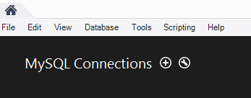
- At the “Setup New Connection” dialog, fill in the information as follows:
Connection Name: class1
Hostname: class1.mis.temple.edu
Username: Your username given to you by your instructor
(If it says that “class1” is already taken, make the connection name something else. Any name is ok for this.)

- Click “OK” and you’ll see the connection under “MySQL Connections”:
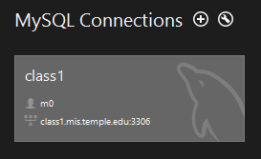
Click on the connection. Make sure the user name matches your ID (it should NOT be m0)!
- It will ask you for your password. Enter your password (it’s case sensitive) and click OK.
(If you’re in a lab, don’t save your password in the vault or other people will be able to access your account!)
- You’ll see the main window for MySQL Workbench:
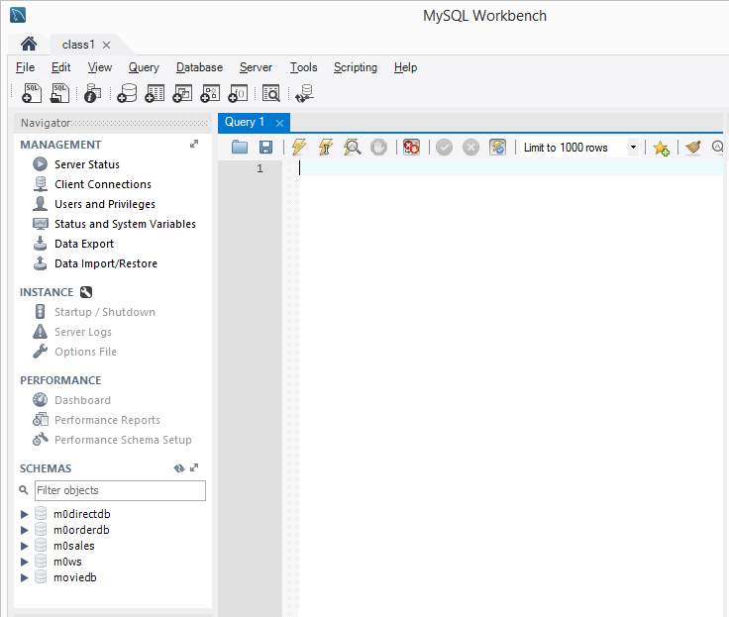
All you really care about is the Query 1 tab on the right and the SCHEMAS section on the left.
- Try a query. In the SQL File 1 window, type:
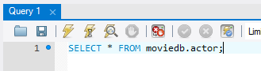
Then click the lightning bolt to execute the query:
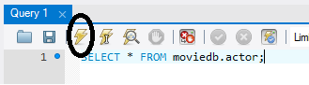

You’ll see output like this:

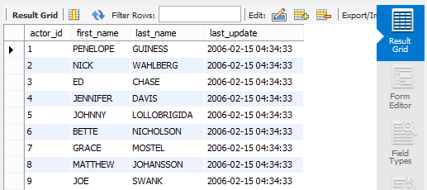

You’ve successfully run your first query!

