Super Quick Guide to MySQL Workbench
Setting up a connection in SQL Workbench (in the lab or your own laptop):
- Start SQL Workbench.

- Click on the “plus sign” next to MySQL Connections to create a new connection.
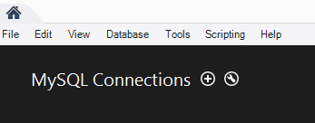
At the “Setup New Connection” dialog, fill in the information as follows:
Connection Name: class1
Hostname: class1.mis.temple.edu
Username: Your username given to you by your instructor
(If it says that “class1” is already taken, make the connection name something else. Any name is ok for this.)
- Click “OK” and you’ll see the connection under “MySQL Connections”:
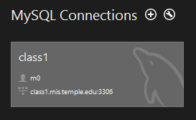
Click on the connection. Make sure the user name matches your ID (it should NOT be m0)!
- You’ll see a password dialog. Enter your password (it’s case sensitive) and click OK.
(If you’re in a lab, don’t save your password in the vault or other people will be able to access your account!)

- You should see the main screen for SQL Workbench:
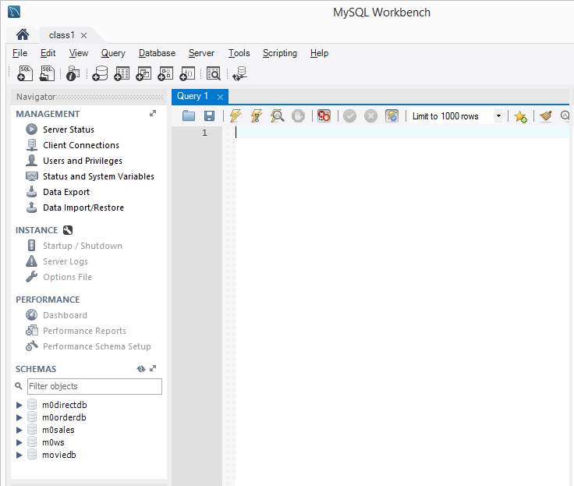

Your SCHEMAS list should reflect your MySQL user ID. For example if your ID is m55, the first schema will be m55directdb.

- You’ve successfully logged in to the MySQL server using MySQL Workbench!

