**Assignment #2: SQL**

|  |
| --- |
| **Submission Instructions**   * Complete and submit the **answer sheet** as a PDF document through the Google Form link. * Please name your submission as LastFirstAssignment2.pdf * You can copy and paste the (i) **SQL query** and (ii) the **results** from SQL Workbench. * If you do not follow the instructions, your assignment will be counted late.   **Evaluation**  Your submission will be graded using two factors:   1. A correctly formed **SQL query** that answers the specific question asked (no extra rows or columns). 2. Providing the **correct answer** to the question (the results returned from MySQL Workbench). |

For this assignment, you will be working with the same movie rental database as the ICA #3. The schema is also the same, so you can use the one provided for ICA #3 as a guide.

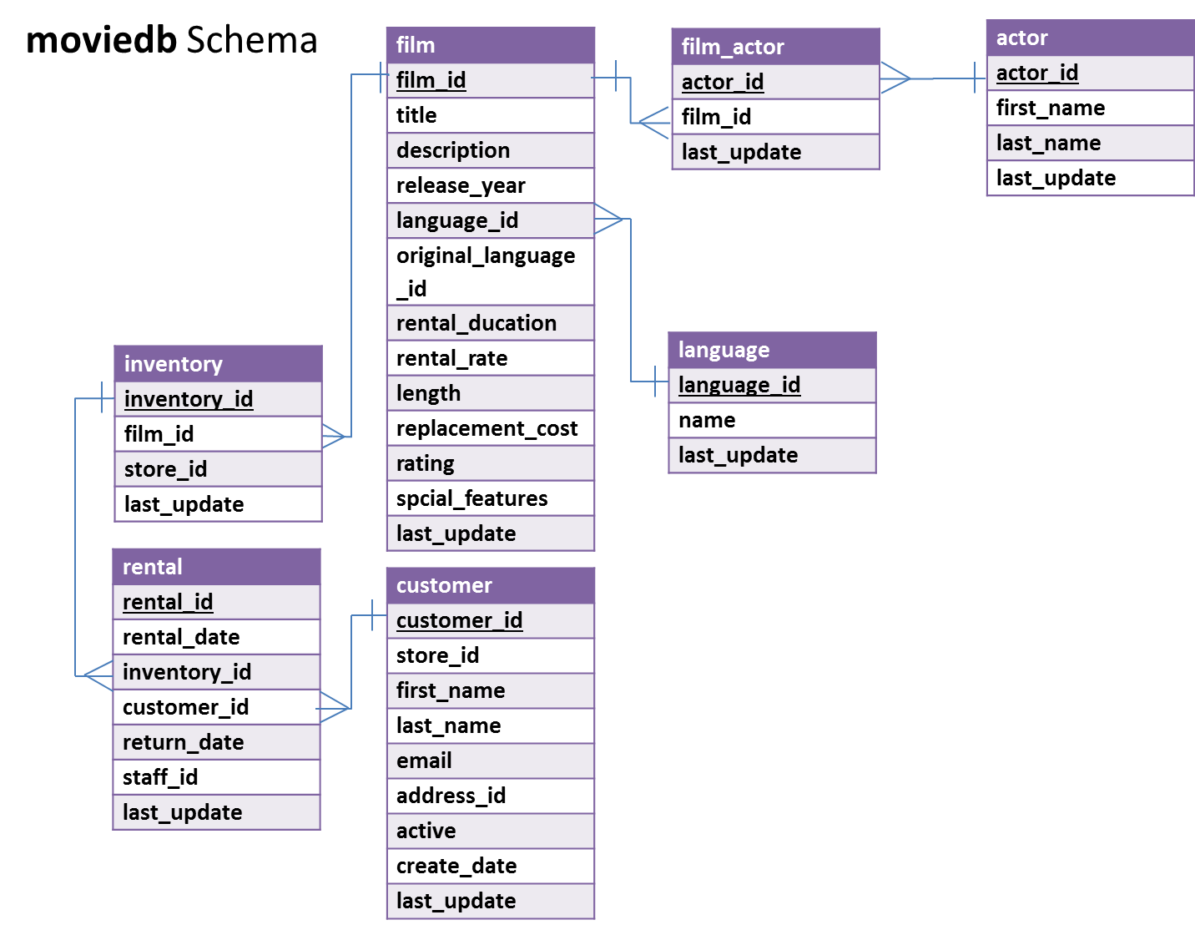

In MySQL Workbench, open the connection to the dataanalytics.temple.edu server using your username and password. Click on the “moviedb” schema and then the tables tab to see the list of tables. Recall the connection configuration as follows:

Connection Name: mis2502  
Hostname: dataanalytics.temple.edu  
Username: Your username is available in the gradebook

**Questions**

1. What are the title and rental rate for films rated PG-13 and shorter than 50 minutes?

(Hint: R-rated movies have rating value equal to ‘R’)

*Display: movie title and rental rate*

1. What are the three most popular last names among the actors in the database (Assume no ties)?

*Display: last name and how many times that name appears in the database*

1. What is the average rental rate for each movie rating (i.e., G, PG, PG-13, R, NC-17)?

*Display: rating and average rental rate*

1. How many movies with a G rating mention ‘action’ in their description?  
   *Display: number of movies*
2. For different film ratings (i.e., G, PG, R, NC-17), which film rating has the lowest average rental rate?

(Hint: Get a list of film ratings and the average rental rate of each film rating, arranged in ascending order based on the average rental rate, and returning only the first row. Assume no ties - there’s only one film rating with the highest value.)

*Display: rating and its average rental rate*

1. How many customers are named “Paula Bryant”?

*Display: number of customers*

1. Return the first five unique last name of customers which starts with a letter “T” based on alphabetical order.

*Display: last name*