**In-class Activity #3: Working with SQL, Part 1**

**Getting Information out of a Database**

|  |
| --- |
| **Submission Instructions**  Answer questions 1 – 6 in the answer sheet. |

To do this exercise, you will be working with a movie rental database. The schema for this database is provided on the accompanying document. All of the tables are in a schema called simply “**moviedb**” (not mxxxmoviedb, etc.). You can’t write to any of the tables – you can only use SELECT statements to read from them (so don’t worry about causing any damage).

Spend some time looking at the schema carefully. The field names are pretty self-explanatory. For example, here are three tables:

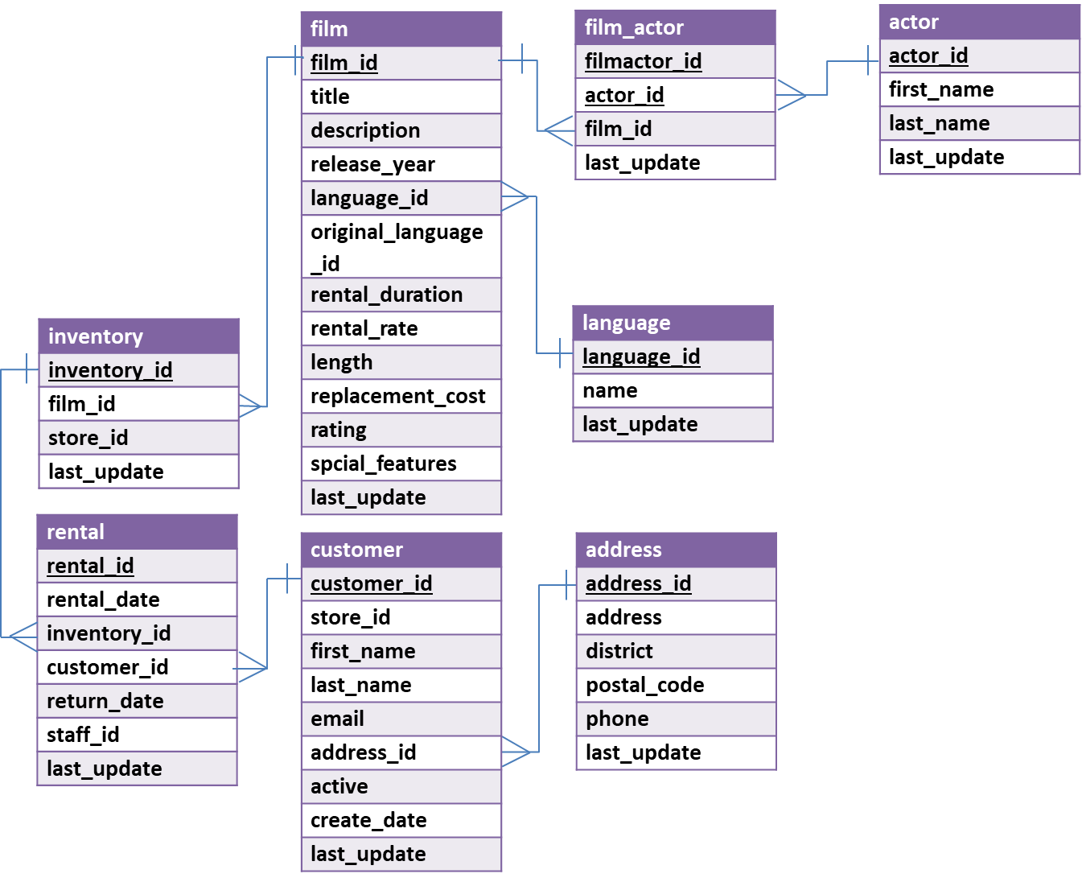

You can see that a film has a title, description, rating, and length (among other things). You can also see that an actor has a first name and a last name. The film_actor table implements the many-to-many relationship between actor and film (i.e., a film can have more than one actor, and an actor can be in more than one film). You’ll also notice that data types are listed for each field, but they should be pretty obvious – for example, first_name is a VARCHAR because it is a string value.

**Part 1: Try out some simple queries**

In the Query 1 pane, type the following (make sure you do not have any typo). And then click the Execute SQL Script button (the lightning bolt):

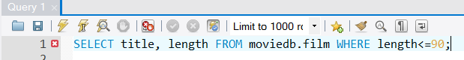

In the output tab, you’ll see this:

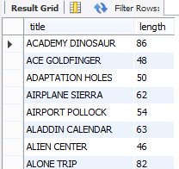

**Part 2: Write queries on your own (Submit your solutions for Part 2 only)**

Create the SQL SELECT query to answer each of the questions in the answersheet. Some of the questions can be answered by querying one table; others will require joining multiple tables to get the answer.

For each question you’ll need to write down **(1)** **the SQL query** (which you can copy and paste from SQL Workbench) and **(2) the answer you get as a result of the query** (which you can copy and paste from the results).