**Assignment #3: SQL Part 2 – Advanced Queries**

|  |
| --- |
| **Submission Instructions**   * Complete and submit the **answer sheet as** a PDF document. * You can copy and paste the (i) **SQL query** and (ii) the **results** from SQL Workbench.   **Evaluation**  Your submission will be graded using two factors:   1. A correctly formed **SQL query** that answers the specific question asked (no extra rows or columns). 2. Providing the **correct answer** to the question (the results returned from MySQL Workbench). |

For this assignment, you will be working with the same movie rental database as the ICA #3. The schema is also the same, so you can use the one provided for ICA #3 as a guide.

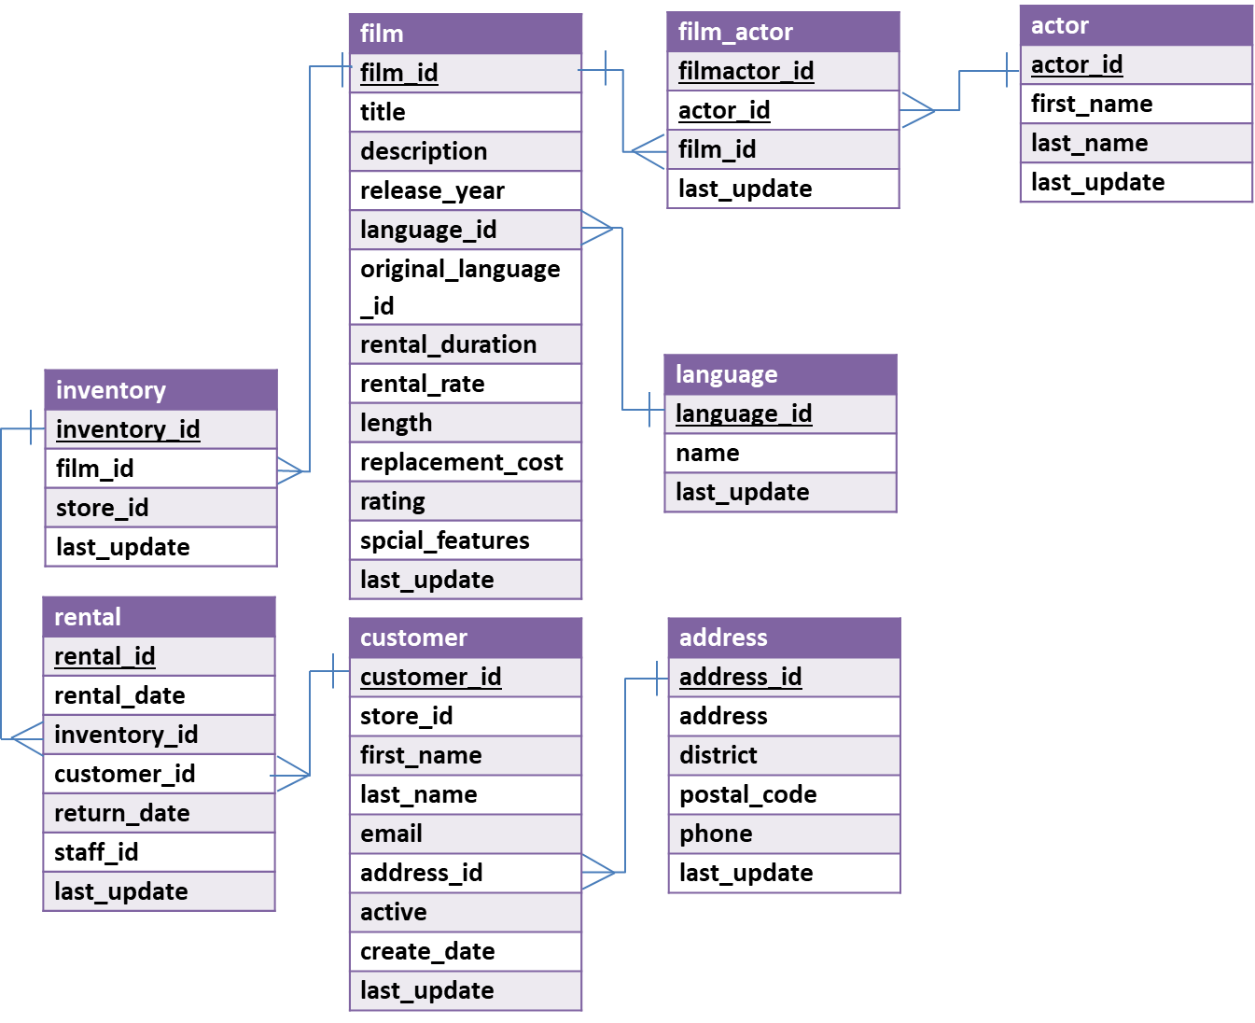

In MySQL Workbench, open the connection to the dataanalytics.temple.edu server using your username and password. Click on the “moviedb” schema and then the tables tab to see the list of tables. Recall the connection configuration as follows:

Connection Name: mis2502  
Hostname: dataanalytics.temple.edu  
Username: Your username is available on Canvas under Grades>MySQL ID/PW

**Questions**

1. How many times has each inventory item been rented? Return the number for the first five inventory items.  
   *Display: inventory id and number of rentals*
2. What is the street address of Patricia Johnson?

*Display: address*

1. Who has starred in movies in the French language? Return only the first five distinct results in alphabetical order by last name.  
   (Hints: (1) Create the query to only return the first five, in alphabetical order by last name; (2) Be sure to reference the language name “French” in your query. In the language table, there is a field “name” that contains the film language names.)

*Display: first name and last name*

1. Who has rented the fewest movies? How many movies did they rent?  
   (Hint: Get a list of all customers and the number of movies they rented, arranged in ascending order and returning only the first row. Assume no ties - there’s only one customer with the lowest value.)

*Display: first name, last name and number of movies*

1. Which are the languages of the movies that Mabel Holland has rented and how many has she rented in each of those languages?

*Display: language and number of languages*

1. What is (are) the shortest R-rated movie(s) in English? And how long is it (are they)?  
   (Hint #1. R-rated movies have rating value equal to ‘R’;

Hint #2: There may be more than one movie returned. Use a **subselect** statement with the MIN() function to return only the shortest movie(s). )

*Display: movie title and movie length*

1. What was the shortest movie starring Daryl Crawford, how long is it, and what was its rating?  
   (Hint: There may be more than one movie returned; Use a **subselect** statement with the MAX() function to return only the shortest movie with Daryl Crawford)

*Display: movie title, length and rating*