In-Class Activity #7: NoSQL Part 1

Submission Instructions
Submit your solutions as a Word or PDF file through the form.
Instructions:
Use MongoDB Compass and open the AirbnbDB. Use the list collection to answer the questions below. Include the query used and the results of the query. (MongoDB Compass is case sensitive).
Here is an example of what a document in this collection looks like (JSON Pretty Print):
Airbnbdb.airbnb

{
"_id": "25167125",
"listing_url": "https://www.airbnb.com/rooms/25167125",
"room_type": "Private room",
"minimum_nights": "1",
"maximum_nights": "1125",
"bedrooms": 1,
"beds": 1,
"number_of_reviews": 11,
"bathrooms": {
"$numberDecimal": "1.0"
},
"amenities": [
"Wifi",
"Air conditioning",
"Kitchen",
"Free parking on premises",
"Pets allowed",
"Breakfast",
"Free street parking",
"Heating",
"Smoke detector",
"First aid kit",
"Essentials",
"Shampoo",
"Hangers",
"Laptop friendly workspace",
"Private entrance",
"Bed linens",
"Extra pillows and blankets",
"Luggage dropoff allowed",
"Cleaning before checkout",
"Disabled parking spot",
"Accessible-height bed",
"Host greets you"
],
"host": {
"host_id": "11490944" }
}
Here is how to view the MongoDB code for an aggregation pipeline:
- Connect to the server on MongoDB Compass.
- Open the database and collection and click on the aggregations tab.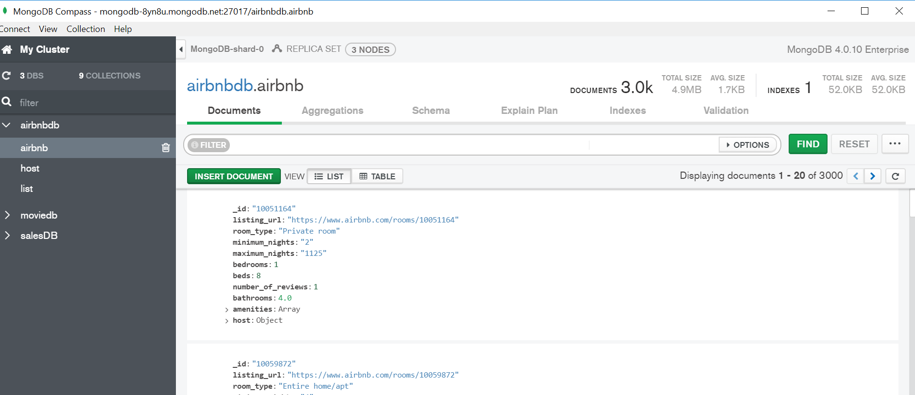

- After creating your pipeline by adding stages, click “Export Pipeline to Language”.
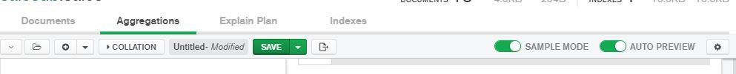

- The text shown in the left box is the MongoDB code for the last pipeline you created.
