Assignment #1: ER Modeling – Key
Answer Sheet
- ERD for Scenario 1: Safety Incident Database for Schuffyland Park
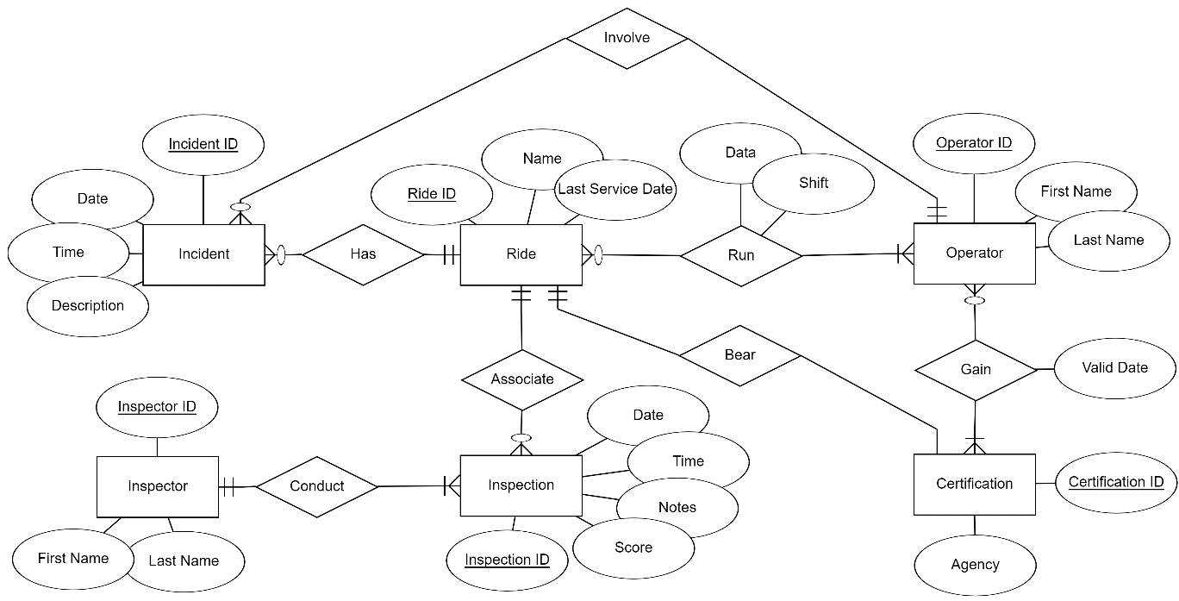

- Scenario 2: Tracking Trips for the SchUber Taxi Service
