Assignment #2: SQL Part 1 - Getting Data out of the Database

Submission Instructions
Due: Tuesday, 2/14/2019 at 9:30 am
- Complete and submit the answer sheet on page 4-5 as a word or PDF document through Canvas>Assignments> Assignments.
- You can copy and paste the (i) SQL query and (ii) the results from SQL Workbench.
- If you do not follow the instructions, your assignment will be counted late.
  - Late Assignment policy: All assignments will be assessed a 50% penalty (subtracted from that assignment’s score) for the first day (i.e. 24 hours) they are late. For this assignment, no credit will be given for assignments turned in after class on 2/14. We will go over the solutions in class.

Evaluation
Your submission will be graded using two factors:
- A correctly formed SQL query that answers the specific question asked (no extra rows or columns).
- Providing the correct answer to the question (the results returned from MySQL Workbench).

For this assignment, you will be working with the same movie rental database as the ICA #5. The schema is also the same, so you can use the one provided for ICA #5 as a guide.
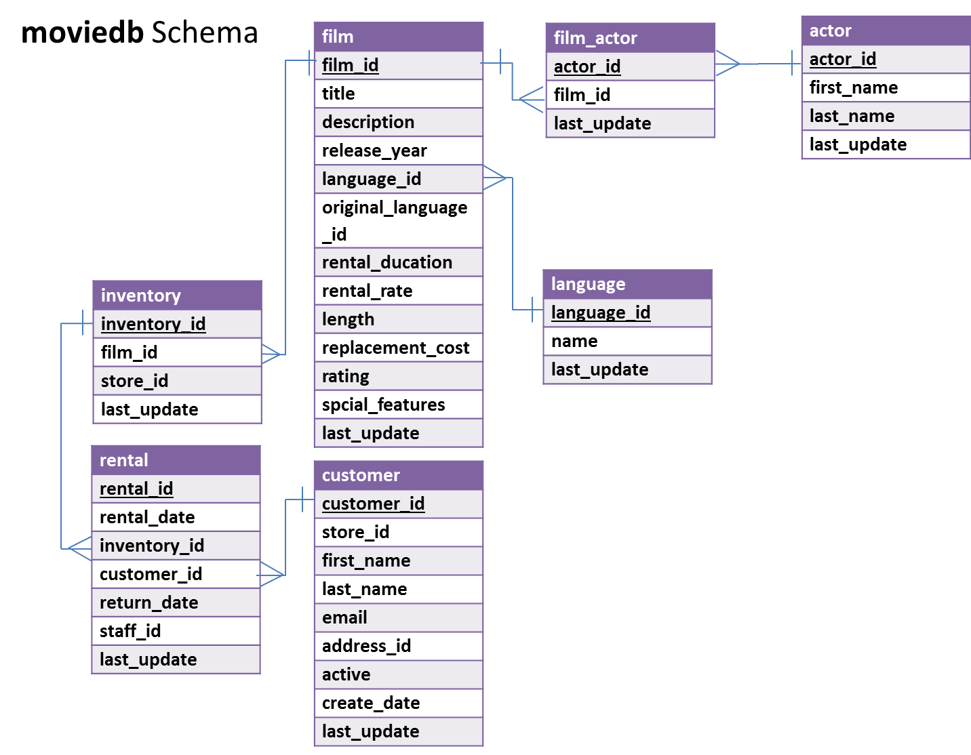
In MySQL Workbench, open the connection to the dataanalytics.temple.edu server using your username and password. Click on the “moviedb” schema and then the tables tab to see the list of tables. Recall the connection configuration as follows:
Connection Name: mis2502
Hostname: dataanalytics.temple.edu
Username: Your username is available in Gradebook on our course website
Questions
- What are the title and length for films rated PG and longer than 180 minutes?
(Hint: R-rated movies have rating value equal to ‘R’)
Display: movie title and length

- What is the average rental rate for each movie rating (i.e., G, PG, PG-13, R, NC-17)?
Display: rating and average rental rate
- How many PG-rated movies mention ‘documentary’ in their description?
(Hints: (1) PG-rated movies have rating value equal to ‘PG’; (2) Use WHERE…LIKE…. Remember, LIKE '%dog%' will match any value containing “dog,” LIKE '%dog' will any value ending in “dog,” and LIKE 'dog%' will match any value beginning in “dog.”)
Display: number of movies

- Who were the stars of the movie “Operation Operation”?
Display: first name and last name

- What are the three most popular last names among the actors in the database (Assume no ties)?
Display: last name and how many times that name appears in the database

- For different film ratings (i.e., G, PG, R, NC-17), which film rating has the lowest average rental rate?
(Hint: Get a list of film ratings and the average rental rate of each film rating, arranged in ascending order based on the average rental rate, and returning only the first row. Assume no ties - there’s only one film rating with the highest value.)
Display: rating and its average rental rate
- Who has starred in movies in the French language? Return only the first five distinct results in alphabetical order by last name.
(Hints: (1) Create the query to only return the first five, in alphabetical order by last name; (2) Be sure to reference the language name “French” in your query. In the language table, there is a field “name” that contains the film language names.)
Display: first name and last name
- Who has rented the fewest movies? How many movies did they rent?
(Hint: Get a list of all customers and the number of movies they rented, arranged in ascending order and returning only the first row. Assume no ties - there’s only one customer with the lowest value.)
Display: first name, last name and number of movies

- What is (are) the shortest G-rated movie(s) in English? And how long is it (are they)?
(Hints: (1) G-rated movies have rating value equal to ‘G’; (2) There may be more than one movie returned. Use a subselect statement with the MIN() function to return only the shortest movie(s). )
Display: movie title and movie length

- What movies starring Humphrey Willis have the highest rental rate? Return both the movie titles and the rental rate.
(Hint: There may be more than one movie returned; Use a subselect statement with the MAX() function to return only the movie with the highest rental rate by Humphrey Willis.)
Display: movie title and rental rate

ANSWER SHEET
Assignment #2: SQL Part 1 - Getting Data out of the Database
Question |  | SQL Query | Results/Answer from MySQL Workbench
1 | What are the title and length for films rated PG and longer than 180 minutes?
2 | What is the average rental rate for each movie rating?
3 | How many PG movies mention ‘documentary’ in their description?
4 | Who were the stars of the movie “Operation Operation”?
5 | What are the three most popular last names among the actors in the database?
6 | For different film ratings (i.e., G, PG, R, NC-17), which film rating has the lowest average rental rate?
7 | Who has starred in movies in the French language? Return only the first five distinct results in alphabetical order by last name.
8 | Who has rented the fewest movies? How many movies did they rent?
9 | What is (are) the shortest G-rated movie(s) in English? And how long is it (are they)?
10 | What movies starring Humphrey Willis have the highest rental rate? Return both the movie titles and the rental rate.

