In-Class Activity 16: Data Visualization using Tableau

What to submit: a .twb file saved in the end (step 4 in Part 8).

This exercise involves utilizing Tableau. It is a continuation of the Tableau Prep exercise. Tableau itself is a data visualization tool that allows you to create charts, graphs, and maps easily. While Tableau Prep cleans and transforms the data, Tableau visualizes the data.

Part 1: Download File and Launch Tableau

- Download and save the file EditedNYCParkingData.csv from the Community Site.

- Open EditedNYCParkingData.csv in Excel and verify the data is there. This data set gives you a sample of 24,328 parking tickets in New York City.

- Tableau Desktop can read different file types. Since the file is in .csv format, we can leave it as that and connect to Tableau.

- Start Tableau Desktop on your computer.

- Under the Connect Area, select Text File.

- Select the file (EditedNYCParkingData.csv) from where you stored it on your computer.

- When you open the file, you will now see a list of datasets on the left side. Since there is only one sheet of data, it also places that data source on the canvas (on the right side).
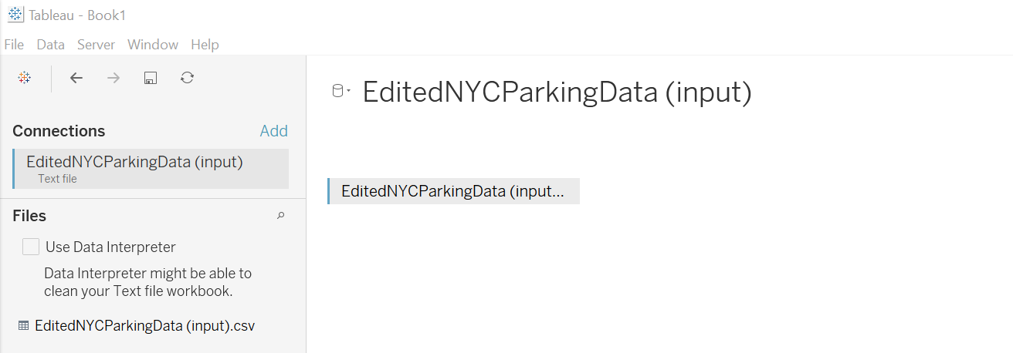

- Click on Sheet 1 (Go to Worksheet) at the bottom left of the window to start working with the data.
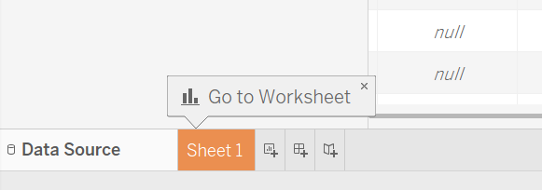
- In the worksheet, you will see a list of fields to the left listed under measures or dimensions. This area is called the Data pane. Dimensions are fields that have text values and measures are fields with numeric values. The field names are based on the column names from the data source.
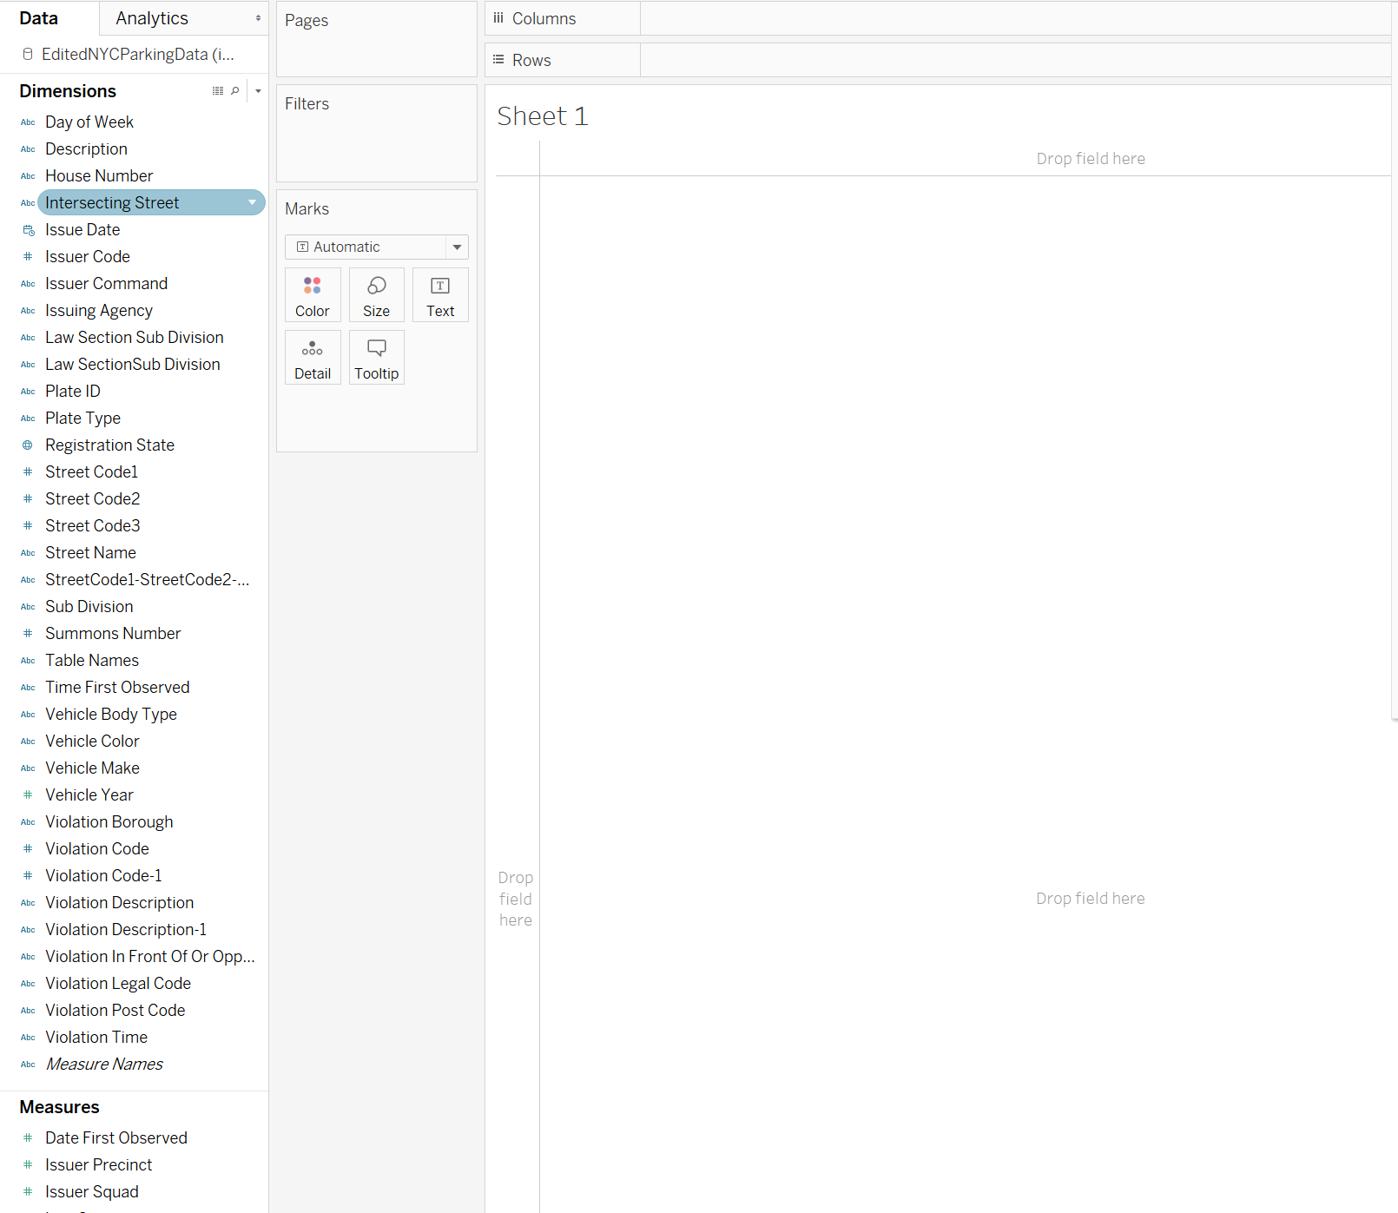

Part 2: Working with Data

- Drag the Vehicle Color under Dimensions to the Rows shelf and you will now see a text table of just vehicle color:
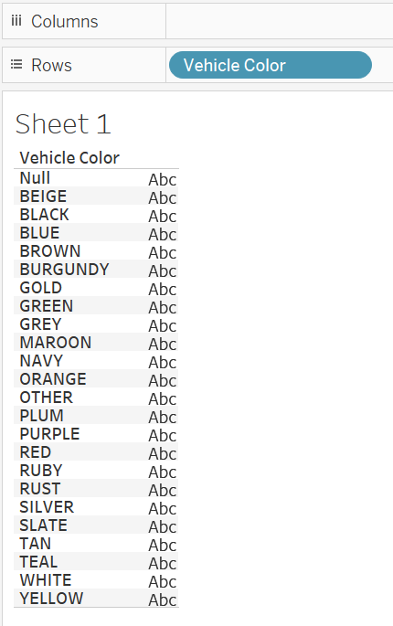

- Drag the Number of Records from the Measures section to the column shelf and you should now see a horizontal bar chart. Number of Records is not a field within the data set; it is a value generated by Tableau that counts the number of rows in the data set.
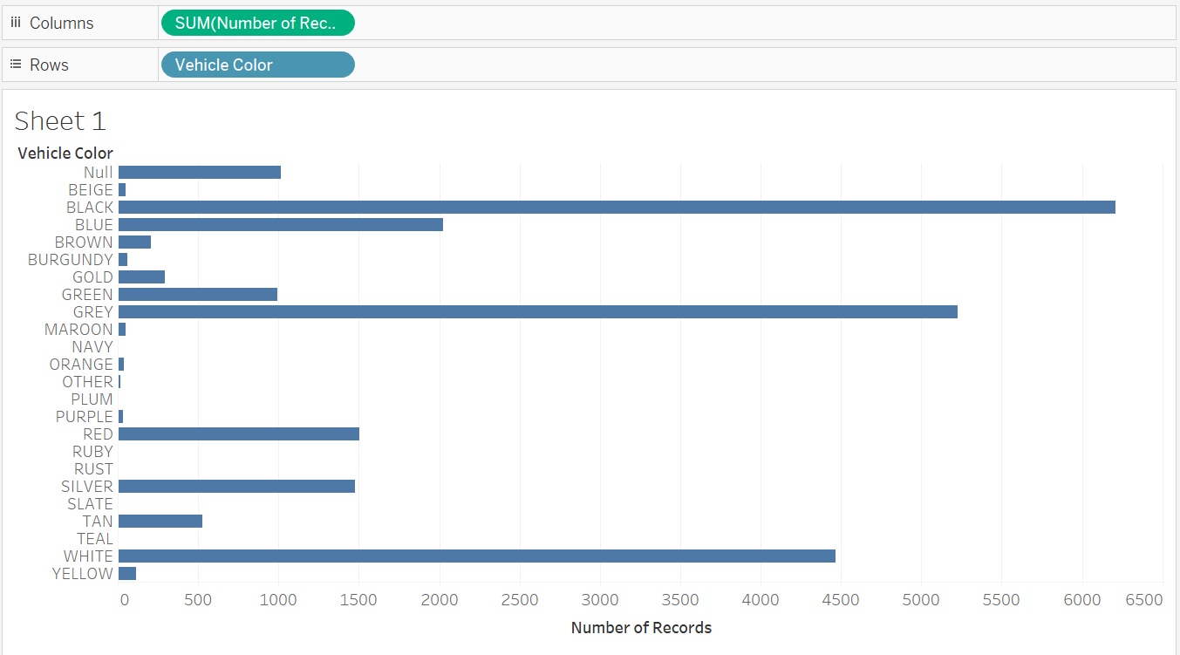
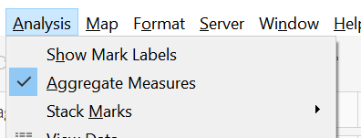
- When using a measure, Tableau automatically assumes you want to aggregate the measure. If you go to the Analysis menu you can verify that the Aggregate Measures option is checked.
Aggregating your data is helpful for many reasons, such as seeing the sum of Sales orders or seeing the total sum of parking tickets. Disaggregating your data lets you see your data at a more detailed level. You would want to uncheck this option if you wanted to display a different mark for each data in each row of the data source.

- In order to sort the data in descending order you can right-click on “Vehicle Color” in the Rows shelf and select “Sort…”
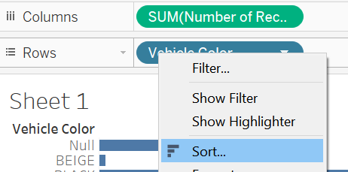

- In the popup menu, select “Field” for Sort by, “Descending” for Sort Order, “Number of Records” for Field Name, and “Sum” for “Aggregation.
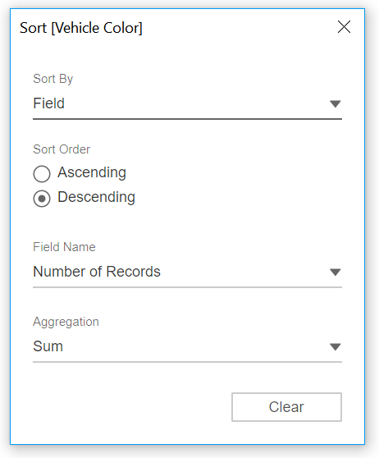

- You will now see a horizontal bar chart in order of vehicle color based on number of tickers for each vehicle color. Close the Sort dialog.
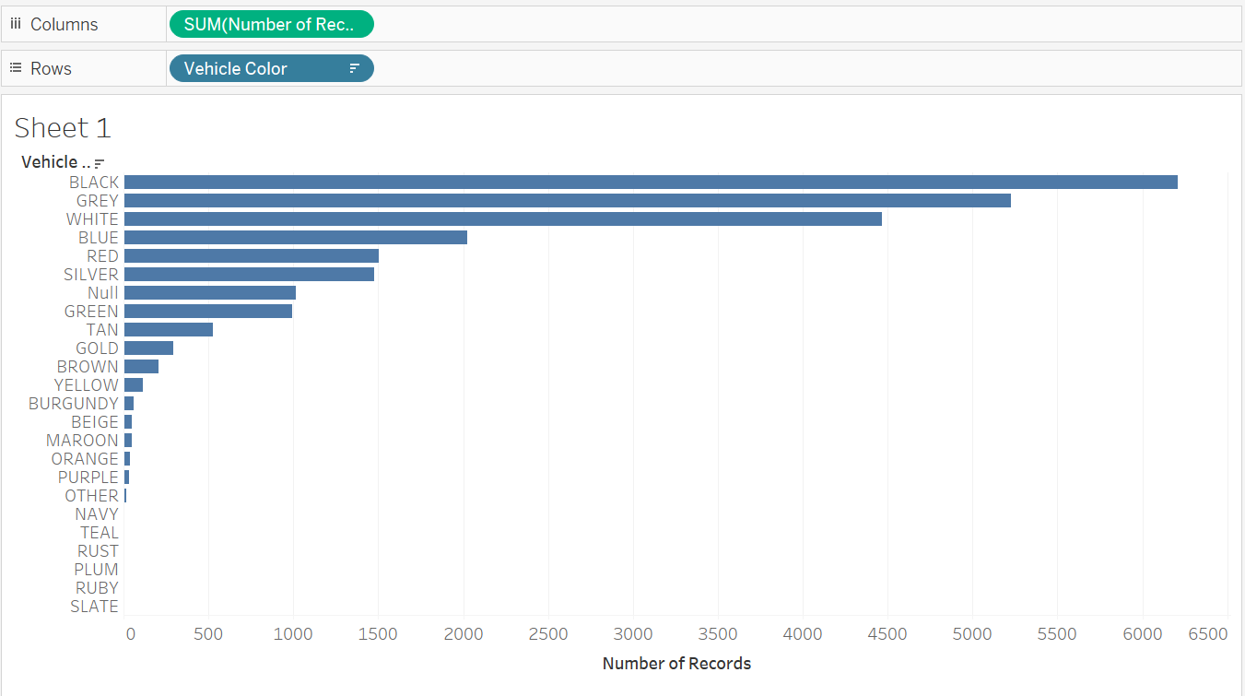
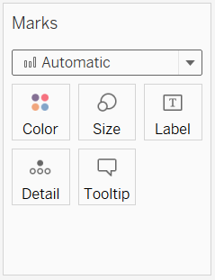
- Next, take a look at the Marks pane. This lets you control how the data is displayed. When you move dimensions or measures into the column or row shelves, Tableau automatically displays the data based on how it thinks it will look best.

- You can change how the data looks by clicking on the drop-down menu within the Marks pane. Click on the drop-down menu and select “Line.” You will see the chart has changed from a bar chart to a line graph:
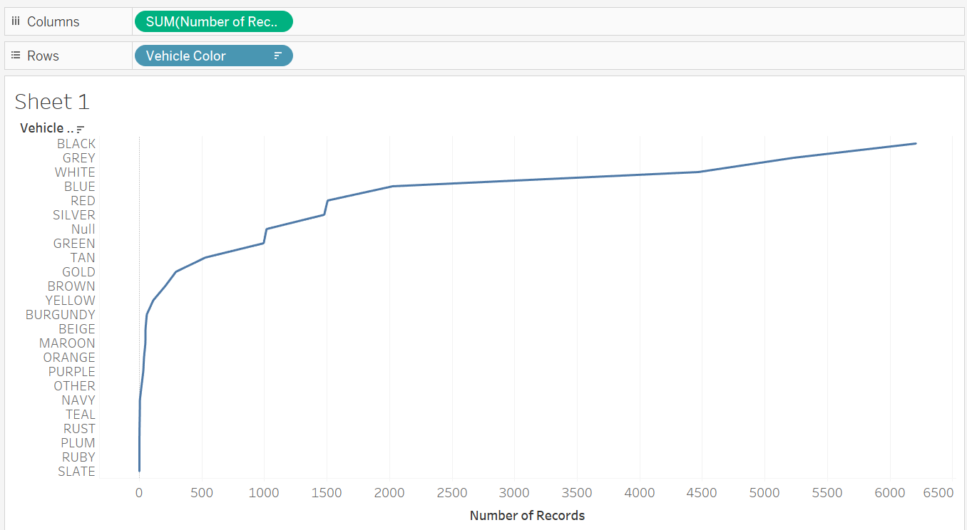

- Remove Vehicle Color and Number of Records from their shelves by right-clicking on each field and selecting Remove from the options. You should now have a blank canvas with no fields selected.

Part 3: Utilizing the Show Me feature

In order to quickly create a view based on the data fields you place in the rows and columns shelves, you can use the “Show Me” feature. Show Me will make recommendations for how the data should appear in the view.

- Navigate to Show me section in the top right corner.

- Show Me creates a view based on the fields that are in use in the view and any fields you selected in the Data pane. Within this menu, you will see a list of either grey or colorful charts that Tableau can create based on selected data. Show Me also gives you suggestions on how to use different dimensions or measures to be able to use a certain Show Me chart.
Since you have not selected any data, all charts will appear grey.

- Within the Data pane, select Vehicle Color from the Dimensions and Number of Records from Measures. To select multiple fields, press and hold the Control key (or the Command key for Mac users) as you single-click on each field.

- When you click on these fields, you will now see the highlighted charts that Show Me recommends.

- Click on the heat map (first row, middle column), and you will see the chart changes to a heat map and that Tableau has moved the Number of Records measure from the column shelf to the Marks section. When using the Show Me feature, Tableau will manipulate and move around how the fields are used.
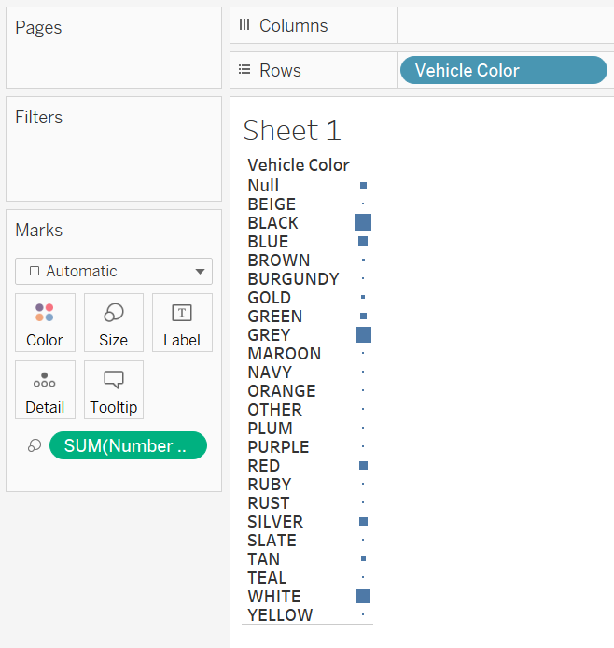

- This is not the best visualization for this data, so let’s choose another chart type. Click on the Treemap chart (first column, fourth row), and the chart is now organized from the largest group to the smallest, with darker shading indicating the groups with more records:
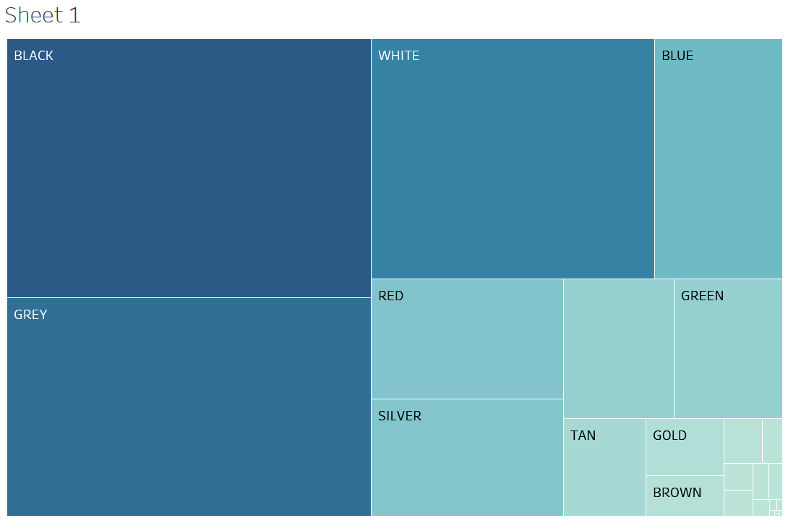
This chart makes it easy to see that black vehicles have received the most tickets, but it would be even more helpful to be able to see the number of tickets by each vehicle color.
Go to the Marks section, and you can see how Tableau organized fields in order to show this view.
- Applying a color mark for the sum of number of records gave the descending gradient color scheme.
- Applying a size mark for the sum of number of records made each color’s size in the treemap based on the amount of tickets associated.
- Applying a text mark for the vehicle color allows you to see the vehicle color associated with each value.

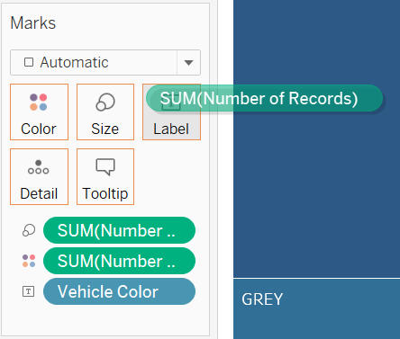
- Go to the measures section and drag “Number of Records” to the Label section of the Marks pane. Even though number of records within Tableau is already listed within the Marks section to determine size and color, you can add it again to the Marks section for a different purpose. You will now see an updated heat map with the Number of Records information shown as a label.
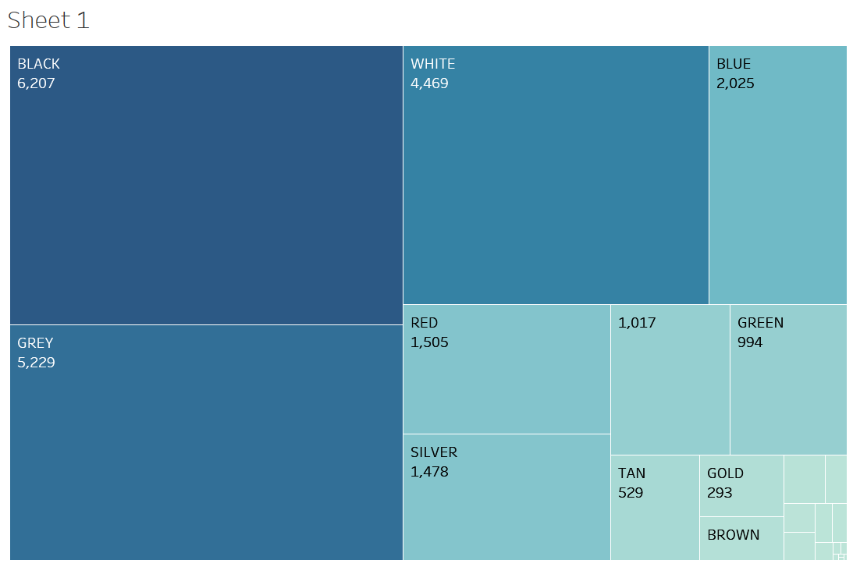
Observe that for one section is labeled 1,017 but has no vehicle color name. This value is actually null – Tableau will often show null values as blank.

- To display the null label, right-click on Vehicle Color within Marks pane and select Edit Aliases…
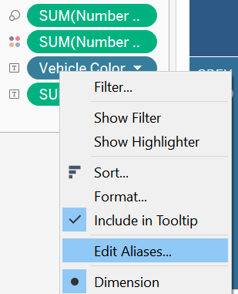

- Within the Edit Aliases… dialog, find Null under the Member column and change its corresponding value from Null to NULL. Press ok to apply changes and you will now see NULL listed as a color within the treemap.
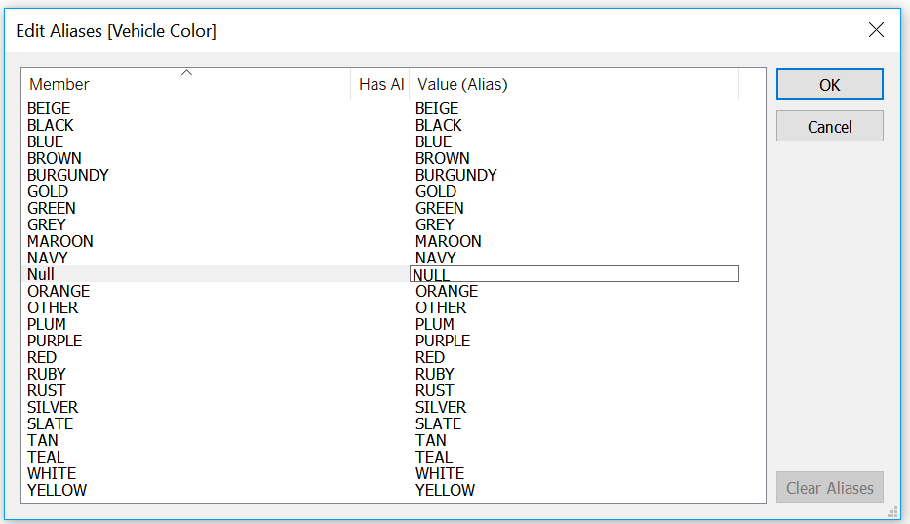
- While now you see the NULL label for that data point, it still doesn’t make a lot of sense to have it there. Let’s exclude that data from our visualization by clicking on the NULL block and selecting Exclude from the pop-up menu.
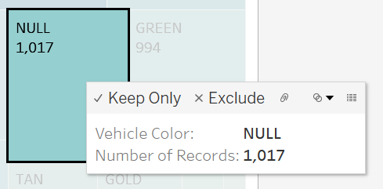

Part 4: Creating a Filter

You can also filter data right from the visualization. Let’s edit our Treemap to show only the top five vehicle colors based on number of tickets. To do that you can use a filter.

- To filter the records right-click on vehicle color within the Marks pane and select Edit Filter...
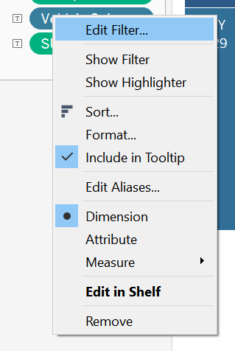

- Within the filter pop-up menu, select ‘Top’ from the menu options listed. Then select “By field” and change the parameter from 10 to 5.
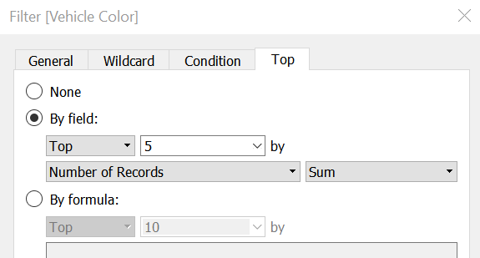
- The Treemap will now show only the vehicle colors with the five highest number of tickets.
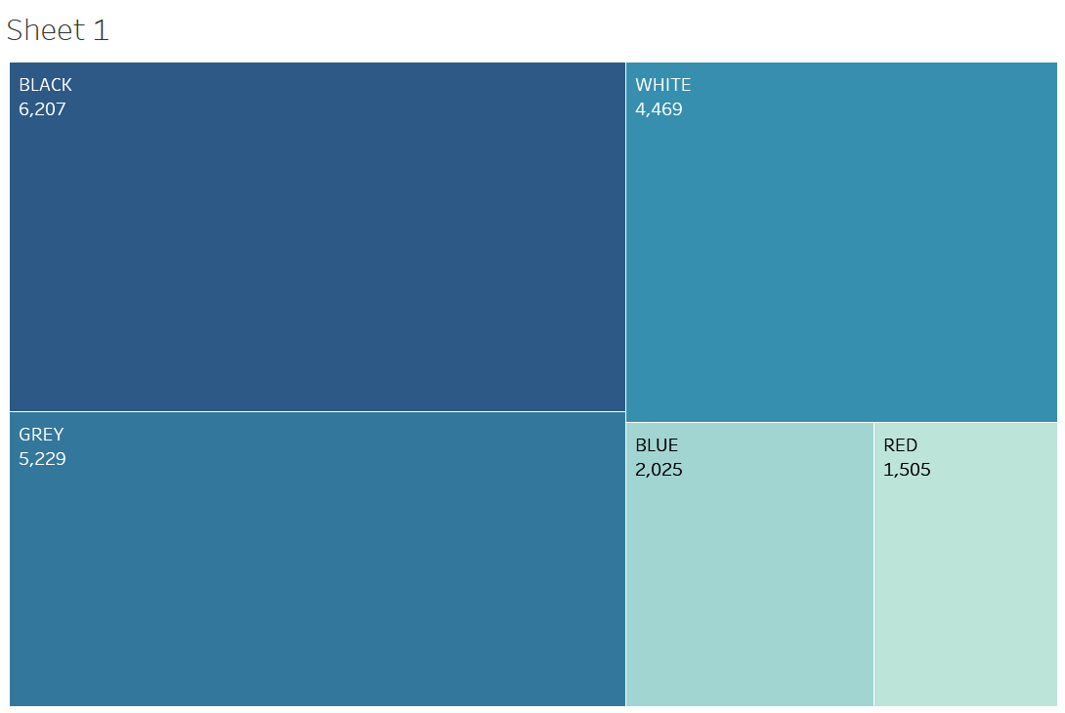

- Double click on “Sheet 1” at the bottom of the screen to rename the sheet to “Parking Tickets by Vehicle Color”.
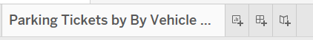

Part 5: Creating a Map chart

Within Tableau, you can create maps out of data that has location information. Tableau uses the data and data types provided to give longitude and latitude to plot a map.

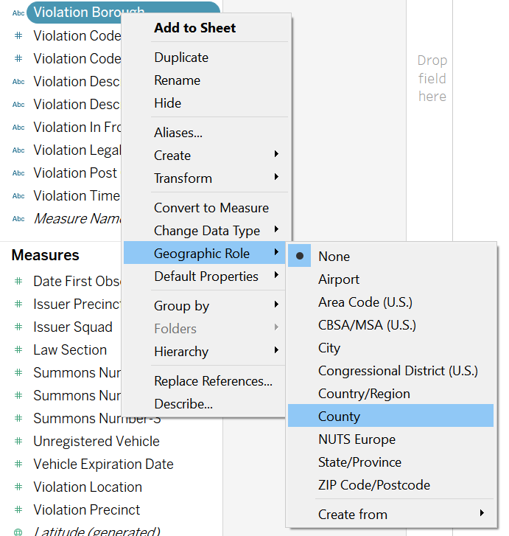
- Create a new worksheet by selecting New Worksheet from the Worksheet menu. Double-click on “Sheet 2” and rename it “Parking Tickets by Borough”.

- You will need to identify the data in your dataset with geographic information so that Tableau knows what it can use to make the map. Within the Dimensions section, right-click on Violation Borough. Within the pop-up menu, select Geographic Role/County.

- Drag the Longitude measure to the column shelf and the Latitude measure to the rows shelf.

Because you changed Violation Borough from being a string to being location information, Tableau can generate longitude and latitude coordinates to map data.

- Drag the Number of Records measure to the Color section of the Marks pane and the Violation Borough to the Detail section of the Marks pane. By applying the color mark to the Number of Rows field, Tableau generated a view that shows the borough with the highest amount of tickets as the darkest color. Using the Violation Borough for the detail mark lets Tableau graph the defined geographic borders around each borough.
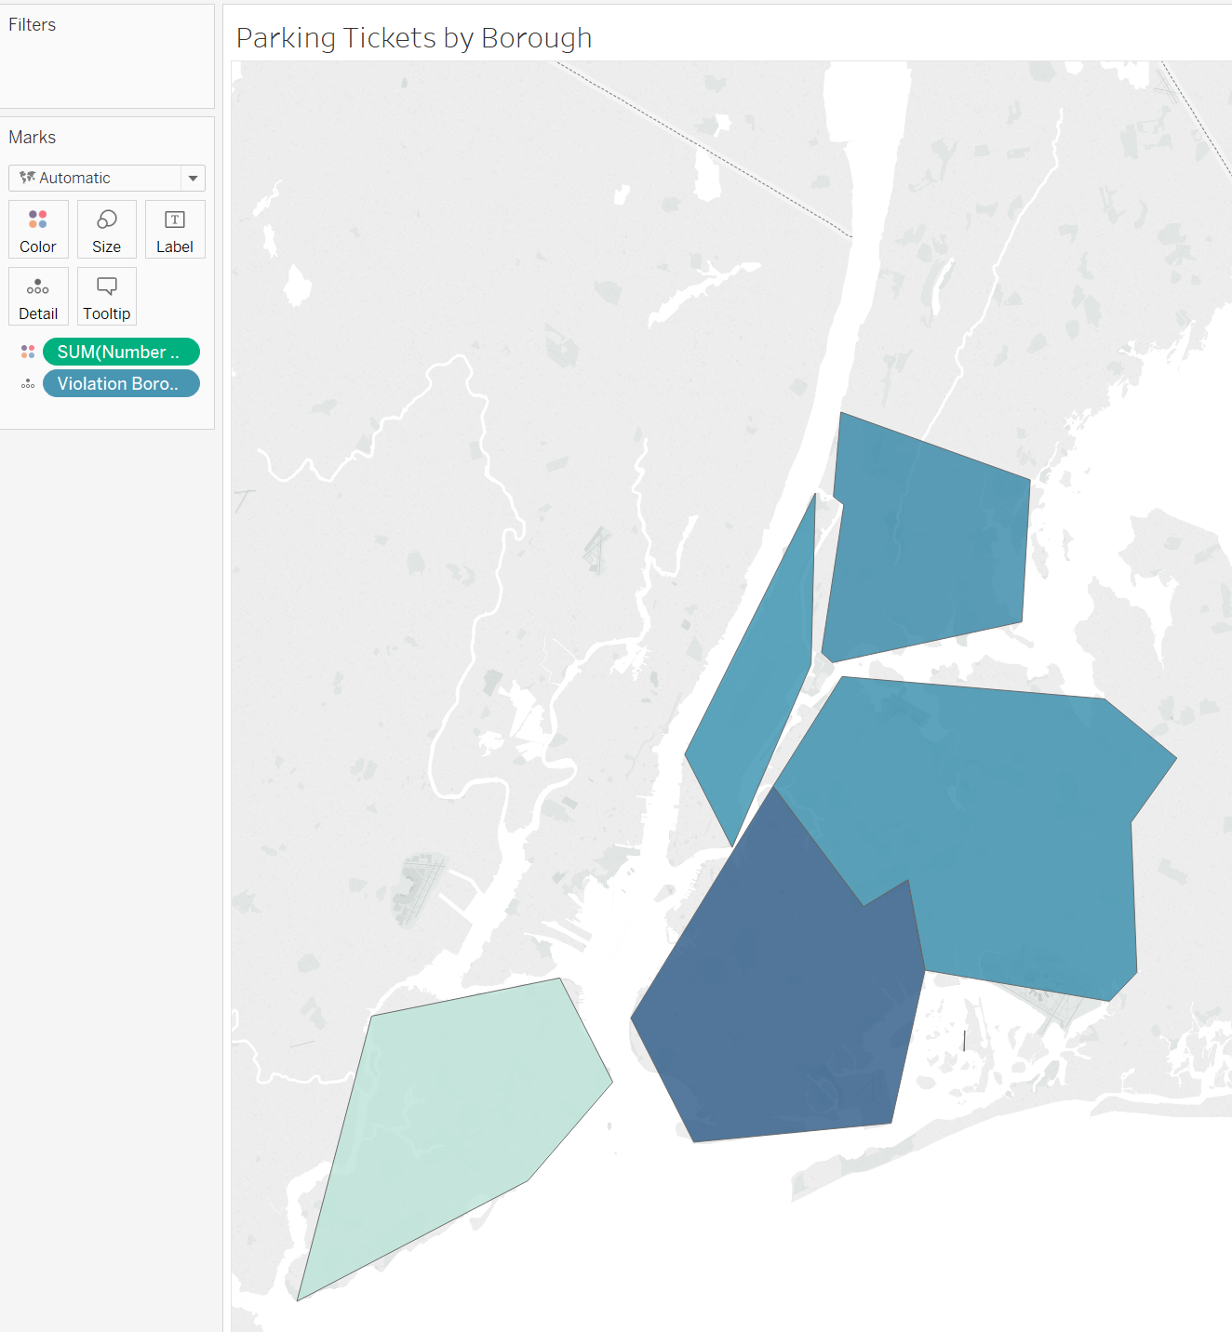

- Change the color of the map to red by clicking on the Color section of the Marks pane, selecting Edit Colors, and then selecting red from the drop-down menu. Then click OK.

- Add the Violation Borough Name to the chart by dragging the Violation Borough from the Dimensions list to the Label section of the Marks pane.

- Add the Number of Records to the map by dragging the Number of Records measure to the Label section of the Marks pane.

- To make the labels clearer, click on the Label section of the Marks pane, change the font size to 12pt, and select bold. You will now see this map:
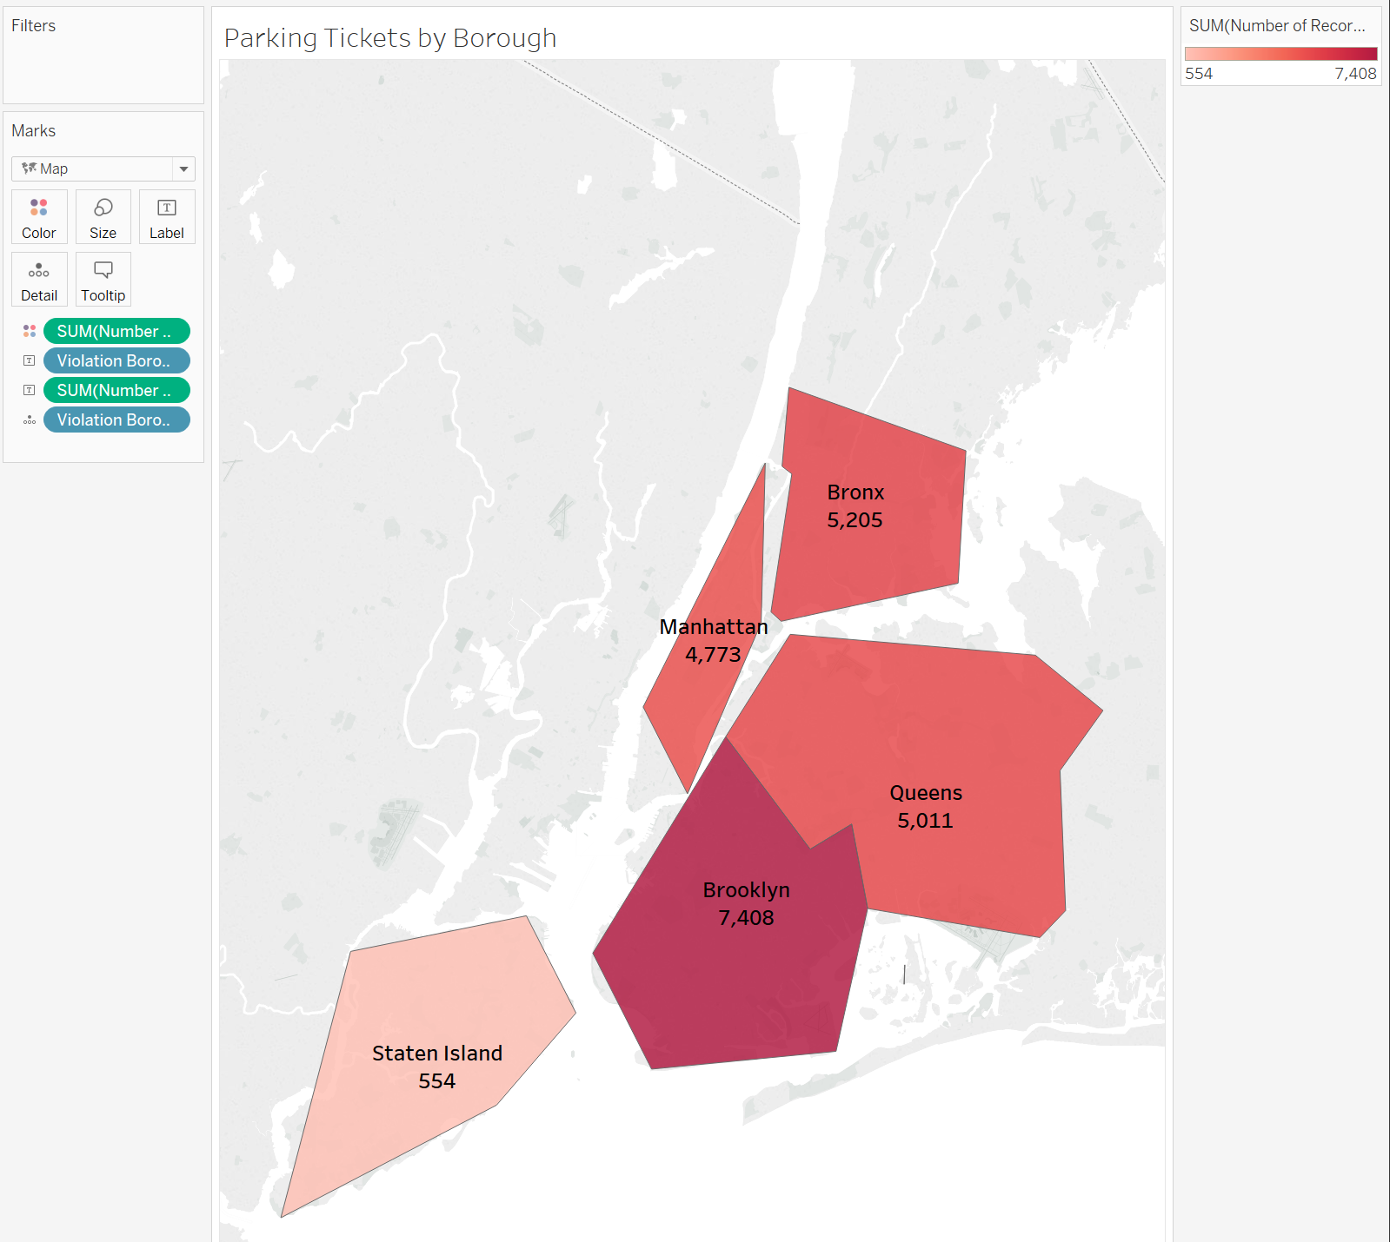

Part 6: Try it on Your Own

- Create a new sheet and name it Parking Tickets by Violation Description.

- Create a bar chart that shows:

- Violation Description sorted in descending order based on Number of Records.
- Use the Marks pane so that the description with the highest number of tickets has the darkest color and the description with the lowest number has the lightest color.
- Use the Marks pane to make the bars green.
- Limit the visualization to only show the top 15 violations.
When you are done, it should look like this:
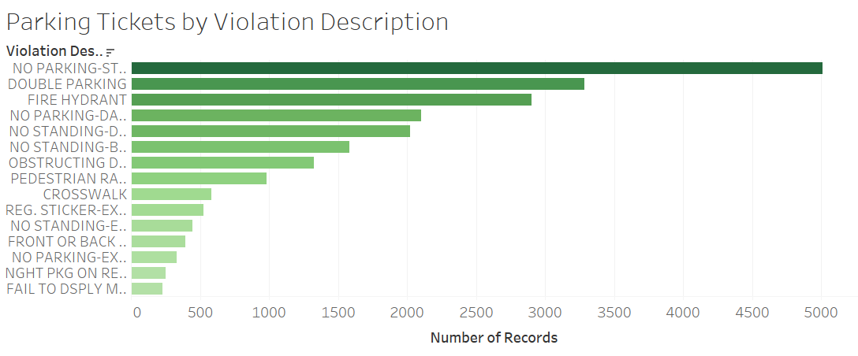
Part 7: Create an Interactive Dashboard

You can put the three visualizations you’ve created onto a single dashboard, and then apply an interactive filter to change the view of the data.

- Create a new dashboard by selecting New Dashboard from the Dashboard menu. Double-click on “Dashboard 1” and rename it “NYC Ticket Dashboard”.
- On the left side of the screen, change Size to Automatic.
- Under Sheets, drag Parking Tickets by Vehicle Color to the dashboard.
- Under Sheets, drag Parking Tickets by Borough to the bottom half of the dashboard, placing it under the Treemap.
- Under Sheets, drag Parking Tickets by Violation to the upper right side of the screen, placing it above the map of New York but to the right of the Treemap. Your Dashboard should look like this:
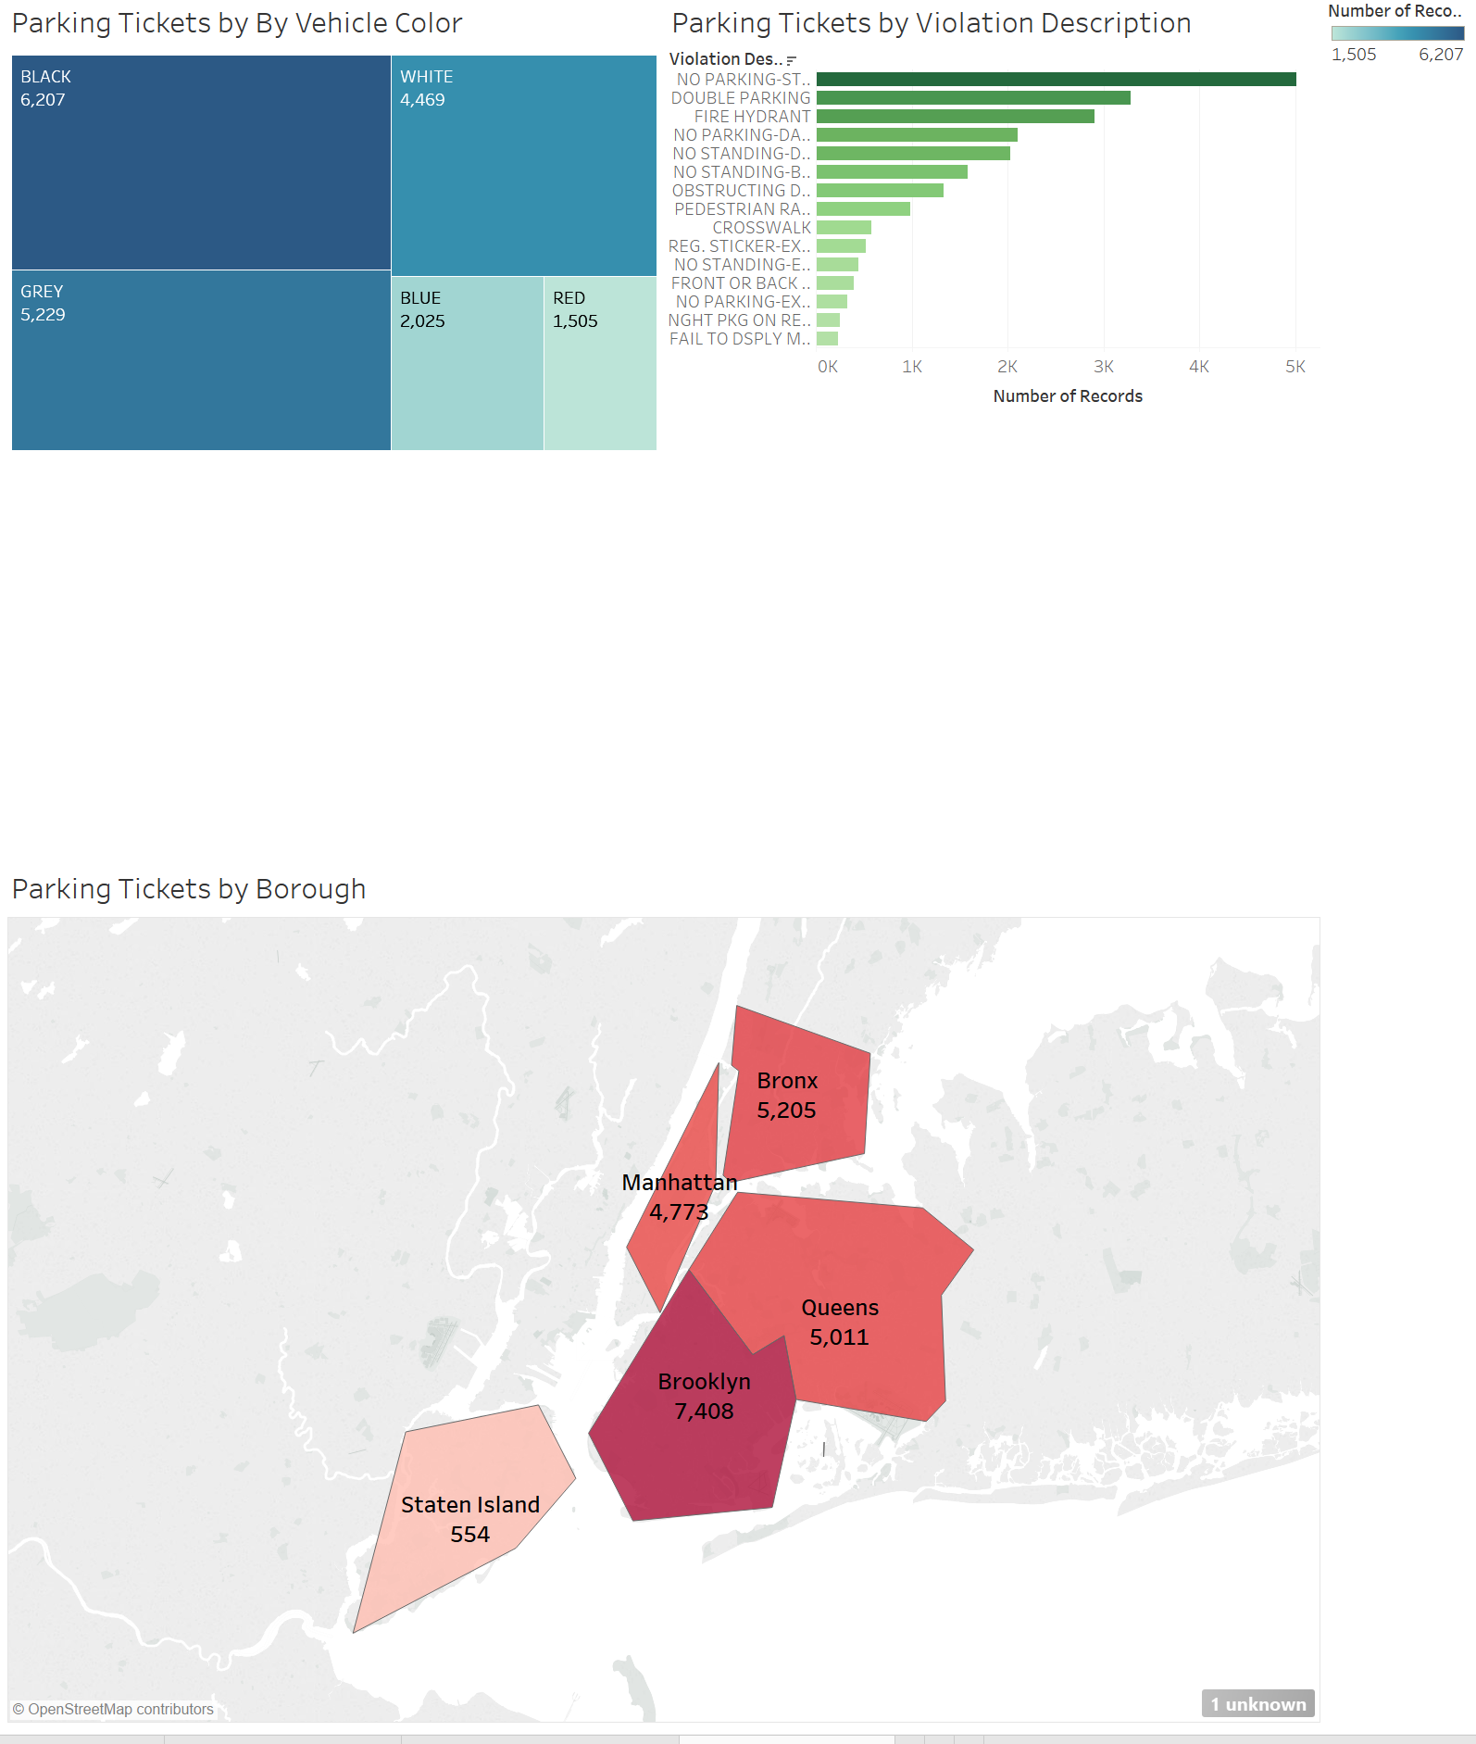
- Now we’ll apply a filter that will control the data we see on these three visualizations. Click once on the “Parking Tickets by Borough” area of the dashboard. Right click up at the top of the map where the “handle” is and select Filters/Violation Borough.
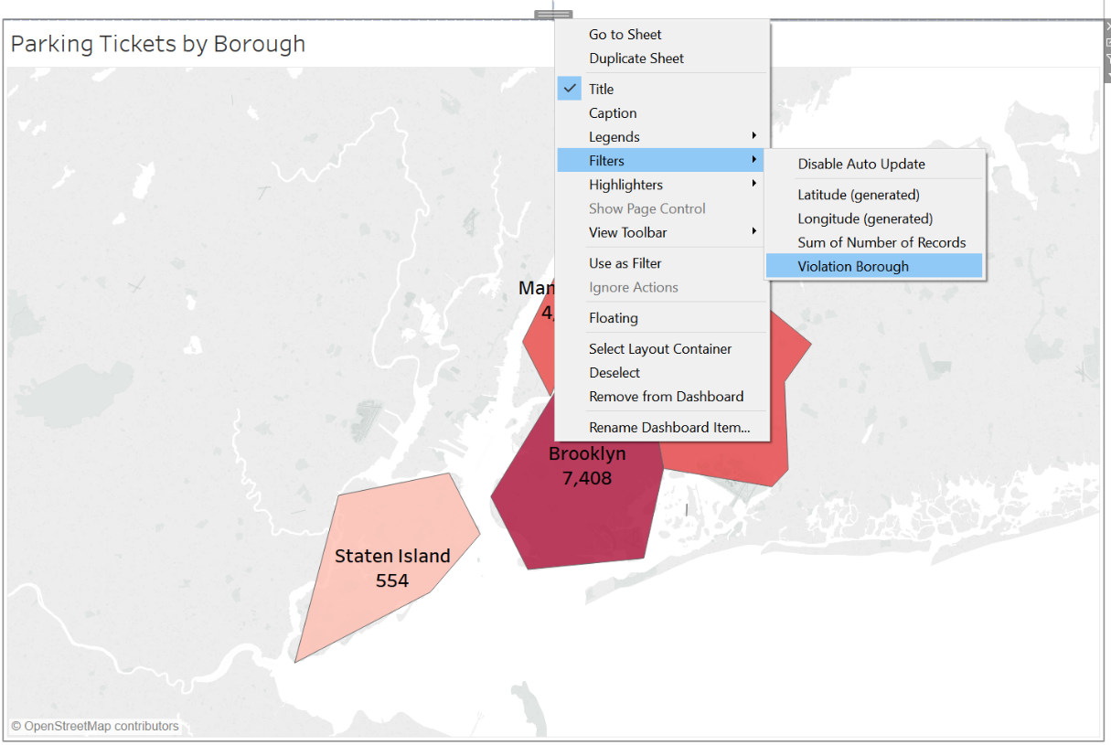
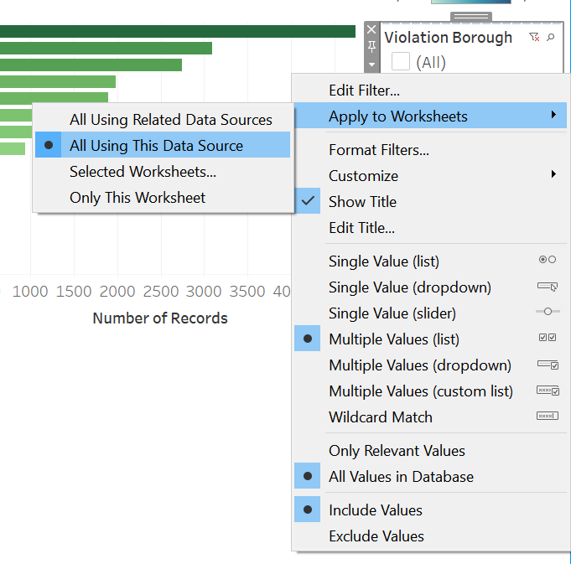
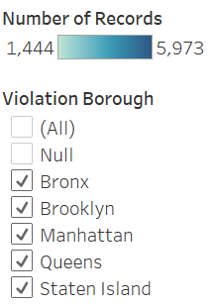
- You’ll now see a filter for Violation Borough on the right side of the screen.
Now right click inside the filter and select Apply to Workheets/All Using This Data Source
- To try out the interactive filter, unselect Manhattan and see how the three visualizations change:
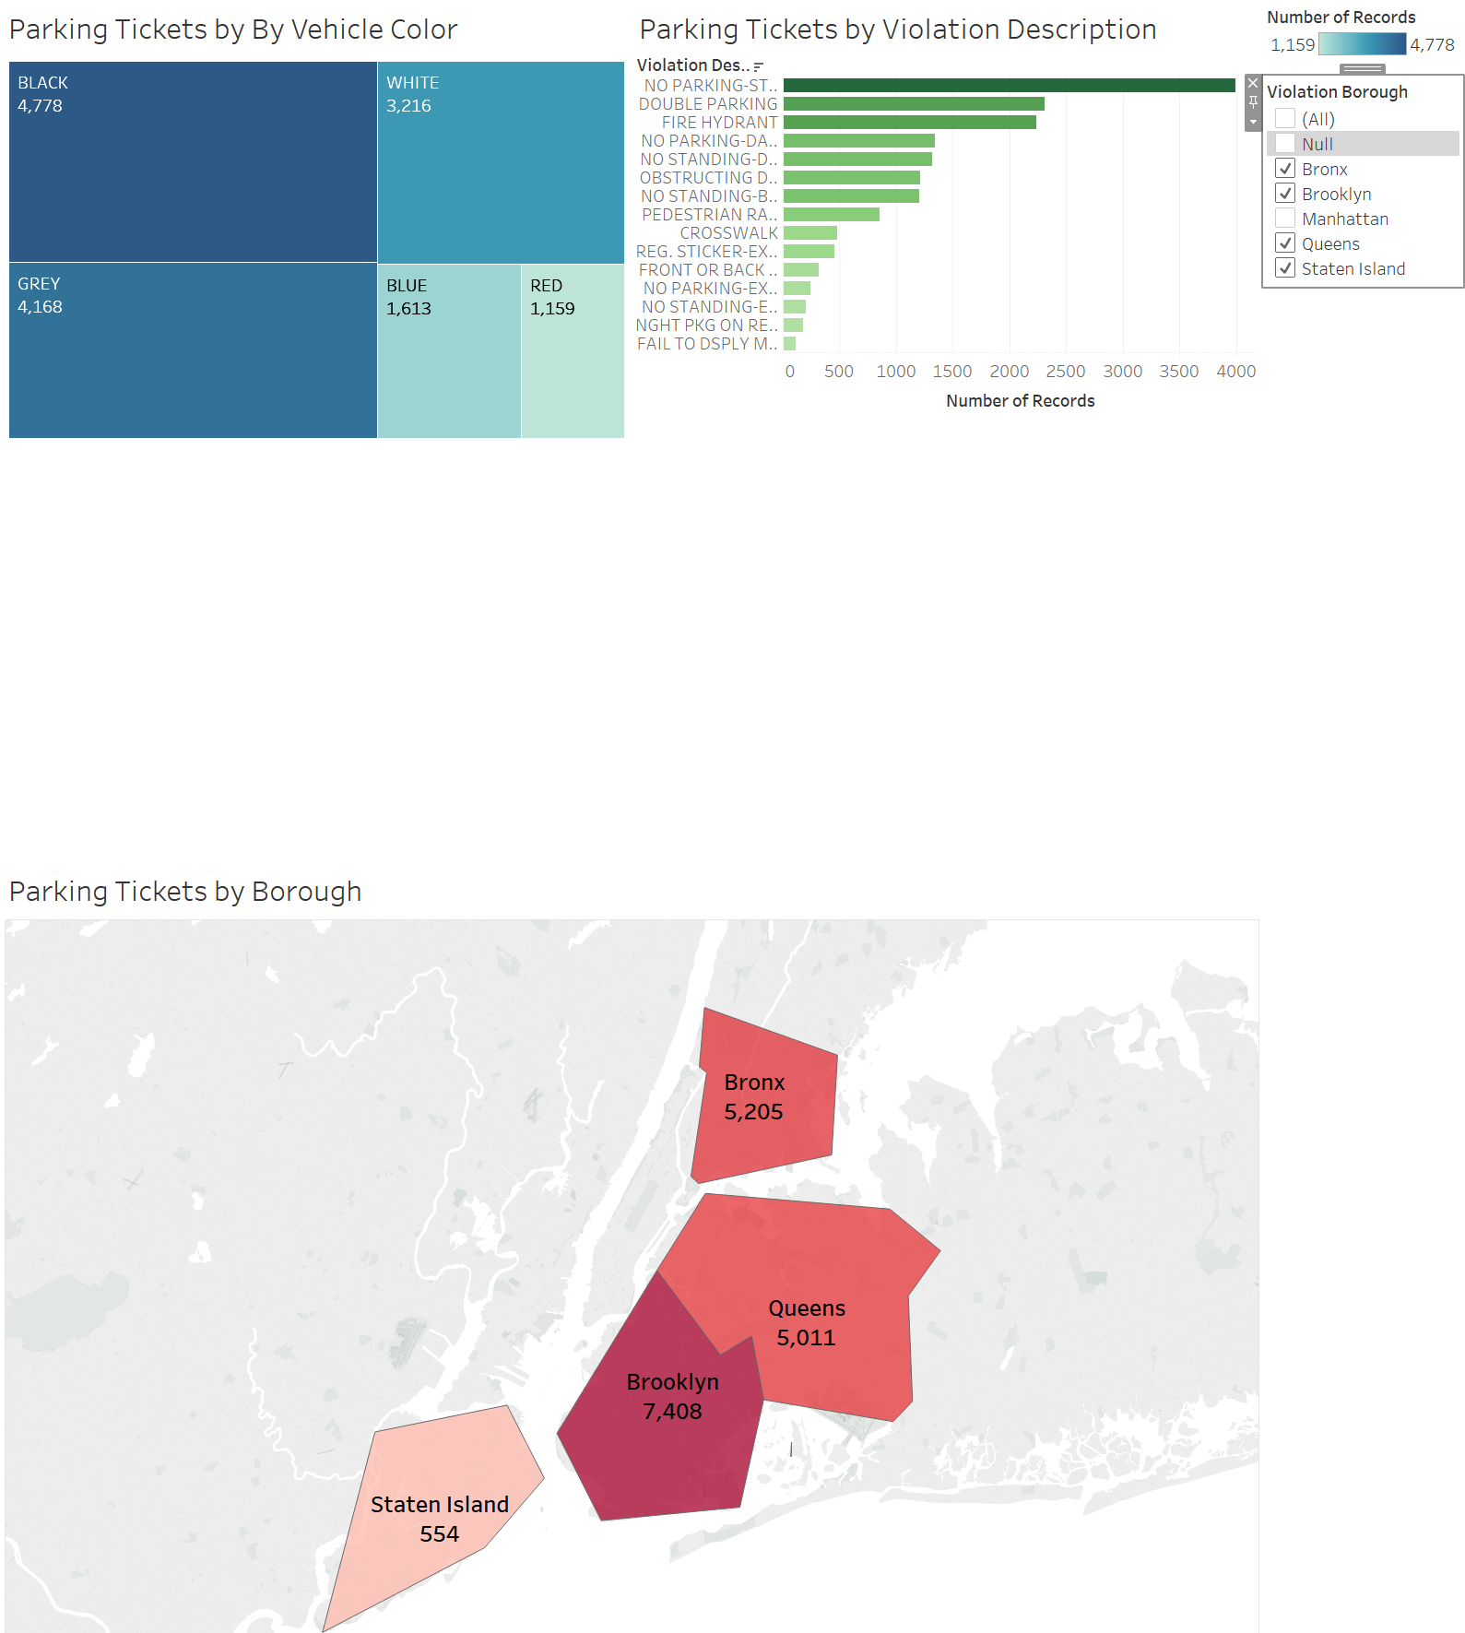

Part 8: Try it on Your Own again!

Create a new visualization that analyzes the number of tickets a particular make gets on each day of the week.

- Create a new sheet and name it “Car Make by Day of Week”.

- Create a bar chart that shows:

- Vehicle Make and Day of Week in a bar chart (Hint: Drag both of those fields to rows and drag Number of Records to columns.).
- Use the Marks pane so that the bar for each day of the week gets its own color.
- Limit the visualization to only show the five most frequently ticketed makes.
When you are done, it should look like this:
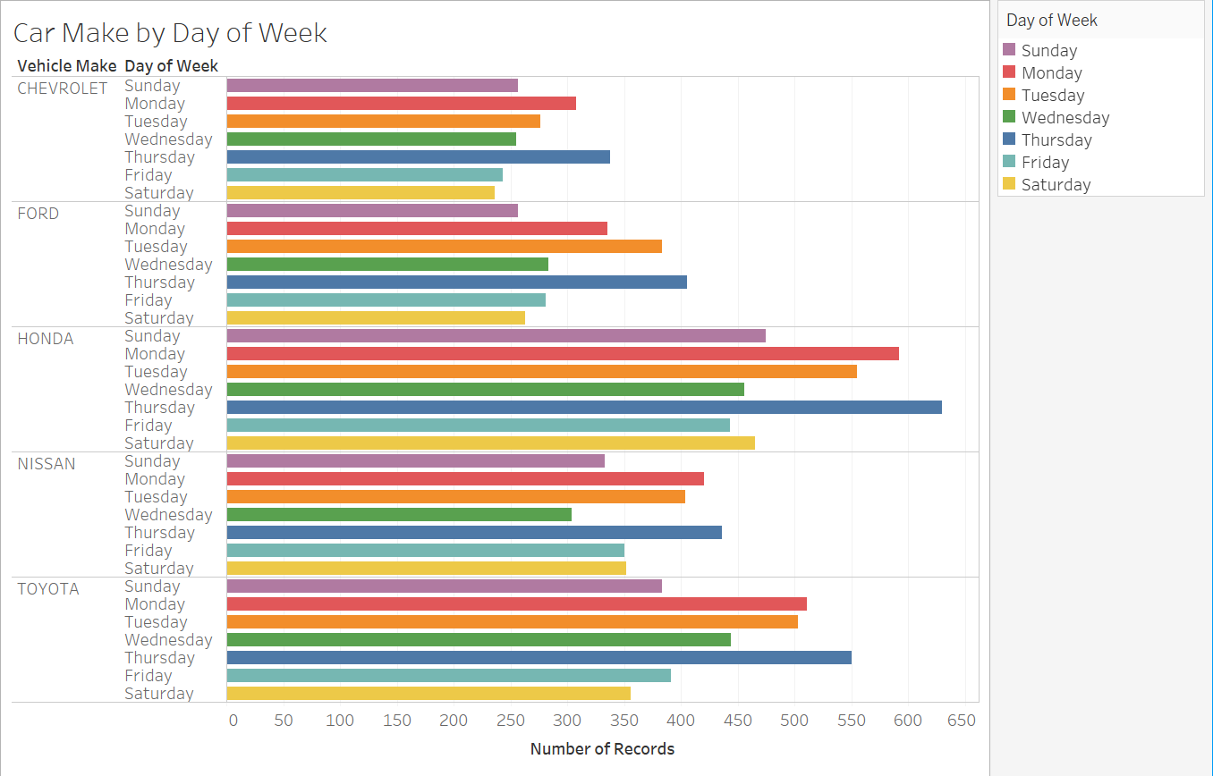
- Place the bar chart at the bottom right of the dashboard. Make sure the Violation Borough filter also works with your new visualization (Hint: Reapply the filter to all worksheets.).

- Save the .twb file and submit. After all the operations above, please click File->Save as and name your .twb file as “NYC Ticket Dashboard” and then submit the file.

