Super Quick Guide to MySQL Workbench
Setting up a connection in SQL Workbench (in the lab or your own laptop):
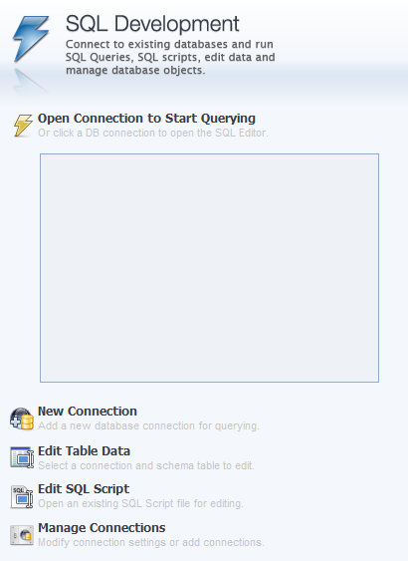
- Start SQL Workbench.

- Under SQL Development, select “New Connection” if one isn’t there already.

- You’ll see a “Setup New Connection” dialog. Fill in the following information:
Connection Name: class1
Hostname: class1.mis.temple.edu
Username: Your username given to you by your instructor
s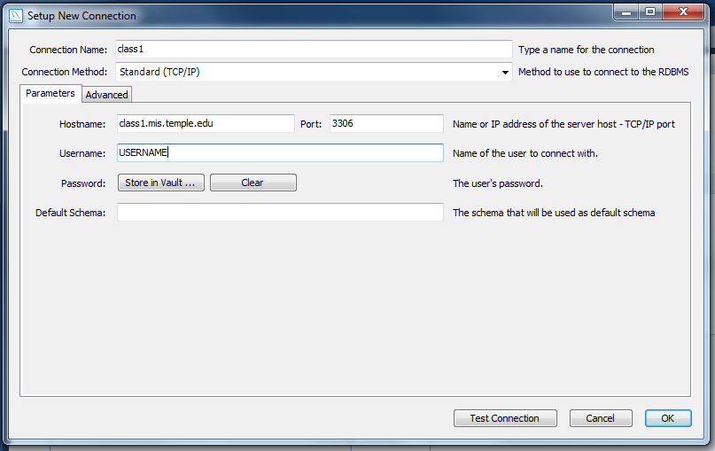
- Click “OK” and you’ll see the connection under “SQL Development”:
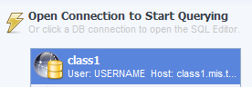
- Double-click on your new connection. You’ll see a password dialog:
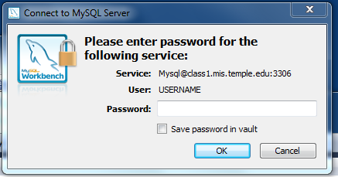
- Enter your password. Then click “OK.”
If you are using your own computer, you can save it in the vault (so you won’t have to enter it again). But if you are in a lab, just to be safe DO NOT save your password.
- You should see the main screen for SQL Workbench:
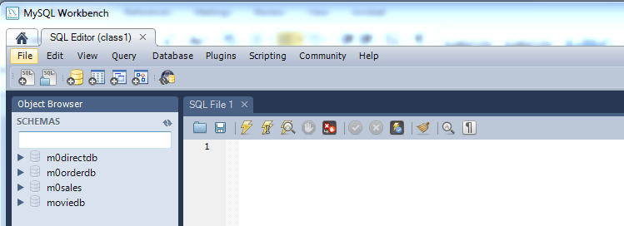
Yours might look a little different, depending on the version you downloaded. But if it basically looks like this, you’ve successfully logged in to the MySQL server using MySQL Workbench!

