# Exercise: Class17 – PDO – Suggestion Box

In this exercise you will provide missing database functionality in a “suggestion box” application that has already been started. You will use the PDO commands previously introduced in class, and will then move your database and application from your local development environment to the class server.

Instructions:

1. Ensure that XAMPP Apache and MySQL is running.
2. Visit <http://localhost/phpmyadmin>
3. Click “Users”
4. Click “Add user”
5. As depicted below, specify a username of “suggestionbox”, a host of “localhost” and a password of “secret123”. Also, check “Create database with same name and grant all privileges.”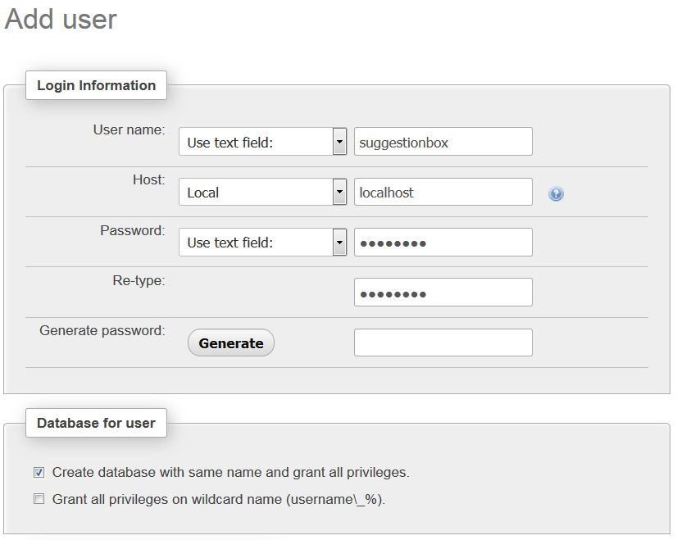
6. Click “Go”. This command creates **both** a user and a database named “suggestionbox”
7. Click on the “suggestionbox” database and the “SQL” tab.
8. Create a table with the following statement:  
     
   CREATE TABLE SUGGESTIONS (  
    suggestion_id INT AUTO_INCREMENT PRIMARY KEY,  
    suggestion_text varchar(2000)  
    );
9. Download the class17_exercise.zip file. Extract the “suggestionbox” folder from this zip file into htdocs.
10. You should now have a partially complete “suggestion box” application on your local computer: <http://localhost/suggestionbox>
11. Edit index.php, providing the missing PDO commands, so that records can be inserted into the database.
12. Edit suggestion_list.php, providing the missing PDO commands, to that records can be retrieved from the database.
13. Upload your work to the class server. This involves:
    1. editing constants.inc.php so that your database credentials are specified there
    2. exporting your local database, and importing it into your assigned database on mis3501.temple.edu
    3. uploading your files using ssh.