Challenge 12 – Add a login page and report to the Yougetta Coffee Shop application

In this challenge you will extend the Yougetta Coffee Shop application. Previously you created a database, table, and the PHP code necessary to insert a record into the database when all required fields are not provided.
Here’s the input form and confirmation page from this the “public facing” part of the application.
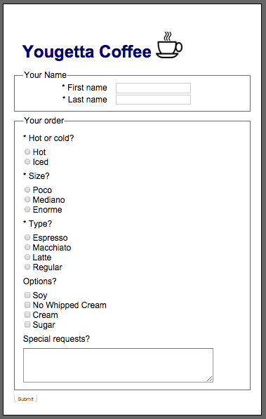 |  | 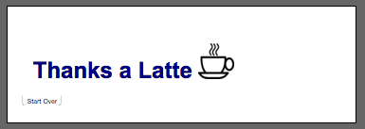

Using the start file that has been provided (challenge_12.zip) do the following:
- Add a login.php page to the application. Your login page should allow a user named “admin” with a password of “mittens” to get to the report.php page.
- Edit report.php. Any authenticated user referencing report.php should be redirected to the login.php page. To accomplish this, you will need to set a session variable upon successful login, and then check for that variable on report.php.
- The report.php page should have a “Log out” link that will end the session.
- Use cookies to ensure that the exact same order is not entered twice in a row. Display an appropriate error message to the user when this happens.
- As always, upload your work to mis3501.temple.edu when you are done.

An illustration of the login page and report follows:
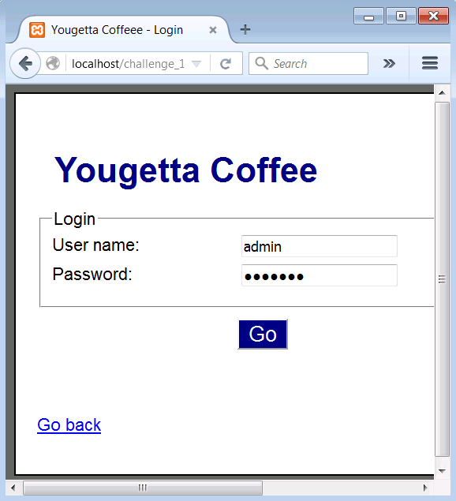 |  | 