Challenge_2_1

This challenge continues the process of building the Product Discount Application.
In this exercise you will need to use the PHP functions named number_format and htmlspecialchars. You can read about these functions in your textbook, at www.php.net or at www.w3schools.com.

- Open up the challenge_2_1.zip provided by your instructor.
- Put the folder challenge_2_1 in htdocs.
- Create a corresponding project in NetBeans.
- Open the display_discount.php file and add statements that format the numeric variables with the currency and percentage formats. Then modify the last four echo statements so they display the formatted data. Save the file. Run the application. The application should now display dollar amounts with a leading $ and two decimal places (for example: $100.00). Percentages should appear with a trailing % character (for example: 25%).
- Keep the application running and navigate to the index.php page in your browser. In the Product Description textbox, enter “<b>Guitar</b>”, and in the Discount Percent textbox enter “<i>10</i>”. Click the Calculate Discount button, and notice that the Product Description value is displayed in bold, and the Standard Discount is displayed in italics.
- Switch to the display_discount.php file and add the htmlspecialchars function to the echo statements for Product Description, List Price, and Standard Discount. Save the file. Run the application. Re-enter “<b>Guitar</b>” and “<i>10</i>” as was done in the previous step. Notice that, this time, the HTML tags are displayed as HTML entities, rather than being interpreted by the browser.
- Add a sales tax calculation of 8% based on the discounted price. Then, display the sales tax rate and the calculated sales tax amount after the discounted price. See sample screenshot below:
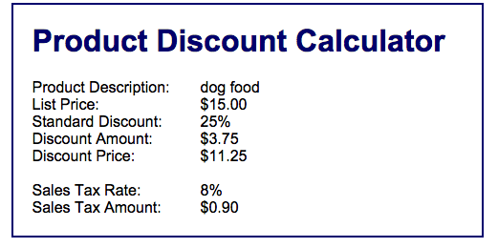
- Upload your work to the class server so that it is visible at a URL with the following format:
http://mis3501.temple.edu/tux99999/challenge_2_1

