Challenge_2_3: Working with loops and the Future Value Application

In this challenge we’ll continue working on the Future Value Application. Specifically, we will:
- Rewrite the working for loop as a while loop
- Add to the code in the while block so that we store data for each step of the loop’s execution
- Display that information as a table below the results
- Use include to put a footer on the index.php page
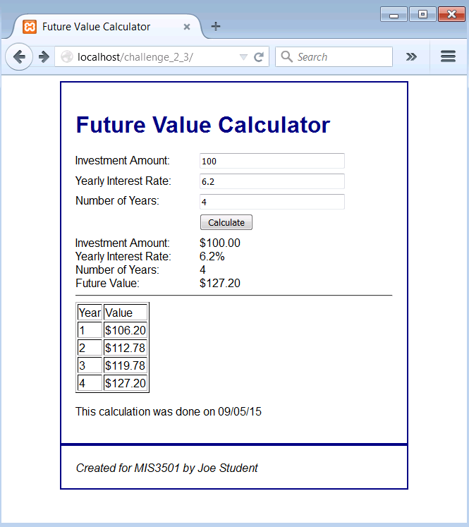
Each step of the calculation is presented here.

(See next page for notes and instructions.)

Notes and Instructions
- Note that, in this particular exercise, a while loop is not really essential to solving the problem. The challenge here is to be able to accomplish the same logic as the existing for loop, but with a different syntax. Students should be comfortable with either syntax.
- In rewriting the “for” loop as a “while” loop you will need to create a variable to use as a counter. You may call it $i. Assign this variable a value of 1 before the loop even begins. At the end of the loop, be sure to add one to the variable. Otherwise, your loop will never end. You can add one to $i with either of the following commands:
  - $i = $i + 1;
  - $i++;
- You will then need to consider the condition of the loop. While the counter is less than or equal to …. something…. (you need to figure out what) the loop will continue to iterate.
- Once the loop is working, create a variable to hold the text that will eventually be echoed out at the bottom of the page. For example, you could name the variable $detail because it is showing detail for each step of the calculation.
- Before the loop begins, start out by assigning that $detail variable an initial value, such as:
$detail = "<table border='1'><tr><td>Year</td><td>Value</td></tr>";
- With each iteration of the loop, use the concatenation operator to add to that piece of text.
- Once the loop is done, concatenate a piece of text to $detail to close the table.
$detail = $detail . "</table>";
- You now have the text of an HTML table inside of the $detail variable. Finally, down in the body of the html document, echo out the $detail variable where you want the table to appear.
- For the horizontal line that appears in the screenshot, you may use the <hr> tag.
- For the include portion of the challenge, start out by creating a file named footer.php and putting the following content into it:
