Challenge 7 – The Yougetta Coffee Shop

In this challenge you will use some of the HTML form elements we introduced in class this week. You are creating an intake form for the Yougetta Coffee Shop. Customers fill out their orders on kiosks when they enter the coffee shop so they don’t have to wait in line.

Here’s the input form and confirmation page:
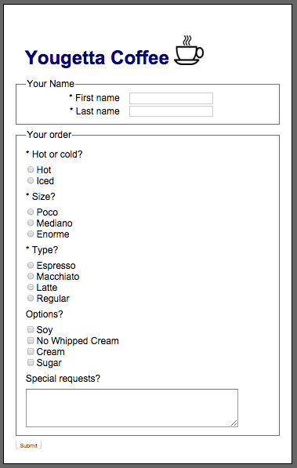 |  | 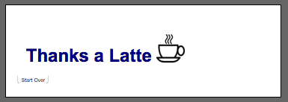

Your solution should write the customer responses to a table in a database. You are to determine the database table name and columns yourself, and create the database. Also, you should confirm that customers have provided all the required fields. In the above screen shot, required fields are marked with an asterisk. Present an appropriate error message to the user if these fields are missing. Don’t insert a record into the database if required fields are not provided.
A start file has been provided (challenge_7.zip)
As always, upload your work to mis3501.temple.edu when you are done.

