Exercise_2_4: Using PHP documentation

In this exercise, you will look up some PHP language features and use them to build a Leap Year Calculator.
For the purpose of this exercise, a year can be identified as a leap year / not leap year using the following pseudocode. (Don’t be thrown by the term “pseudocode”. Pseudocode is just a very general, English-like, description of how a piece of logic should work. )
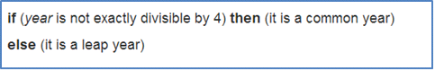
Note: The above definition of leap year is not entirely correct, but we will use it for this exercise. The real, full, pseudo code can be found at https://en.wikipedia.org/wiki/Leap_year#Algorithm. Students who wish to implement the full, correct algorithm are welcome to do so on their own.

Instructions
- Start with the exercise_2_4.zip file provided by your instructor.
- Create an exercise_2_4 folder in htdocs, and create a new NetBeans project as done in previous exercises.
- In index.php, inside the <main> tag, create a form. It should appear as follows:
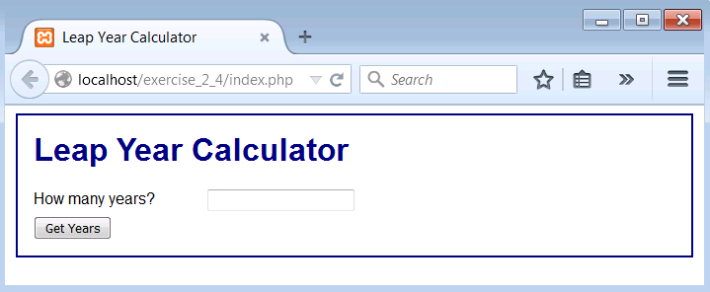

- Add a <?php ?> block to index.php. Add a loop so that when the “Get Years” button is clicked, a series of years are generated.
  - Each date is to be surrounded by a <div class=”decoration”> tag, and followed by a <br> tag.
  - The style “decoration” is already defined for you in main.css.
  - You may assume that the starting year is 2015.
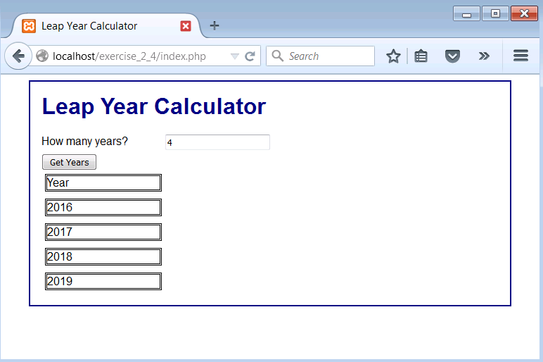
- Now research PHP date functions. You are to look for a function which will indicate the date of the holiday Easter for a given year. Use your newfound knowledge to add “Date of Easter” to your results.
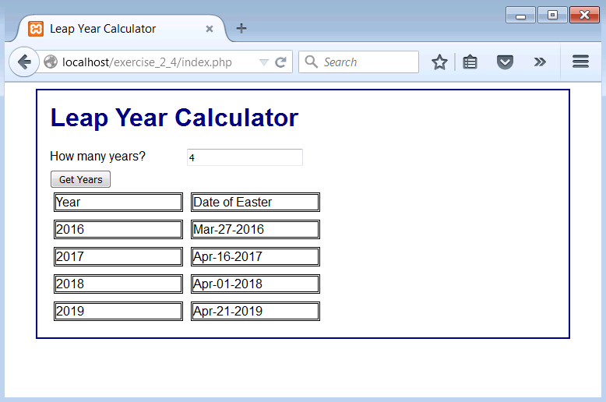
- Now research the modulus operator. (Hint: if you are using php.net you may need to look up Arithmetic Operators first.)
- Use this operator, and the pseudocode above, to add “Is Leap Year” to your results.
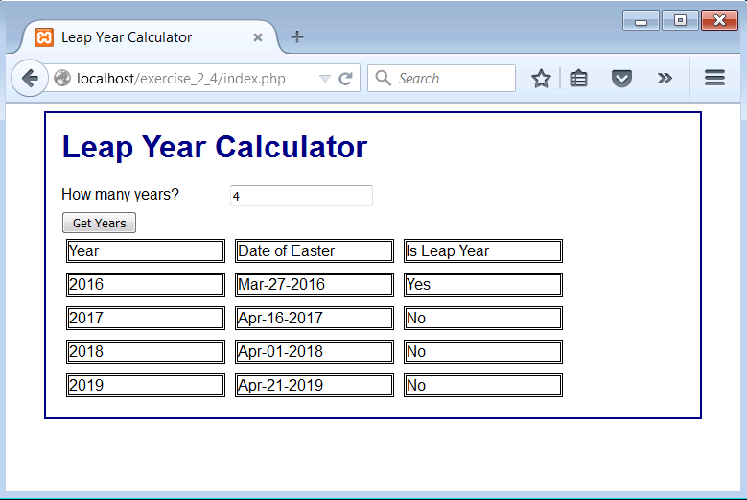
- Save and test your work.
- Upload your work to the class server so that it is visible at a URL with the following format:
http://mis3501.temple.edu/tux99999/exercise_2_4

