Exercise_7_2: Enhance the future application viewer

In this exercise, you will enhance the Future Value application of Chapter 2 so it uses drop down lists instead of text boxes. You will also add contact information fields and a checkbox feature.

Instructions
- Start with the exercise_7_2.zip file provided by your instructor.
- Create an exercise_7_2 folder in htdocs, and create a new NetBeans project as done in previous exercises.
- Open and test the application. Note that this page displays fields that request contact information, and also the three input fields from the original investment calculator from Chapter 2.
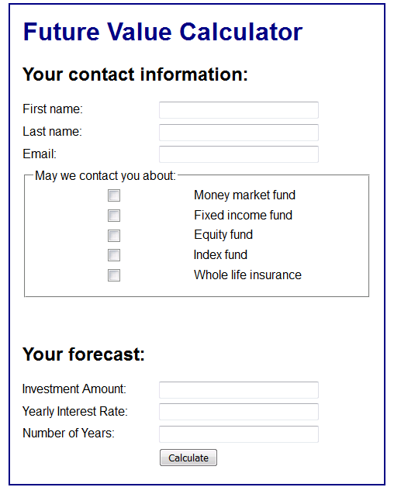
- Note the HTML name attributes of the tags used for Investment Amount and Yearly Interest Rate. In the following steps we will replace these text inputs with select tags.
- For the Investment Amount, the drop-down list should display values from 10000 to 50000 incremented by 5000. Use a PHP for loop to generate the <option> tags of the <select> tag.
- For the Year Interest Rate, the drop-down list should display values from 4 to 12, incremented by .5. Again, use a PHP for loop to generate the <option> tags of the <select> tag.
- Test the application, and make sure that the calculation works properly.
- Now look at the HTML used to create the checkboxes in the contact information portion of the page. They all have the same name: products[].
- In the display_results.php page, retrieve the vales for first name, last name, email and checked products from the form post. Be sure that you use the FILTER_SANITIZE_SPECIAL_CHARS and FILTER_REQUIRE_ARRAY options of filter_input function when you retrieve the checked product data. Your aim is to create an array in a variable named $products.
- Write a loop that iterates through the products array, and generates a bulleted list of items. An example follows:
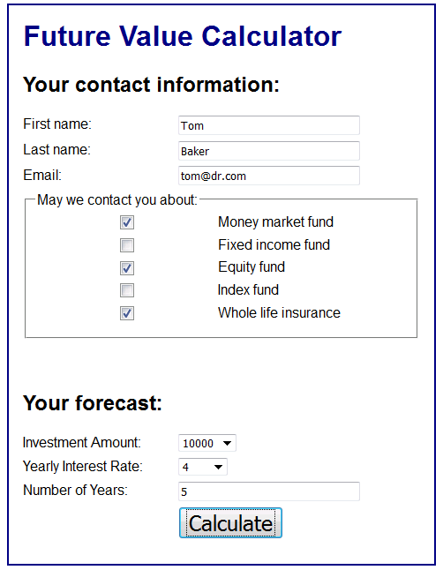 |  | 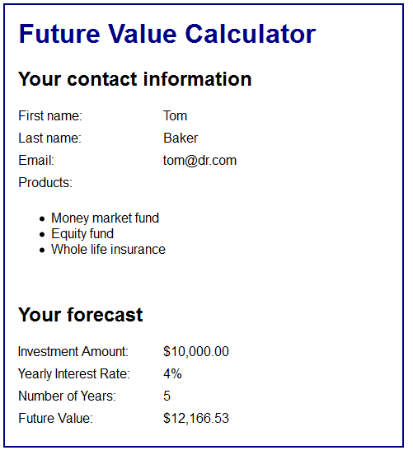

- Upload your work to the class server so that it is visible at a URL with the following format:
http://mis3501.temple.edu/tux99999/exercise_7_2

