Exercise: Kickstarter Data / SQL Select statements

To do:
- Create a database on your local installation of XAMPP MySQL. Name it kickstarter.
- Import kickstarter_data.sql into the database.
Now write queries that do the following, save your work in a text file named kickstarter.txt.
- Retrieve all data from the kickstarter_data table.
SELECT * FROM `kickstarter_data`
- Retrieve name, founder, and category from table.
SELECT name,founder,main_category FROM `kickstarter_data`
- Retrieve the distinct category names.
SELECT DISTINCT main_category FROM `kickstarter_data`
- Retrieve the count(*) of each category. Present the categories in descending order, with the highest count appearing first.
SELECT count(main_category),main_category FROM `kickstarter_data` group by main_category
order by count(id) desc
- Retrieve campaign names started after 2012.
SELECT name, startDate FROM `kickstarter_data`
WHERE STR_TO_DATE(startDate, '%Y-%m-%d') > '2012-12-31'

- Pull all successful after 2012.
SELECT name, startDate FROM `kickstarter_data`
WHERE STR_TO_DATE(startDate, '%Y-%m-%d') > '2012-12-31'
and outcome = 'successful'
- Pull all people who have started two projects
SELECT founder FROM `kickstarter_data`
Group by founder
Having count(founder) = 2

When you are done…
- Export the table kickstarter_data table using phpMyAdmin. Be sure to:
  - Choose a custom export
  - Check “DROP TABLE / VIEW / PROCEDURE / FUNCTION / EVENT / TRIGGER statement”
  - Uncheck “CREATE TABLE OPTIONS”
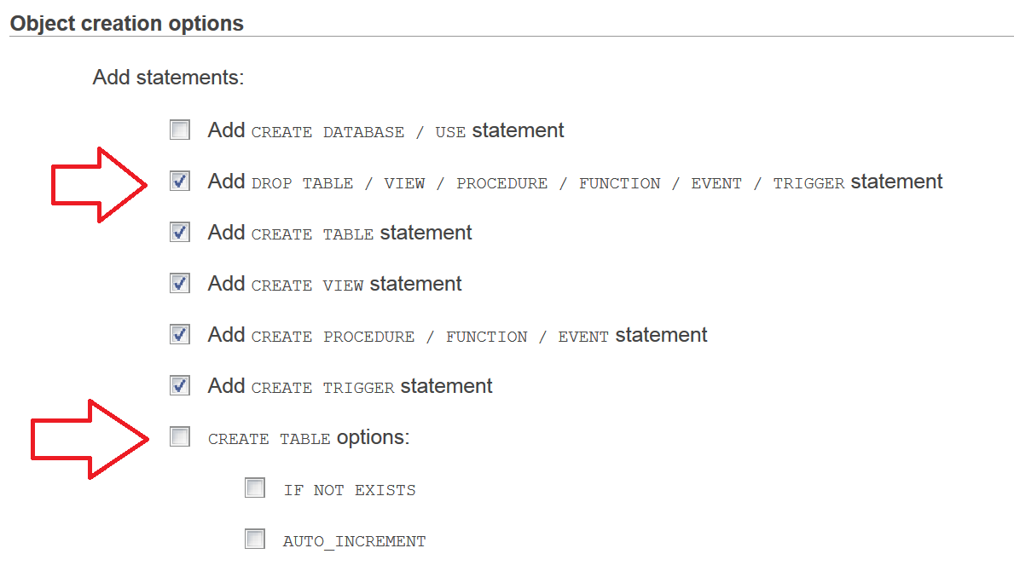
- Drop the local kickstarter database from your machine.
- Email kickstarter.txt to your instructor with the subject MIS3501 – Kickstarter.

