Exercise: Kickstarter Data / SQL Select statements

To do:
- Create a database on your local installation of XAMPP MySQL. Name it kickstarter.
- Import kickstarter_data.sql into the database.
Now write queries that do the following, save your work in a text file named kickstarter.txt.
- Retrieve all data from the kickstarter_data table.
- Retrieve name, founder, and category from table.
- Retrieve the distinct category names.
- Retrieve the count(*) of each category. Present the categories in descending order, with the highest count appearing first.
- Retrieve campaign names started after 2012.
- Pull all successful after 2012.
- Pull all people who have started two projects
Continued!

When you are done…
- Export the table kickstarter_data table using phpMyAdmin. Be sure to:
  - Choose a custom export
  - Check “DROP TABLE / VIEW / PROCEDURE / FUNCTION / EVENT / TRIGGER statement”
  - Uncheck “CREATE TABLE OPTIONS”
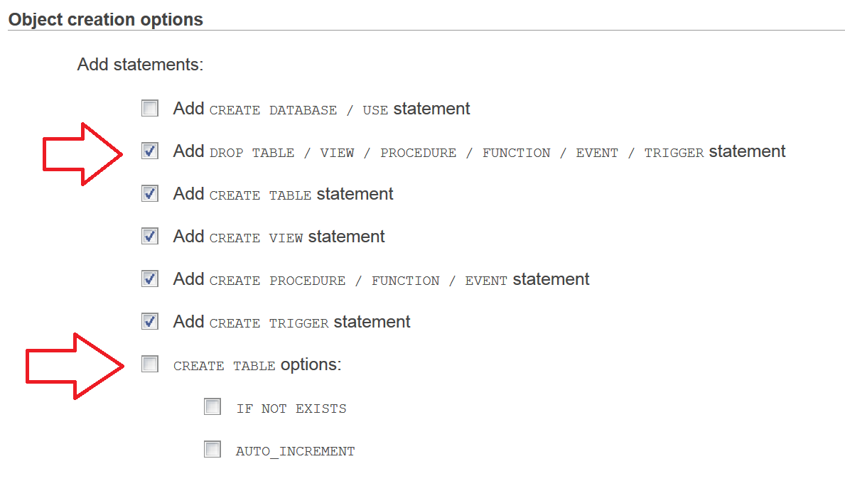
- Drop the local kickstarter database from your machine.
- Email kickstarter.txt to your instructor with the subject MIS3501 – Kickstarter.

