MSI3501 – Exam 3 Prep

Edit PHP pages as described below.
Scenario
Complete the online survey “Vote4Movies” which allows anonymous users to (you guessed it) vote for their favorite movies. While anonymous users may vote for movies, only authenticated users may add a new movie or get the report of movies voted for.
The vote4movies database schema diagram is shown below.
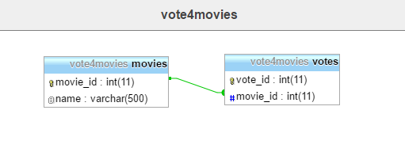

Instructions
Open the vote4movies.zip file. Copy the vote4movies folder to htdocs and set up a NetBeans project. Set up a database named vote4movies, a user named vote4movies and a password of “movies123”.

Steps
- Find the footer file in the view folder. Add text to the footer file so that your name appears in the footer of every page.
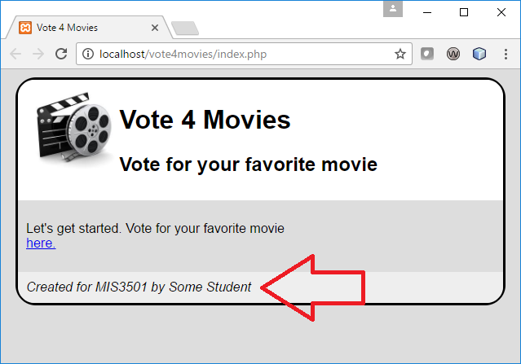
- You’ll need to login in order to work on the application. Click on the “Staff Only” link and login with a username of “admin” and a password of “mittens”.
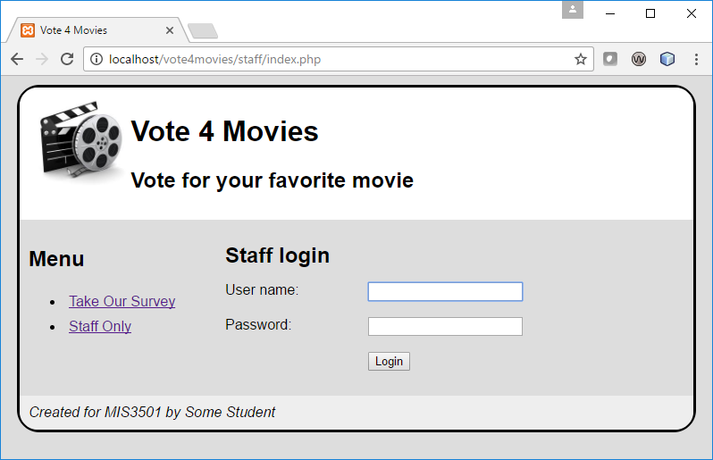
- Notice that the password is not masked. Correct this so that passwords cannot be seen as they are typed.
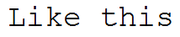
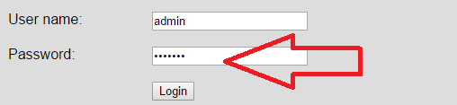
- Notice that the “add a movie” feature is mysteriously broken. Fix this. (HINT: the problem is on the view.)
- If you click on “Take Our Survey”, you will notice that movies are not presented in any useful order. Change the movies model so that movies are displayed in ascending alphabetical order.
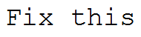
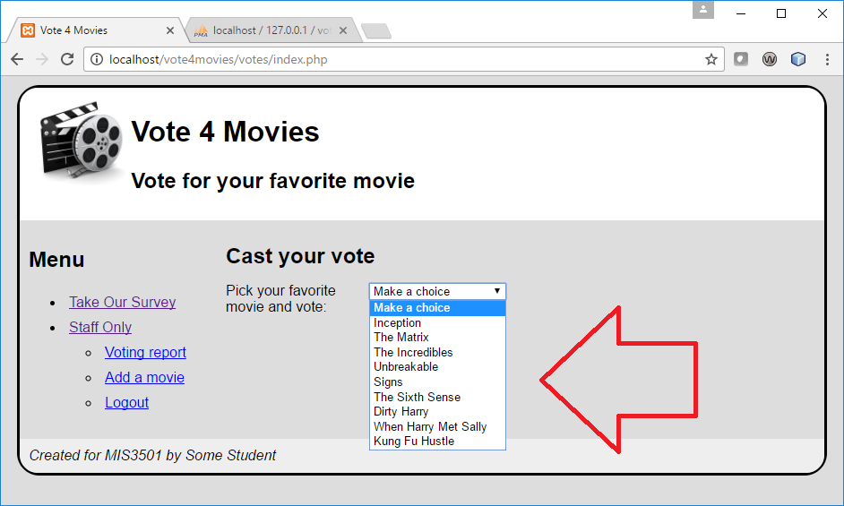
- Notice the movie camera logo at the top of each page. Add an html anchor tag, so that clicking on this image returns you to the landing page.
- Implement the voting report. This means that you should:
  - Complete the getVoteReport function in the votes model. The SQL query to use is already provided for you there.
  - Use the getVotesReport function in the votes controller.
  - Complete the vote_list.php view
  - Add security. Specifically, edit the votes controller to that the session variable $_SESSION['LOGGED_IN'] must exist in order to get that view.
Here’s example of what it should look like when you are done:
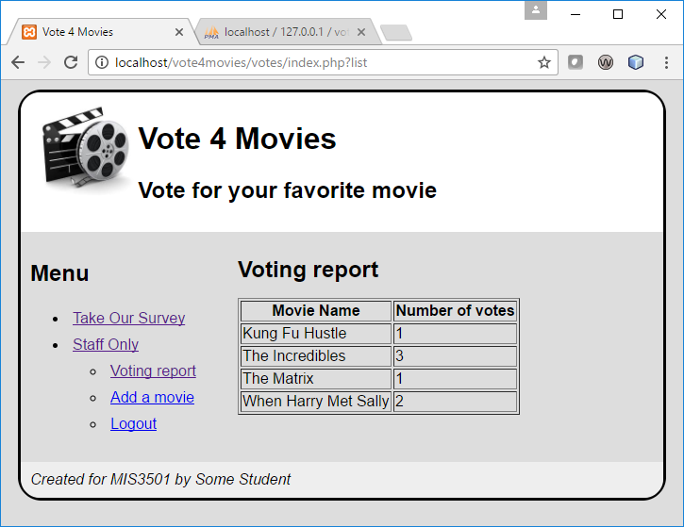
Notice that if a movie has no votes, it does not appear on this list. That is acceptable and expected.
- Notice that it is possible to add a movie name with HTML tags when adding a movie name. We want to prevent this. So, if I add a movie name of “<b>test</b>”, and vote for it, I should see those exact same characters on the report. To fix this, edit the movies controller. See the illustrations below.
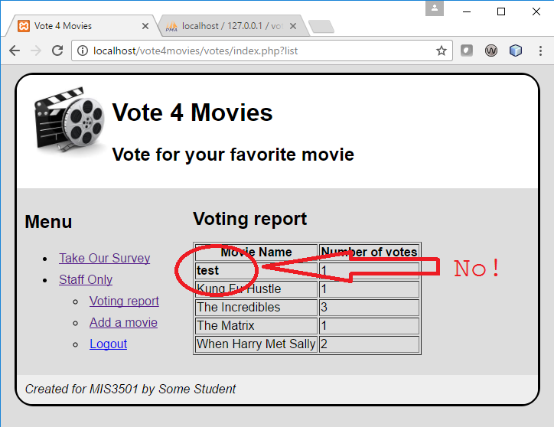
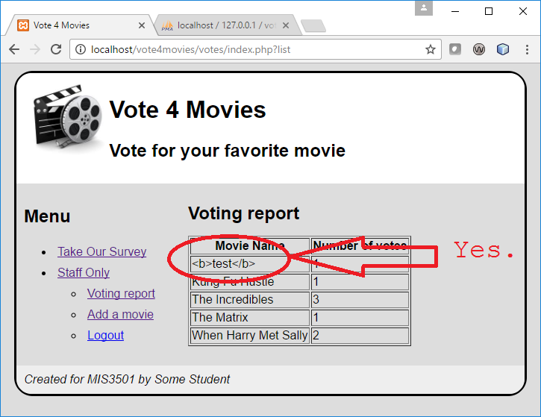
- When you are done with your work, upload your solution to the MIS3501 class server. Make sure your code is working there.

