Lab 8: Physical Security Scavenger Hunt

Names:

Note: This lab can be completed in a group of up to four members. Turn in one document to Canvas with all group members’ names listed.

To earn full credit for this lab, complete 5 of the 13 options below.

Option 1: Obtain the Password Hashes from an Unattended Public Computer

Note: This option uses Cain, which is installed on the lab VM. It can be downloaded from www.oxid.it. However, this file will set off all sorts of malware detection alarms and warnings, both in the browser and on your computer. Cain is not malware, and www.oxid.it is the official site to obtain the file from. But you can use Cain to do malware-like things, so it gets flagged.
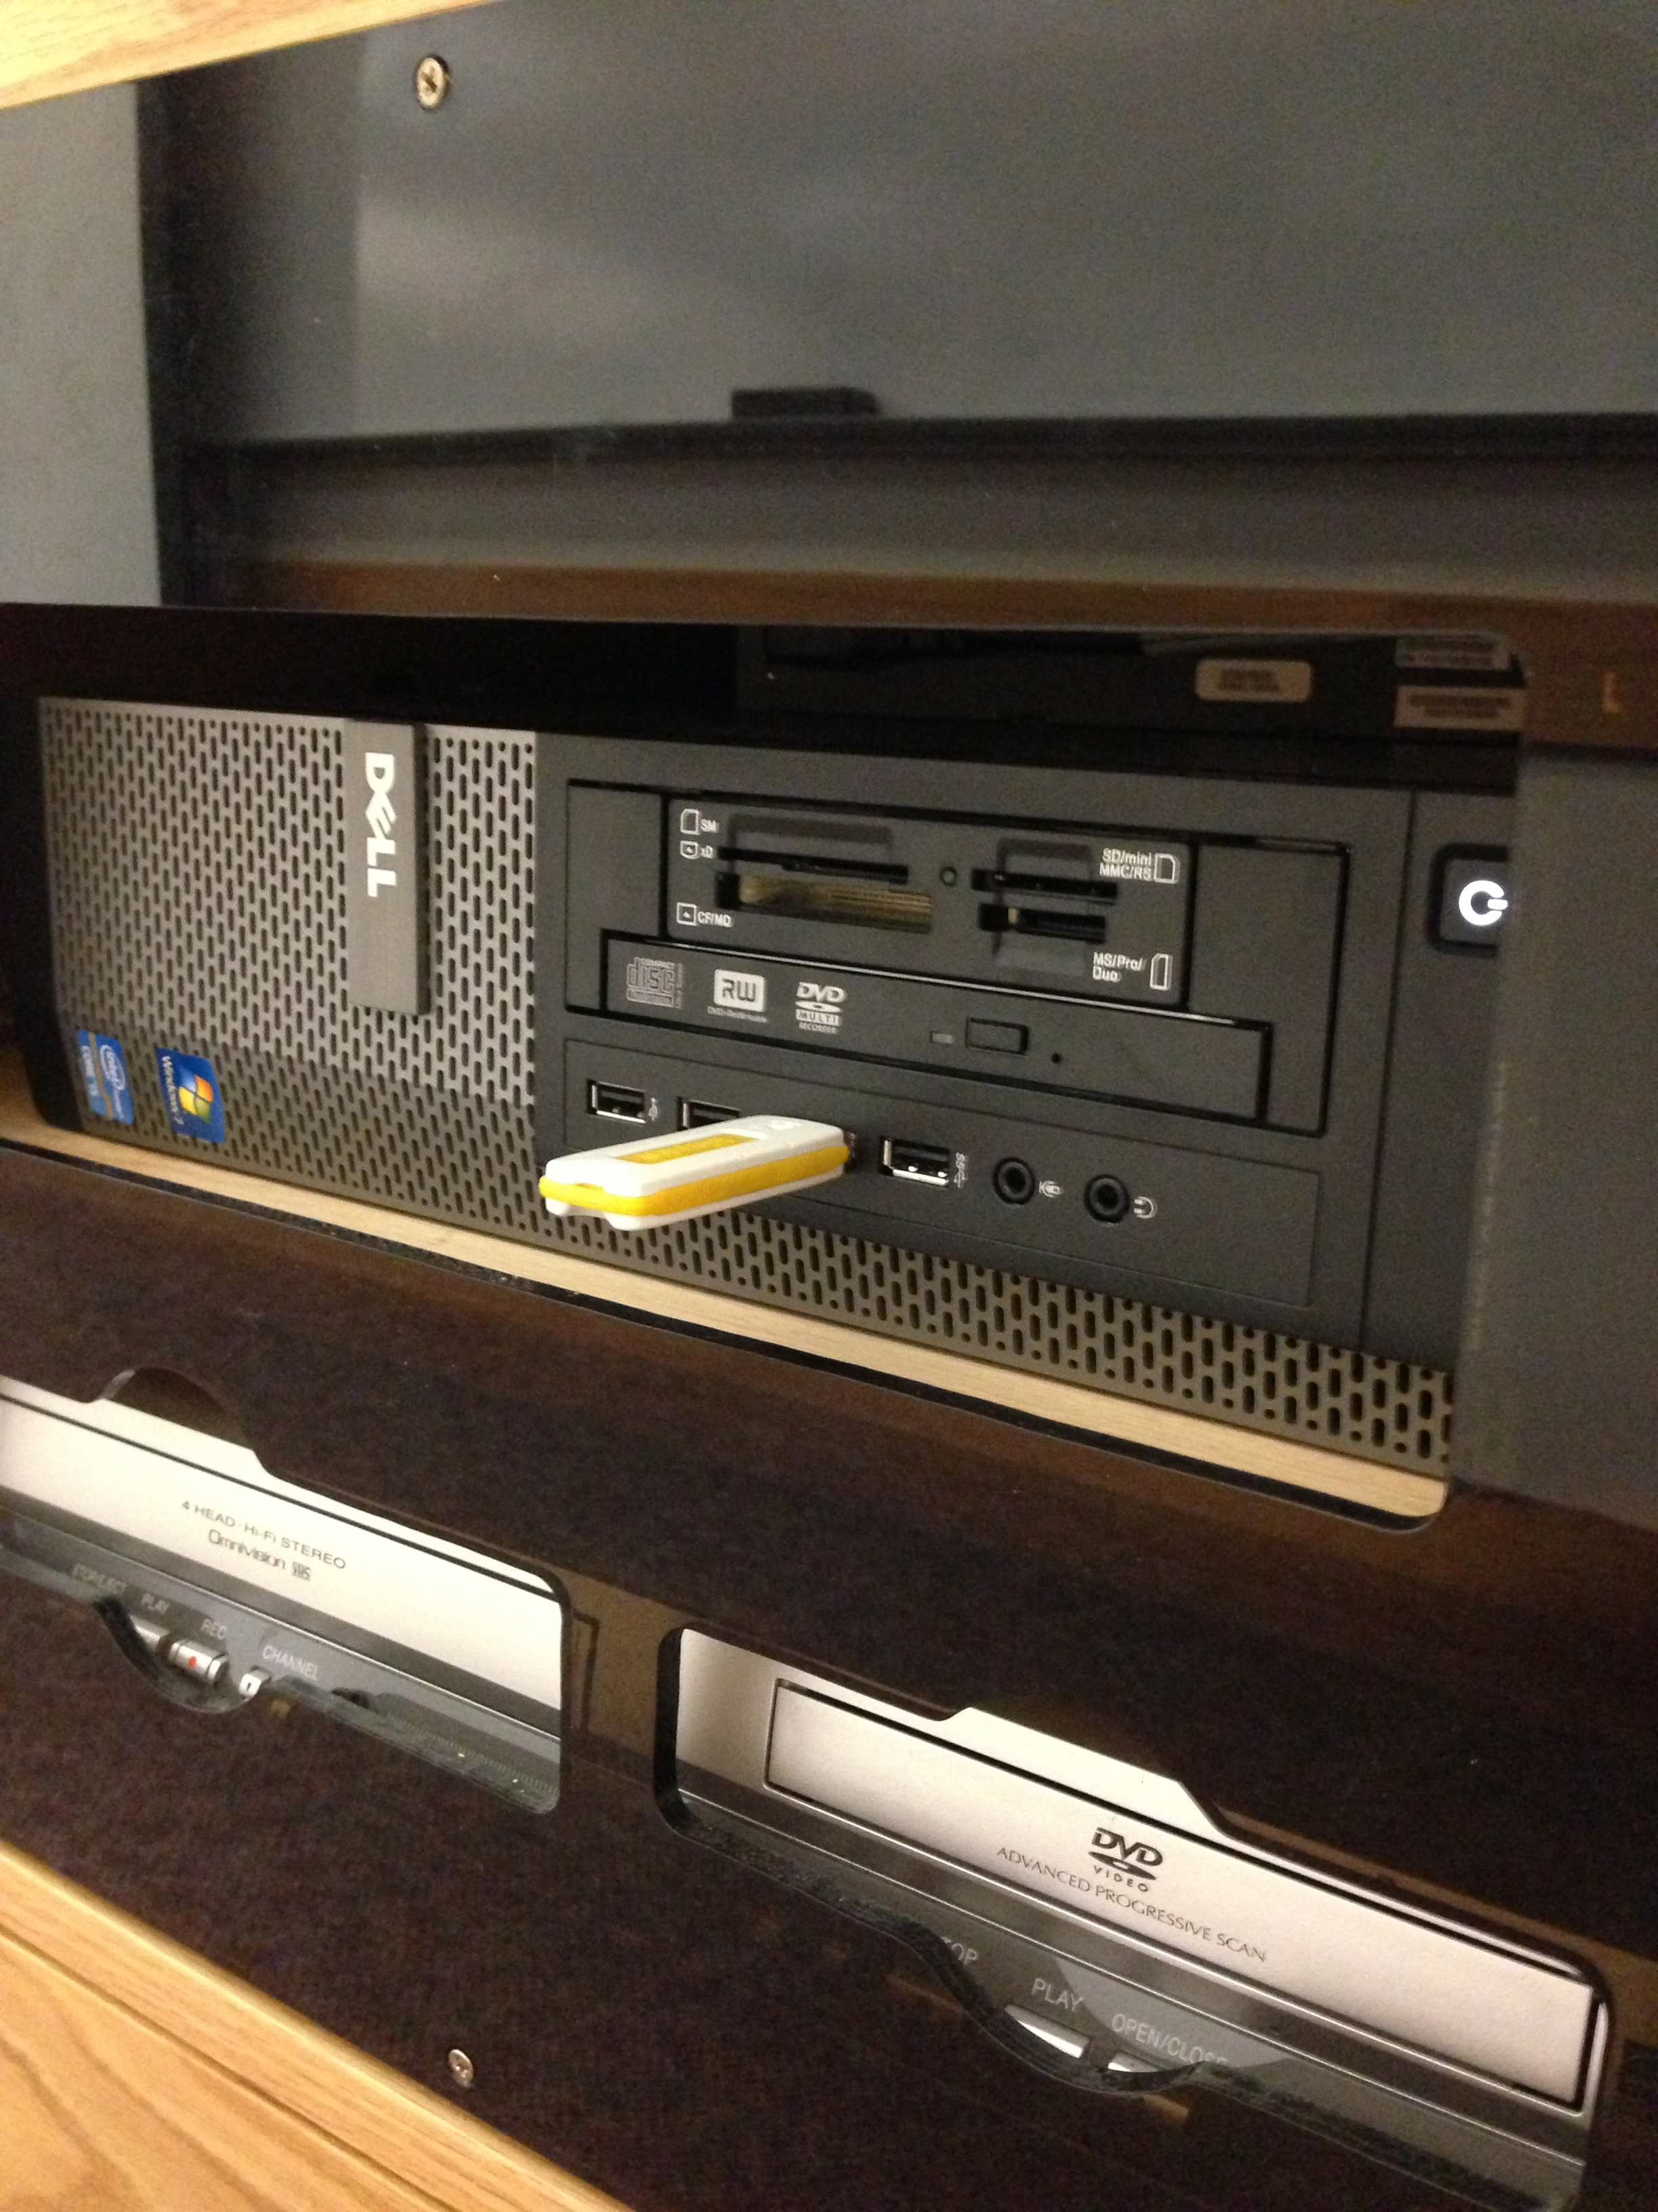
Obtain the password hashes from an unattended public computer. In Windows 7/10, the password hashes are contained in two files (you’ll need both):
C:\Windows\system32\config\SAM
C:\Windows\system32\config\system
Since these files are protected by the operating system, boot from a Live CD/USB Linux distribution, such as Kali. From within Kali, copy the SAM and system files to a USB stick.
Password hashes can be dumped from the SAM file using a number of tools. For this lab, use Cain.
Run Cain (ignore any messages about the Windows firewall). Click the “Cracker” tab, and click within the right-hand pane to give it focus. Click on the + button in the toolbar and select Import Hashes from a SAM Database. Select the SAM file you obtained. Next to the Boot Key (HEX) field, select the System file you obtained. This will yield a hex string that you must copy and paste into the Boot Key (HEX) field.
Include a screen shot of the hashes below to prove that you’ve done it.
Note: Include a photo of the hashes, but don’t actually crack the hashes.
Example:

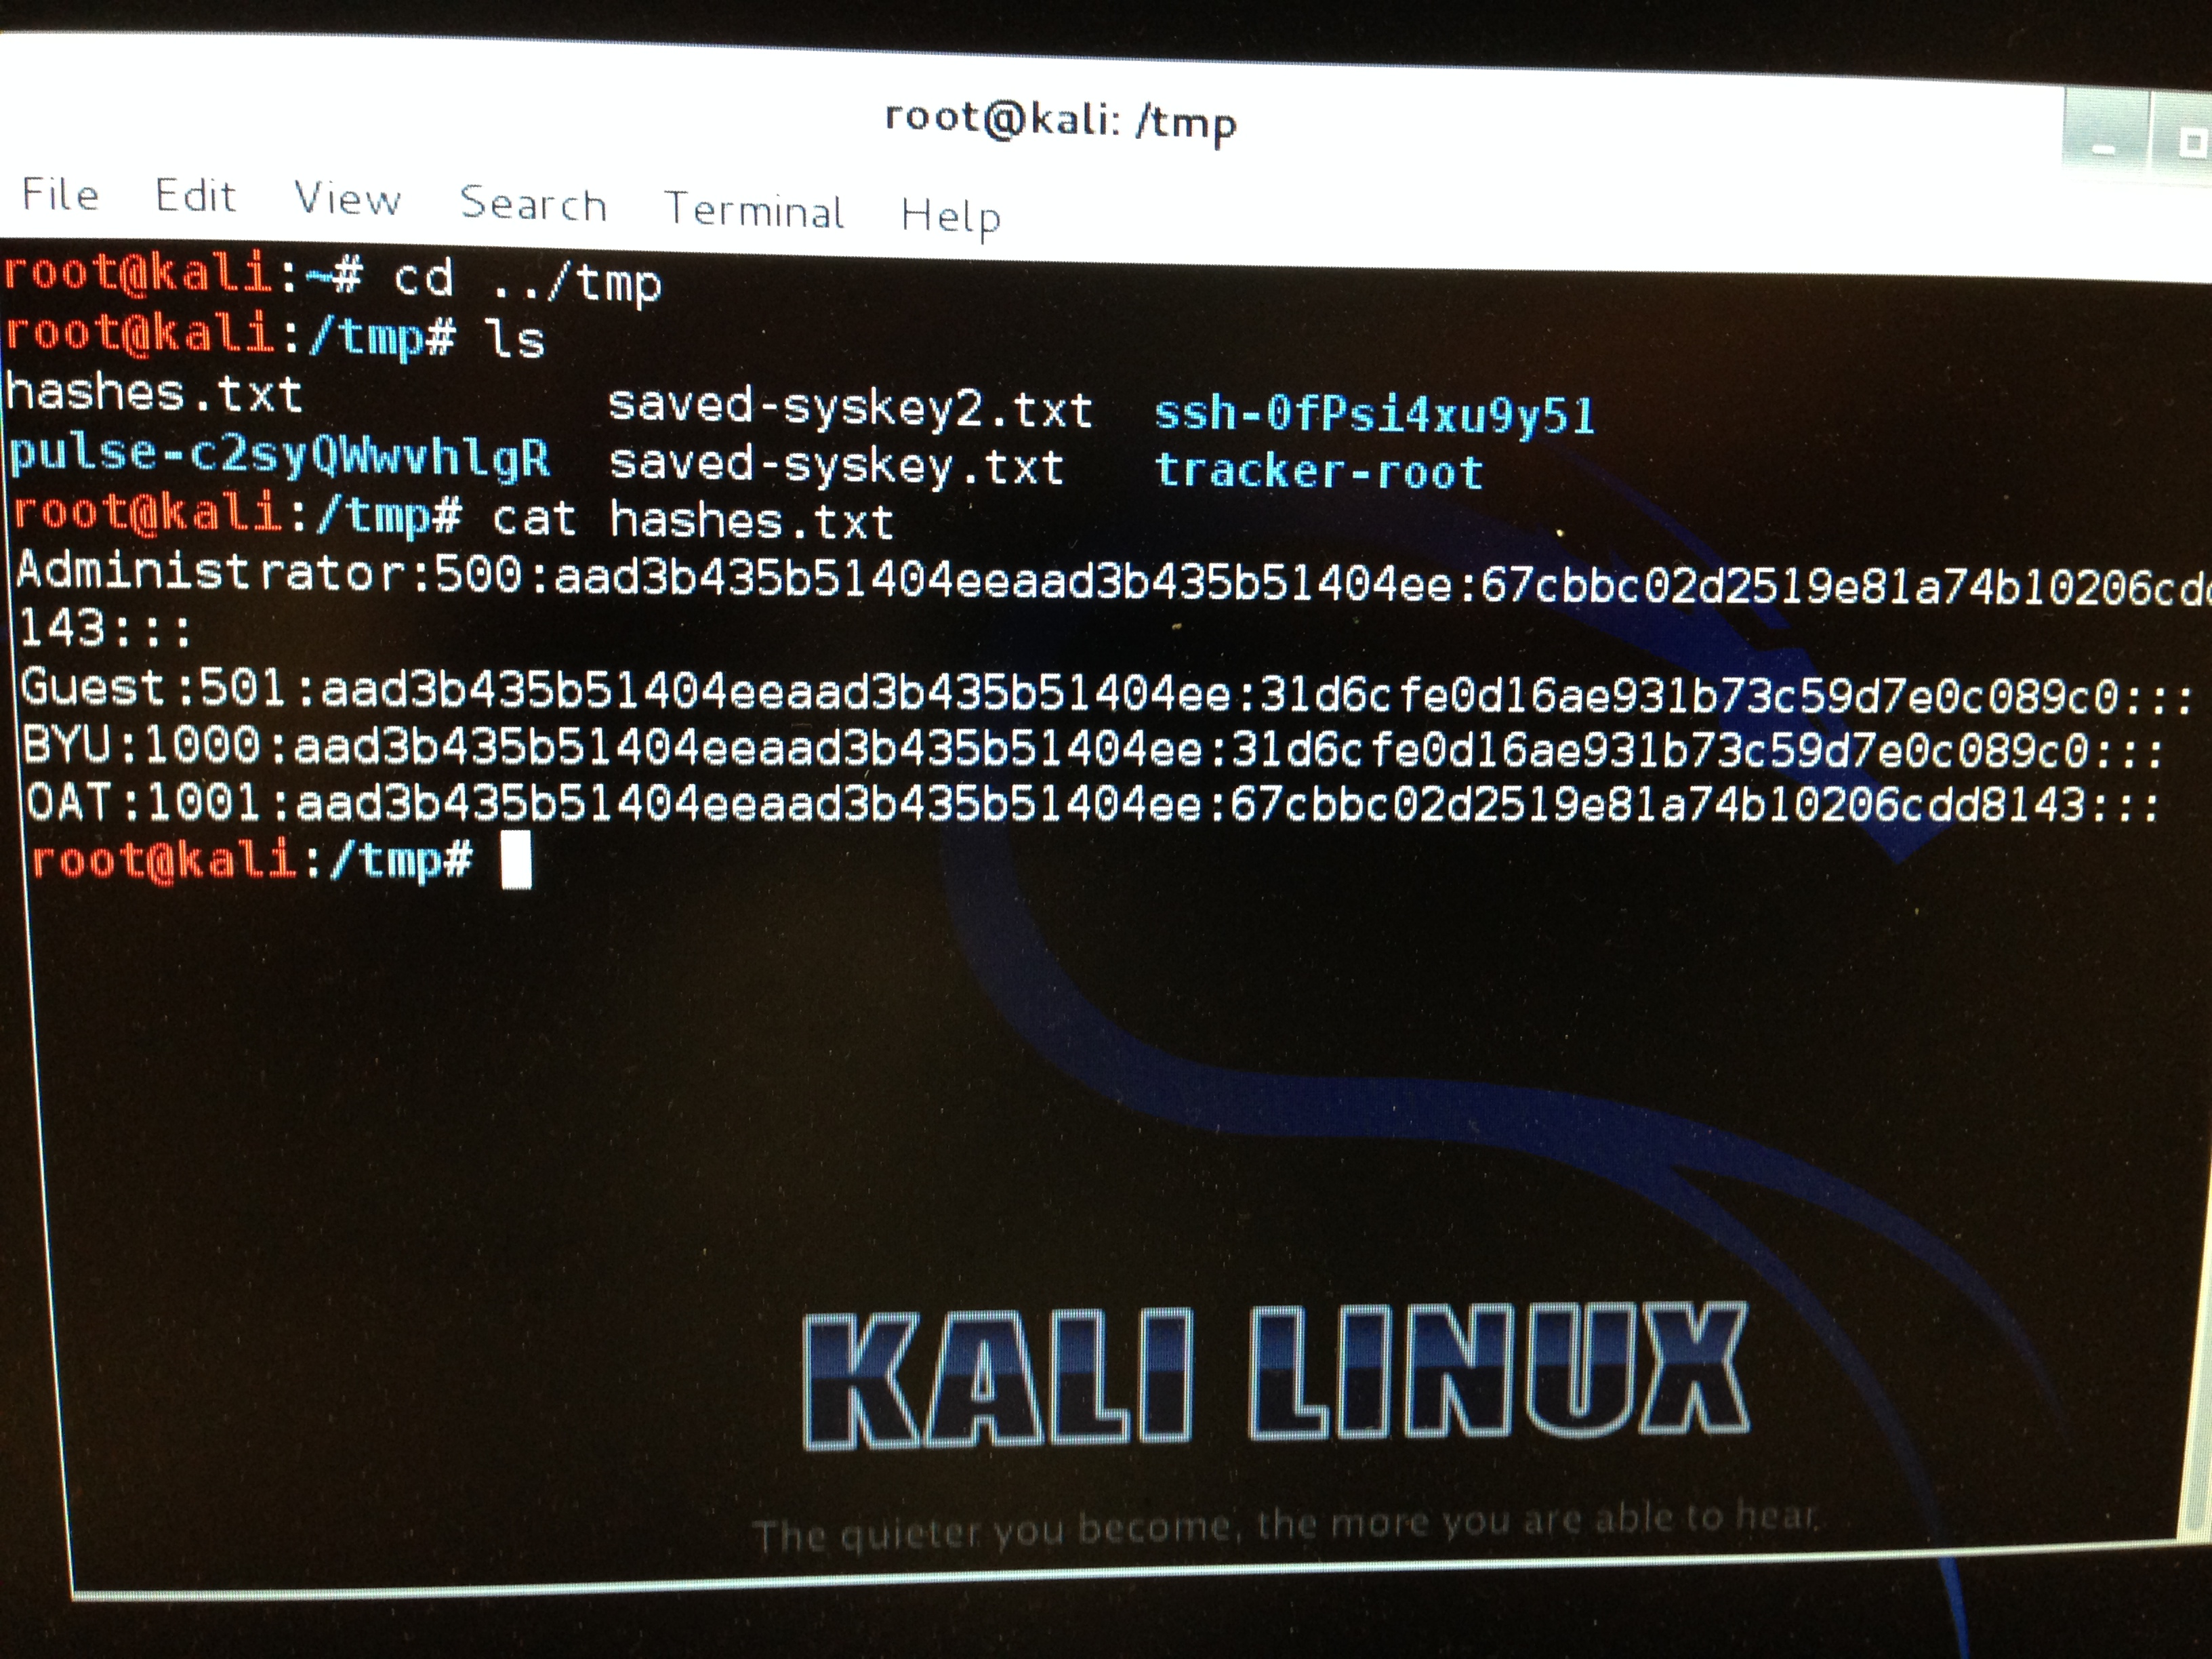

Option 2: Get a Legible Photograph an Unlocked, Unattended Terminal

Example:

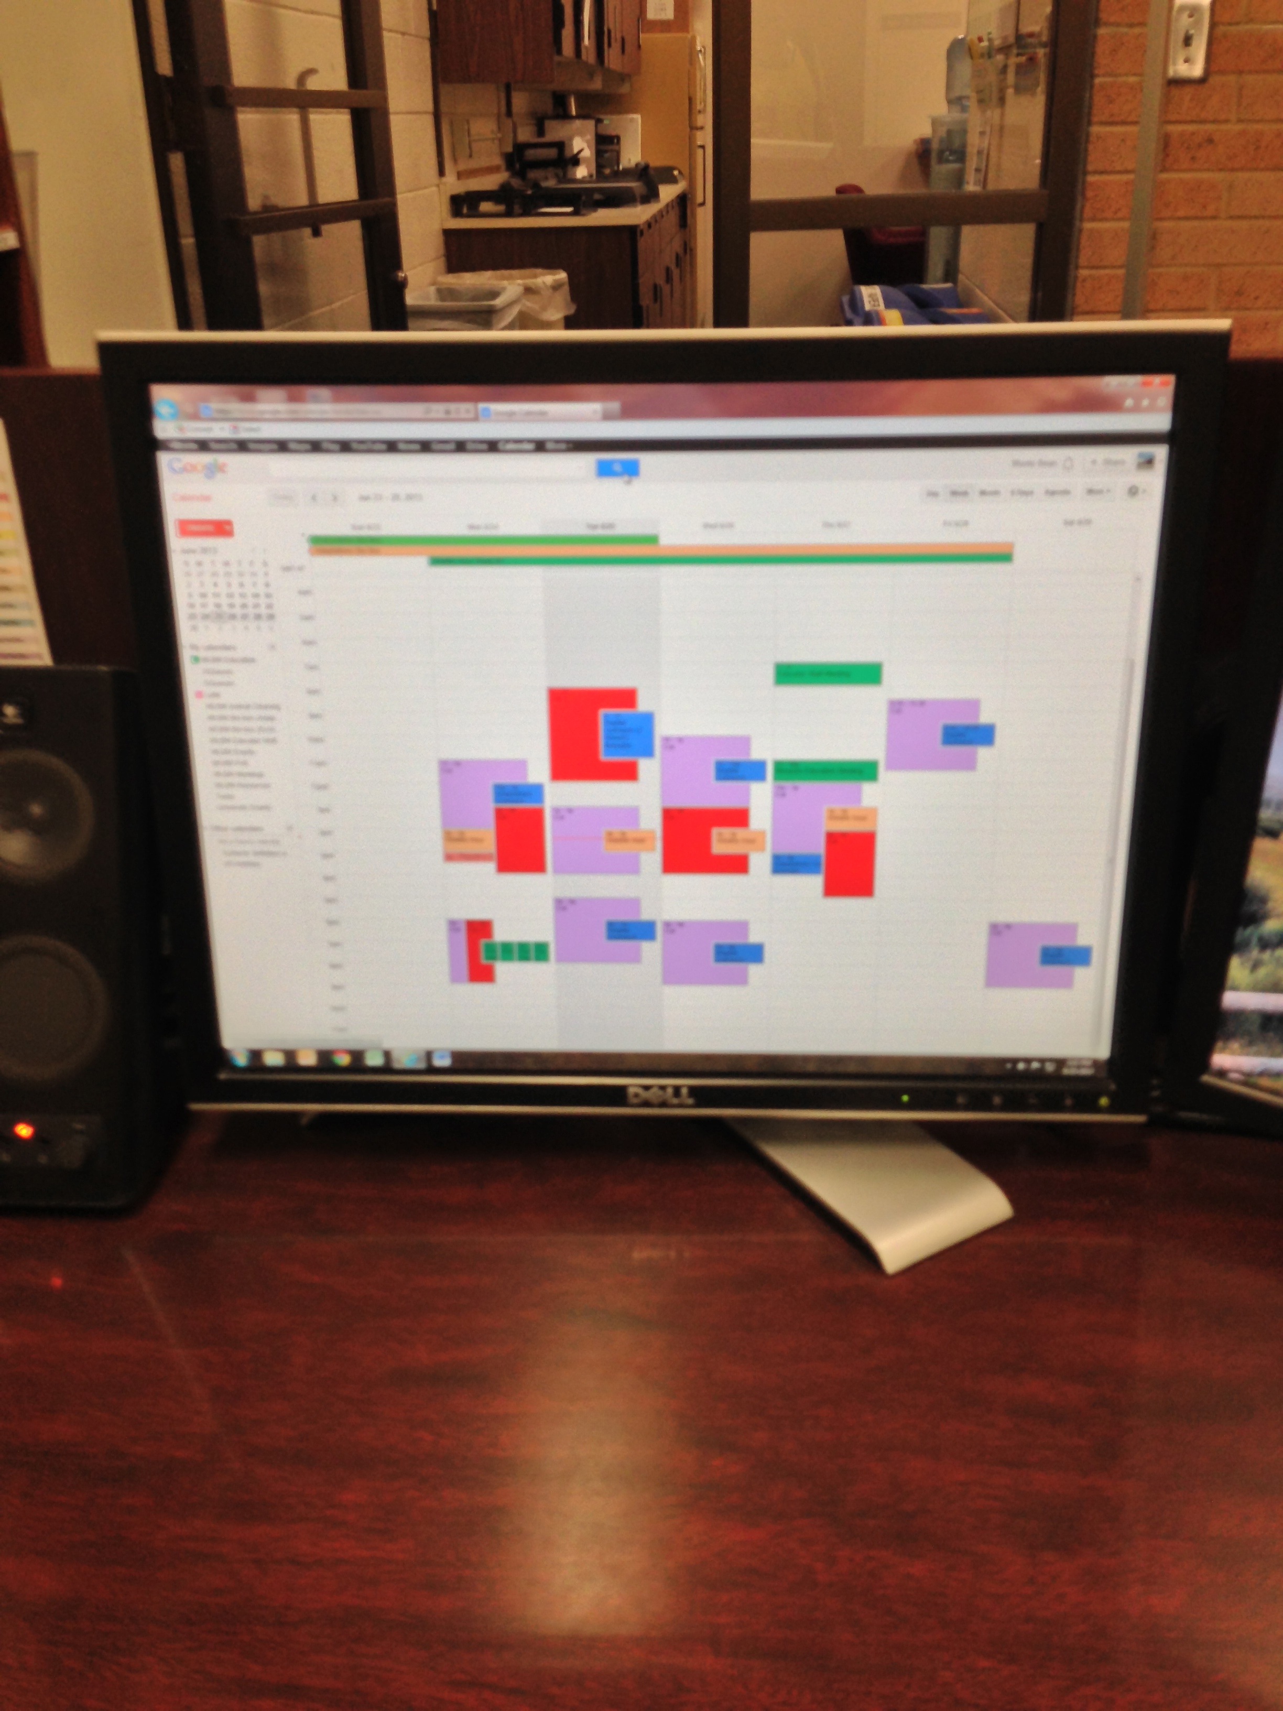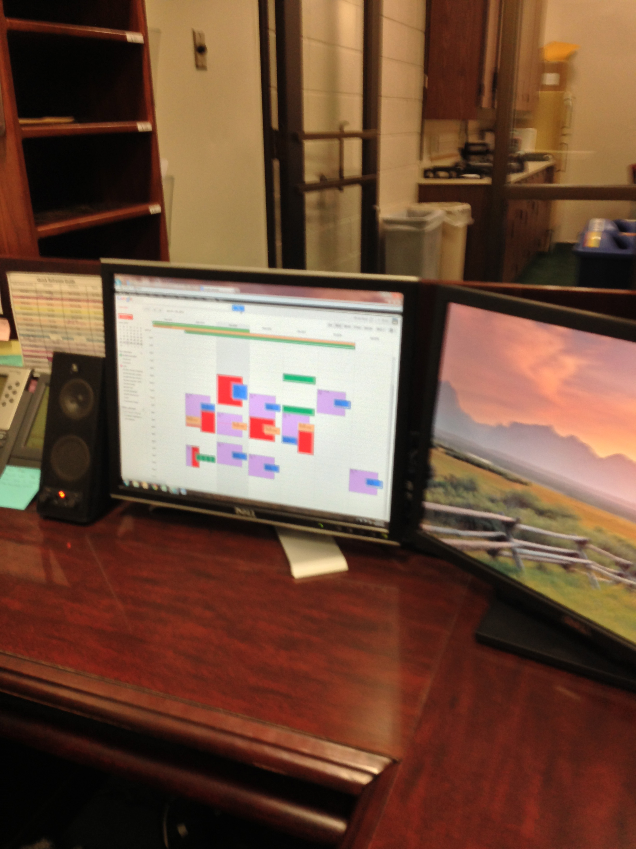

Option 3: Shoulder Surf to Get a Legible Photo of a Screen in Use

Example:

Option 4: Go Dumpster Diving to Obtain a Photo of Sensitive and/or Potentially Valuable Information

Note: Please specify the information, but redact the information in the attached photo.

Note: Although dumpster diving is legal in the United States, an exception is when it is prohibited by trespassing.

Example:

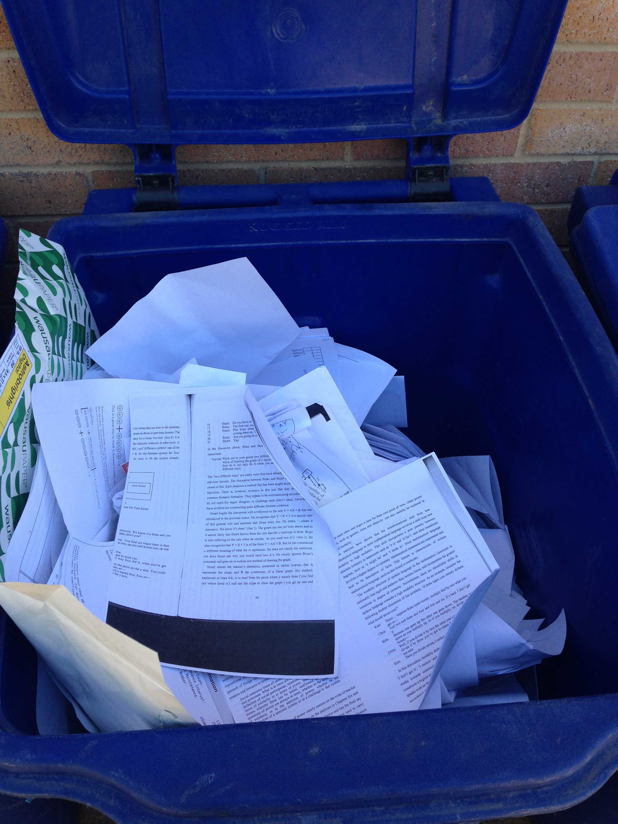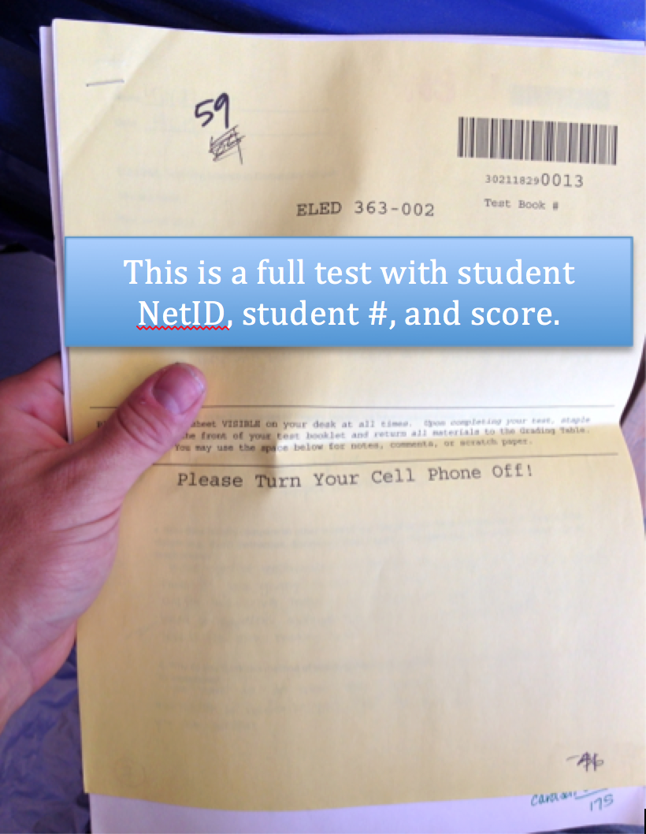

Option 5: Gain Access to a Pre-approved Restricted Area

Take a picture of yourself in the restricted area and document how you did it (e.g., tailgaiting). Get permission from a manager, etc. before entering the restricted area. For example, you might explain to a manager that you are doing a class assignment and you would like to test whether their employees will prohibit you from entering the restricted area. Only proceed with the test with the manager’s approval.

Example:

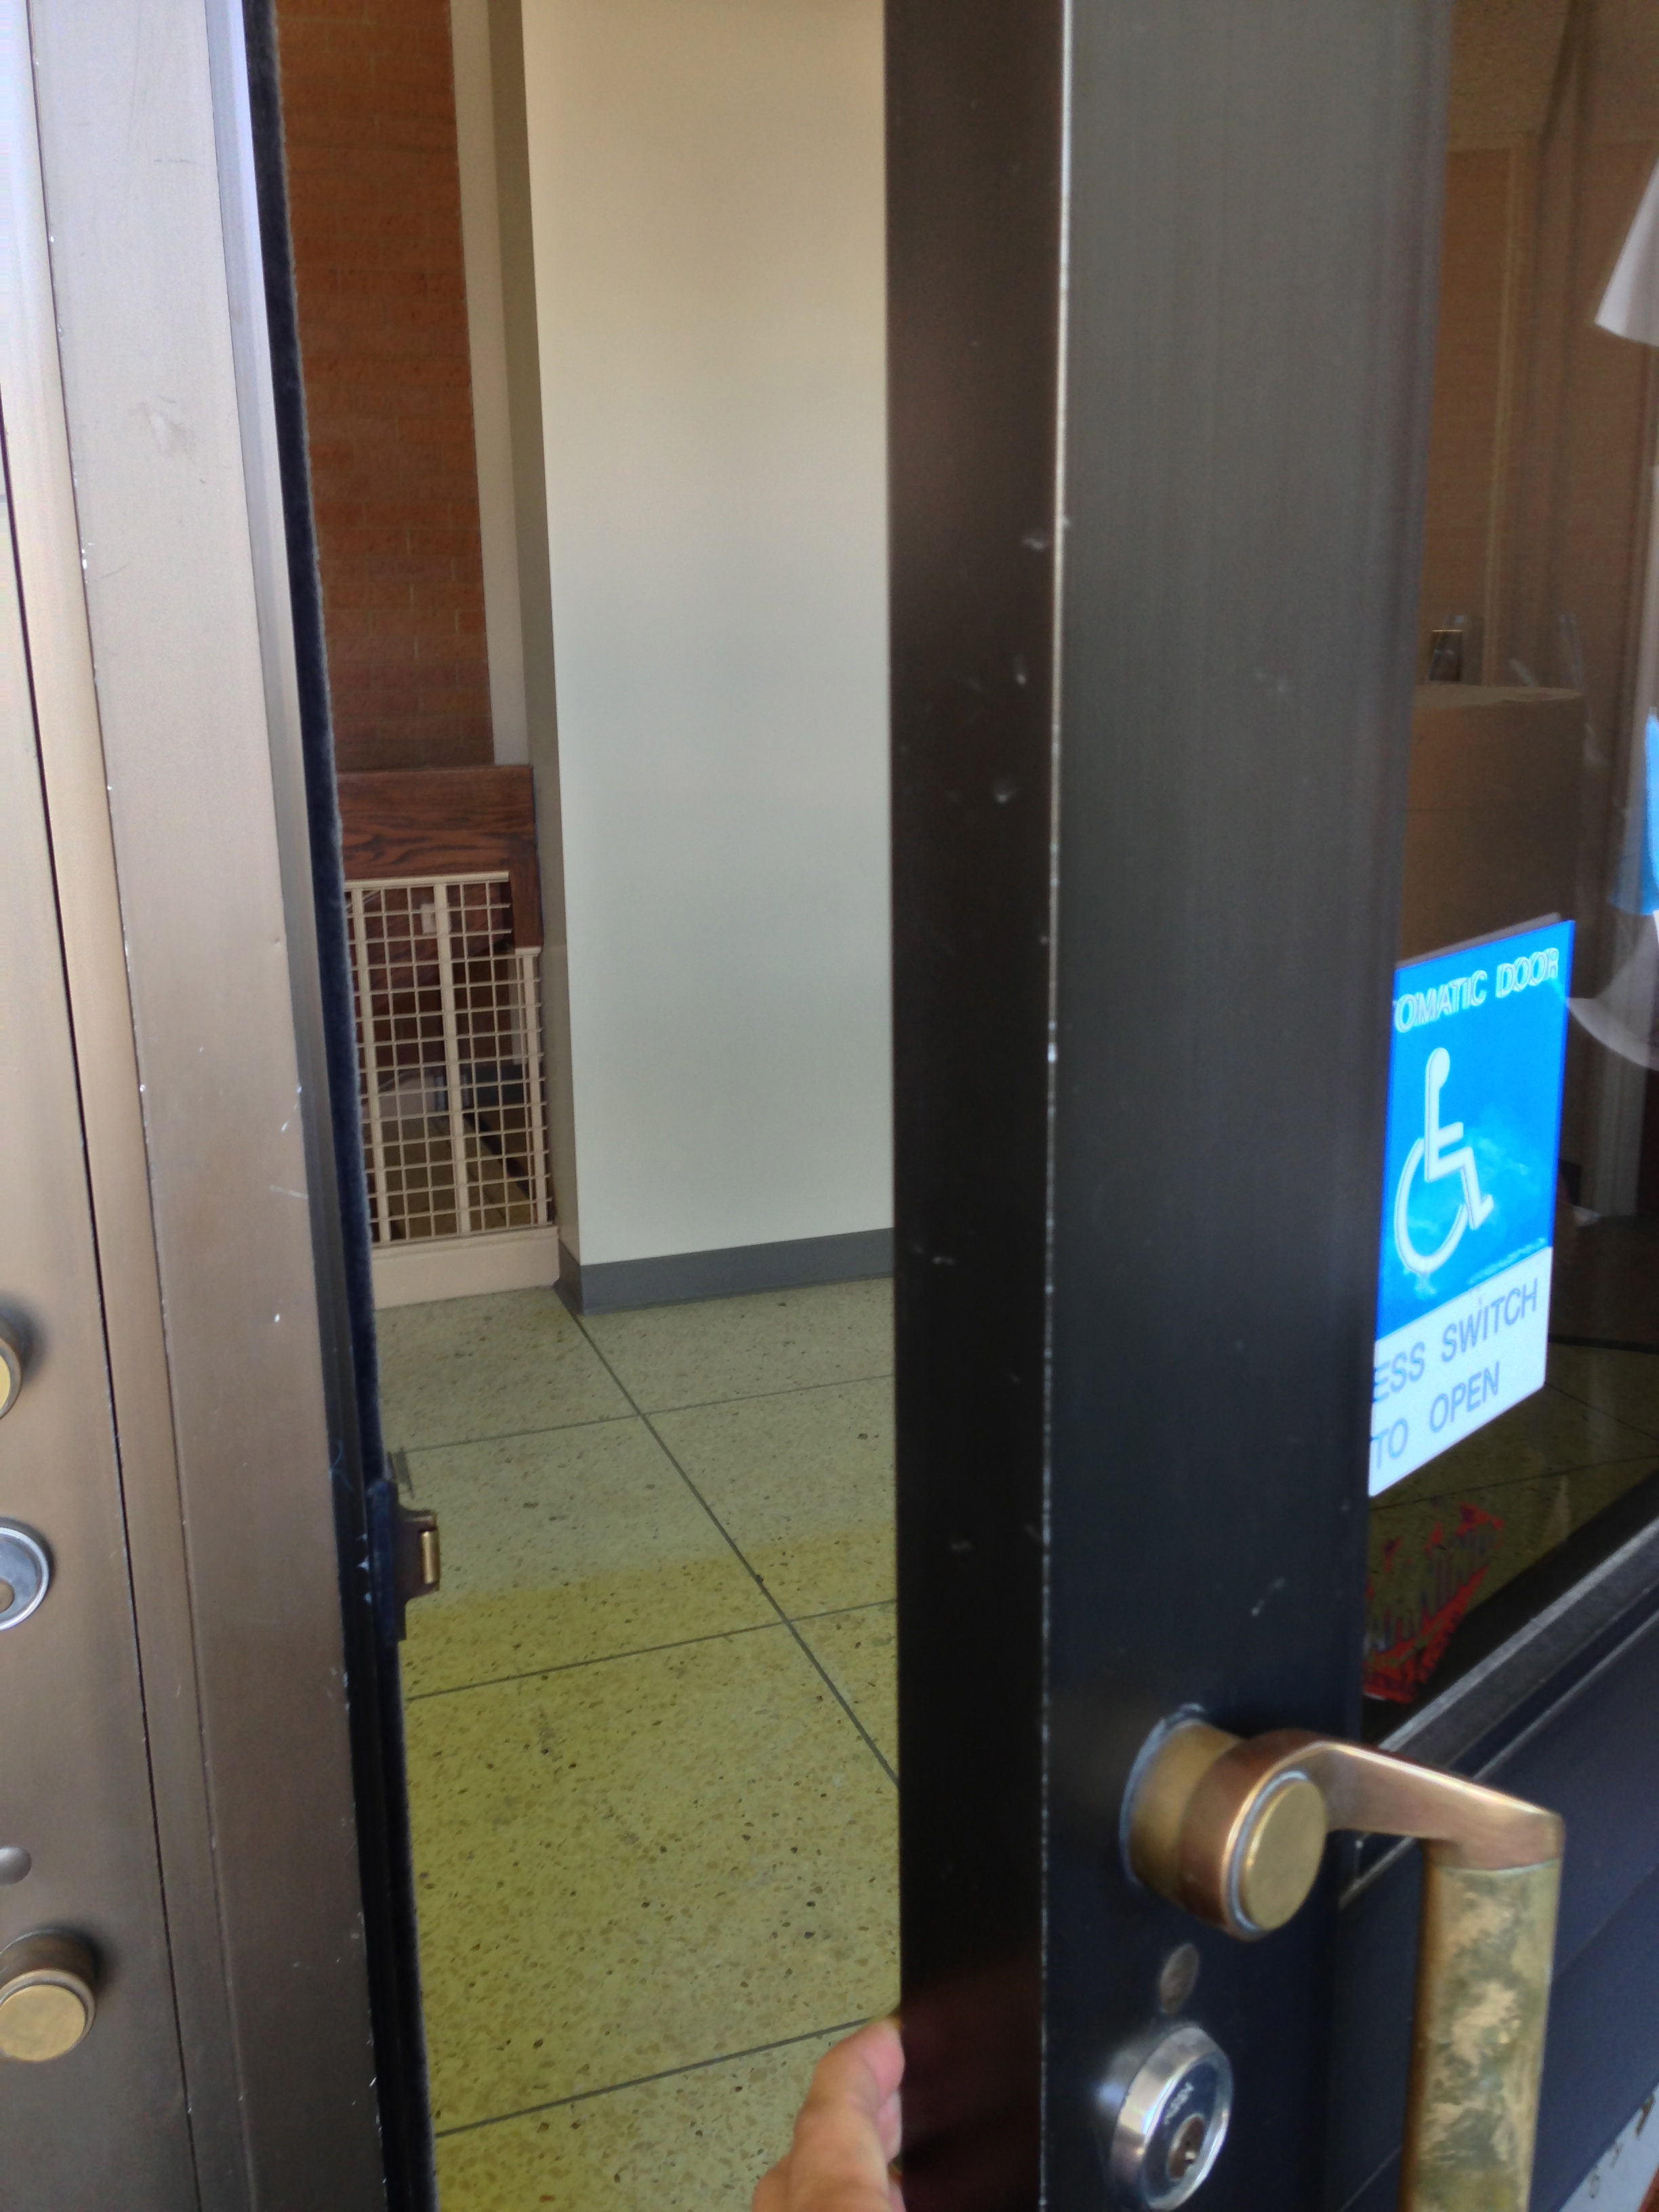
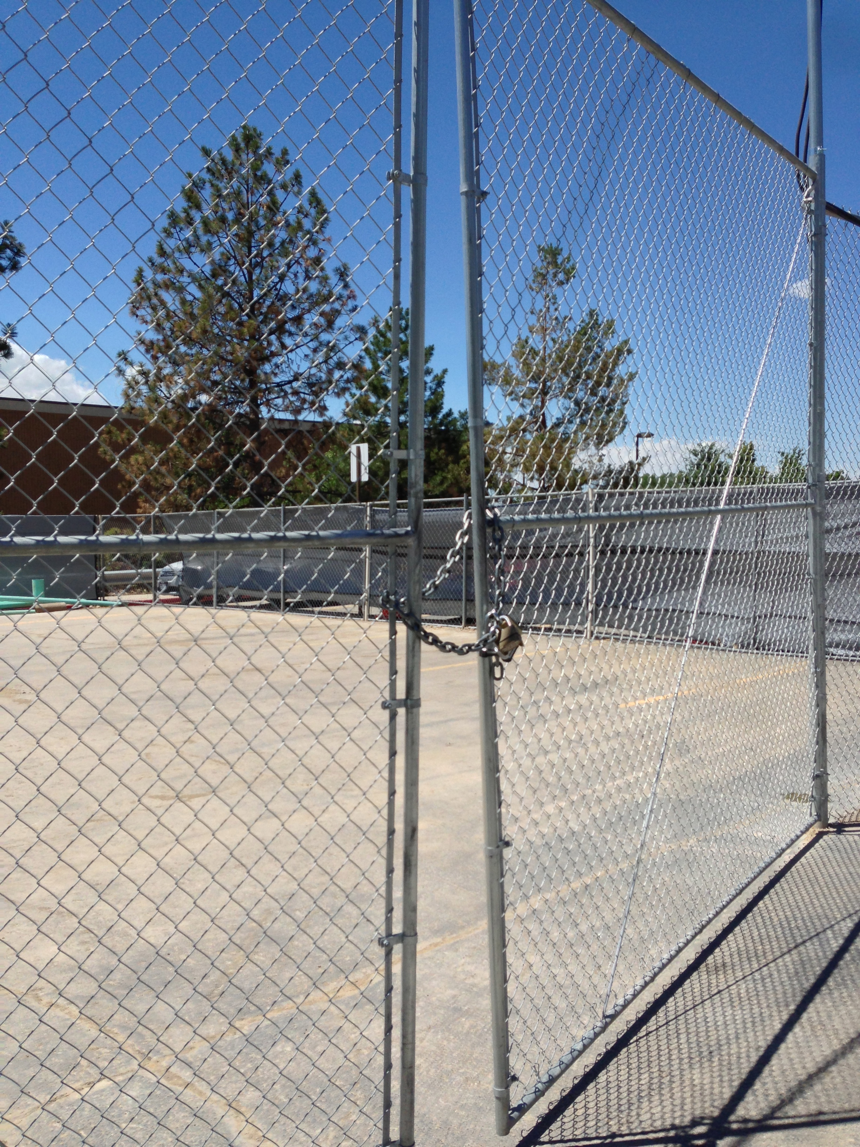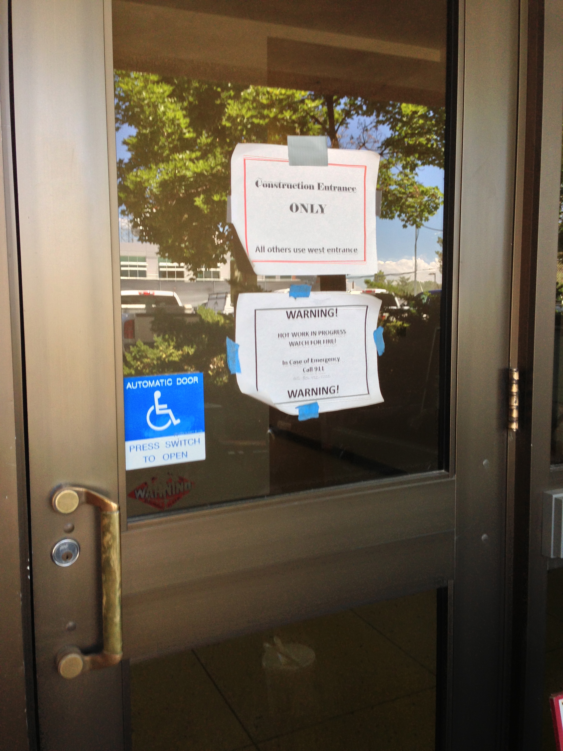

Option 6: Take a Picture of Sensitive/Potentially Valuable Information Left in Someone’s Car

Example:
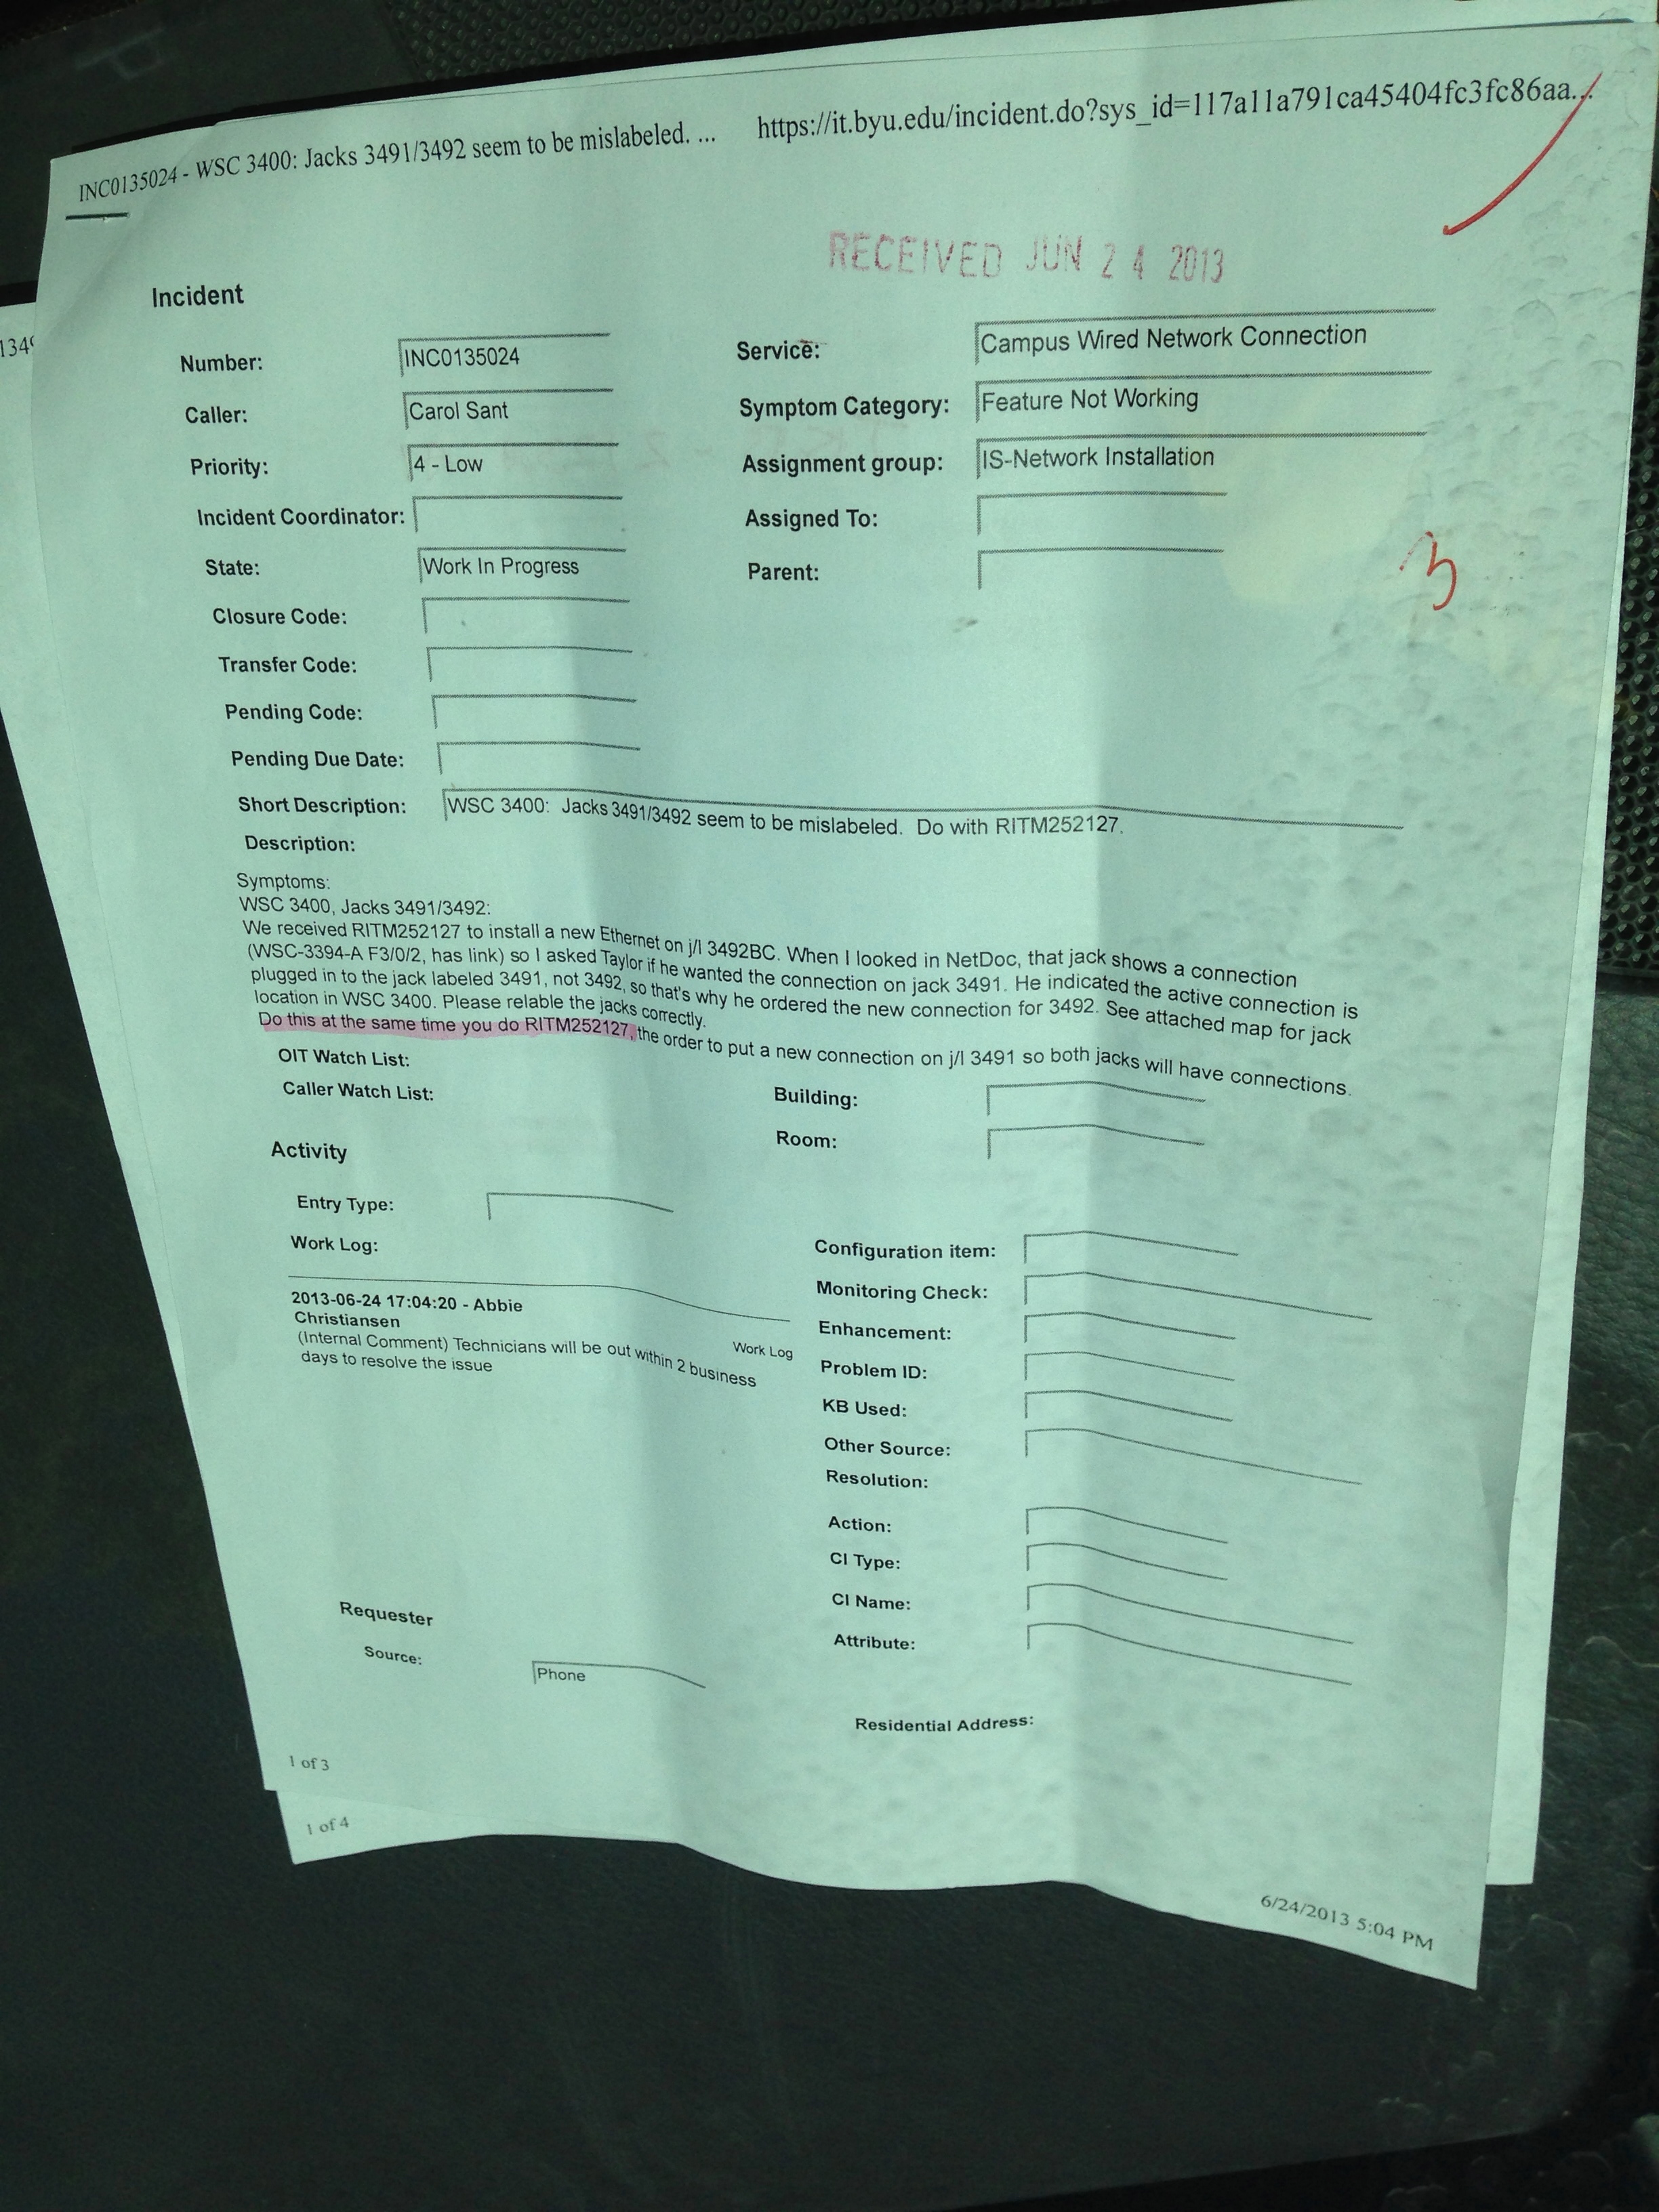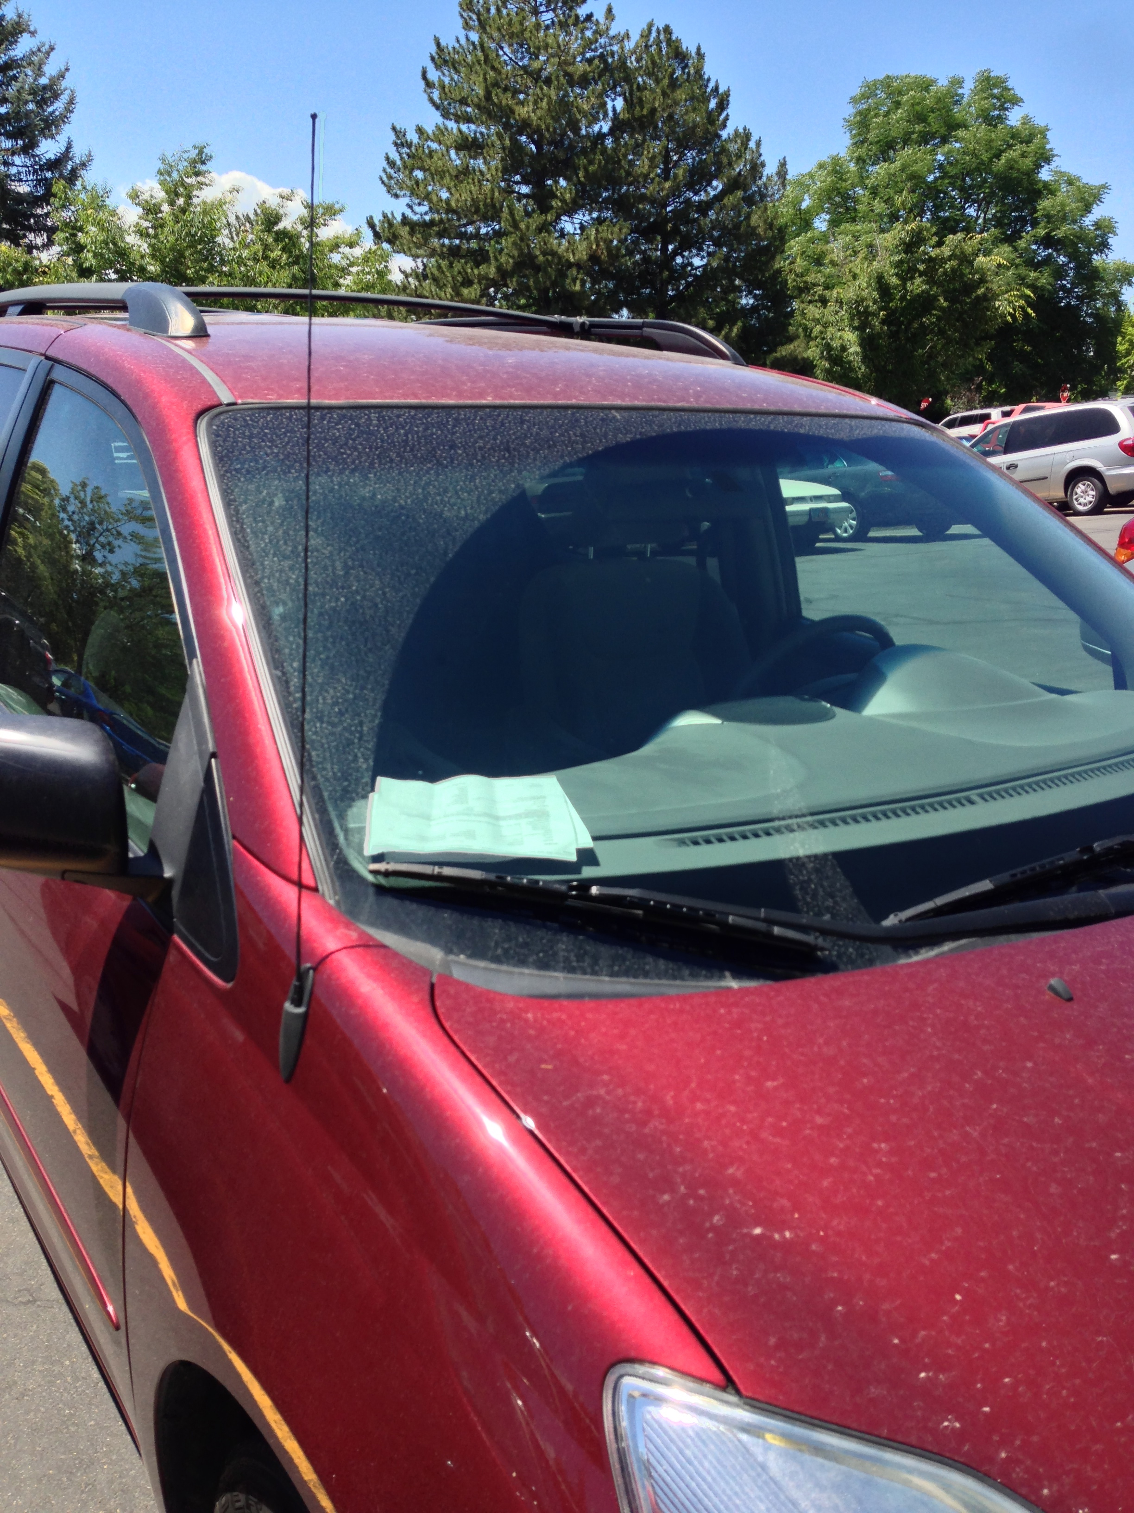
Option 7: Access Saved Passwords in a Web Browser on an Unattended Computer

This website has a list of helpful tools to recover passwords from web browsers:

http://www.nirsoft.net/password_recovery_tools.html

Option 8: Get a photo of an ID badge that is good enough to make a duplicate.

Note: Bonus points if you actually make a passable counterfeit badge.

Option 9: Photo Document the Security Cameras in a Building and Document a Route through the Building without Being Recorded

Option 10: Install a False Keylogger on a Public Computer

Pretend that a USB drive is a keylogger. Plug it into the back of a public computer, and leave it for a day. Retrieve it later. Take a picture or video of when you leave it, and when you return.

Important: Do not use an actual keylogger unless you have prior approval from the device owner.

Option 11: Enter a Pre-approved Restricted Area by Disguise

For example, use a clipboard or fake ID. You can combine this one with Option 5.

Option 12: Boot a Macintosh or Linux Computer in Single User Mode and Dump the Hash

Boot up a Linux or Unix computer (or VM) in single user mode by entering the keyword “single” at the end of the boot loader options. On a Macintosh, you can boot into single user mode by holding down the keys “⌘” and “s”.

Search online for how to dump the hash for your particular operating system. List your operating system, the commands you ran, and the password hash below.

Note: You won’t be able to enter single user mode on a Macintosh or Linux computer if full disk encryption is enabled. On a Mac, you can check to see whether FileVault is enabled by issuing this command:
fdesetup status

Option 13: Install a Reverse Shell Payload on a Powered-off Windows Computer

Follow the instructions below to install a reverse shell payload on a power-off Windows computer:

https://null-byte.wonderhowto.com/how-to/hacking-windows-10-break-into-somebodys-computer-without-password-exploiting-system-0183743/

Take a video of the Windows computer booting up and show the established Meterpreter session on your Kali VM.

Lifelong Learning

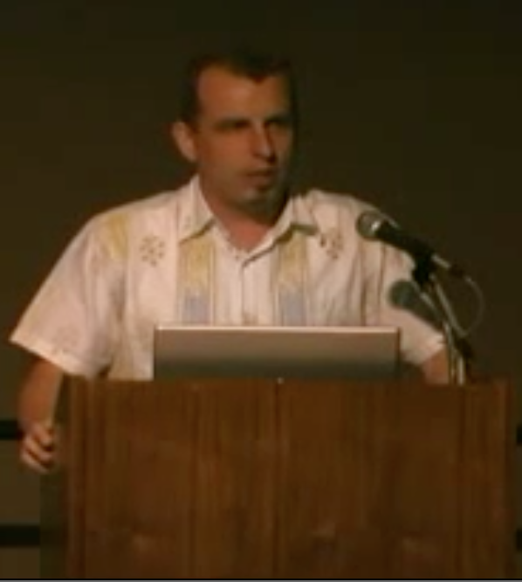 | Johnny Long, No-tech Hacking, Defcon 15  A classic Defcon talk on the effectiveness of no-tech hacking. Much of what is discussed relates to physical security.  Video: http://youtu.be/qfFELeCP-oA
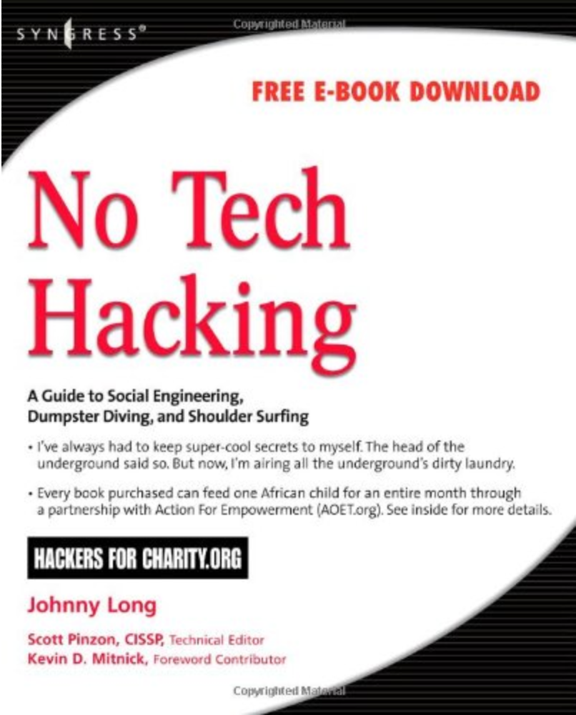 | “No Tech Hacking: A Guide to Social Engineering, Dumpster Diving, and Shoulder Surfing” by Johnny Long.  This book is an expansion of the classic Defcon talk above.  PDF on Dropbox, via BYU Library access: http://bit.ly/17ICtEa  Amazon: http://amzn.com/1597492159
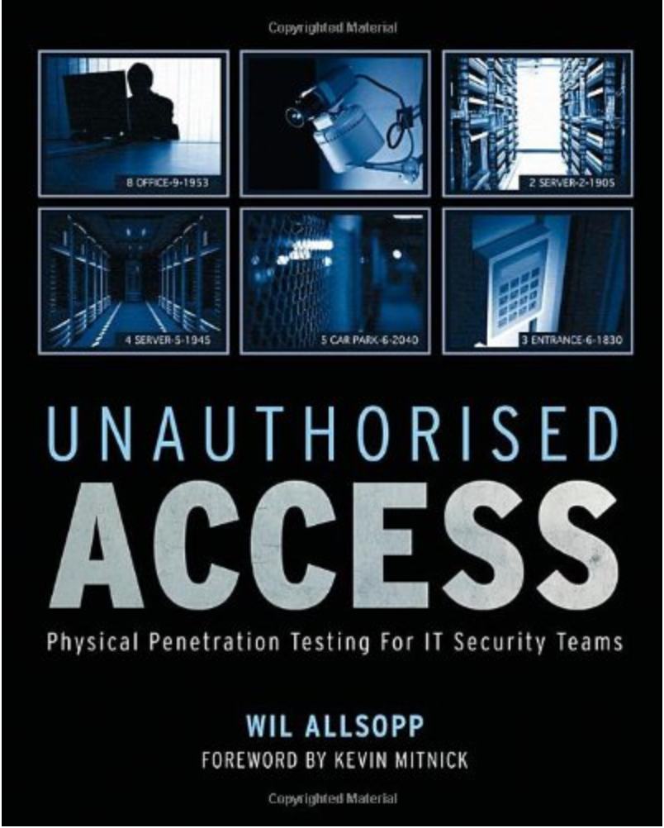 | “Unauthorised Access Physical Penetration Testing for IT Security Teams,” by Wil Allsopp  Another good book on penetration testing of physical security.  BYU library: http://site.ebrary.com.erl.lib.byu.edu/lib/byuprovo/docDetail.action?docID=10325810  Amazon: http://amzn.com/0470747617
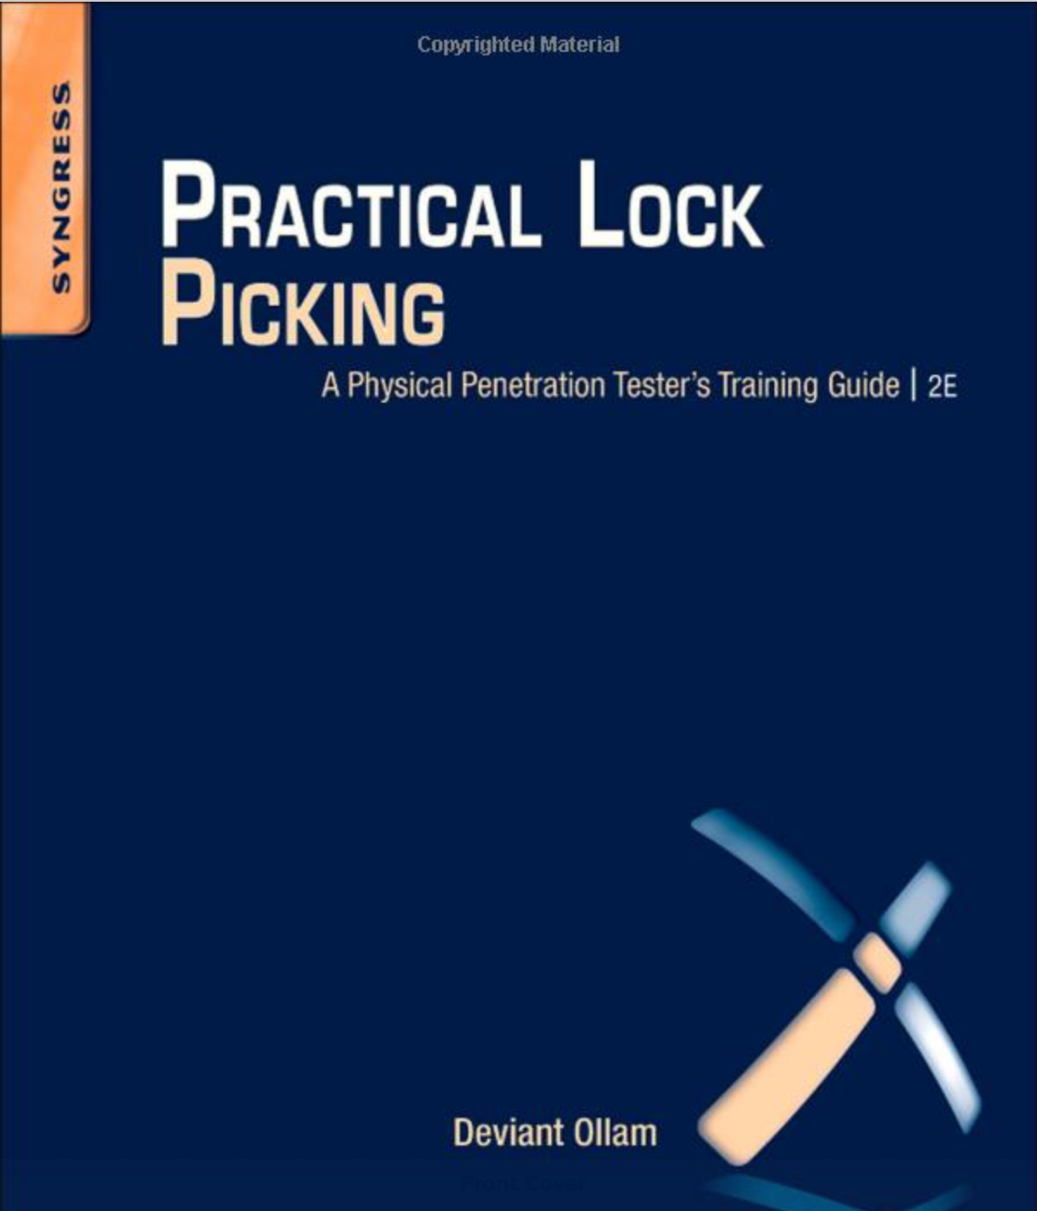 | “Practical Lock Picking, Second Edition: A Physical Penetration Tester’s Training Guide” by Deviant Ollam  The best book available to learn lock-picking.  PDF on Dropbox, via BYU Library access: http://bit.ly/GQCekn  Amazon: http://amzn.com/1597499897
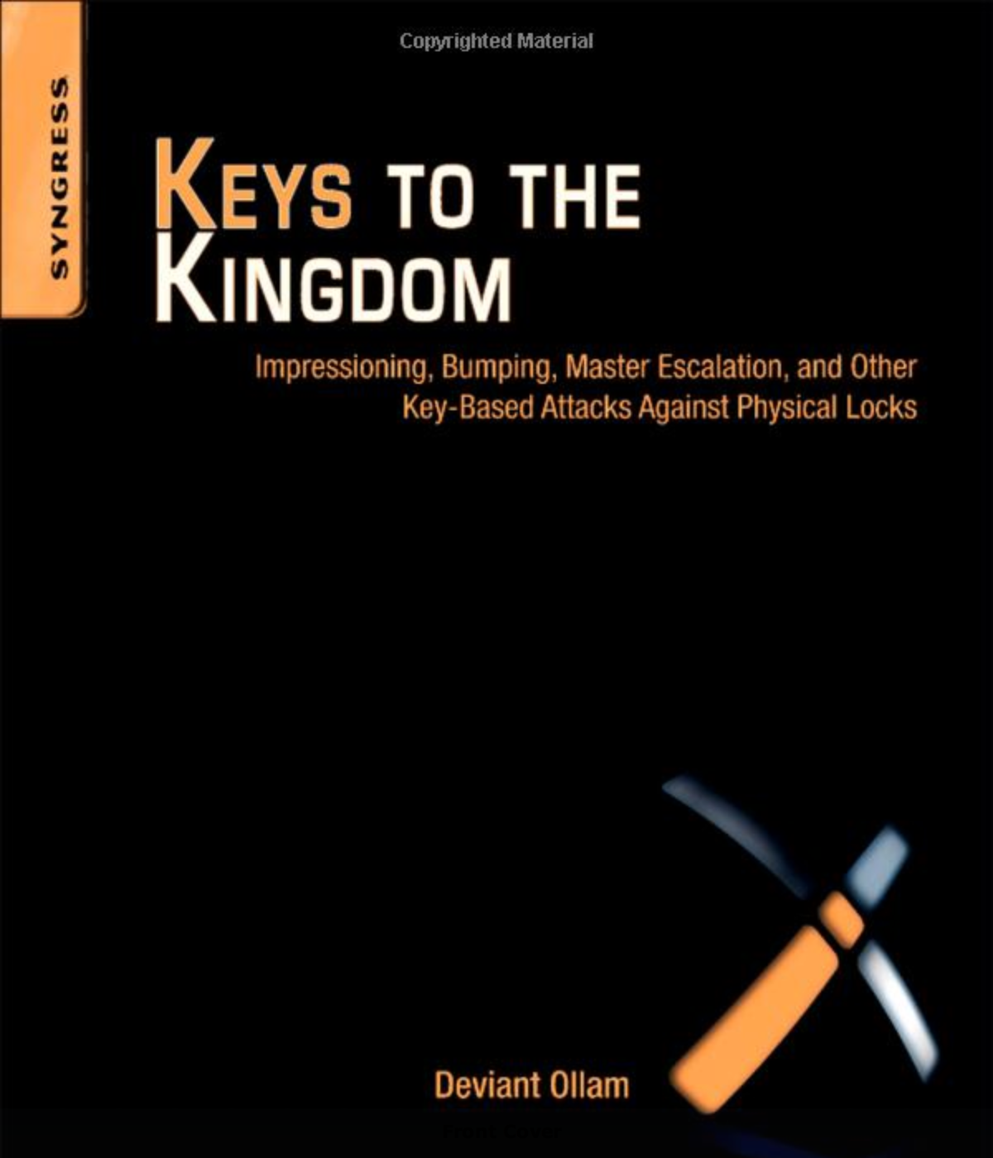 | “Keys to the Kingdom: Impressioning, Privilege Escalation, Bumping, and Other Key-Based Attacks Against Physical Locks” by Deviant Ollam  Another great and accessible book on more advanced lock-picking by Deviant Ollam.  PDF on Dropbox, via BYU Library access: http://bit.ly/1crwlFD  Amazon: http://amzn.com/1597499838

