MIS 3537
Internet & Supply Chains

Refer to the case “RFID at the Metro Group” from the course packet

Answer the following questions briefly (6-7 lines each):
- List any three advantages of RFID over bar-code scanning?

- One of the important decisions that companies make in RFID is what level should the tagging be done. Tagging can be done at the pallet level or at the case level or even at the individual product level (see figure below for the difference between pallets and cases). Metro Group (which is the retailer) is debating whether to implement the tags at the pallet level or the case level. Perform a cost benefit analysis to make your recommendation to the company. Each pallet has 70 cases and every week, a single retail store processes 30 pallets. Assume that Metro Group has 436 stores. Each RFID tag costs 17 €-cents.
Hint: perform a quantitative analysis using the information in Exhibit 9
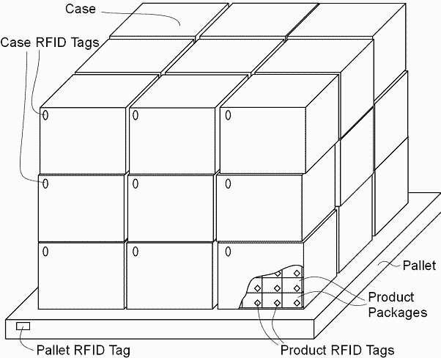

- What were the challenges faced by Metro during the RFID rollout?

- Look at Metro DC’s process flow in Exhibit 8. List 3 ways in which the retailer can benefit from using RFID.

- What IT infrastructure would Metro Group need to put in place for adopting RFID?

All groups (expect the group making the presentation) are required to submit a printout of their answers to the instructor at the beginning of the class. Also, be prepared to discuss the case in the class.

Source: http://www.jefflindsay.com/gif/rfid-pallet.gif

