Quick Guide to MySQL Workbench
If you want to install MySQL Workbench on your own computer:
- Go to: http://dev.mysql.com/downloads/tools/workbench/5.2.html
(Version 5.2 is not the latest version, but it’s the one we have installed in the labs, so you might as well use that one.)
- Download the version for your operating system. For Windows, use the “Windows (x86, 32-bit), MSI Installer.” For Mac, use the “Mac OS X (x86, 32-bit), DMG Archive.”
- Install the software just like you would any other program (double-click on the installer and follow the wizard’s instructions).

Setting up a connection in SQL Workbench for the first time (in the lab or your own computer):
- Start SQL Workbench.
- Under SQL Development, select “New Connection”.
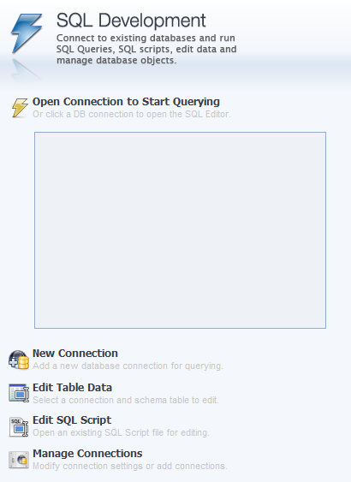

- You’ll see a “Setup New Connection” dialog. Fill in the following information:
Connection Name: class1
Hostname: class1.mis.temple.edu
Username: Your username given to you by your instructor
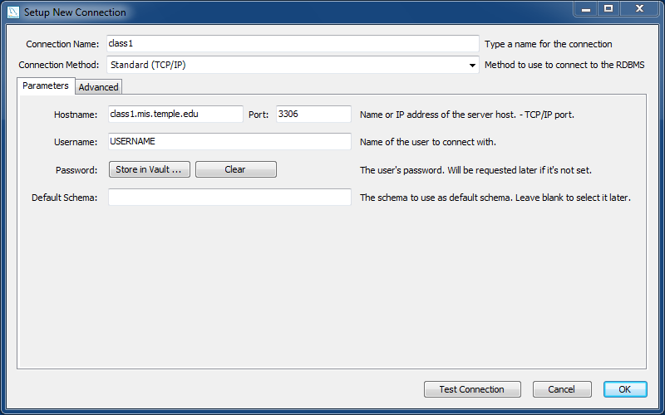
- Click “OK” and you’ll see the connection under “SQL Development”:
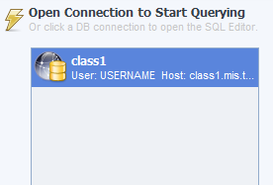
- Double-click on your new connection. You’ll see a password dialog:
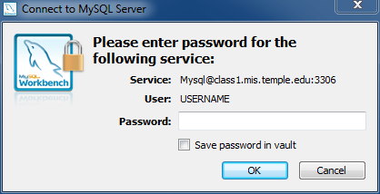
- Enter your password. Then click “OK.”
If you are using your own computer, you can save it in the vault (so you won’t have to enter it again). But if you are in a lab, just to be safe DO NOT save your password.
- You should see the main screen for SQL Workbench:
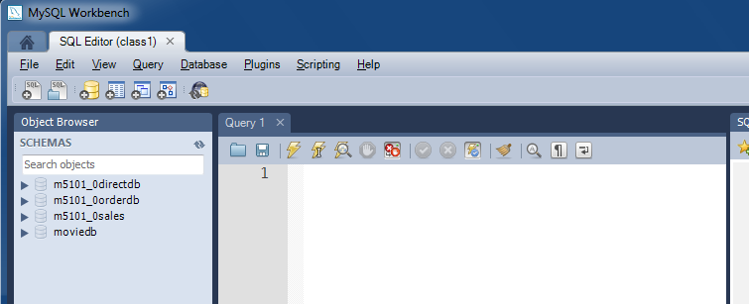
Your Object Browser will look a little different. But if it basically looks like this, you’ve successfully logged in to the MySQL server using MySQL Workbench!
On your home computer, once your connection is set up, you can just start MySQL Workbench and skip to step 5.
Try a few things out to make sure everything is working:
- First, click on the arrow beside the moviedb schema. You should see this:
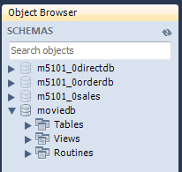

- Now click the arrow beside Tables. You should see this (a list of all the tables in the moviedb database):
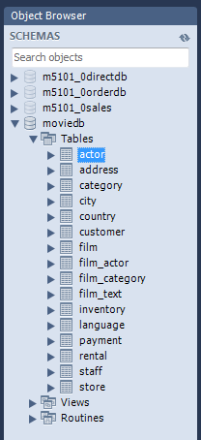

- Now that you see all the tables are there, type the following query in the “Query 1” pane:
SELECT * FROM moviedb.actor

- Then click the lightning bolt () to execute the query.

- You should see the following set of results:

