**In-class Exercise for Week 6: Data Visualization with Tableau Public**

**Objective:** Try out an information visualization tool to apply best practices.

To complete this exercise, you’ll be working with Tableau Public, a web-based tool for creating data visualizations. Follow the steps below:

1. Start Tableau Public.   
     
   If you want to install the software on your own computer, go to <http://www.tableausoftware.com/public/download>. Enter your email and click “Download Tableau Public” and follow the instructions provided.
2. Download the “Olympic Athletes” dataset from the Community Site and save it to your desktop.
3. At the top left of the screen click the orange “Open Data” button. Under “In a file” on the left side, click Microsoft Excel.   
     
   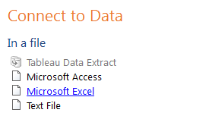
4. Open the “Olympic Athletes” dataset that you saved to your computer.   
     
   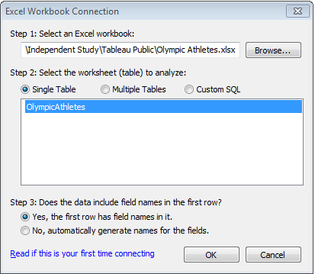  
     
   Select “Single Table” and “Yes, the first row has field names in it” and click “OK”.
5. Let’s say you want to determine the total number of Bronze Medals won each year. Drag the ‘Year’ dimension to the ‘Columns’ field and the ‘Bronze Medals’ measure to the ‘Rows’ field. This should automatically create a bar chart and show the sum of bronze medals for each year from 2000 to 2012.   
     
   What year were the most bronze medals won? _____________________  
     
   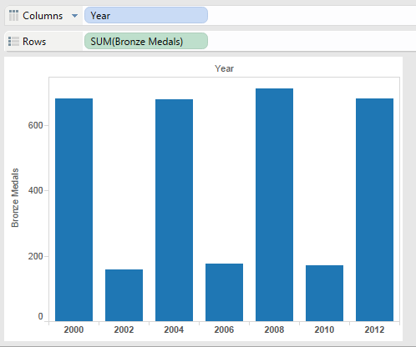
6. Now let’s add a chart of all medals won by adding Total Medals to the Rows field, right after Bronze Medals. You will now see Total Medals underneath the count of Bronze medals.  
     
   Looking at both charts, what can you tell about the Olympics in 2000, 2004, 2008, 2012 versus those in 2002, 2006, and 2010?   
     
   _________________________________________________________
7. Now determine the Total Medals by Year by Sport. Remove ‘Bronze Medals’ from Rows by clicking on the label and pressing delete.   
     
   Under ‘Dimensions’ drag the ‘Sport’ label to the ‘Color’ icon under ‘Marks.’   
     
   
8. It will look like a mess – a stacked bar chart. So using the drop down in the Marks box, switch to a Circle chart.
9. Now also apply a filter to analyze specific sports. Select Swimming, Tennis, and Wrestling by selecting each one (use CTRL + click). Then apply the filter by clicking “Keep Only.”  
   *(If you don’t see that option make sure you are hovering over one of the selected sports.)*  
     
   You’ll now see something like this:  
     
   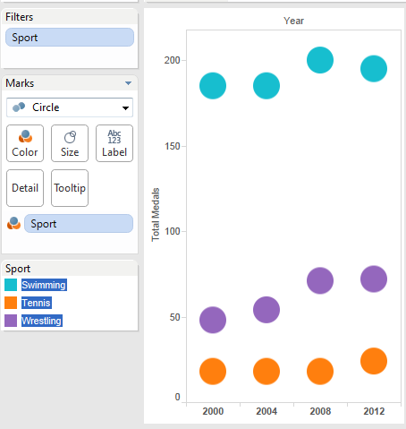

Which sport consistently has the most medals? _______________________________  
  
  
Which sport is growing the most? _______________________________________

1. Rename the sheet ‘Total Medals by Sport’ by double-clicking the tab at the bottom and typing the new label.
2. Create a new sheet by clicking the () icon at the bottom of the page.
3. Let’s determine total medals by Country. Drag the Country dimension to the Columns field and Total Medals to the Rows field.
4. Now filter to see only the year 2012 by dragging the Year dimension under the Marks box (the white space below Detail and Tooltip).  
     
   Then double-click on Year and unselect everything except 2012. Then click OK.  
     
   Which country won the most medals in 2012? ____________________________________
5. Now remove Year from Marks and Total Medals from the Rows.
6. Now add Bronze Medals to Rows.
7. Country names are geographic data. We can map the data by changing the chart type to Map. Click “Show Me” in the top right corner of the window and select the “symbol map” (first row, second column)  
     
   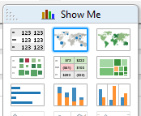
8. Looking at this map, we can see by the size of the circles where the most bronze medals were and where the least. You can place your mouse over a circle to see the exact number. For example:  
     
   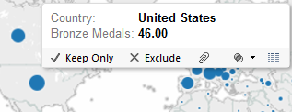  
     
   Which country has won the most bronze medals? __________________________
9. Now switch the visualization under “Show Me” to a filled map by selecting the map icon in the third column of the first row. This is a heatmap – the darker the color, the higher the number.  
     
   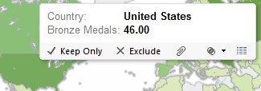  
     
   Verify your answer above was correct.
10. Finally, we’ll make a tree map (under “Show Me,” it’s the icon in the second row, third column). From left to right we can see the greatest number of bronze medals to least, respectively.   
      
    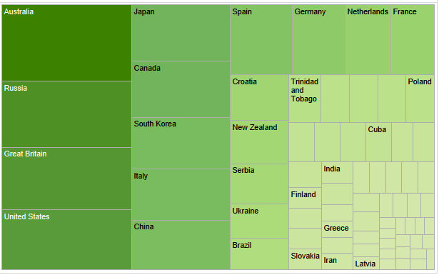

Using the tree map helps us identify the highest/least number more easily since finding the smallest dot (or the lightest color) on the map feature could be difficult. If you run your mouse over each square, details will pop-up.  
  
Name two of the countries with the least number of bronze medals?   
  
_____________________________________________________________________

1. Our last step is to construct a dashboard. Create a new dashboard by clicking on the () icon at the bottom of the window. First drag the “Total Medals By Sport” sheet (under the Dashboard pane on the left side of the window) to the blank space.   
     
   Then drag the “Total Medals by Country” sheet to the bottom of the window. It will look like it’s overlapping the “Total Medals by Sport” graphic – that’s ok – it will resize.  
     
   You’ll wind up with something like this:  
     
   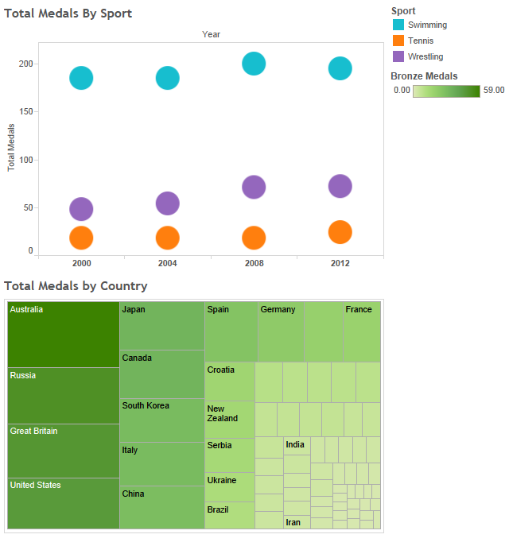
2. If you want to save your workbook, you’ll need to create a Tableau Public account. The “Public” version of Tableau only lets you save to the web.

You can do that by setting up an account. However, you can also save your work by “screencapping” the graphic.  
  
From the Start Menu, type “snip” and press Enter. That will bring up the snipping tool (a separate program that comes with Windows – it’s not part of Tableau).

1. Under the “New” menu, select “Rectangular Snip”  
     
   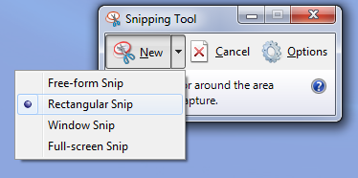
2. Draw a box around the graphic by clicking and dragging your mouse. When you are done, you’ll see the image appear in a separate window.
3. Go to File/Save As… and give the file a name.
4. You can now insert the graphic into any document.