Creating Your SAS OnDemand Enterprise Miner Account

This document will guide you how to create an online account to use SAS services.

Every time you use the SAS OnDemand service, start with this URL:
https://support.sas.com/ctx3/sodareg/index.html?execution=e1s1
You should see following interface when you go to the page:
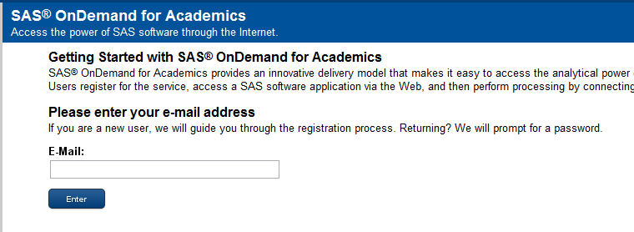

Input your email address. We recommend you use your Temple email address.

If this is your first time, it will redirect you to following page:
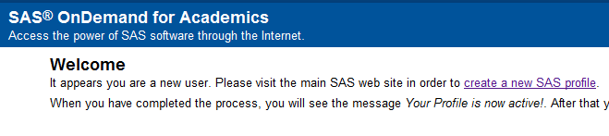
Click “create a new SAS profile”.

You should see this registration page:

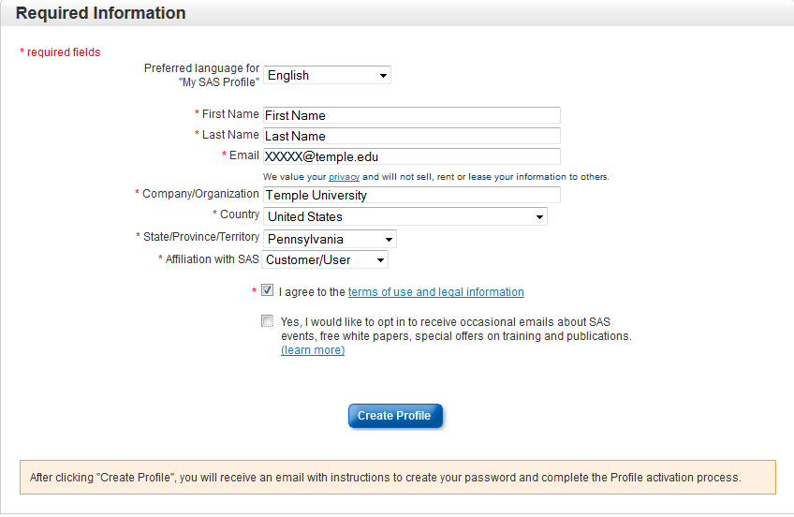
Fill in all the fields above. Make sure your company name is “Temple University”. This is very important (spell it correctly!)! Otherwise you might not be able to use this service for free!

When you finish, click “Create Profile”, and you will see:
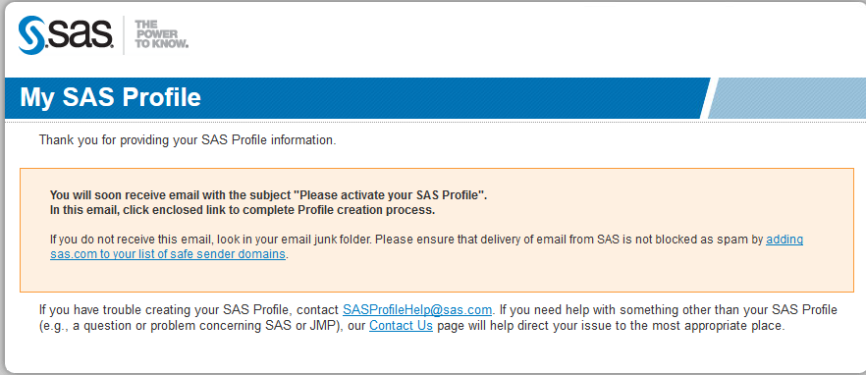
Nowcheck your email and click the activiation link like this:
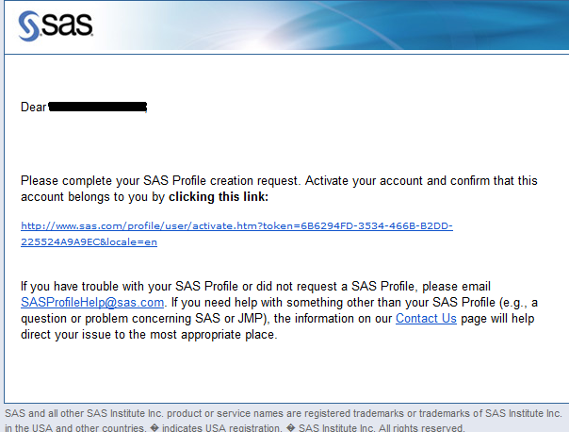
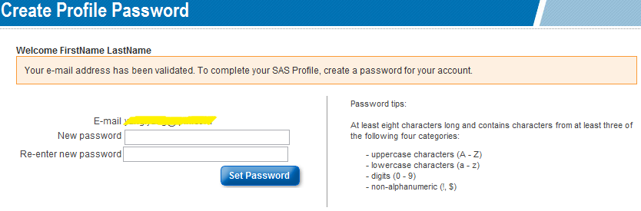
Input your password twice. Click “Set Password.” The password rules are similar to your Temple Email account. It’s easiest if you use the same password as your Temple (AccessNet) ID.
Now your account is active:
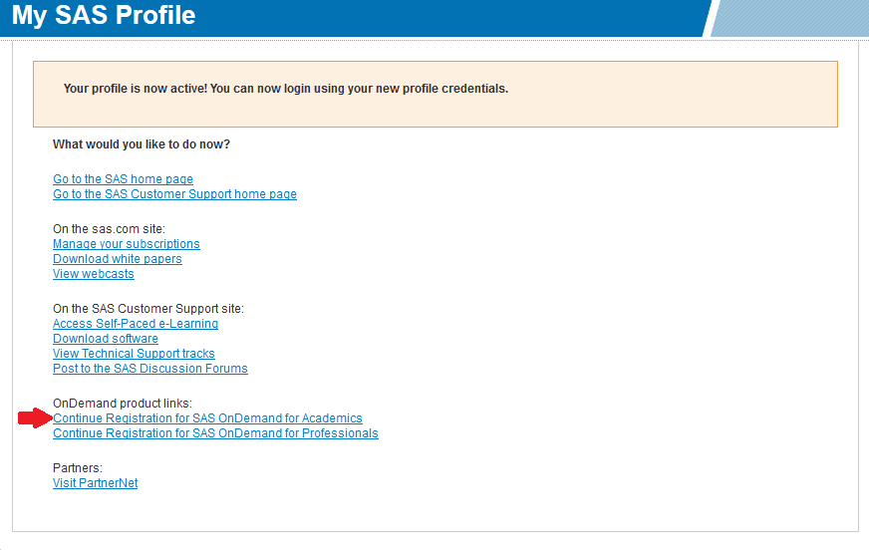
Click “Continue Registration for SAS OnDemand for Academics.”

You’ll see the following page. Choose the “I am a student …” option.
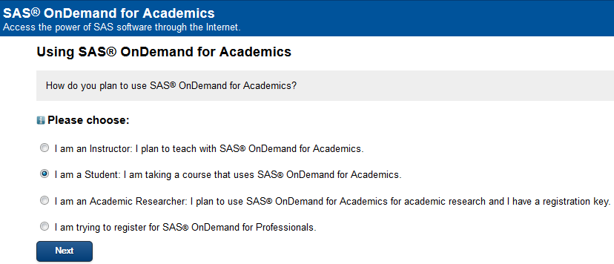
Then click “Next” button.

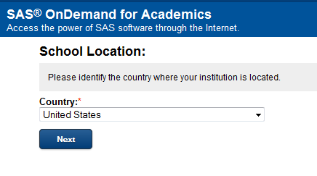
Choose “United States” as your school location. Then click “Next.”
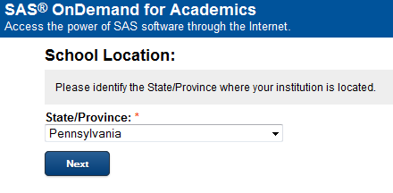
Choose “Pennsylvania” and click “Next.”
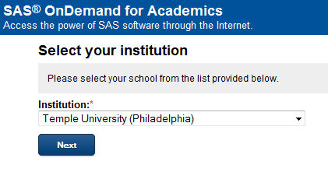
Choose “Temple University (Philadelphia)” and click “Next.”
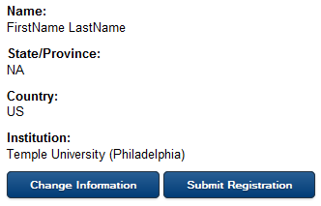
Click “Submit Registration.”

You’ll now see the following confirmation screen:
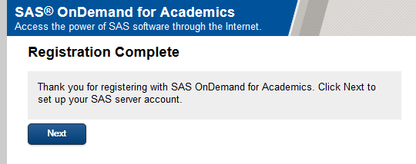
Click on the “Next” link above.
After you finish the registration, you’llneed to accept the SAS license agreement on this screen:
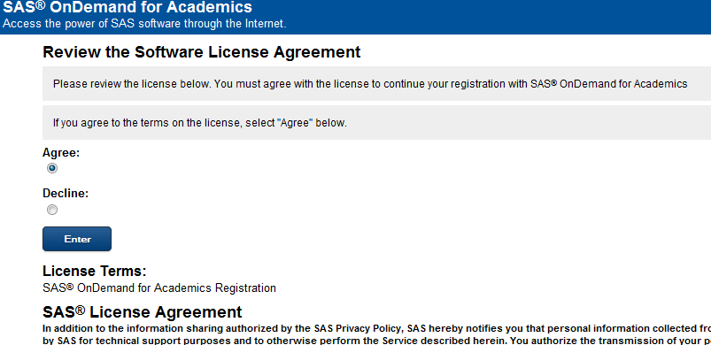
Select “Agree” and click the “Enter” button.

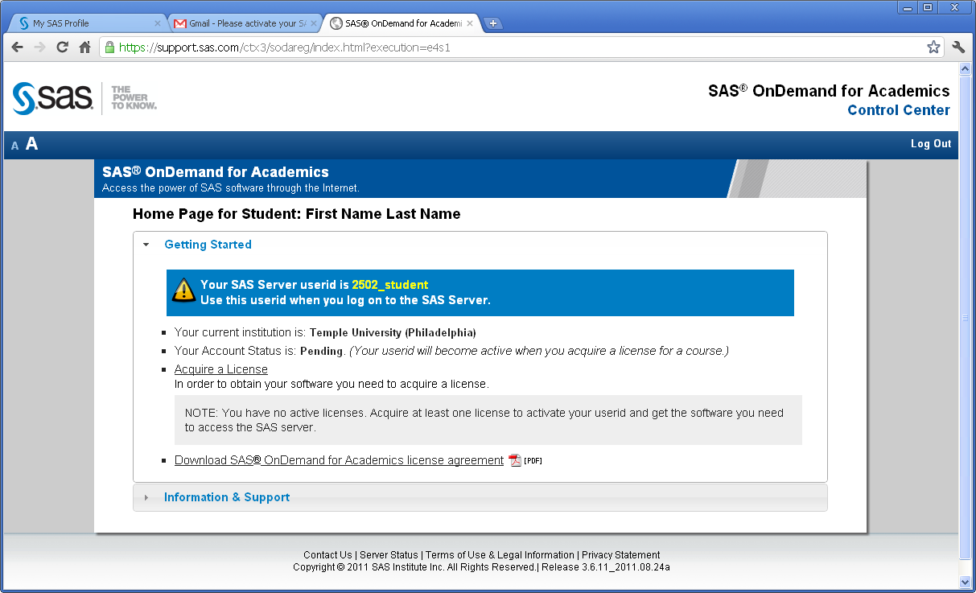

Now you need to get an active license for your use of the SAS OnDemand service.
Click “Acquire a License”. You should see following screen:
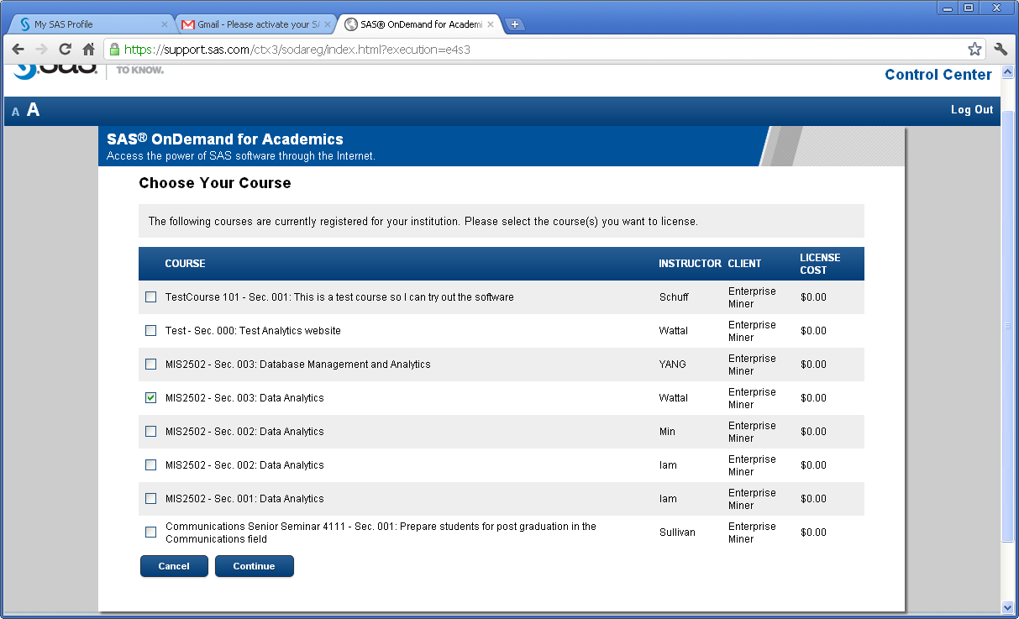
This screen lists all available courses that Temple University is providing at SAS. Choose your course section (“MIS5101 – Business Intelligence) and click “Continue”.

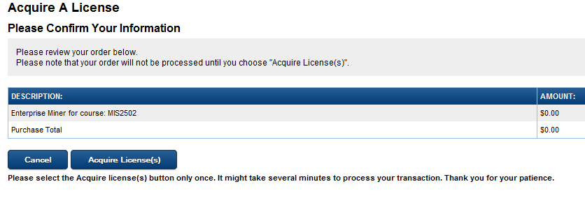
Click “Acquire License(s)” to continue. You should see this screen:
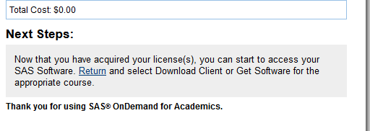
Click “Return”

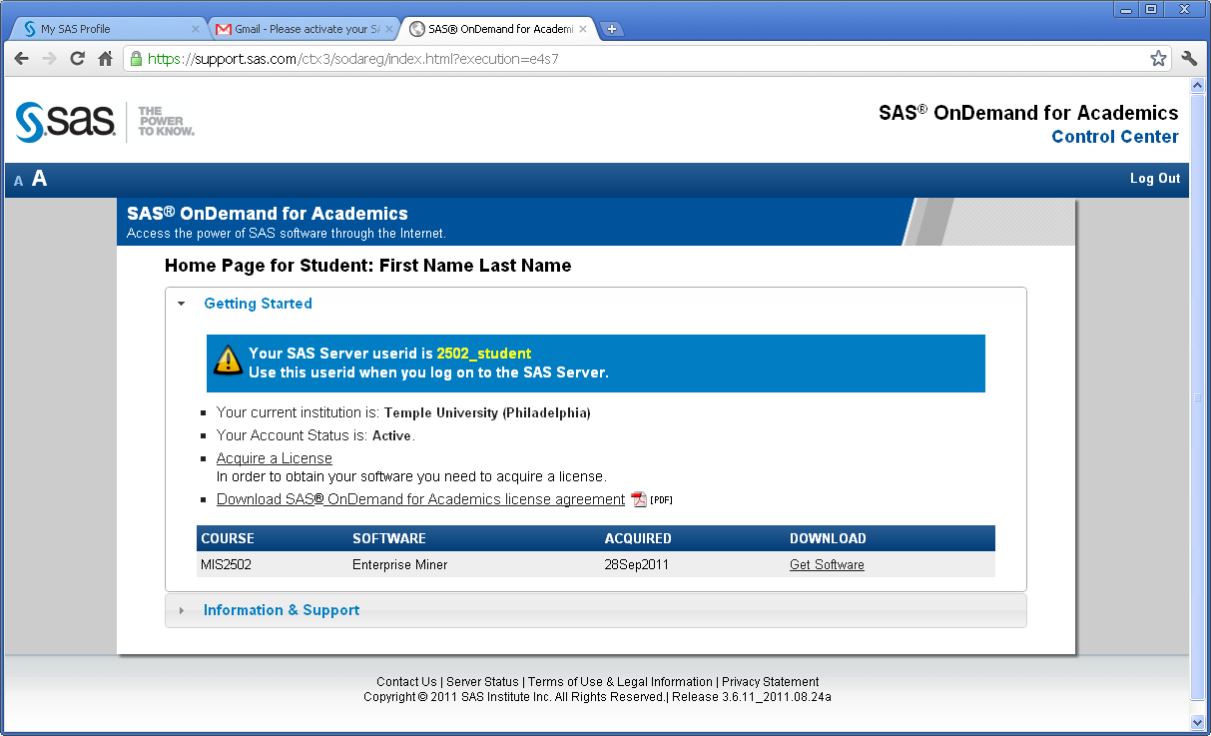
You should see your course listed. In that row, click “Get Software”
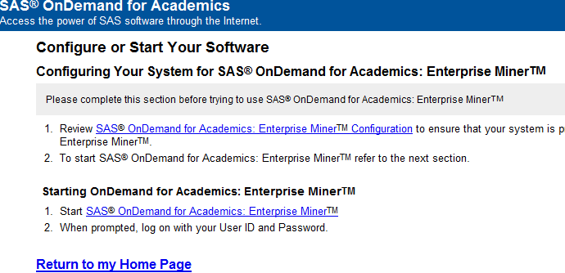

You are now ready to use SAS Miner by clicking “Start SAS OnDemand for Academics: Enterprise Miner.”.
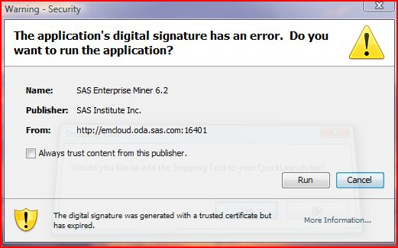
You may see a pop-up window as following and ask you whether trust this program. Select the option to “Always trust content from this publisher” and click “Run” button.
If the same warning window comes up a second time, just repeat that step.

You may see a different pop-up window as following and ask you how to open the file. Select the option to “Java™ Web Start Launcher” and click “OK” button.
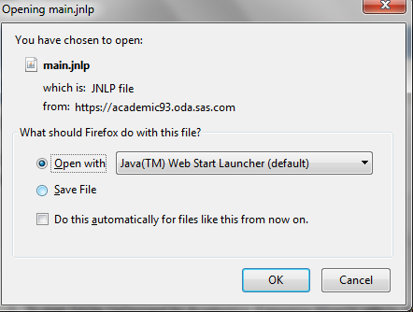
SAS OnDemand takes a while to load, especially the first time. It can take as long as three minutes! Just be patient and you’ll get to the login screen.

Along the way, you may see another pop-up box which asks you whether block this application Click “No.”
YOUR INSTINCT WILL BE TO CLICK “YES” HERE. DON’T DO IT!
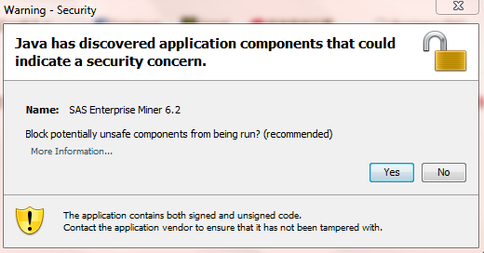
Next you will see a pop-up window which is our entrance to SAS Enterprise Miner
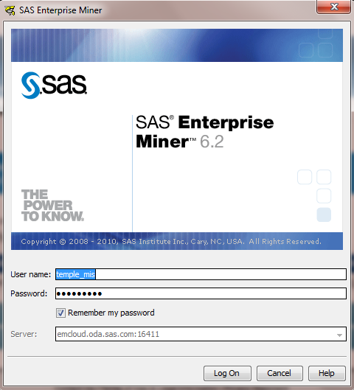
User id, not email!

Input your user name (NOT your email address) and password, then click “Log On”.

You should be now able to see our SAS OnDemand workspace:
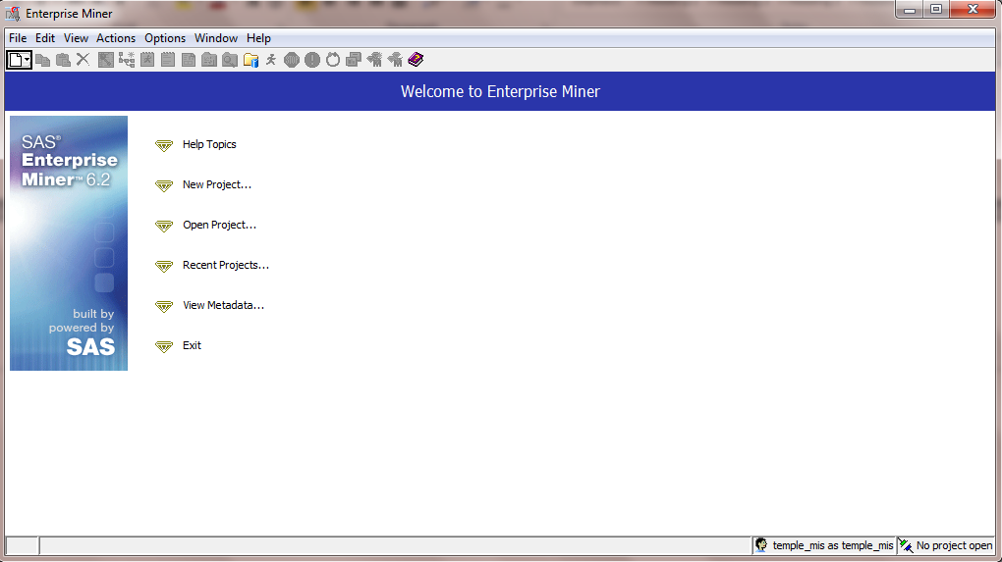
IF YOU JUST REGISTERED AND CAN’T LOG IN FOR THE FIRST TIME
If you are told you’re using the wrong user id or password, first double-check your input. Make sure you’re using your username and not your email address. If you are sure that you are using the correct user name and password, then go to check your Account status:
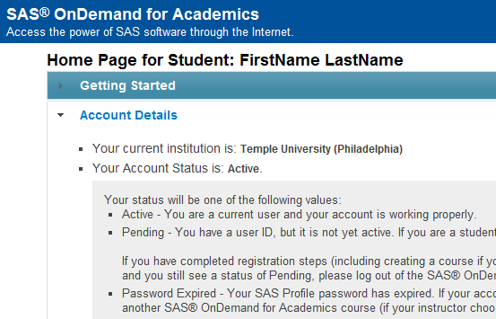
If your account status is not active, you have to wait for approval from SAS. Sometimes SAS may take several hours to activate your account. Before that, you account status may displayed as “undefined.”

