Sample questions

Q1: How does data analytics facilitate data-driven management? Refer to a specific example we discussed during the course to illustrate your answer. (75 words maximum)

Q2: If you were providing advice to a colleague running a commercial website, how would you explain to them the business value of Association Mining? Use facts from the Netflix case to back up your answer. (75 words maximum)

Q3: Consider the following two graphics. For each graphic, identify two aspects that could be improved using the data visualization concepts we discussed in class. For each aspect, explain what they are doing wrong and how the diagram can be improved. Refer to specific rules we established for good visual representations. (75 words maximum for each aspect)
Graphic A
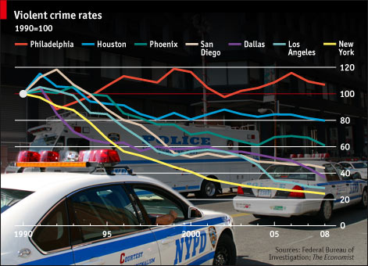

Q4: Do big data technologies portend the end of ETL? List and explain scenarios where firms could find ETL useful.

Q5: List and explain any three business applications for decision trees. What is the role of training and validation data sets in association mining?

