# Getting Started

1. Start with the motherboard oriented as in the manual

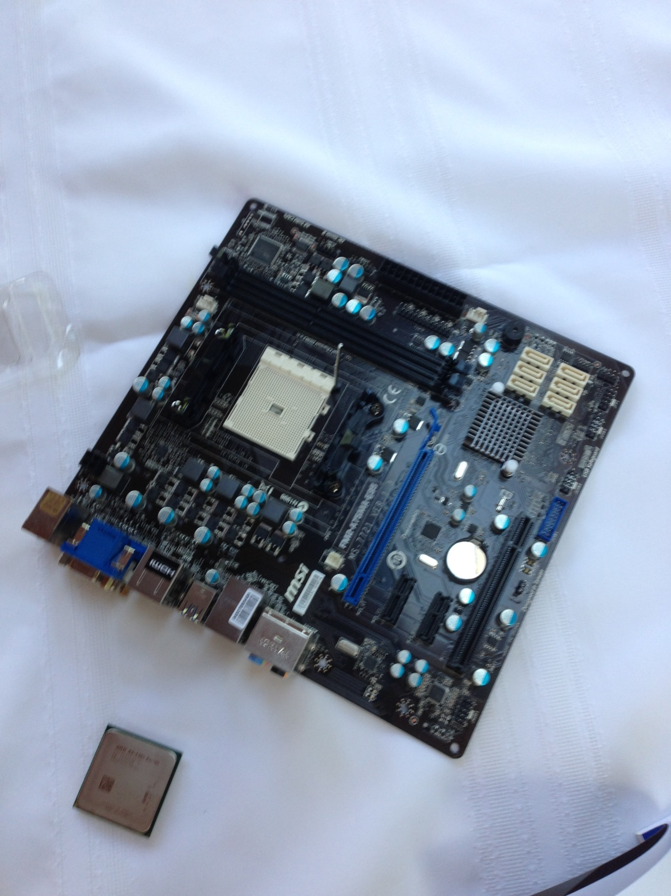

# Install the CPU

1. Lift up the lever that locks in the CPU.
2. Install the CPU with the gold arrow in the opposite corner of the base of the lever that locks in the CPU. It should drop into position.
3. Lock the CPU down by pushing down on the lever.

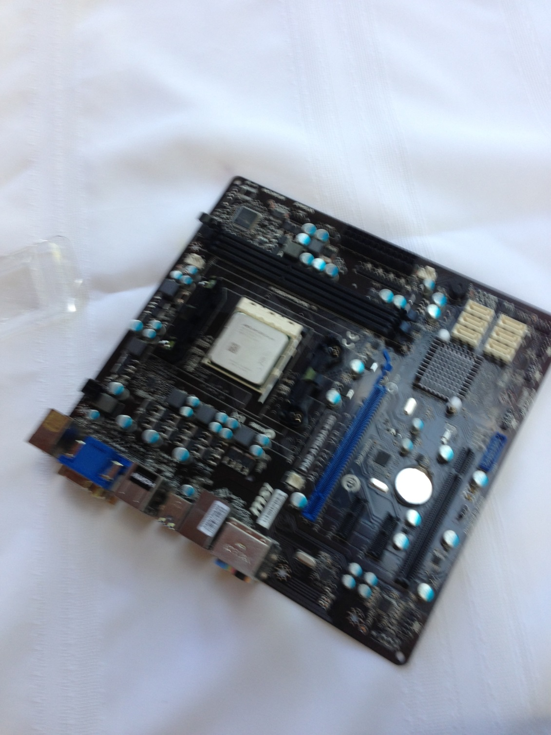

# Provide Power to the CPU

1. Connect the 4-pin power line from the power supply into JPWR2.



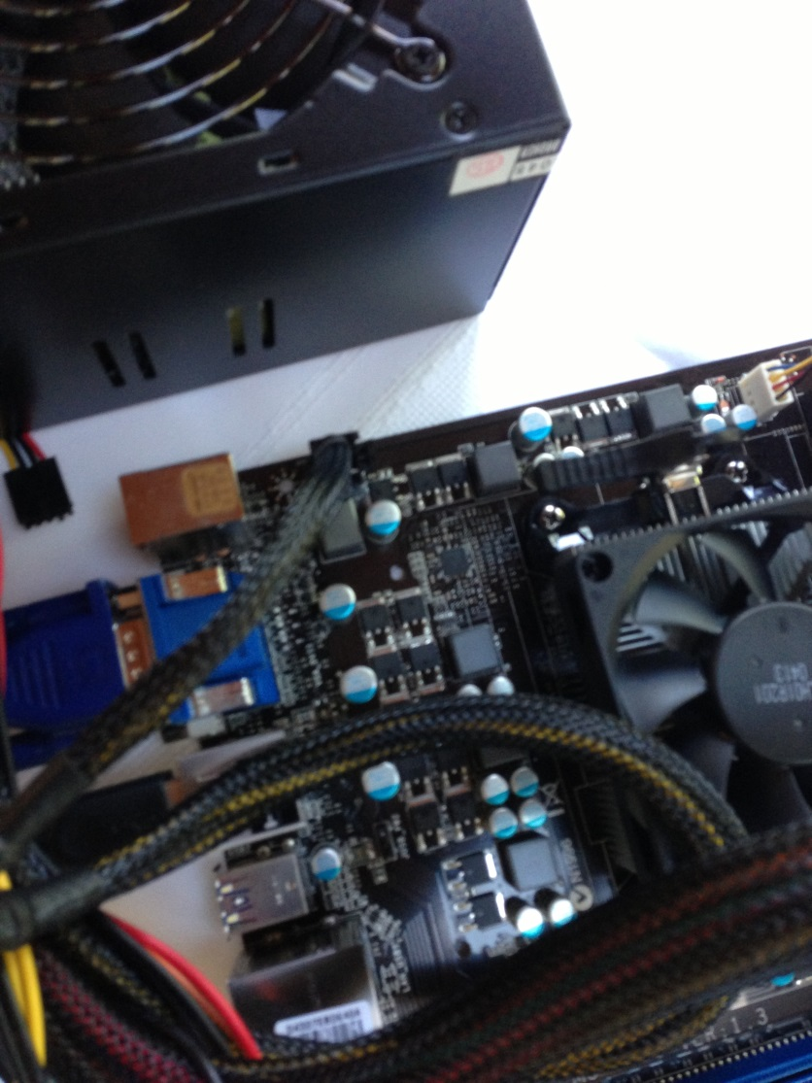

# Install Heat Sink and CPU fan

1. Attach the heat sink and CPU fan to the top of the CPU.
2. Connect the power line on the CPU fan to CPUFAN on the motherboard.

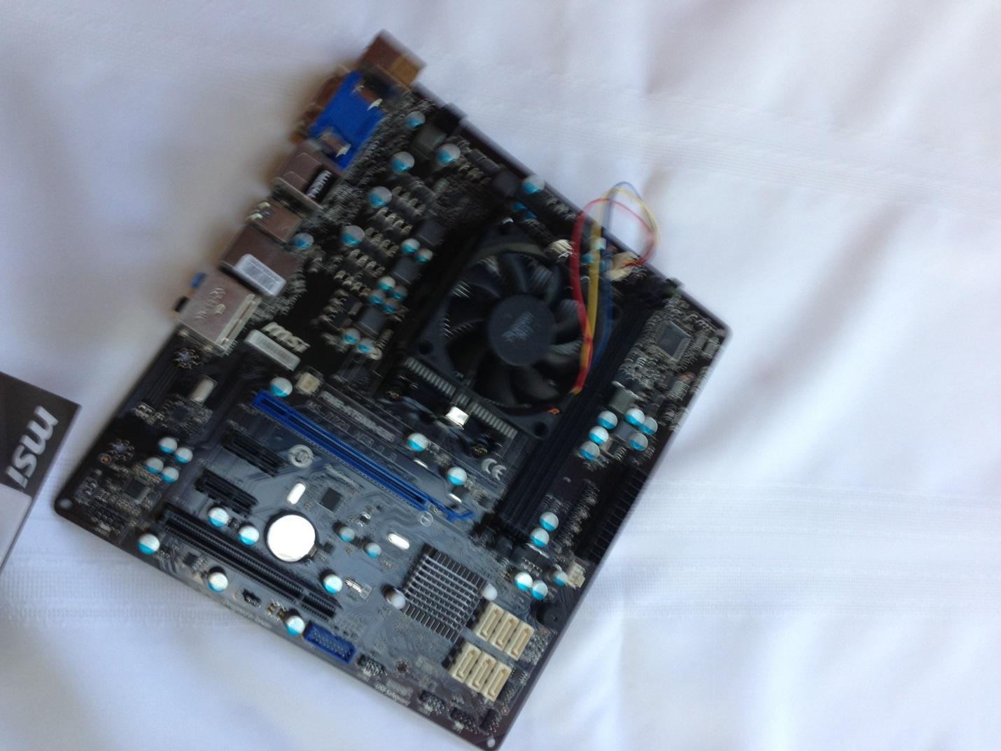

# Install RAM

1. Install DIMM into DIMM1 (the slot closest to the CPU)

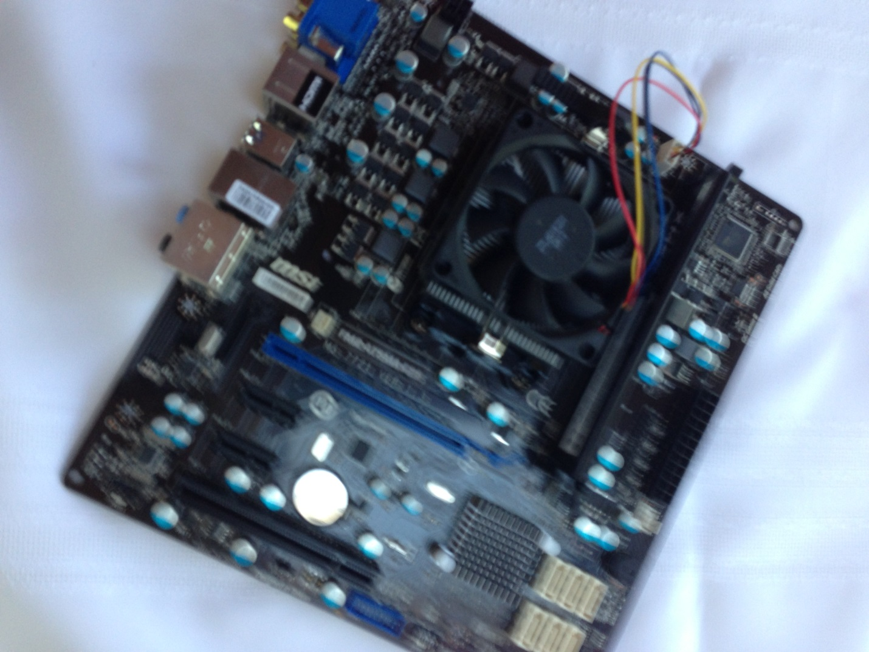

# Install hard drive

1. Connect hard drive to SATA1.
2. Connect an SATA power line to the hard drive.

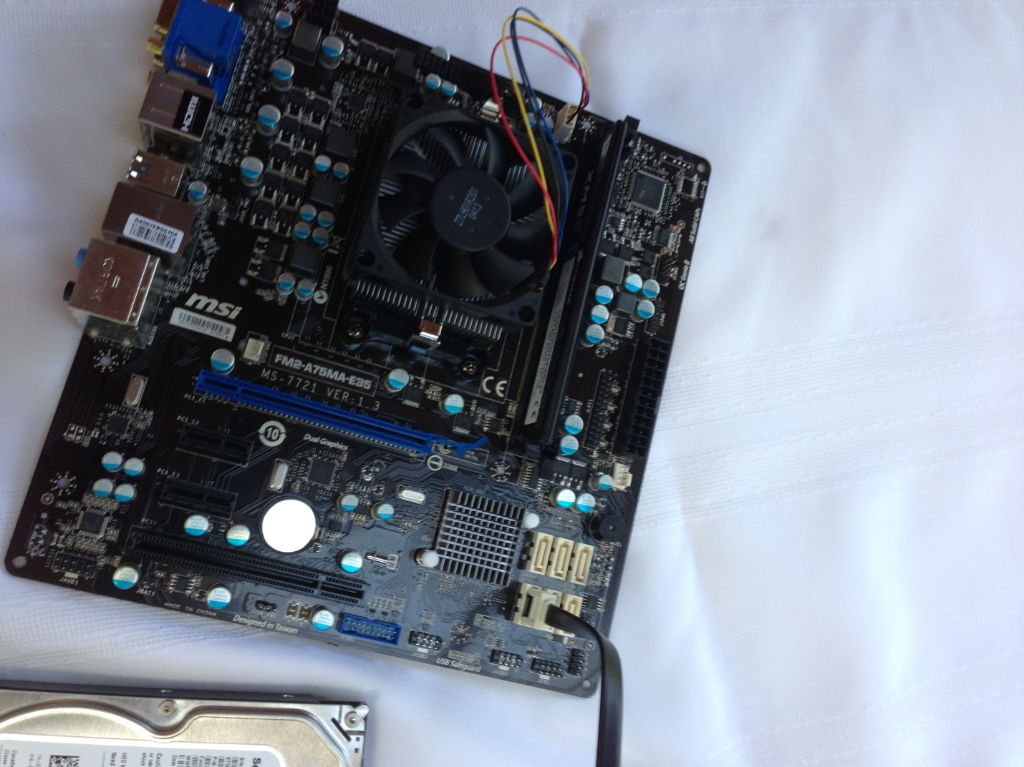

# Connect speaker and Power Button

1. Install the speaker on pins 2, 4, 6 and 8 on JFP2 (JFP2 may look different depending on the motherboard).
2. Install the power button on pins 6 and 8 on JFP1.



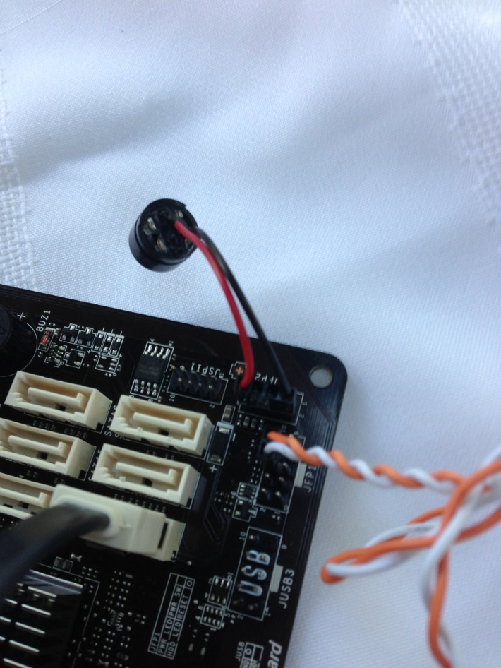

# Main Power

1. Connect the 24-pin plug from the power supply to the motherboard.



# Keyboard, Monitor and Mouse

1. Plug in the keyboard, monitor and mouse and boot up.

A75MA-E35 Motherboard Layout



A78M-E35 Motherboard Layout

