**Week 8**

**Number 1:**  It is your duty to know where the evidence is and how to find it.

Building a practice – data mapping

**Number 2:**   Reduce the size of the data

**825,000 Emails**

**5,200 in first cut**

**Number 3:** Harmful email: good email. Be proactive instead of reactive. Familiarize yourself with the lingo and the likely terms that are used.

**Number 4:**  The involvement of the client and the entire litigation team. Data or review.

**Number 5:**  There is no cookie cutter case involving e-discovery.  Tracking the data and decisions you make during the various phases of the case are very important if opposing counsel decides to challenge your process.

ERDM

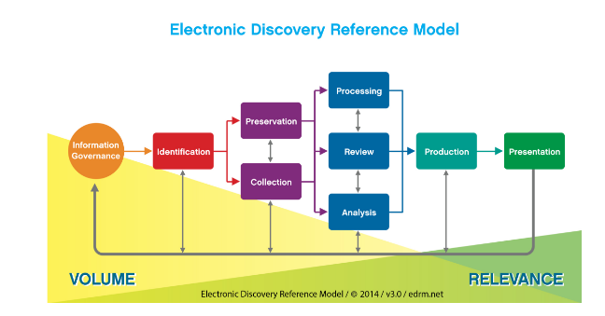

Can I just keep asking for more and more data?

Opinion on keeping everything forever.

Assignment – 1 pager (no bullet points) to Pros and Cons for keeping all information or archive/purge.