# Audit Plan

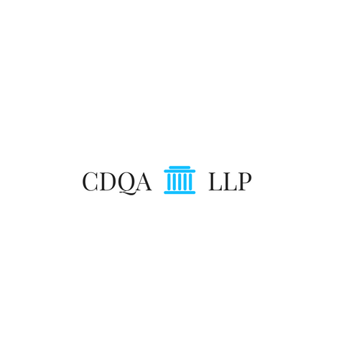

Contents

1. Executive Summary 3

1.1 Our Core Principles 3

1.2 What We Offer 3

1.3 Why Us 3

2. Audit Objective and Scope 4

2.1 Audit Objective 4

2.2 Audit Scope 4

3. Audit Process and Plan 6

3.1 Audit Process 6

3.2 Audit Plan 7

|  |  |  |  |  |  |
| --- | --- | --- | --- | --- | --- |
|  |  |  |  |  |  |

# 1. Executive Summary

## 1.1 Our Core Principles

Temple 5202 Real Estate recently enacted a Social Security Number Policy to make sure they maintain the trust of their clients and employees. CDHQ LLP is one of the most trusted and experienced auditing firm in the country and our purpose is to ensure Temple 5202 Real Estate Inc. controls are in place throughout the organization. We also provided some recommendations/ enhancements to the policy. We at CDHQ LLP want to show why CDHQ LLP is one of the most premier auditing firms in the country.

## 1.2 What We Offer

As one of the premier auditing firms we have multiple services that are offered. We worked with hundreds of different clients and as a result we develop multiple tools to automate task. With these tools, we could help reduce the time on task. This will help your internal audit department audit task much faster and better. We also offer encryption services that will help encrypt information that need encryption. This would be perfect for the Social Security Number policy that was implemented.

## 1.3 Why Us

When it comes to delivering an audit, quality is CDHQ LLP top priority. Our audit’s professional responsibility is to serve clients with reasonable assurance. CDHQ LLP is committed to continuously identifying and implementing innovative approaches and tools to help deliver and enhance a quality audit. CDHQ LLP is making a significant investment in innovations that enhance audit quality, bring greater relevance to audit findings and ultimately enrich the client experience.

# 2. Audit Objective and Scope

## 2.1 Audit Objective

At CDHQ LLP we commit to maintaining a high level of trust and integrity towards our clients, partners and employees. Protecting company’s assets, including those of our clients’, partners’ and employees in both tangible and intangible forms, is one of our main priorities. The Acceptable Usage Policy, which provides direction on appropriate usage of CDHQ LLP IT assets, is developed based on this core principle.

Furthermore, we understand that having a policy in place is only the first step in fulfilling this task. Auditing the policy once it has been implemented is the next step to ensure that employees are complying with established policy. Internal Audit will validate and test controls around this policy. The two main objectives that we seek in this audit are:

* To determine whether Temple 5202 Real Estate Inc. Social Security Number Policy was created and written in such a manner that is conducive to the Temple 5202 Real Estate Inc. end goal of proper Social Security number retention and use in a secure manner; and
* To ensure that Acceptable Usage Policies exist and provide adequate requirement for the security of the environment while ensuring compliance evidence that proper controls exist and are well designed and implemented to safeguard the environment.

## 2.2 Audit Scope

CDHQ LLP audit will encompass the examination of all systems and processes to ensure the current systems does not violate any instances outlined in the policy plan. CDHQ LLP audit will cover the following areas:

**Administrative**

* Collection of Social security number from employees will be used to meet federal, state and local reporting requirements
* Employees will not be asked to provide Social Security # to conduct any business such as identification. An employee # will be provided for Identification purposes.
* Collection of Social Security number from clients will only be or use to facilitate the transaction of the real estate sale.
* Employees should not trash paper work that that contains Social Security information before shredding the paperwork or destroying the information properly to remain confidentiality.
* Employee will have limited access to social security information.
* Employee working with paper work that contain social security number information such as tax return should not leave it in the open when done with the paper work.
* All Social Security information shall be black out when information is given to outside vendors such as third-party auditors.
* Employees shall not publicly display or discuss in any manner a client/ employee Social Security Number.

**Technical**

* Social Security number should not be emailed unless the information is encrypted.
* To access social security number information in the system employees must enter their login and password.
* Access to Social Security information will be time stamped.
* All employee should not send sensitive information using personal emails.
* All computers must be locked unless an employee is currently using the work station.
* Sensitive information should not be downloaded into external drive.

**Physical**

* Social security information shall be stored and filed in a secured location that is locked.
* While working with sensitive information at your desk information must be locked in your drawer.
* Social security information shall be stored and filed in a secured location that is locked.

**Legal and Regulatory**

* Legal Requirements documented for the current year.
* Legal Review Completed
* Regulatory Review Completed
* Regulatory Requirements documented for the current year.

# 3. Audit Process and Plan

## 3.1 Audit Process

## 



## 3.2 Audit Plan

