Introduction
- Perform all the searches in your text from pages 44 – 50
- Submit a screen shot of your search results WITH the query statement you used to produce the results.

Searches

Top Browsers
source=”access*.log” index=”lab0506” sourcetype=”access_combined_wcookie” | top useragent
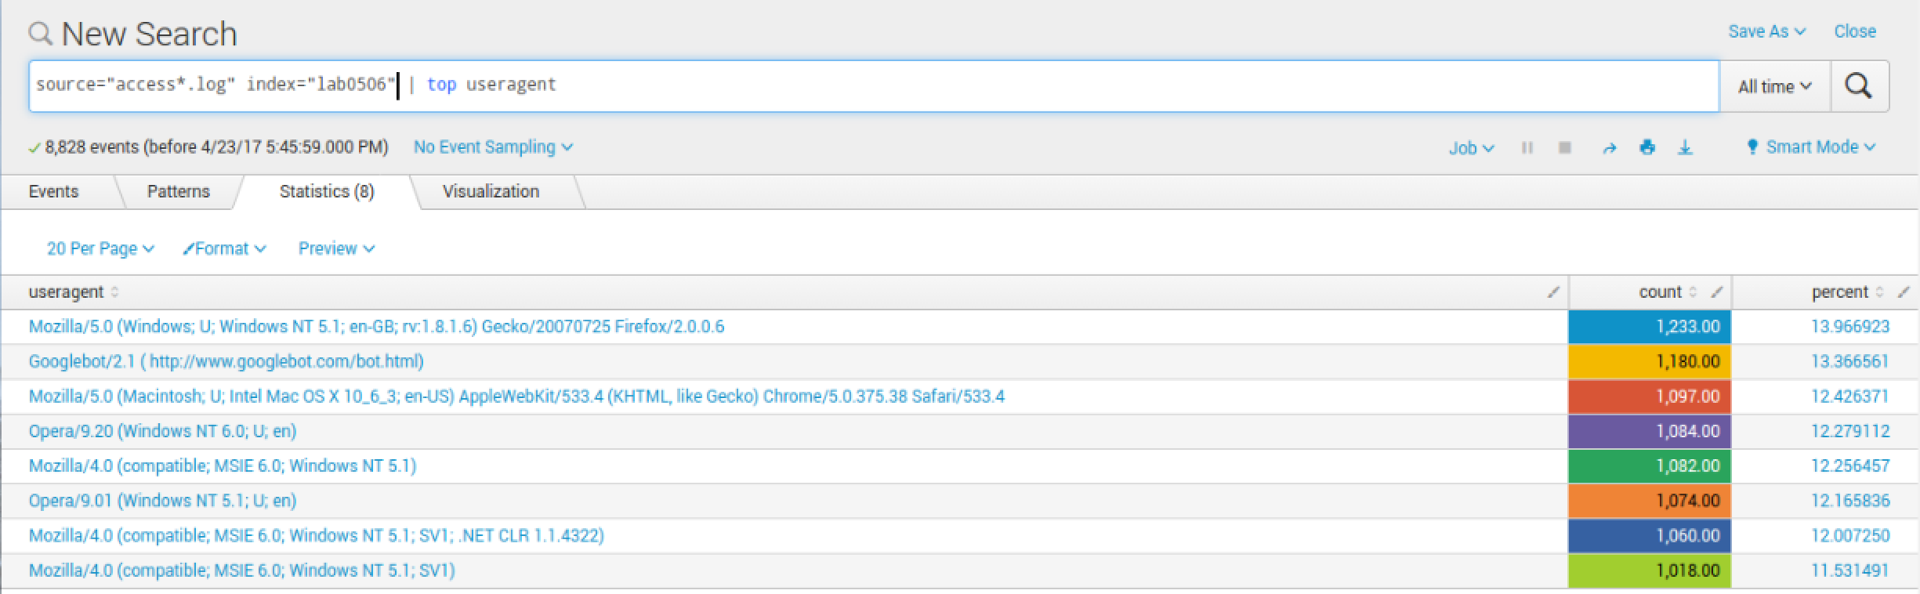

Top 5 IP Addresses
source=”access*.log” host=”UD1404” index=”lab0506” sourcetype=”access_combined_wcookie” | limit=5 clientip

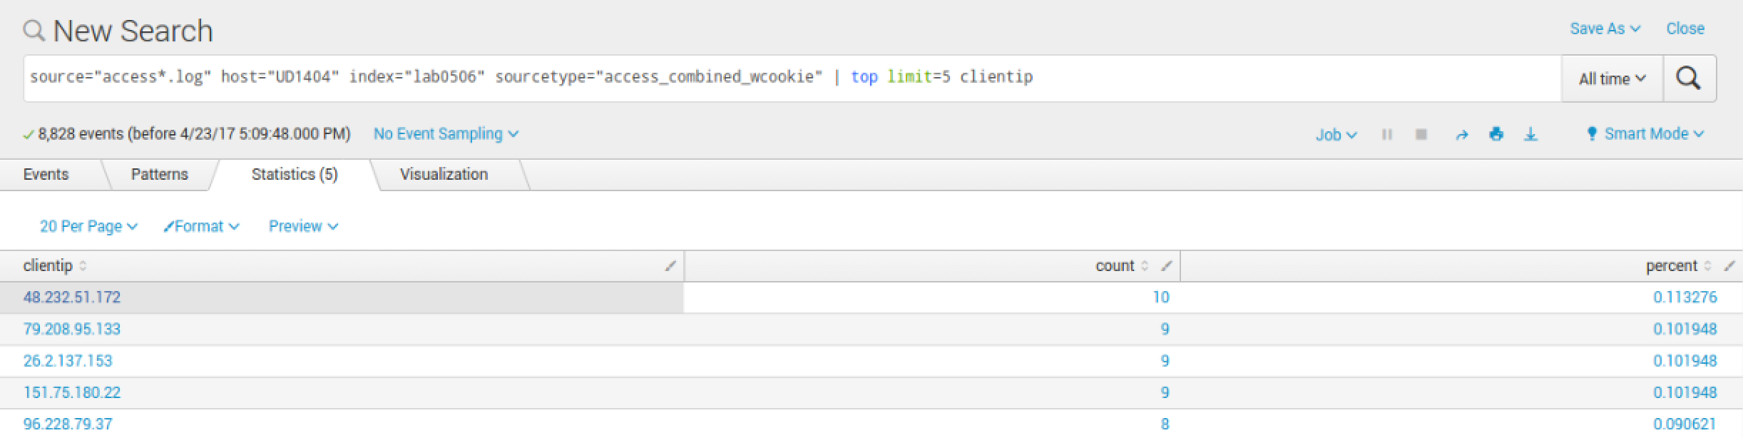

Top Referral Web Sites
source=”access*.log” index=”lab0506” referer != *MyGizmo* | top referer | fields – percent
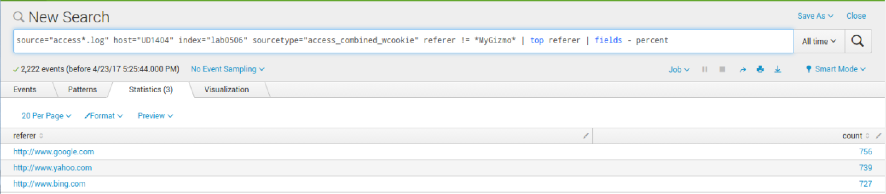
source=”access*.log” index=”lab0506” referer != *MyGizmo* | top referer
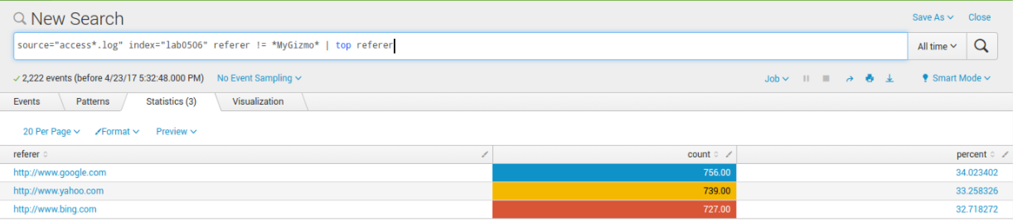

How Many Events have HTTP 404 Status
source=”access*.log” index=”lab0506” referer != *MyGizmo* | top referer

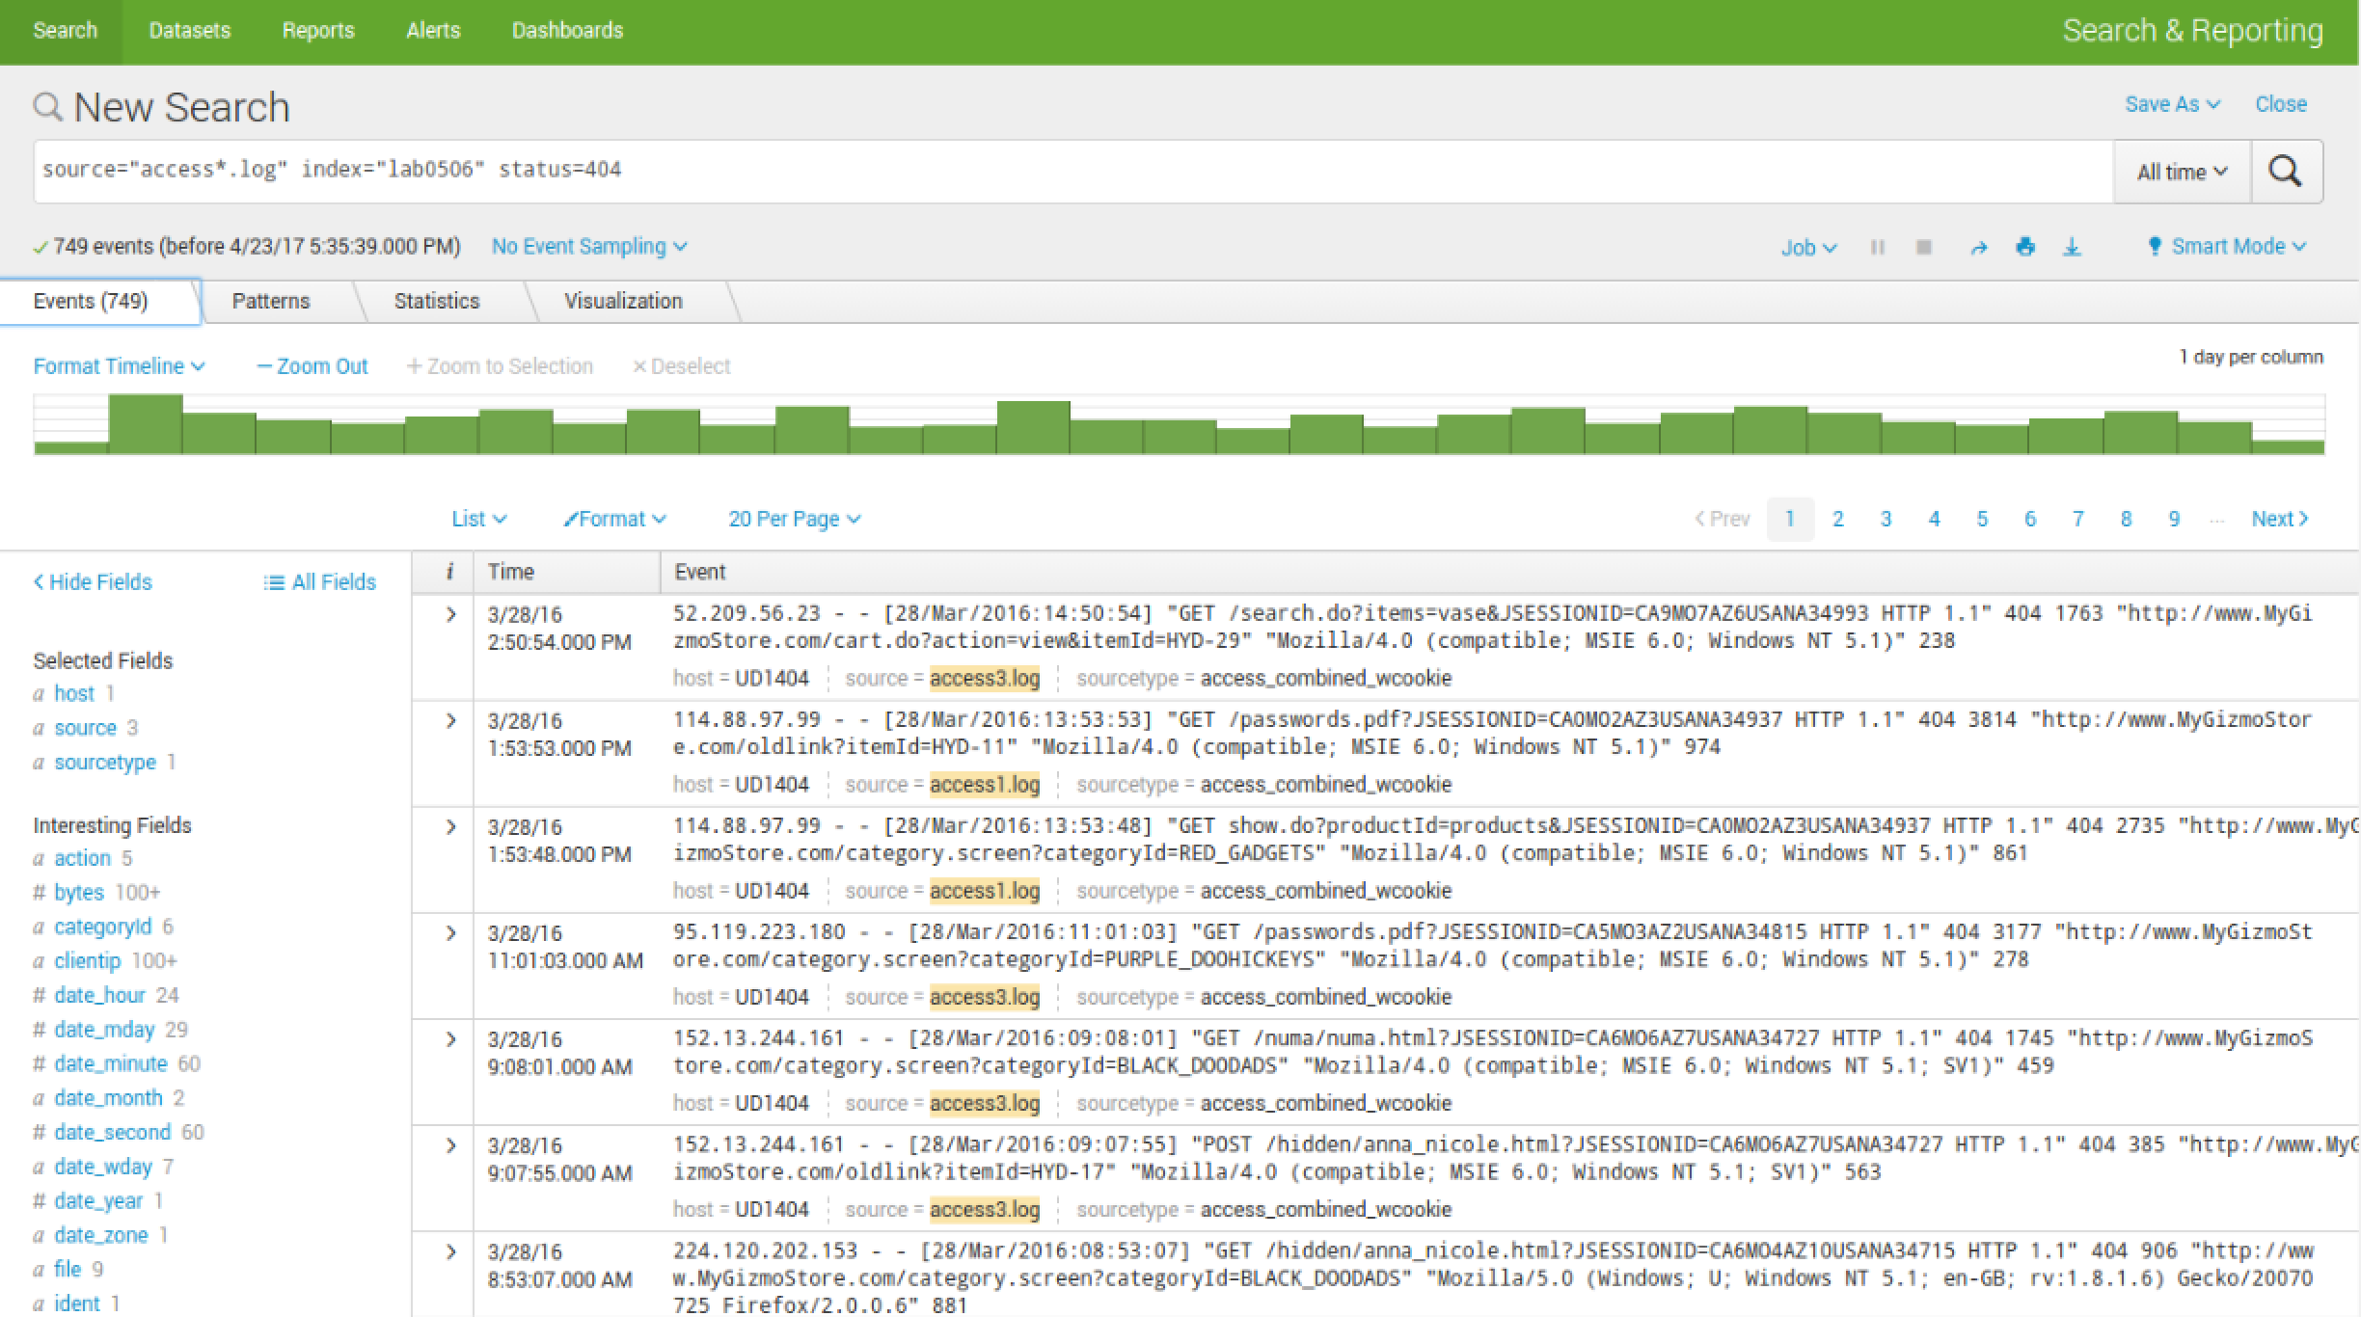

Searching by source (Web Server) – click on the source hyperlink
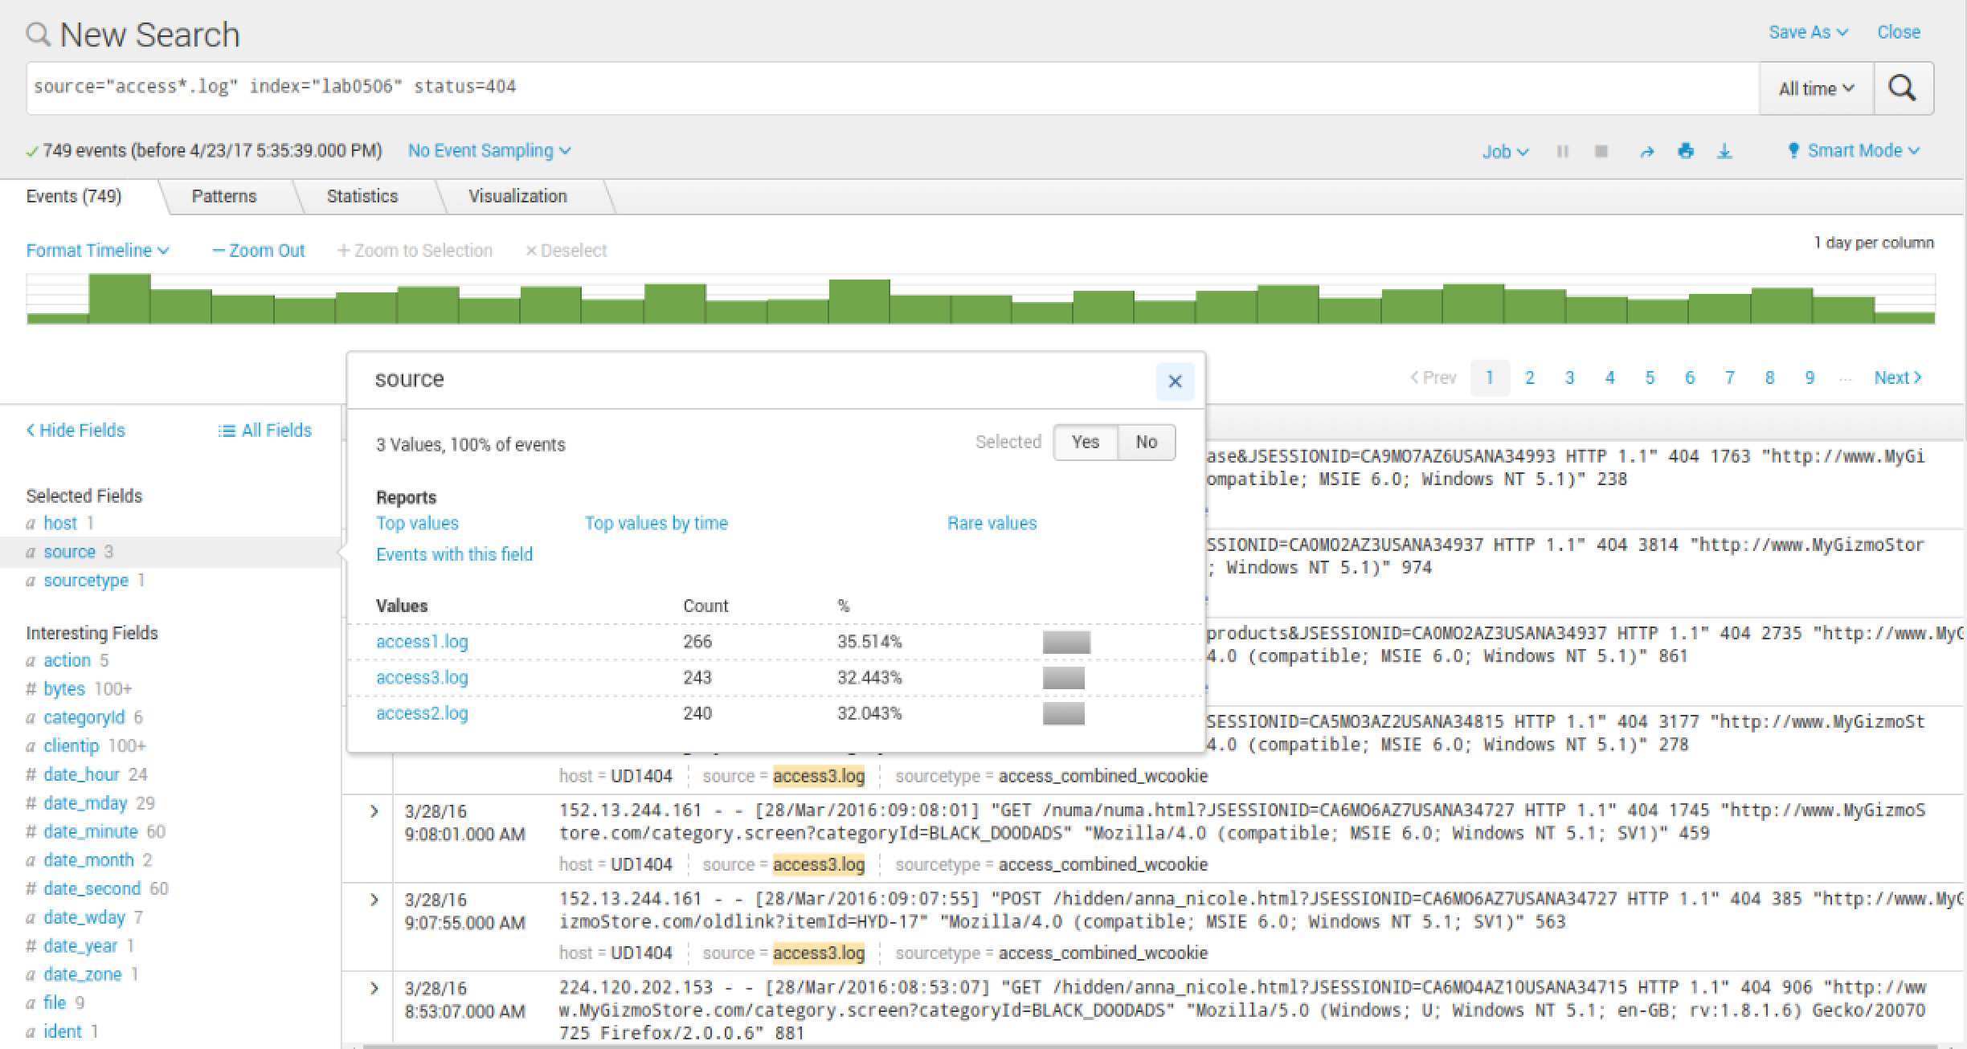
source=”access*.log” index=”lab0506” status=404 | stats count by host (source)
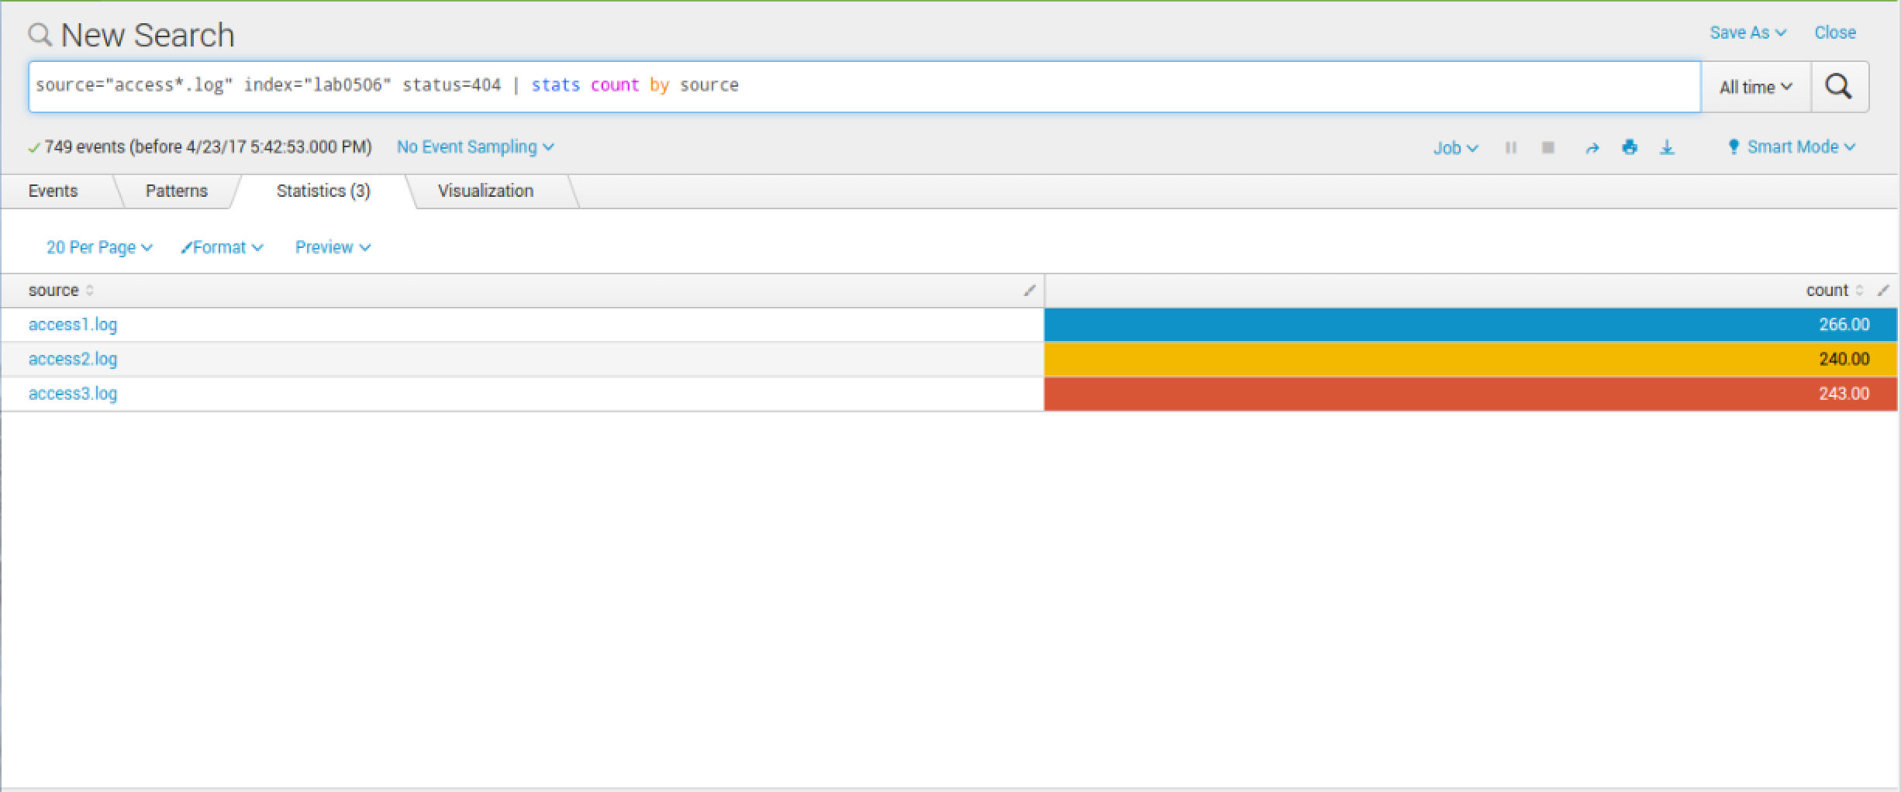

source=”access*.log” index=”lab0506” action=purchase | stats count by productId
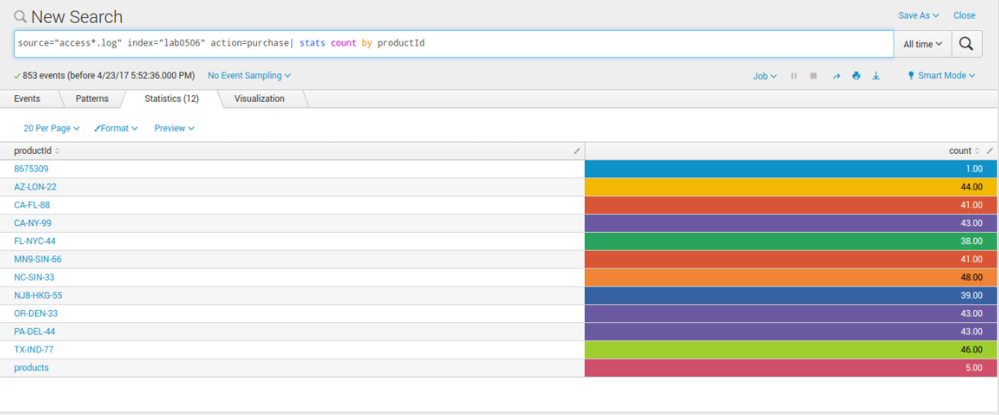
source=”access*.log” index=”lab0506” action=purchase | stats count by productId | addtotals labelfield=Total label=AllProducts
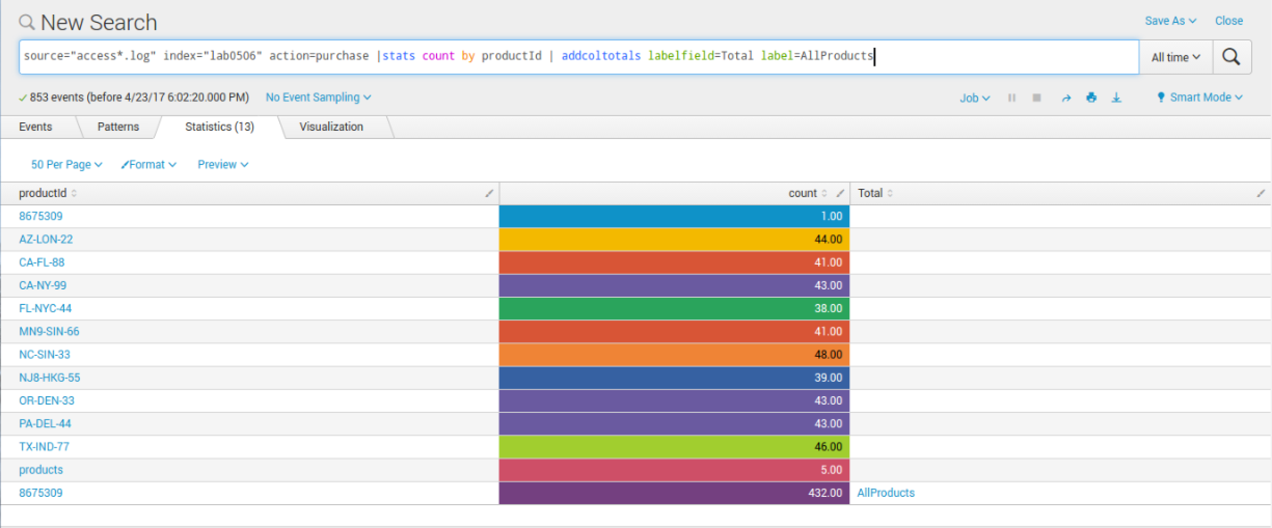

If you did not load the files as a separate host you will need to use a different method to differentiate the three data sources.

