Final Exam – Fall 2014
MIS5401 – Data Analytics
Sunil Wattal
Max Points 60

Please email the completed exam to me (swattal@temple.edu) before 6:00pm Sunday Dec 14, 2104

Overview
Please read the instructions carefully – you must answer all parts of the questions to get full credit.

Please provide clear and concise answers and limit your answer to the space provided. I will ignore anything you write beyond that space limit! Your grade will be determined by the clarity and accuracy of your response. Extraneous detail unrelated to the question will be penalized.
It should be clear that you are drawing on the course material in your answers. Generic responses that don’t reflect the lessons learned in the course will not receive credit.

Also, make sure that when asked for multiple items (i.e., multiple challenges, factors, solutions, etc.) that each one represents a different idea. If an answer merely restates a previous point, you will only receive credit for your first answer.

This is an open book, open notes, open laptop exam. You are not allowed to use the internet during the exam. After you complete the exam, please email the completed copy to me (swattal@temple.edu)

Finally, as this is a “take-home” exam, and everyone must follow an honor code. I ask that prior to submitting the exam, you acknowledge compliance with this statement by typing your name in place of the line after “Name.”
“The only reference materials I have consulted in preparing my response are those assigned for this course. I have not given assistance to anyone else and have not received any assistance on this exam from anyone else. I also did not use the internet while working on the exam – except for downloading the exam and emailing back the completed exam”

Name: ___________________________________

Q1: Consider the following two graphics. For each graphic, identify two aspects that could be improved using the data visualization concepts we discussed in class. For each aspect, explain what they are doing wrong and how the diagram can be improved. Refer to specific rules we established for good visual representations. (10 pts)
Graphic A
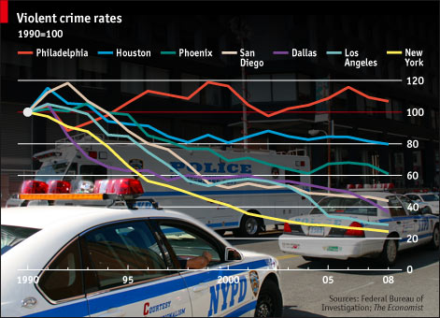
What they are doing wrong:

Recommendation to improve the graphic:

Graphic B
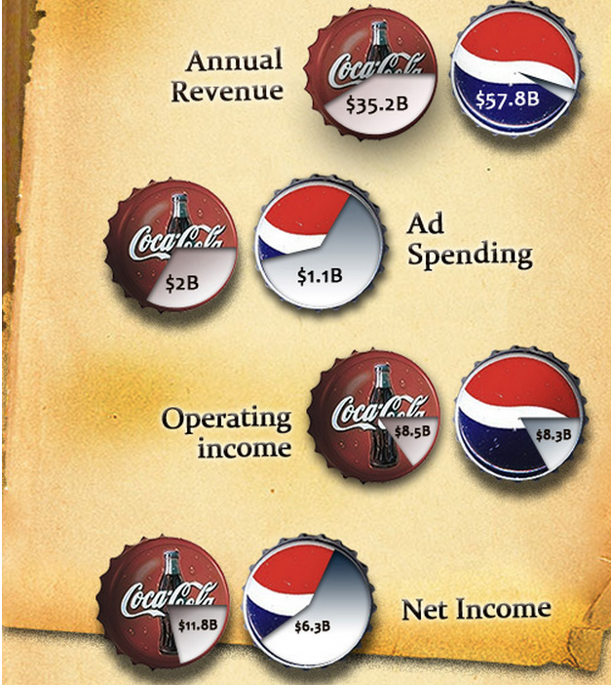
What they are doing wrong:

Recommendation to improve the graphic:

Q2: If you were providing advice to a colleague running a commercial website, what would you tell them the business value of website analytics is? Also list any five web analytics metrics. (8pts)

Business Value of Website Analytics

Web Analytics Metrics
1.
2.
3.
4.
5.

Q3: If you were providing advice to Netflix, how would you explain the business value of Association Mining in the context of their business? (6 pts)

Q4: Consider this scenario. The new director of information technology at Campbell wants to improve organizational decision-making by giving area managers greater access to the company’s (structured) transactional data. But there is a debate regarding the best way to give them access.
List and explain two reasons why putting the data into a cube and having managers browse it using a Pivot Table is a better alternative to having them use SQL to query the database? (8 pts)

1.

2.

Q5: Does data analytics facilitate scientific management? Use examples to highlight your answer. (5 pts)

Q6: Do big data technologies portend the end of ETL? List and explain scenarios where firms could find ETL useful. (5 pts)

Q7: List and explain any 3 business applications for decision trees. What is the role of training and validation data sets in association mining? (8 pts)

Applications of decision trees
1.

2.

3.

Role of training and validation data sets

Q8. Consider the following scenario. (10 pts)
You have just been hired as a university professor to develop a new course in data analytics. You and three other professors will all be teaching sections of the course.
1a) The department chair has asked you to prepare a set of key performance indicators (KPIs) to measure the success of the new course. Propose 2 KPIs to assess the new course. For each KPI describe what it measures, how it is calculated, where the data will come from and why it is a good KPI.

1

2

1b) Assume that your KPIs had been collected for 3 years of courses (4 sections taught 2 per year each). Describe at least one additional use of this data.

