Maria Uniyat
MIS 3406 – Flash Research Paper
Mart Doyle

Flash Research Assignment: Virtualization and Cloud Computing

By upgrading from traditional to virtual machine servers our company can generate a net benefit of $9,200,000 over a three-year period. “VMware is a virtualization product that makes it possible to partition a single physical server into multiple virtual machines” ("What Is Vmware Server? - Definition From Whatis.Com"). A virtualized datacenter will decrease our yearly maintenance costs.
If our company implements virtual machines using VMware, it will allow 800 servers to run on only 80 machines. This is an example of the main benefit of server consolidation. Also, server consolidation reduces time and money spent on hardware and software maintenance, technical support, power and cooling. The key capability is that by implementing virtualization, we can reduce our 1000 physical servers to 280 without any reduction in performance.
Total cost of implementing to new virtual machine for three years will be $4,800,000 for purchase of hardware, hardware and software maintenance, technical support, power, and cooling. The benefit over a three- year period is $14,000,000 from not purchasing and spending money on maintenance of 720 physical machines. There will be net benefit of $9,200,000 over three years period if we implement VMware.

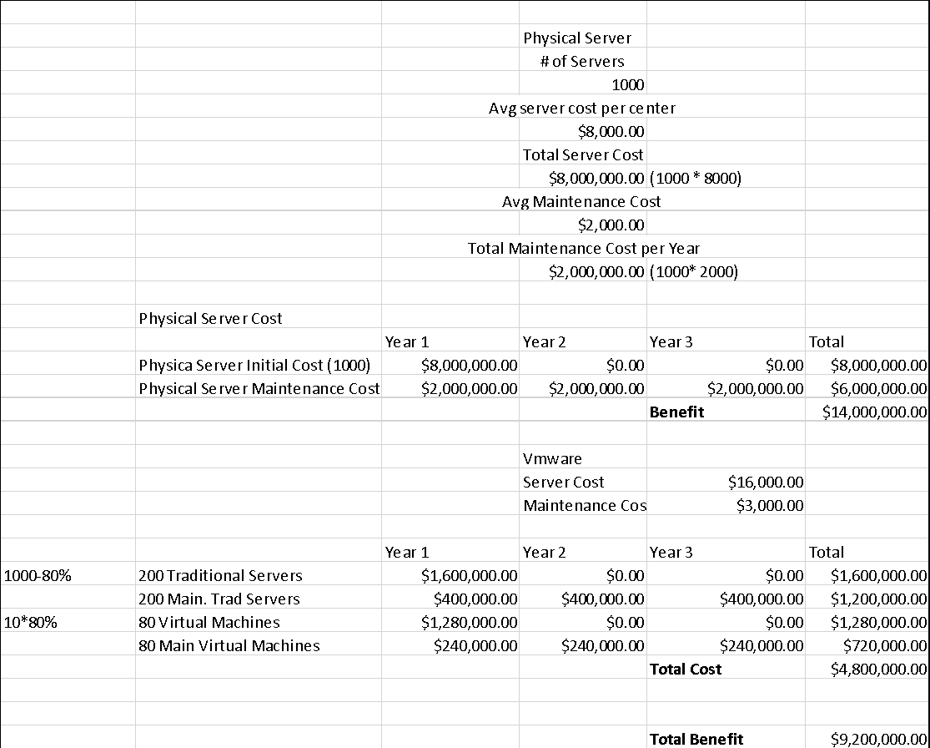
References:
"Vmware Vsphere 5.1". Pubs.Vmware.Com, 2018, https://pubs.vmware.com/vsphere-51/index.jsp?topic=%2Fcom.vmware.vsphere.vcenterhost.doc%2FGUID-ED375B12-7D08-4B7E-81EE-DCE83E51B1AF.html. Accessed 10 Oct 2018.
"What Is Vmware Server? - Definition From Whatis.Com". Searchvmware, 2018, https://searchvmware.techtarget.com/definition/VMware-Server. Accessed 10 Oct 2018.
"10 Benefits Of Virtualization In The Data Center". Techrepublic, 2018, https://www.techrepublic.com/blog/10-things/10-benefits-of-virtualization-in-the-data-center/. Accessed 10 Oct 2018.

