Thomas Murphy

Professor Doyle

Flash Research #4

4/2/17

SharePoint

Our company would benefit $948,500 in three years by investing in Microsoft SharePoint. SharePoint is an employee collaboration tool that would make management of documents easier. We will be able to increase productivity by eliminating this wasted time PMPs use on document management and more efficient collaboration.

Microsoft SharePoint is a software platform that allows easy access to documents for employees and our clients. They will be able to access these shared documents on the web, allowing for easy collaboration and quicker communication. SharePoint allows documents to be securely managed in one location. This eliminates our PMPs waste of time locating information, file duplication and lost knowledge dispersed among employees with separate documents. Productivity, collaboration, and added value to our clients will increase with implementation of this product due to its features.

Our three year costs for Microsoft SharePoint would be $1,151,500 for initial investment, annual maintenance cost, and PMP support. Our three year benefits would be $2,100,000 from upgrading from the time we save with easier collaboration and quicker communication. This would lead to us having a three year net benefit of $$948,500.

3 Year Costs:

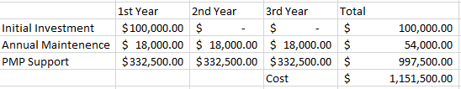

3 Year Benefits:

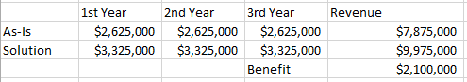

3 Year Net Benefits:

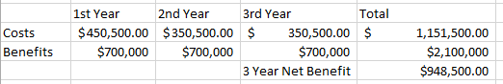

<https://www.softeng.es/en-us/products/microsoft-sharepoint-online/benefits-of-sharepoint-intranet.html>

<http://www.totalsol.com/sharepoint/why-sharepoint/>

<https://www.linkedin.com/pulse/20140703175001-392712-top-10-benefits-of-microsoft-sharepoint-server>